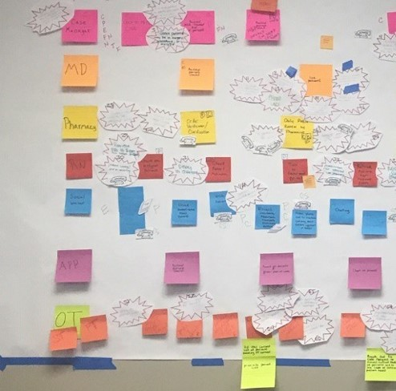
Figure 2. Value stream map – current state

