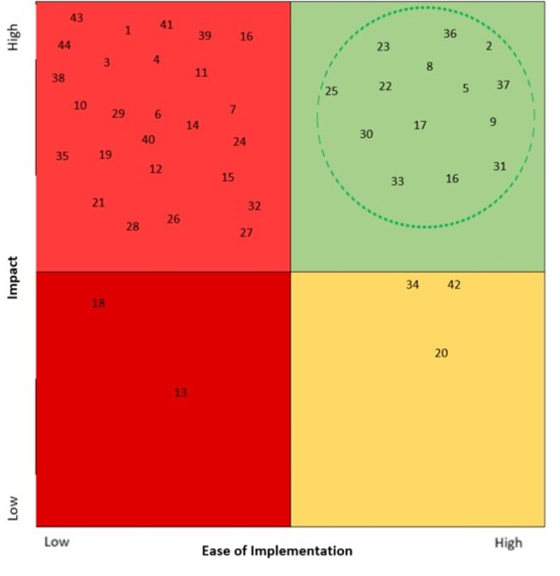
Figure 3. Kaizen bursts mapped on a prioritization matrix

