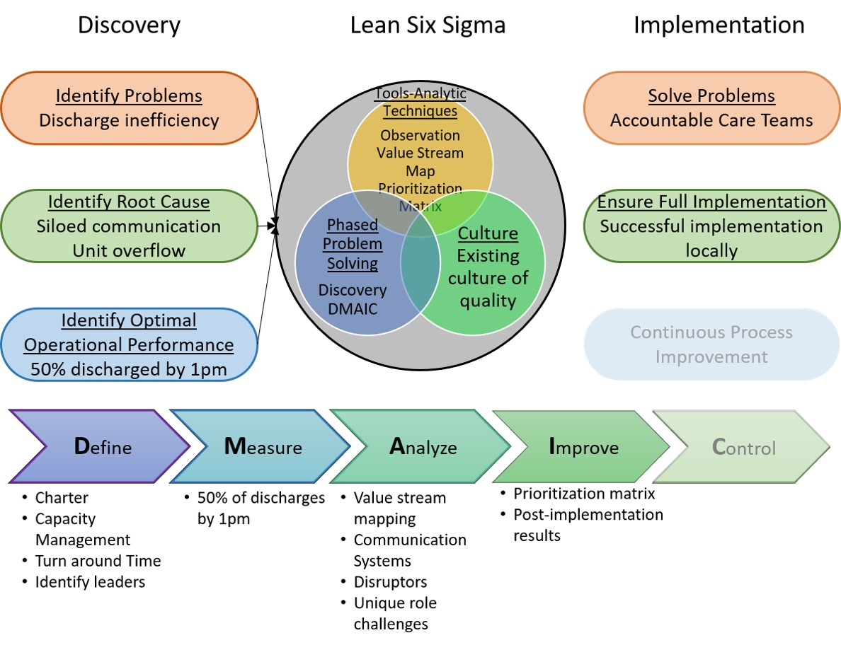Figure 4. Findings as applied to the conceptual framework

