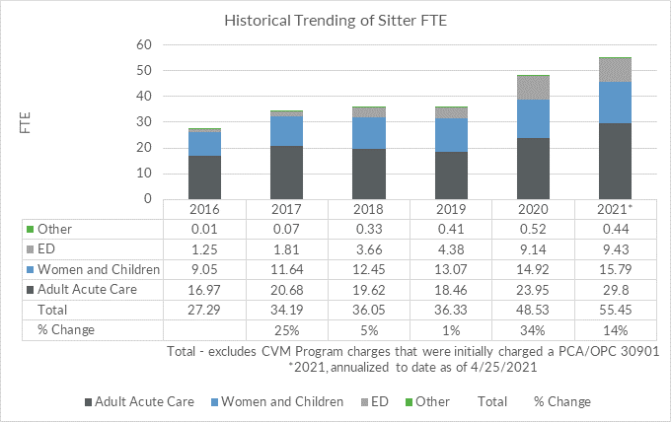

Supplemental Digital Content, Figure 1. Historical Trending of Sitter FTE.

ED, Emergency Department

CVM, Continuous Video Monitoring

PCA/OPC, Patient Care Attendant/sitter

FTE, Full Time Equivalents