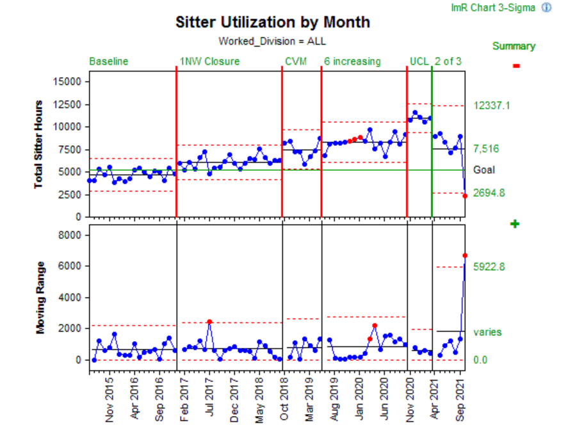
Supplemental Digital Content, Figure 2. Sitter Utilization by Month
1NW, 1 Northwest (Psychiatric Unit)
CVM, Continuous Video Monitoring

