Supplemental Digital Content, Figure 1: Zero Board Template
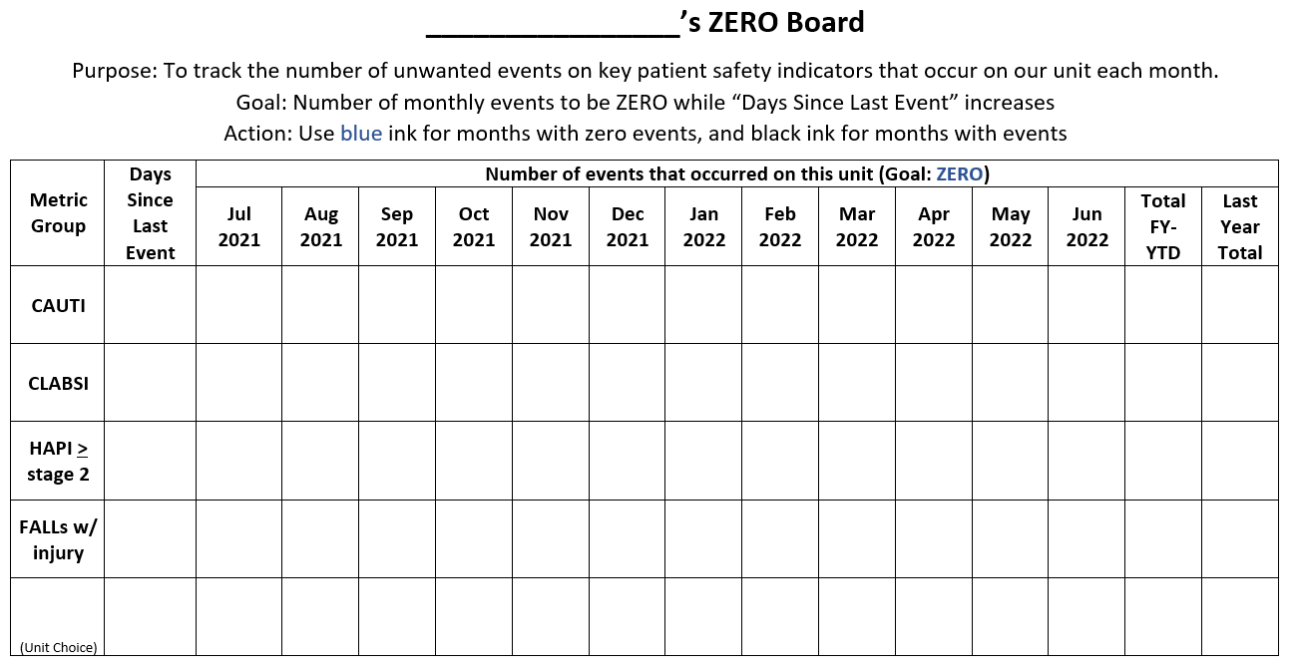
Reprinted by permission Memorial Hermann – Texas Medical Center, 4-12-2022

