Supplemental Digital Content, Figure 2: Report Card Template
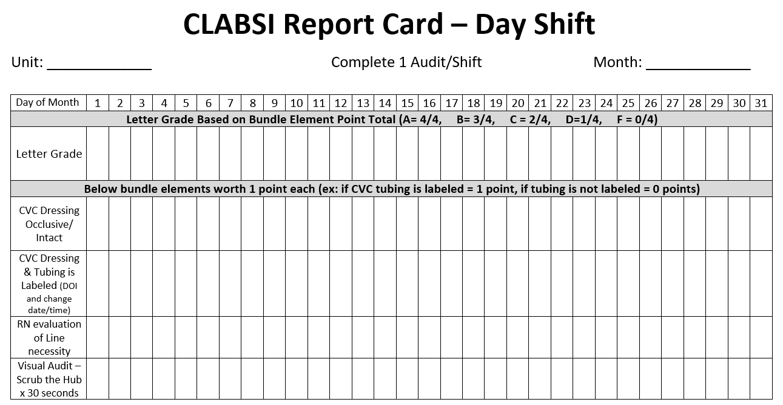
Reprinted by permission Memorial Hermann – Texas Medical Center, 4-12-2022

