Supplemental Digital Content, Figure 3: Leader Rounding Guide
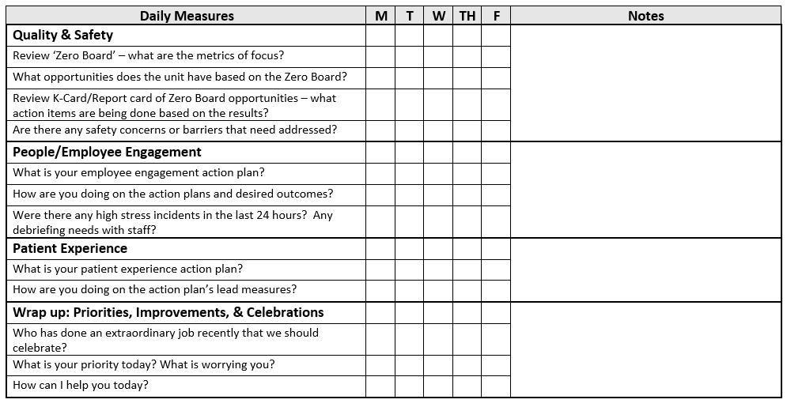
Adapted from Barnas K, Beyond Heroes¹²
Reprinted by permission Memorial Hermann – Texas Medical Center, 4-12-2022

