Supplemental Digital Content Figure. Plots of Simple Path and Effects with Workplace Violence Reporting Culture as the Moderator Variable
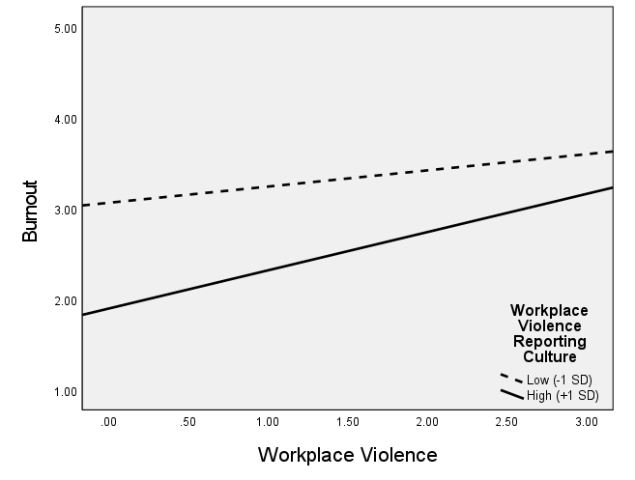 | Panel A. The effect of workplace violence on burnout at different levels of workplace violence reporting culture:  The experiences of WPV increased nurses' burnout for all levels of WPV reporting culture. However, as WPV experience increased, burnout level increased at a higher rate for the high level of WPV reporting culture compared with the low level of WPV reporting culture.
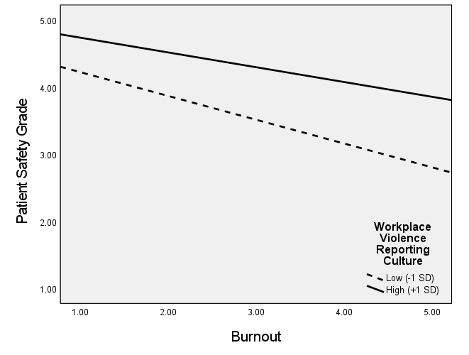 | Panel B. The effect of burnout on patient safety grade at different levels of workplace violence reporting culture:  Nurse burnout was negatively associated with patient safety grades for all levels of WPV reporting culture. However, the high level of WPV reporting culture weakened the negative effect of burnout on patient safety grade.
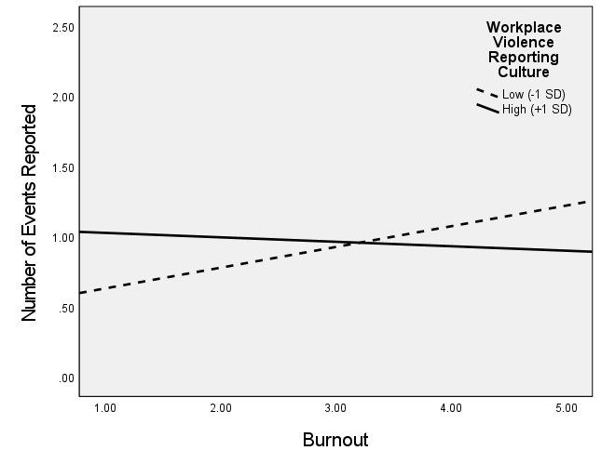 | Panel C. The effect of burnout on the number of events reported at different levels of workplace violence reporting culture:  An increase in burnout was associated with an increase in the number of events reported at the low level of WPV reporting culture.

