SUPPLEMENTARY DIGITAL CONTENT 2
FIGURE S1. Results of correlation analysis of change from baseline to week 12 between the different workplace productivity and functioning domains (observed cases).
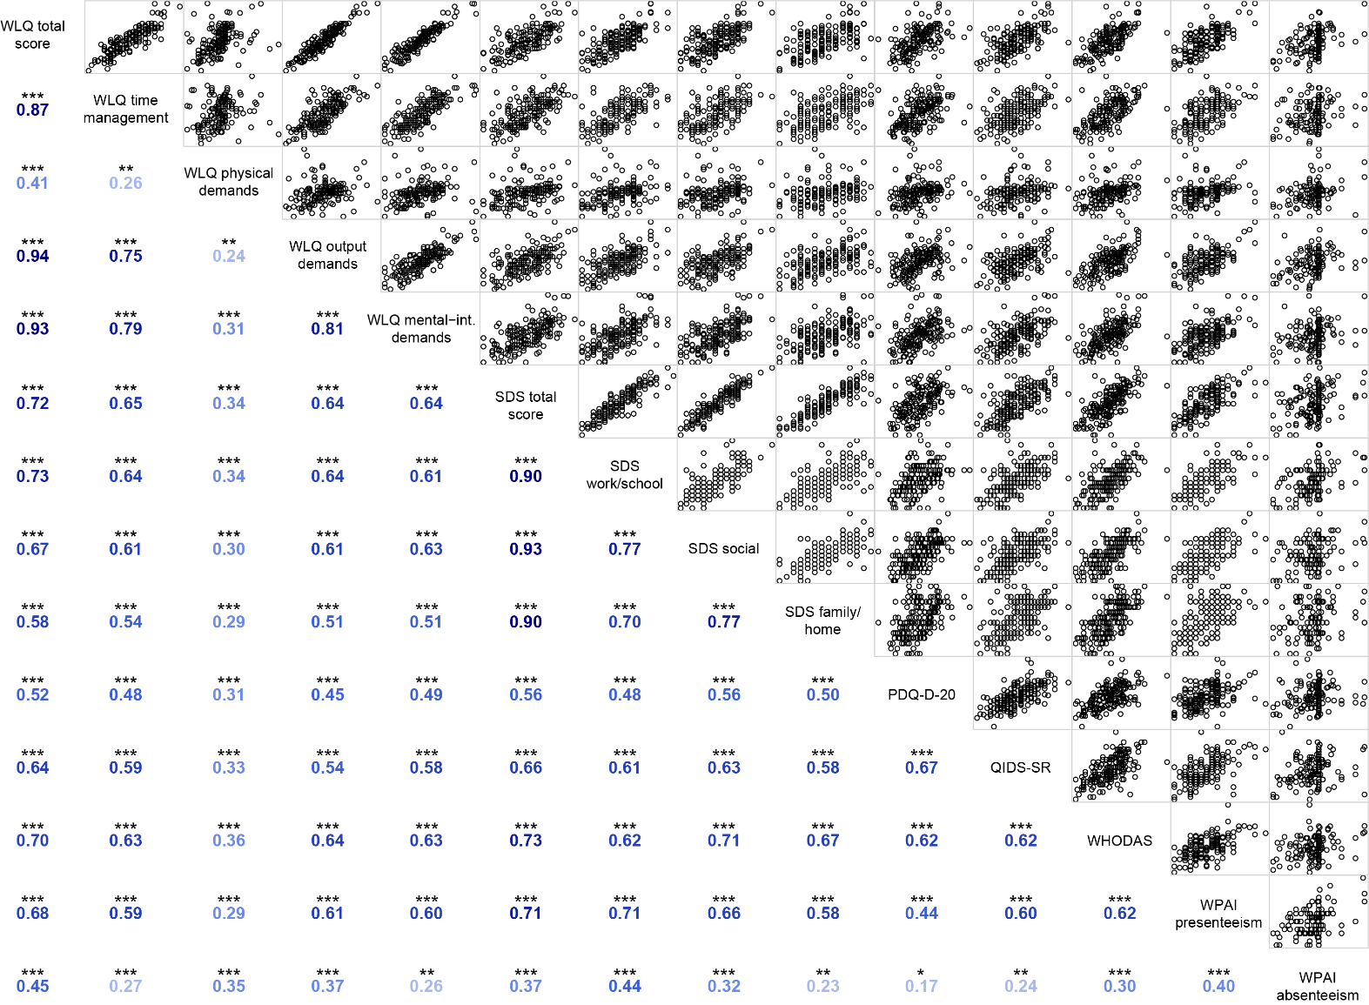
*p<0.05, **p<0.01, ***p<0.001
Scatterplots are shown on the upper right side of the correlation plot, with corresponding Pearson correlation coefficients on the lower left side (darker values indicate greater correlation coefficients).
PDQ-D-20, 20-item Perceived Deficits Questionnaire–Depression; QIDS-SR, Quick Inventory of Depressive Symptomatology–self-report; SDS, Sheehan Disability Scale; WHODAS, 12-item World Health Organization Disability Assessment Schedule 2.0; WLQ, Work Limitations Questionnaire; WPAI, Work Productivity and Activity Impairment.

