Supplement Figure 3. Kidney function

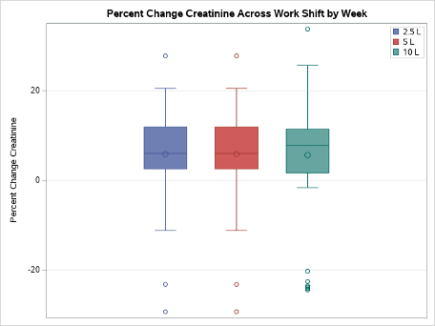
Supplement Figure 3. Percent change in creatinine across work shift by intervention week

