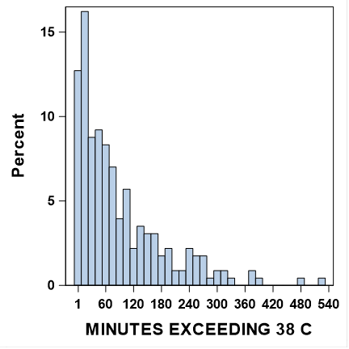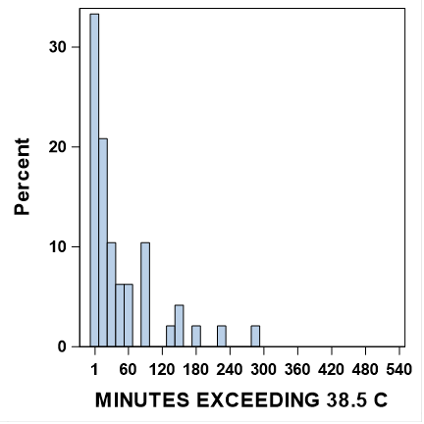

**Supplemental Figure 1.** Distribution of minutes Tc above 38 (number of days=228) or 38.5 C (number of days=48), among those who exceeded those thresholds. Tc38 median= 59 [Q1 19 – Q3 131] and Tc38.5 median =13 [Q1 5 - Q3 59].