Supplemental Figure 1a & 1b with Supplemental Addendum Text.

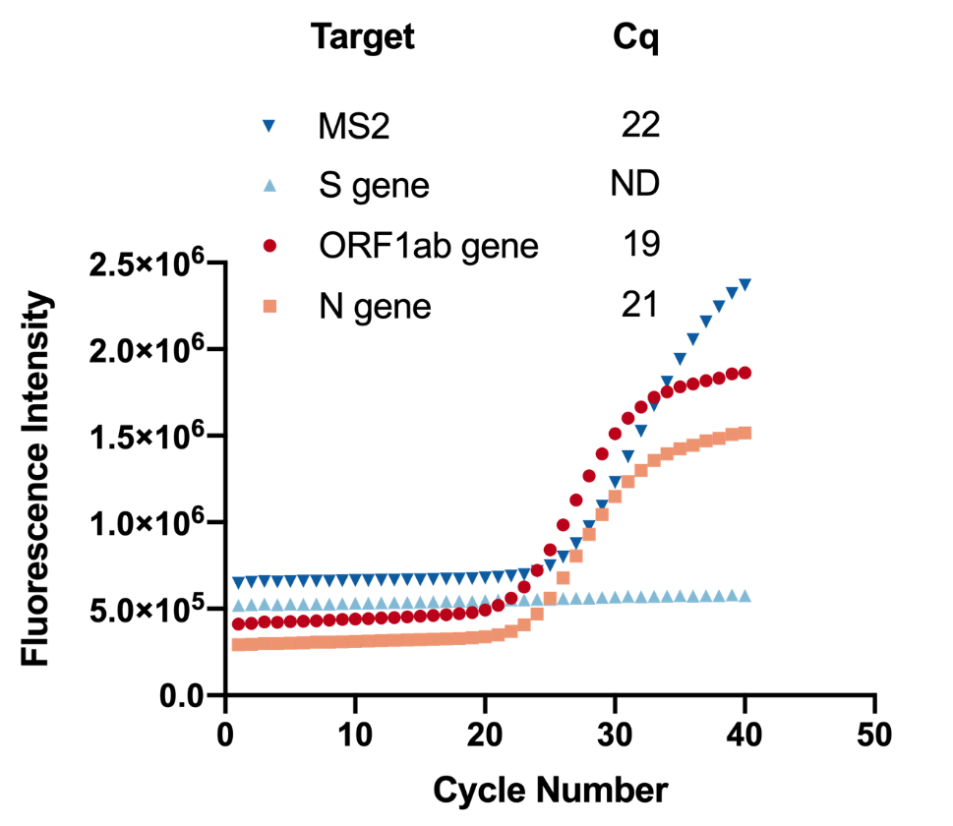
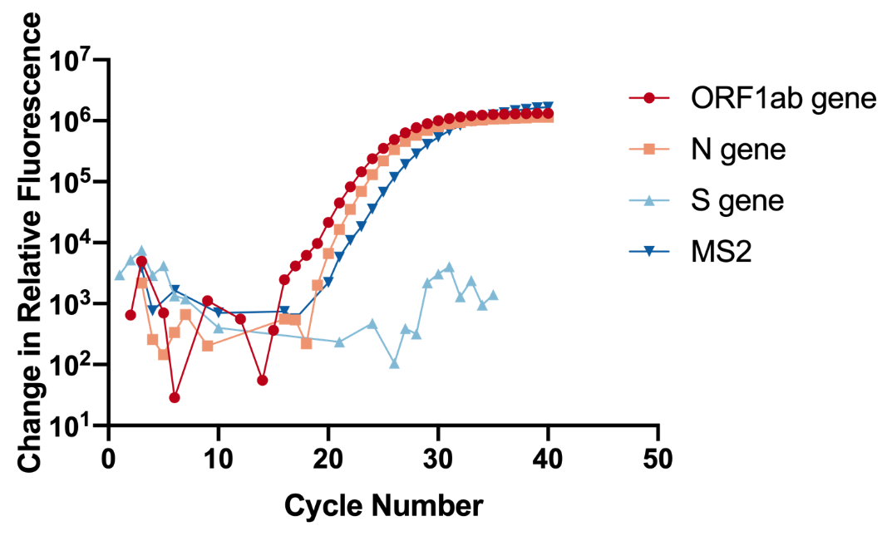
Note: Two amplification plots depicting S gene drop off in PCR Ct results for a case; SF1a illustrates the S gene drop off and SF1b shows curves in differential values (change in relative flouresence).

Supplemental textual discussion.
Occasionally, molecular diagnostic tests produce results that are invalid, inconclusive or unexpected based on the prescribed interpretation of results from samples or controls¹. Staff continuously evaluate these aberrant results to identify problems with sample collection, RNA extraction, reagent quality, plate preparation and mixing, real-time PCR system performance, or potential contamination. However, mutations in SARS-CoV-2 can also produce aberrant results when they interfere with primer or probe binding to the viral RNA or cDNA².

Most mutations in SARS-CoV-2 appear to be neutral –they do not affect the virus’s transmissibility or pathogenesis³. However, some mutations could help the virus spread, enabling escape from neutralizing antibodies⁴ or increased transmissibility. For example, some highly transmissible variants have altered spike proteins such as D614G⁵ or the 69-70del, N501Y and P681H combination found in Variant of Concern (VOC-202012/01) or the B.1.1.7 lineage. The six nucleotide deletion that causes the deletion of amino acids 69-70 interferes with S gene identification and amplification in the TaqPath™ COVID-19 assay (Figure 2). Because this multiplexed test identifies three different genes in the virus, a drop out of only the S gene signal does not invalidate a positive result. It does indicate a potential mutation that could be associated with either the B.1.1.7 lineage or a less concerning lineage such as B.1.375.

Viral genome sequencing can be used to confirm mutations and collect epidemiological data. Viral RNA is extracted and amplified from samples for comparison with the Wuhan-Hu-1 reference sequence⁶ or multiple sequence alignments. Although a variety of sequencing methods have been developed for SARS-CoV-2 and other positive ssRNA viruses, they require equipment, expertise and funding that may not be available to occupational health services or other laboratory testing in primary care. Furthermore, the amplification, DNA purification, and library preparation procedures for sequencing could contaminate high-throughput tests with amplified DNA⁷. To confirm whether the S gene drop out is caused by the 69-70del mutation we (and others) are developing mutation detection assays using RT-qPCR with primers or probes that discriminate between reference SARS-CoV-2 sequences and variants of concern. Such methods are compatible with equipment, reagents and workflows in the testing laboratory. Multiplexed assays can be performed using oligonucleotides that are carefully designed to distinguish mutations characteristic of variant lineages and labeled with different fluorophores appropriate for the lab’s calibrated real-time PCR instruments. Results from these in-house tests provide quality control on high-throughput commercial tests and can be used to prioritize samples for offsite sequencing and detailed analysis.

Supplemental References

1. Burd EM. Validation of Laboratory-Developed Molecular Assays for Infectious Diseases. Clinical Microbiology Reviews. 2010;23:550-576.
2. Wang R, Hozumi Y, Yin C, Wei G-W. Mutations on COVID-19 diagnostic targets. Genomics. 2020;112:5204-5213.
3. van Dorp L, Richard D, Tan CCS, Shaw LP, Acman M, Balloux F. No evidence for increased transmissibility from recurrent mutations in SARS-CoV-2. Nature Communications. 2020;11:5986.
4. Weisblum Y, Schmidt F, Zhang F, et al. Escape from neutralizing antibodies by SARS-CoV-2 spike protein variants. eLife. 2020;9:e61312.
5. Plante JA, Liu Y, Liu J, et al. Spike mutation D614G alters SARS-CoV-2 fitness. Nature. 2020.
6. Wu F, Zhao S, Yu B, et al. A new coronavirus associated with human respiratory disease in China. Nature. 2020;579:265-269.
7. Sefers S, Schmitz JE. Molecular contamination and amplification product inactivation. In: Tang Y-W, Stratton CW, eds. Advanced Techniques in Diagnostic Microbiology: Volume 1: Techniques. Cham: Springer International Publishing; 2018:505-526.

