Supplementary Figure 2a. Kaplan-Meir survival curve for seroconversion within 35 days.

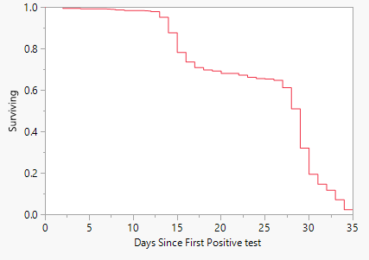

Supplemental Figure 2b. Kaplan-Meir survival curve for seroreversion and symptom status at initial positive RT-qPCR result.

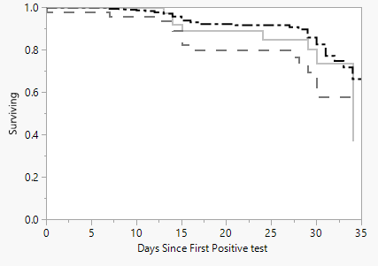 

Note: Product-Limit survival plot for reactive IgG antibody status from serum samples taken within 35 days of RT-qPCR confirmed COVID-19 diagnosis for symptomatic (n = 314), presymptomatic (n = 47), and asymptomatic (n = 38) cases. Combined percent reactive = 92%.