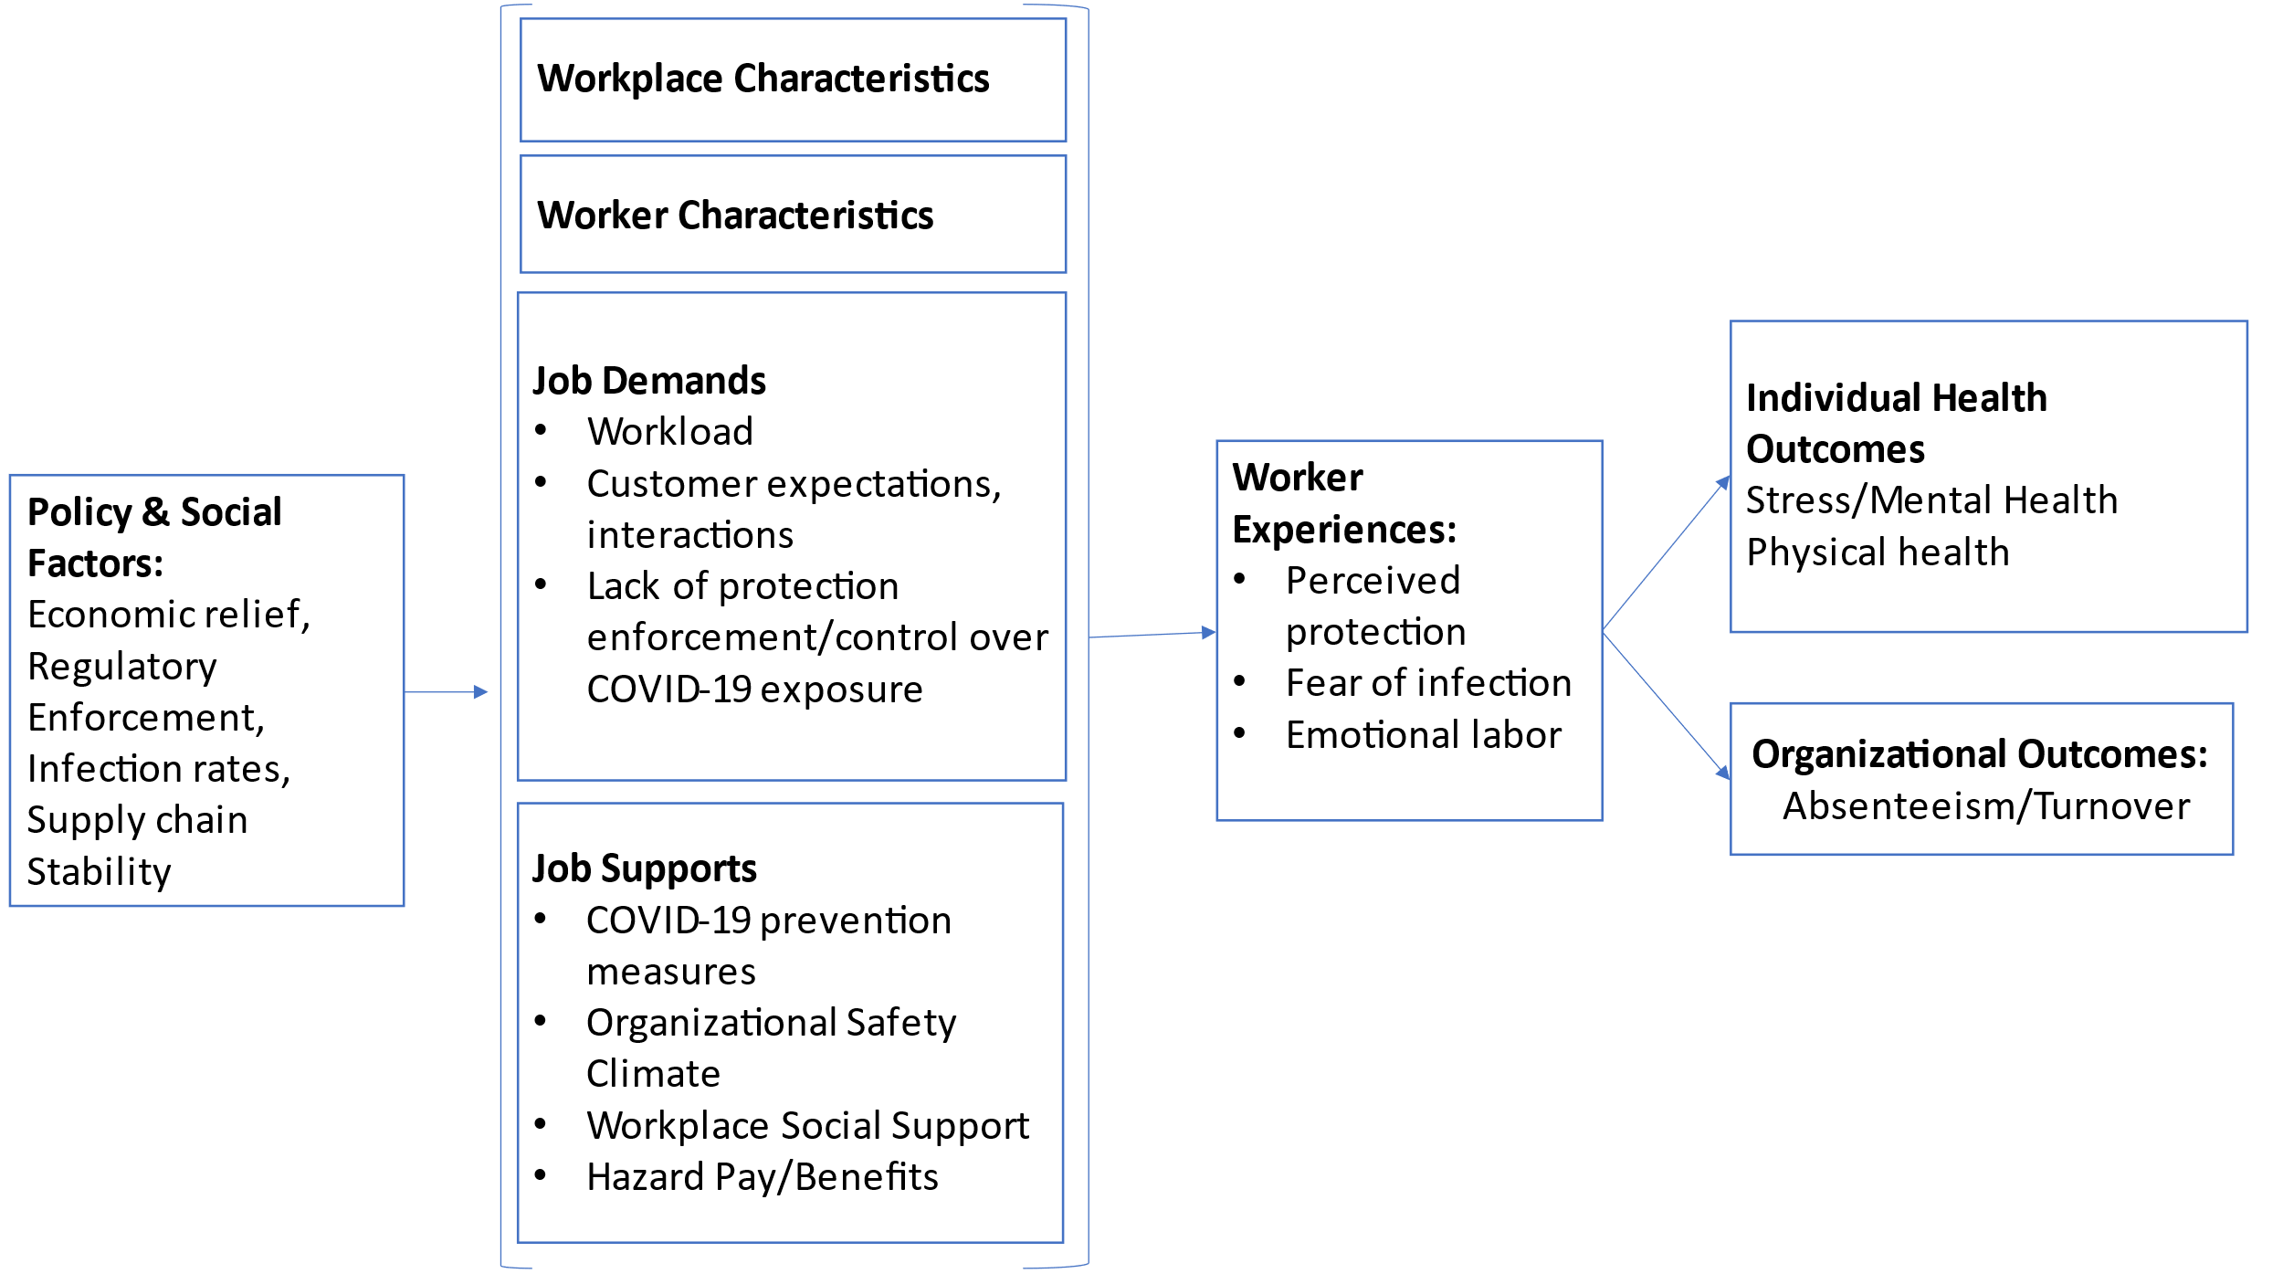
Appendix C. Conceptual model for COVID-19 job stress antecedents and outcomes in food retail workers based on the Job Demands-Resources model.

