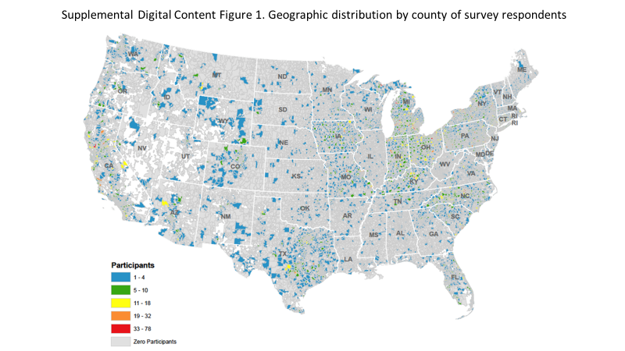

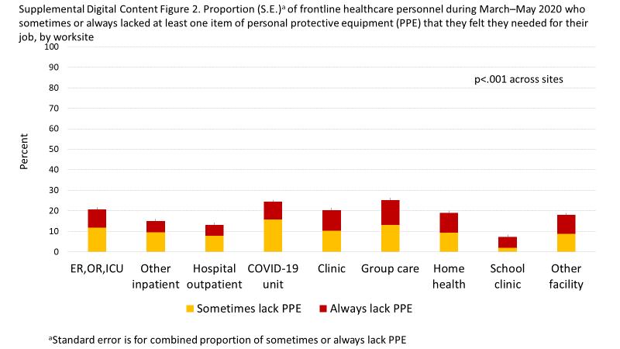

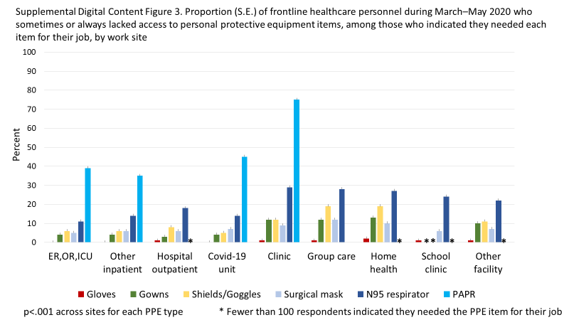
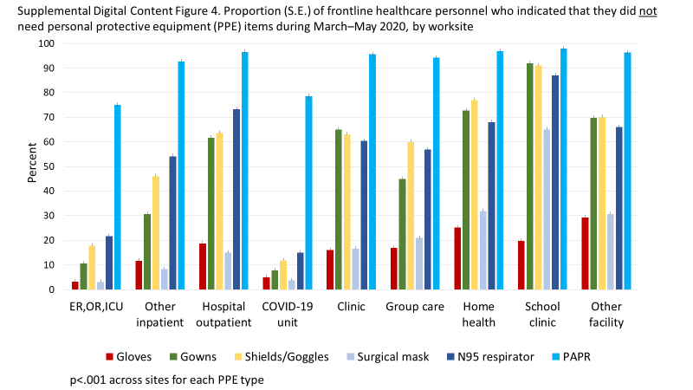
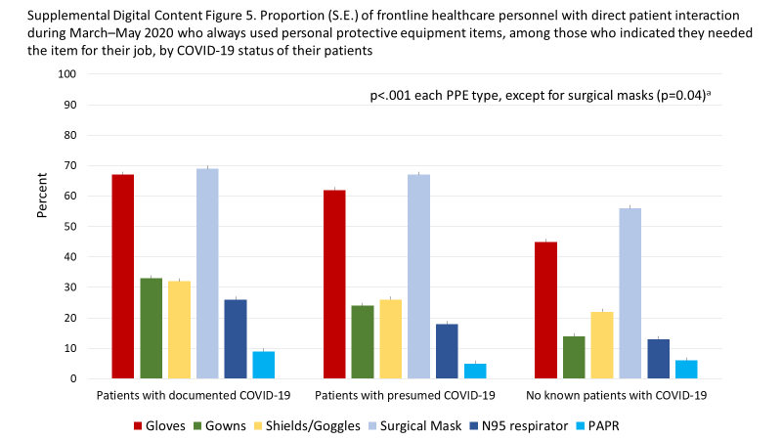
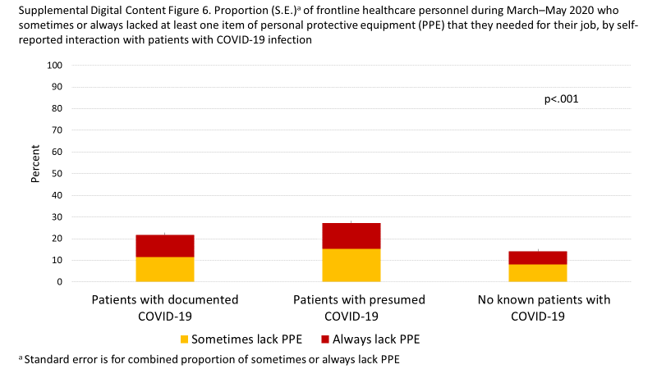
Supplemental Digital Table 1. Odds Ratio (95% CI) for COVID-19 outcomes by U.S. frontline healthcare personnel status, March–May 2020
 | Cases/n | Model 1ª | Model 2^{b} | Model 3^{c}
Outcome: Tested positive for SARS-CoV-2 infection or antibodies
Not frontline healthcare personnel^{d} | 89/1325 | 1.0 (ref) | 1.0 (ref) | 1.0 (ref)
Frontline healthcare personnel | 321/2900 | 1.84  (1.43 to 2.38) | 1.84  (1.43 to 2.37) | 1.45  (1.12 to 1.89)
Outcome: Symptom-predicted COVID-19
Not frontline healthcare personnel⁴ | 1074/34524 | 1.0 (ref) | 1.0 (ref) | 1.0 (ref)
Frontline healthcare personnel | 1037/22232 | 1.59  (1.45 to 1.74) | 1.59  (1.45 to 1.75) | 1.34  (1.22 to 1.48)
ª Adjusted for age in years (continuous), sex, and race/ethnicity (white, other)
^{b} Adjusted for age (continuous), sex, race/ethnicity (white, other), body mass index (continuous), current smoking (yes/no)
^{c} Adjusted for age (continuous), sex, race/ethnicity (white, other), body mass index (continuous), current smoking (yes/no), and interaction with people other than patients with presumed or documented COVID-19 (yes, documented; yes, presumed; not that I know of)
^{d} Includes healthcare personnel working remotely, employed non-healthcare workers, retired workers and healthcare personnel, and other
Abbreviations: CI, confidence interval; ref, reference group

Supplemental Digital Table 2. Odds Ratio (95% CI) for COVID-19 outcomes among U.S. frontline healthcare personnel by lack of personal protective equipment (PPE), March–May 2020
 | Cases/n | Model 1ª | Model 2^{b} | Model 3^{c}
Outcome: Tested positive for SARS-CoV-2 infection or antibodies
Never Lack PPE | 197/1919 | 1.0 (ref) | 1.0 (ref) | 1.0 (ref)
Sometimes Lack PPE | 38/324 | 1.20  (0.83 to 1.74) | 1.20  (0.82 to 1.74) | 1.14  (0.78 to 1.68)
Always Lack PPE | 44/260 | 1.79  (1.25 to 2.56) | 1.74  (1.22 to 2.49) | 1.60  (1.10 to 2.31)
Outcome: Symptom-predicted COVID-19
Never Lack PPE | 604/14715 | 1.0 (ref) | 1.0 (ref) | 1.0 (ref)
Sometimes Lack PPE | 120/1906 | 1.58  (1.11 to 2.25) | 1.58  (1.11 to 2.25) | 1.35  (0.94 to 1.93)
Always Lack PPE | 140/1503 | 2.28  (1.63 to 3.17) | 2.24  (1.61 to 3.13) | 1.85  (1.32 to 2.60)

ª Adjusted for age in years (continuous), sex, and race/ethnicity (white, other)
^{b} Adjusted for age (continuous), sex, race/ethnicity (white, other), body mass index (continuous), current smoking (yes/no)
^{c} Adjusted for age (continuous), sex, race/ethnicity (white, other), body mass index (continuous), current smoking (yes/no), and interaction with people other than patients with presumed or documented COVID-19 (yes, documented; yes, presumed; not that I know of)
Abbreviations: PPE, personal protective equipment; CI, confidence interval; ref, reference group

Supplemental Digital Table 3. Odds Ratio (95% CI) for COVID-19 outcomes among U.S. frontline healthcare personnel by interaction with patients with COVID-19 infection, March–May 2020
 | Cases/n | Model 1ª | Model 2^{b} | Model 3^{c}
Outcome: Tested positive for SARS-CoV-2 infection or antibodies
No known patients with COVID-19 | 73/1039 | 1.0 (ref) | 1.0 (ref) | 1.0 (ref)
Patients with presumed COVID-19 | 121/831 | 2.50  (1.83 to 3.42) | 2.50  (1.82 to 3.42) | 1.96  (1.42 to 2.71)
Patients with documented COVID-19 | 85/633 | 2.10  (1.50 to 2.92) | 2.12  (1.52 to 2.95) | 1.56  (1.10 to 2.20)
Outcome: Symptom-predicted COVID-19
No known patients with COVID-19 | 73/10766 | 1.0 (ref) | 1.0 (ref) | 1.0 (ref)
Patients with presumed COVID-19 | 121/4869 | 4.17  (3.09 to 5.62) | 4.14  (3.07–5.58) | 2.76  (2.02 to 3.76)
Patients with documented COVID-19 | 85/2489 | 5.40  (3.93 to 7.41) | 5.39  (3.93 to 7.40) | 3.09  (2.22 to 4.32)
ª Adjusted for age in years (continuous), sex, and race/ethnicity (white, other)
^{b} Adjusted for age (continuous), sex, race/ethnicity (white, other), body mass index (continuous), current smoking (yes/no)
^{c} Adjusted for age (continuous), sex, race/ethnicity (white, other), body mass index (continuous), current smoking (yes/no), and interaction with people other than patients with presumed or documented COVID-19 (yes, documented; yes, presumed; not that I know of)
Abbreviations: CI, confidence interval; ref, reference group

Supplemental Digital Table 4. Odds Ratio (95% CI) for COVID-19 outcomes among U.S. frontline healthcare personnel by lack of personal protective equipment (PPE) and interaction with patients with COVID-19 infection, March–May 2020, with adjustment for local COVID-19 mortalityª in place of interaction with individuals other than patients with COVID-19
 | Interaction with Patients with COVID-19 infection
 | No known interaction |  | Interaction with  presumed cases |  | Interaction with documented cases
 | Cases/n | OR (95% CI)^{b} | Cases/n | OR (95% CI) ^{b} | Cases/n | OR (95% CI) ^{b}
Outcome: Tested positive for SARS-CoV-2 infection or antibodies
Never Lack PPE | 59/864 | 1.0 (ref) | 81/570 | 2.06  (1.42 to 3.25) | 56/461 | 1.36  (0.91 to 2.02)
Sometimes Lack PPE | 4/94 | 0.66  (0.23 to 1.87) | 19/137 | 1.83  (1.03 to 3.25) | 14/89 | 2.21  (1.16 to 4.21)
Always Lack PPE | 10/74 | 1.94  (0.93 to 4.06) | 19/109 | 2.52  (1.40 to 4.52) | 14/73 | 2.22  (1.15 to 4.30)
p-value for interaction <0.001
Outcome: Symptom-predicted COVID-19
Never Lack PPE | 298/9116 | 1.0 (ref) | 188/3472 | 3.21  (2.27 to 4.53) | 115/1909 | 3.13  (2.15 to 4.56)
Sometimes Lack PPE | 40/861 | 0.76  (0.28 to 2.12) | 53/731 | 3.67  (2.14 to 6.28) | 26/282 | 6.41  (3.49 to 11.77)
Always Lack PPE | 45/654 | 2.51  (1.27 to 4.95) | 55/575 | 4.66  (2.72 to 7.97) | 38/252 | 5.91  (3.21 to 10.87)
p-value for interaction <0.001
ªDong E, Du H, Gardner L. An interactive web-based dashboard to track COVID-19 in real time. Lancet Inf Dis. 20(5):533-534. doi: 10.1016/S1473-3099(20)30120-1.
^{b}Adjusted for age in years (continuous), race (white, other), body mass index (continuous), and current smoking (yes/no), adjusted for median county COVID-19-mortality in the 13 days after questionnaire returnª (0; >0–<0.25; 0.25–<0.75; 0.75–<2; 2– <4; 4–7.80 deaths per 10,000; missing). Men were excluded to permit model convergence.
Abbreviations: PPE, personal protective equipment; OR, odds ratio; CI, confidence interval; ref, reference group

