Section I. Models and assumptions of the comparative interrupted time series analysis
The daily incidence of positive tests for COVID-19, our outcome variable, was modeled using hierarchical negative binomial regression models, and county population size was the rate denominator. Given the relatively large number of covariates, we used Bayesian information criterion (BIC) to select a parsimonious model. The Distressed Communities Index (DCI) was excluded from final models, as this covariate led to a larger BIC in all main and sensitivity analyses.
Models for daily incidence of positive tests for COVID-19:
$$ln(Y_{ij}){=\ln\left({population}_{ij}\right)}+β_{0}+β_{1}{time}_{0}+β_{2}phase+β_{3}{time}_{1}×phase+β_{4}closure$$
$+β_{5}{time}_{0}×closure+β_{6}closure×phase+β_{7}closure×phase×{time}_{1}+γ_{1}age18+γ_{2}{state_order}_{j}+γ_{3}{state_phase}_{j}$+$γ_{4}× {state_order}_{j}×{state_phase}_{j}$
$$+γ_{5}{state_order}_{j}×{time}_{0}+γ_{6}{state_phase}_{j}×{time}_{2}+γ_{7}{state_order}_{j}×{state_phase}_{j}×{time}_{2}+ε_{j}+ω_{i(j)}$$
$Y_{ij}:$ daily number of positive tests for COVID-19 in county i in state j;
$β_{0}:$ model intercept, indicating the log count of daily positive tests in control counties at states without state-level orders 20 days before their “quasi-intervention”;
$β_{1}$: time effect in control counties before their “quasi- intervention”;
$β_{2}:$ intercept change in control counties after their “quasi- intervention”;
$β_{3}:$ time effect in control counties after their “quasi- intervention”;
$β_{4}:$ intercept difference in anchor closure counties relative to control counties;
$β_{5}:$ time effect in anchor closure counties before their closure;
$β_{6}:$ intercept change in anchor closure counties after their closure;
$β_{7}:$ time effect in anchor closure counties after their closure;
$γ_{1}$: effect of percent population under 18 years old;
$γ_{2}:$ intercept difference among states with state-level orders at baseline;
$γ_{3}:$ intercept change in control states after their “quasi-state-level orders”;
$γ_{4}:$ intercept change in states after their state-level orders;
$γ_{5}:$ time effect in states with state-level orders before their orders;
$γ_{6}:$ time effect in control states after their “quasi-state-level orders;
$γ_{7}:$ time effect in states with state-level orders after their orders;
$ε_{j}:$ random effect for state j;
$ω_{i(j)}:$ random effect for county i nested in state j;

Closure is an indicator variable denoting anchor closure counties (=1) and control counties (=0). Phase designates if a day is after closure or “quasi-intervention”: phase = 1 indicates that it is after closure for anchor closure counties or after “quasi-intervention” for control counties.${time}_{0}$ represents the temporal trend before any closure, and ${time}_{1}$describes the temporal trend after anchor closure or “quasi-intervention”.$age18$ denotes the percent of the county population under 18 years old. ${state_order}_{j}$, ${state_phase}_{j}$ represents state-level order and phase status, and${time}_{2}$ describes the temporal trend after the state-level order.
This comparative interrupted times series model includes several assumptions. Time trends in the pre- and post- periods for the control counties and counties with anchor closures can be estimated as linear combinations of parameters (Figure S1). The outcome variable is on logarithmic scale, calculated as:$ln(Y_{ij}){-\ln\left({population}_{ij}\right)}=In(Y_{ij}/{population}_{ij})$, representing daily incidence of positive tests for COVID-19. Under this assumption, the parameters in the model were estimated and time trends were represented using linear combinations of estimated parameters: (1) log of incidence trend in control counties before the quasi-intervention date (blue dots from day -20 to day -1 in Figure S1) using $β_{0}+β_{1}{time}_{0}$; (2) log of incidence trend in control counties after the quasi-intervention date (blue dots from day 0 to day 40) using $β_{0}+β_{1}{time}_{0}{+β}_{2}+β_{3}{time}_{1}$; (3) log of incidence trend in counties with an anchor closure before the closure (black dots from day -20 to day -1) using $β_{0}+β_{4}+(β_{1}+β_{5}){time}_{0}$; (4) log of incidence trend in counties with an anchor closure after the closure (black dots from day 0 to day 40) using $β_{0}+β_{4}+\left(β_{1}+β_{5}\right){time}_{0}{+β}_{2}{+β}_{6}+\left(β_{3}+β_{7}\right){time}_{1}$; (5) log of incidence trend in counties with an anchor closure under the counterfactual (red circles from day 0 to day 40) using $β_{0}+β_{4}+\left(β_{1}+β_{5}\right){time}_{0}{+β}_{2}{+β}_{6}+β_{3}{time}_{1}$. Since the red circles were under counterfactual, their estimates were the same except for leaving out time effect of anchor closure ($β_{7})$. Note that we are not comparing point estimates on a single day. Our model estimated the difference in slopes of the red and black lines over the 40 days, which was $β_{7}$ (Figure S1).

Figure S1. A study frame of the comparative interrupted time series analysis
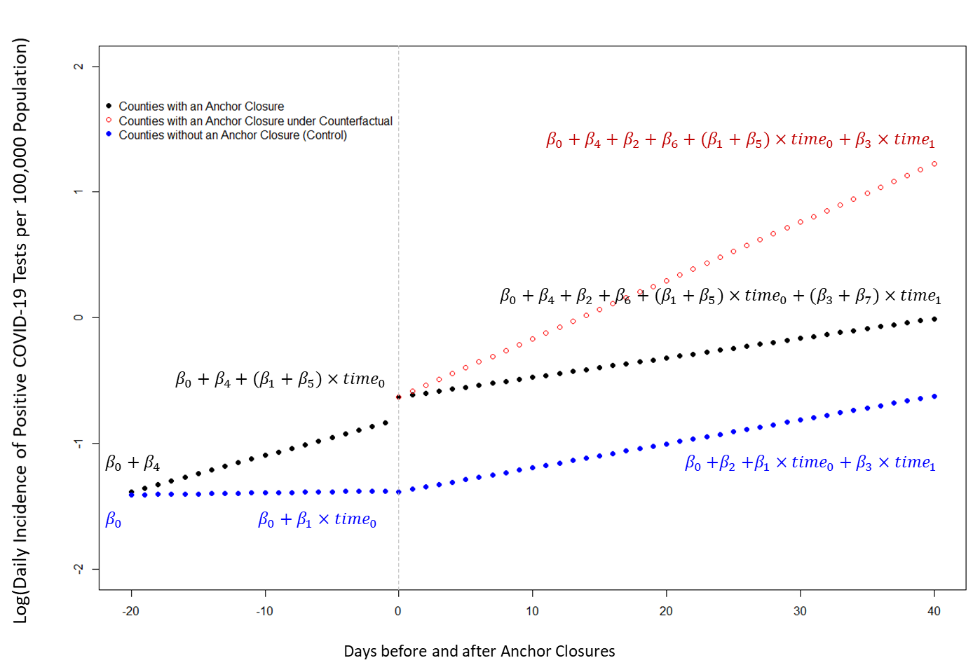
Section II. Results from Main Analysis
Main Analysis | Coefficient | Exponential of coefficient | p-value
${\hat{β}}_{1}$: time effect in control counties before their “quasi-closure” | 0.0037 | 1.004 | 0.840
${\hat{β}}_{2}:$ intercept change in control counties after their “quasi-intervention” | -0.0156 | 0.985 | 0.869
${\hat{β}}_{3}:$ time effect in control counties after their “quasi-intervention” | 0.0400 | 1.041 | 0.001
${\hat{β}}_{4}:$ intercept difference in anchor closure counties relative to control counties | 0.0533 | 1.055 | 0.821
${\hat{β}}_{5}:$ time effect in anchor closure counties before their closure | 0.0629 | 1.065 | <0.0001
${\hat{β}}_{6}:$ intercept change in anchor closure counties after their closure | 0.4199 | 1.522 | 0.022
${\hat{β}}_{7}:$ time effect in anchor closure counties after their closure | -0.0709 | 0.932 | <0.0001
${\hat{γ}}_{1}$: effect of percent population under 18 years old | 0.0893 | 1.093 | 0.026
${\hat{γ}}_{2}:$ intercept difference among states with state-level orders at baseline | 0.8962 | 2.450 | 0.027
${\hat{γ}}_{3}:$ intercept change in control states after their “quasi-state-level orders” | -0.0325 | 0.968 | 0.904
${\hat{γ}}_{4}:$ intercept change in states after their state-level orders | 0.7309 | 2.077 | 0.009
${\hat{γ}}_{5}:$ time effect in states with state-level orders before their orders | 0.0145 | 1.015 | 0.426
${\hat{γ}}_{6}:$ time effect in control states after their “quasi-state-level orders | -0.0024 | 0.998 | 0.898
${\hat{γ}}_{7}:$ time effect in states with state-level orders after their orders | -0.0446 | 0.956 | 0.017

The highlighted cell is the key outcome. The effect of Anchor Closure was $exponential ({\hat{β}}_{7})$. In a county with an Anchor Closure, the incidence on Day n (the day of Anchor Closure) is 0.23469, and the incidence on Day n+1 is 0.24325. The growth rate (incidence of Day n+1/ incidence of Day n) is 1.0364. In the absence of Anchor Closure, the incidence on day n is 0.23469, and the incidence on Day n+1 is 0.26111, for a growth rate of 1.1126. The ratio of the two growth rates is 0.93. In other words, the model predicted that the adjusted daily incidence after Anchor Closure is 0.93 times lower than in the absence of closure, after controlling for trends in control counties.

Section III. Results from sensitivity analyses
Sensitivity analyses | Anchor closure associated relative change in daily incidence of positive tests for COVID-19 | p-value
Sensitivity 1a, assuming any type of anchor closure (short, long, partial, and full) would have effect after 7-days of closure | 0.935 | <0.0001
Sensitivity 1b, assuming any type of anchor closure would have effect after 14-days of closure | 0.926 | <0.0001
Sensitivity 2a, assuming long-term closure (>21 days, 3 weeks) would have effect after anchor closure | 0.944 | 0.0003
Sensitivity 2a, assuming short-term closure (<=21 days, 3 weeks) would have effect after anchor closure | 0.932 | 0.0001
Sensitivity 3a, assuming full closure would have effect after anchor closure | 0.921 | <0.0001
Sensitivity 3b,assuming partial closure would have effect after anchor closure | 0.924 | 0.0008

