APPENDIX:

APPENDIX A: Yale Stress Self-Assessment
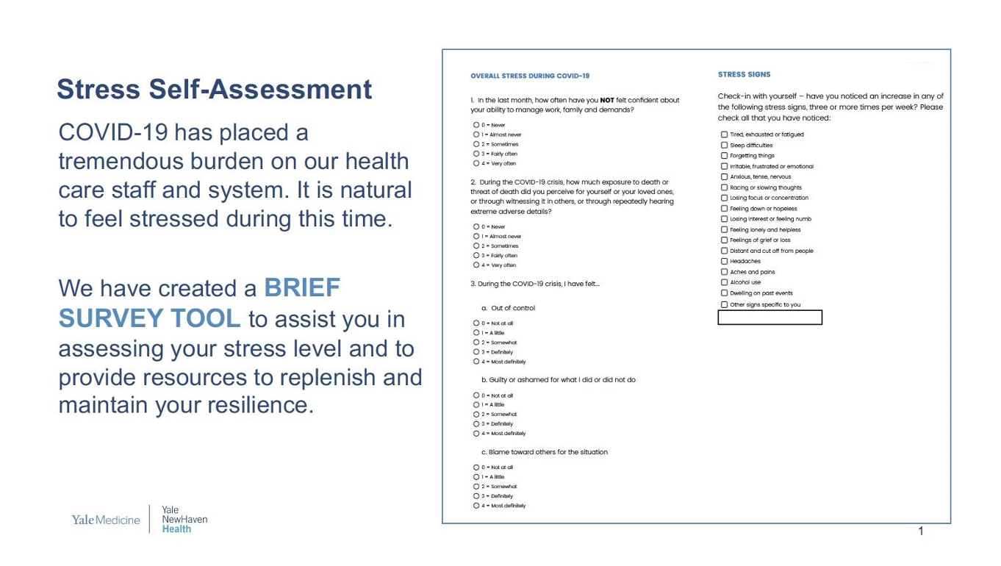

Appendix B: Table comparing respondents who completed Part A (Event Stressors) versus Part B (Stress Symptoms)
 |  | 7253 (100) | 8299 (100)
Age | <30 | 927 (12.8) | 1094 (13.2)
 | 30-39 | 1629 (22.5) | 1876 (22.6)
 | 40-49 | 1485 (20.5) | 1695 (20.4)
 | 50-59 | 1691 (23.3) | 1909 (23.0)
 | ≥60 | 1139 (15.7) | 1276 (15.4)
Gender | Female | 5731 (79.0) | 6547 (78.9)
 | Male | 1396 (19.2) | 1603 (19.3)
 | Non-binary/Unknown | 126 (1.7) | 149 (1.8)
Education | Associates or less | 2094 (28.9) | 2371 (28.6)
 | Bachelors | 2405 (33.2) | 2725 (32.8)
 | Master | 1590 (21.9) | 1803 (21.7)
 | Other Doctoral | 543 (7.5) | 645 (7.8)
 | MD | 588 (8.1) | 710 (8.6)
Affiliation | Academic, non-clinical | 1113 (15.3) | 1342 (16.2)
 | Academic, clinical faculty | 472 (6.5) | 581 (7.0)
 | Health system employees, non-medical clinical, non-clinical | 4617 (63.7) | 5152 (62.1)
 | Employed, medical staff | 609 (8.4) | 698 (8.4)
 | Private practice | 314 (4.3) | 411 (5.0)

APPENDIX C: Higher Stress Appraisal Items Predict Greater Probability of High Stress Symptoms.
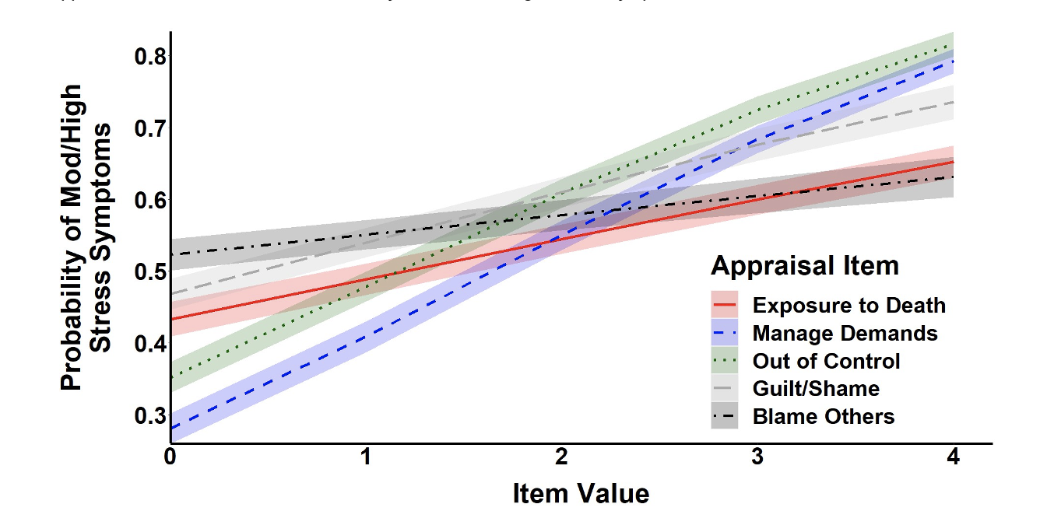
Appendix C. Higher Stress Appraisal Items Predict Greater Probability of High Stress Symptoms. Higher scores on all 5 Stress Appraisal items significantly predicted a greater likelihood of high Stress Symptoms (difficulty managing demands OR: 1.77 95%CI: 1.66-1.89 p < 0.001; feeling out of control OR: 1.69 95%CI: 1.59-1.81 p < 0.001; feeling guilt/shame OR: 1.34 95%CI: 1.26-1.42 p < 0.001; fear/threat of exposure to death OR: 1.25 95%CI: 1.18-1.32 p < 0.001; blaming others OR: 1.12 95%CI: 1.06-1.18 p < 0.001).

APPENDIX D: Assessing Stress High Stress Appraisal and Symptoms.
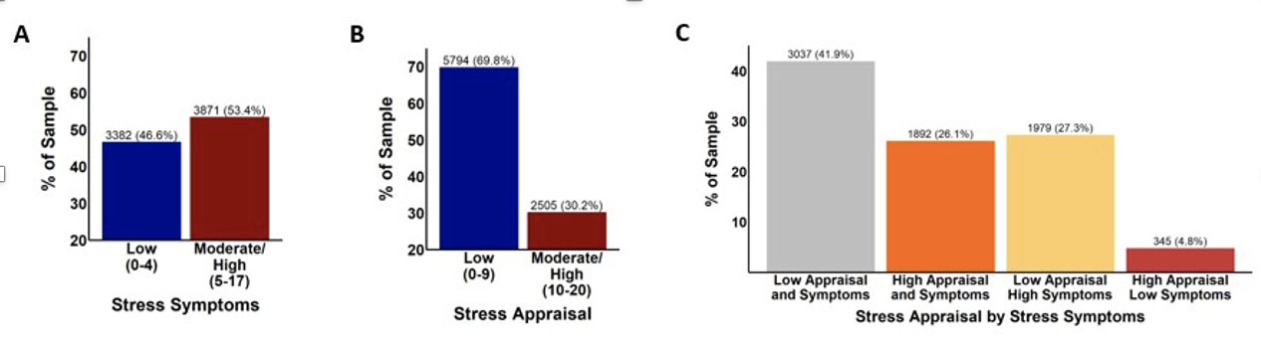
Appendix D: Assessing Stress High Stress Appraisal and Symptoms. A. A majority of the sample endorsed low levels of Stress Appraisal related to Covid-19 (69.8% low v. 30.2% high) out of 8299 participants. B. A majority of participants endorsed high stress symptoms (53.4% high v. 46.6% low) out of the 7253 participants who completed this portion of the assessment. C. Out of the 7253 participants who completed both portions of the assessment, a majority were congruent between the two parts (41.9% low on both and 26.1% high on both; 68% in total).

