This report is a visual depiction of your suggestions, input and ideas that have come to life on the unit. Items in green indicate complete; yellow indicates a work in progress; red indicates something that we cannot complete or work on at this time, along with a rationale. We hope this tool makes you proud of our unit and inspires you to make more suggestions for unit improvement!

GREEN/Complete  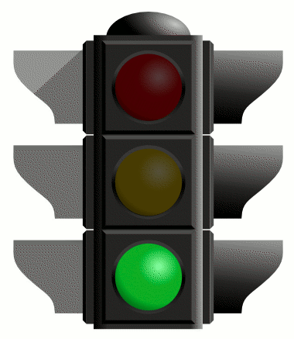 | YELLOW/Work in Progress  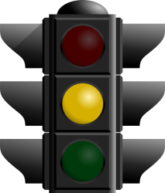 | red/can’t complete at this time and why  