251658240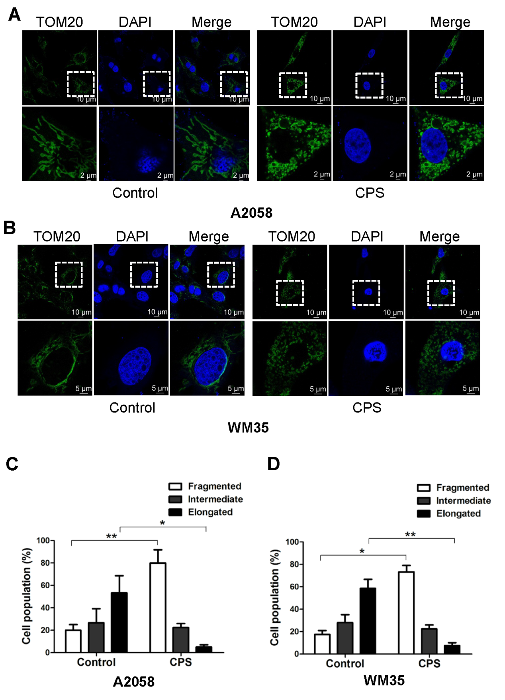
Supplementary Figure 2 Mitochondrial fission induced by CPS was validated using TOM20 staining. A2058 and WM35 cells were treated with or without CPS (120μM) for 16h. Mitochondrial network was displayed by TOM20 staining. Representative confocal microscope images of the mitochondrial network are shown in A and B. The proportion of cells (n = 100 cells for each sample) with fragmented, intermediate and elongated mitochondria was quantified in C and D. The data are presented as mean ± SD of three independent experiments. *P<0.05; **P<0.01.

