Figure 3: Zika Virus Search Interest in the United States, January 1st 2016 – September 14th, 2016
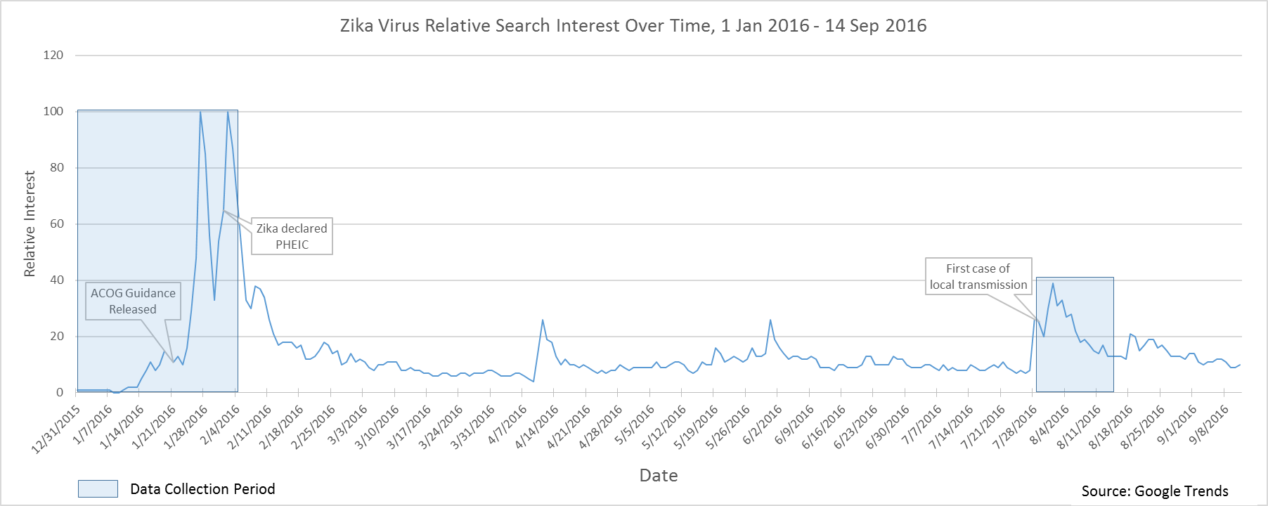

Data Source: Google Trends, Search Term “Zika Virus”, January 1st 2016 – September 14th 2016. Available at: https://www.google.com/trends/

