Supplemental Digital Content, Figure 1: Substance Use Disorder Online Module Visuals including Introduction Page, Typical Screen Shot and Question and Answer

Introduction Page. This provides a general orientation to learners starting the module series.

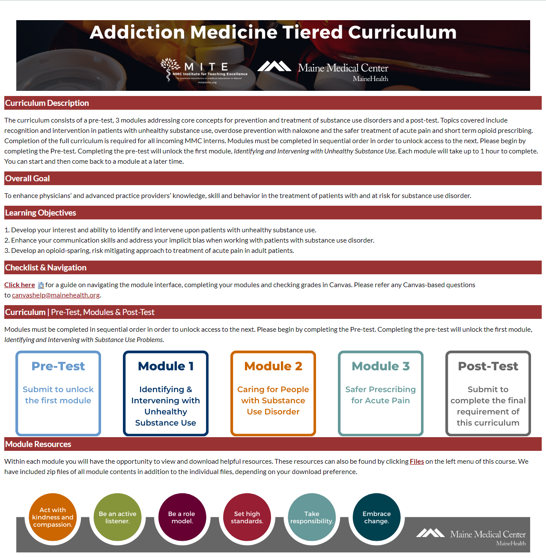

Typical Screen Shot: Slide contains note of percent progress through the module and a narration progress bar for the slide, as well as keys to advance. On the left of the main slide is a script of the narration and a “menu” tab which is like a table of contents that allows learners to view a listing of all of the module’s slide titles. Tabs on the top right of the screen offer access to downloadable “Resources” referenced throughout the module (ie, screening tools) and a glossary. 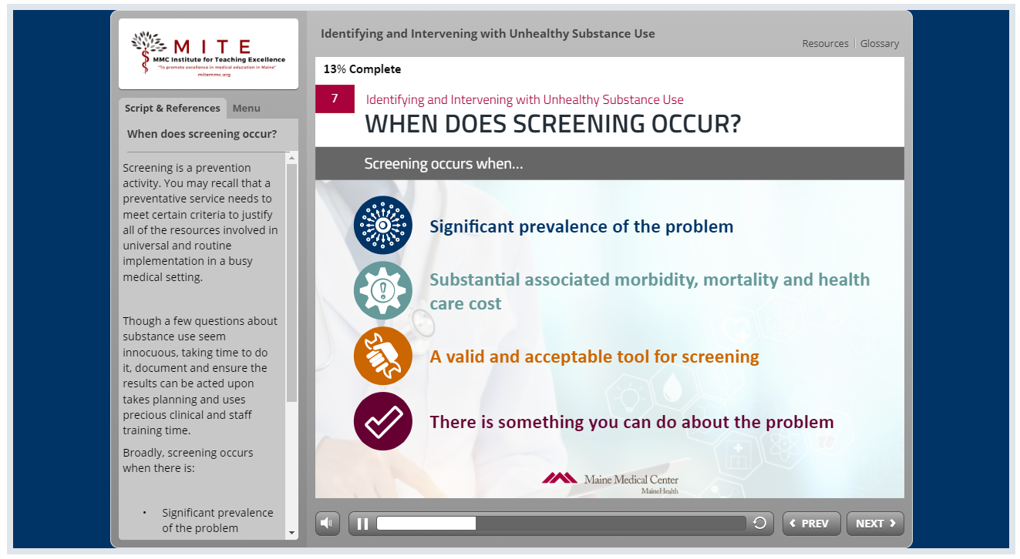

Typical embedded question and answer. Learners are provided with choices and provided with immediate feedback.
