Supplemental Figure 1: Feature Importance
Note: Feature importance identifies which variables are the most relevant for the classification decisions the models make. The algorithms are ensemble learners, meaning they are comprised of a collection of decisions trees that are aggregated to make decisions. Feature importance is calculated by measuring how much each feature contributes the accuracy of the model.
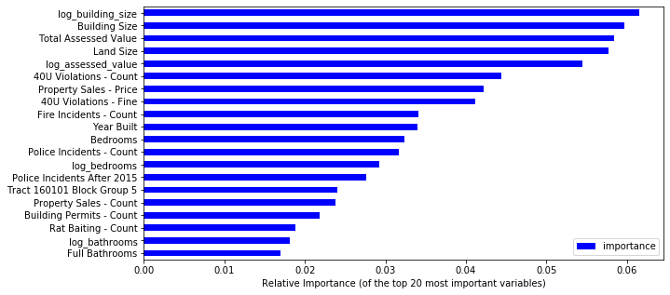
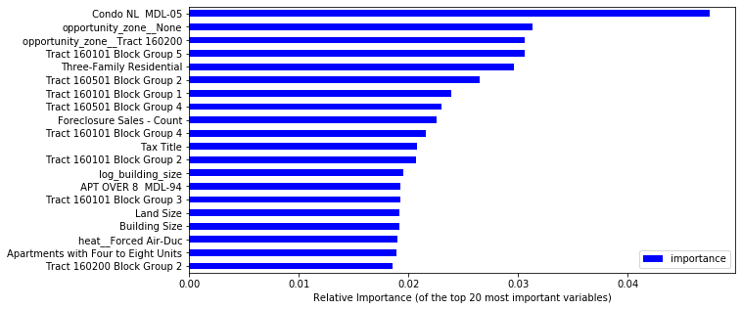
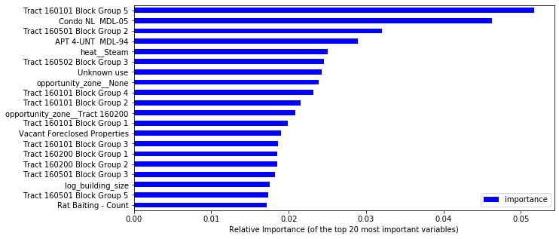
Overcrowding
High-Risk
Any Violation

