TECHNICAL APPENDIX
Data
We used a previously published evaluation study that assessed the COVID-19 case investigation and contact tracing efforts of 14 health departments (HDs) in 11 states and one tribal nation in the United States over 4-week asynchronous periods during June – October 2020, covering a total of 20 million population.¹ The study focused on assessing process indicators of the completeness and timeliness of case investigation and contact tracing (CICT) program implementation such as the proportions of cases interviewed, contacts notified and monitored, and the time between case identification and contact notification. We obtained the COVID-19 daily incidence data from the Centers for Disease Control and Prevention (CDC)’s COVID Data Tracker.² The tribal jurisdiction included in this data set is not represented in the CDC COVID Tracker database, and the data was directly provided to us by the jurisdiction.

Epidemiological Inputs
COVIDTracer Advanced³ is a spreadsheet-based compartmental Susceptible-Exposed-Infectious-Recovered (SEIR) epidemiological model, which illustrates the spread of a pathogen, resultant disease, and impact of interventions in a user-defined population. Readers can download the tool and enter input values of their choosing, exploring the impact of scenarios and assumptions beyond those covered in this manuscript. To model the clinical progression and transmission of disease using COVIDTracer Advanced, we used the following definitions and assumptions. A “case” was defined as a person who has been exposed, infected and subsequently becomes infectious, regardless of the presence of clinical symptoms. We assumed that for the first 3 days after infection, cases do not infect others. During days 4–5 post-infection, cases are pre-symptomatic but shed virus in amounts that may infect others.⁴⁻⁷ During days 6–14, the infected person can be symptomatic and shedding virus, albeit during days 11–14 the risk of onward transmission is relatively low but non-zero (the complete infectivity distribution is given in Table A1). We assumed that approximately 40% of cases are asymptomatic during days 6-14 yet have a risk of onward transmission equal to 75% of symptomatic cases (Table A2).

Table A1: Daily percentage risk of onward transmission by state of infectiousness and clinical symptoms.
Days post infection | Daily percentage of risk of onward transmissionª | Infectious person’s state
1 | 0.00% | Infected,  not yet infectious
2 | 0.00%
3 | 0.00%
4 | 16.78% | Infectious,  pre-symptomatic
5 | 18.03%
6 | 17.07% | Infectious, symptomatic
7 | 14.52%
8 | 11.27%
9 | 8.10%
10 | 5.48%
11 | 3.55%
12 | 2.26%
13 | 1.46%
14 | 1.48%
Total | 100%
ªPercentages show when onward transmission might occur by day of infectiousness
Sources: He et al.^{4, 5} and Ferretti et al.⁶. See also COVIDTracer Advanced manual.¹⁰

Table A2: Epidemiological parameters, values, and sources.
Parameter | Default Value | Source
Infected but not yet infectious period | 3 days | CDC COVID-19 Pandemic Planning Scenarios⁷
Pre-symptomatic and contagious (infectious) period | 2 days | He et al.^{4, 5}, Ferretti et al.⁶
Symptomatic and contagious (infectious) period | 9 days | He et al.^{4, 5}, Ferretti et al.⁶
New infections per case (R₀) | 2.5 | CDC COVID-19 Pandemic Planning Scenarios⁷
% of cases that are asymptomatic | 40% | CDC COVID-19 Pandemic Planning Scenarios⁷
Infectiousness of asymptomatic cases  (relative to symptomatic cases) | 75% | CDC COVID-19 Pandemic Planning Scenarios⁷

Table A3: Assumed proportion of cases by age group and infection-to-hospitalization rate, default values in COVIDTracer Advanced and sources.
Age group  (year) | % of Total Cases | Source | % of all cases admitted to hospital care | Source
0 to 17 | 15% | CDC COVID Data Tracker² | 0.21 | CDC COVID-19 Response Team⁸, Wu et al.⁹
18 to 64 | 55% |  | 2.17
65+ | 30% |  | 4.12

Figure A1 (locations 1-9*). Fitted cumulative epidemic curve output from COVIDTracer Advanced and observed data for the 60-day period beginning at the time program evaluations began at each location.
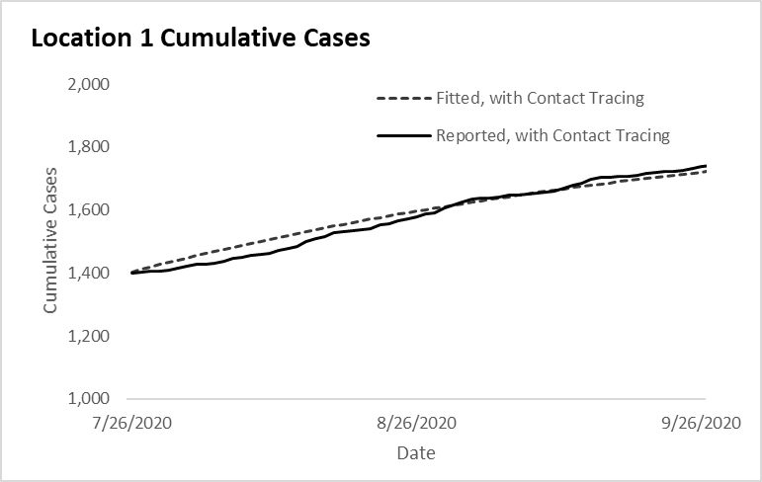 | 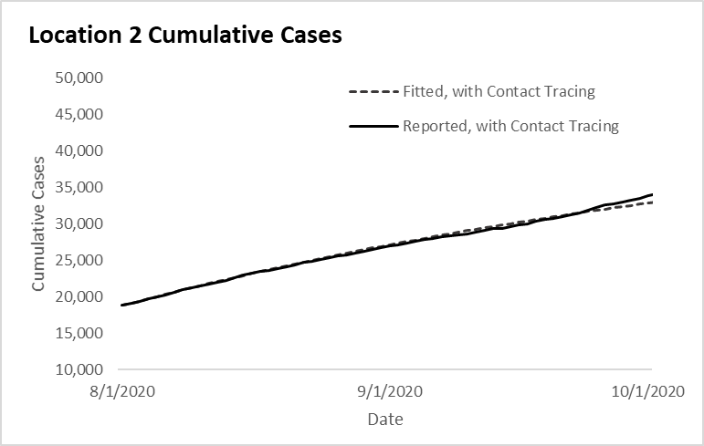 | 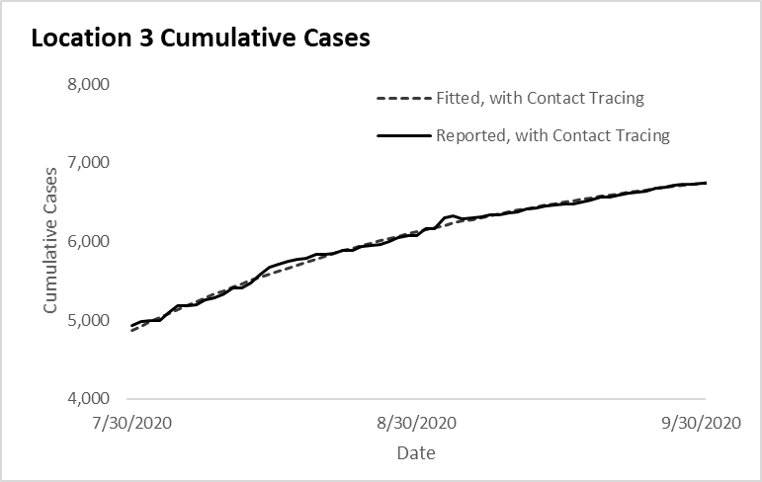
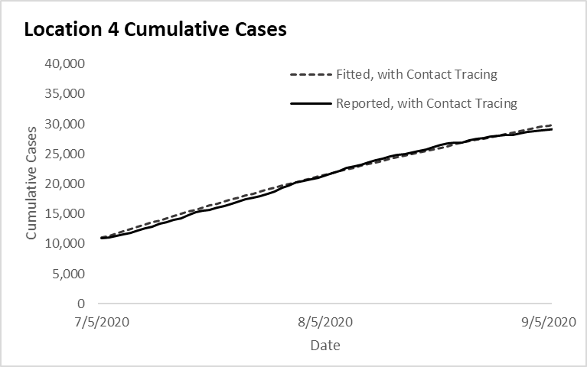 | 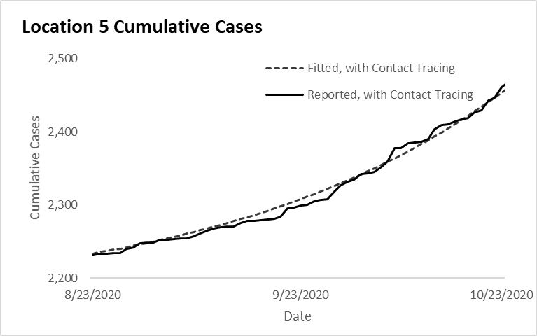 | 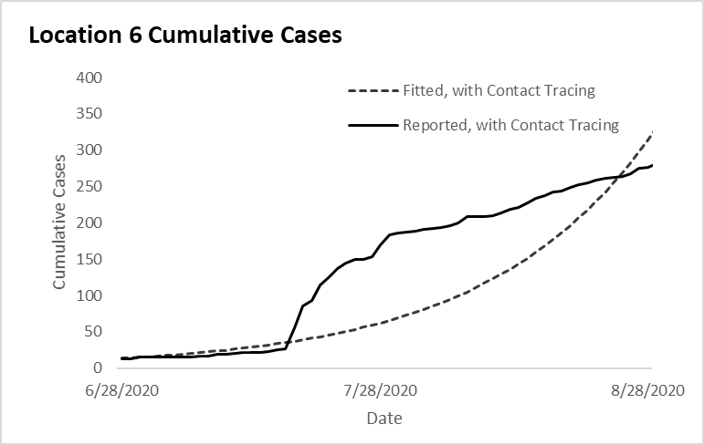
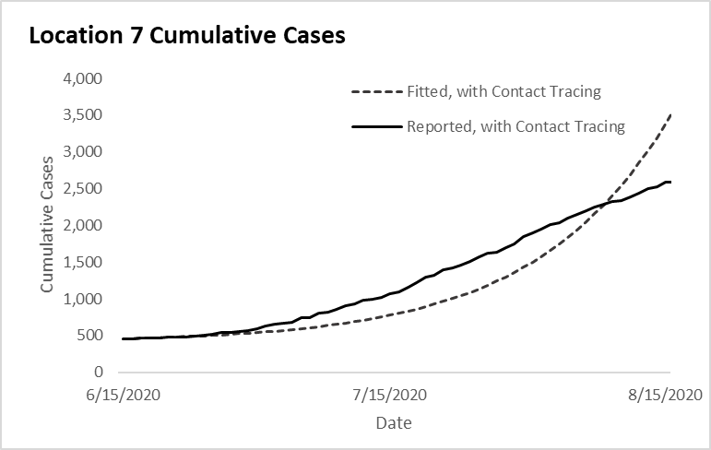 | 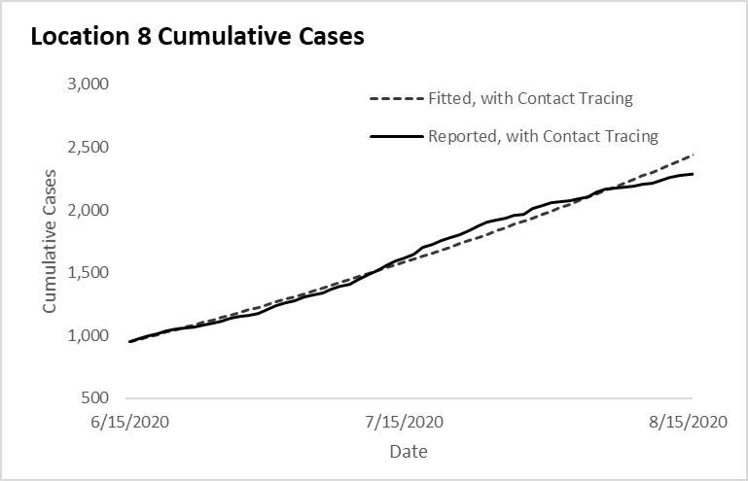 | 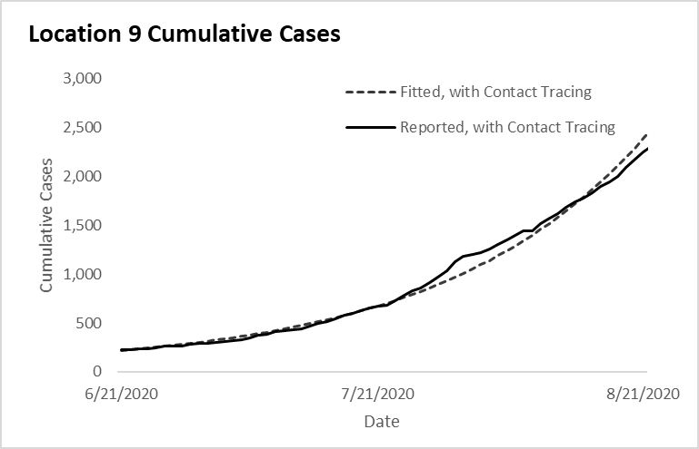
* Locations 1-4 here correspond to locations 1-4 in the main text.
Figure A1 Continued (locations 10-14). Fitted cumulative epidemic curve output from COVIDTracer Advanced and observed data for the 60-day period beginning at the time program evaluations began at each location.
Location 10 not fitted due to unavailable data on days from case identification to isolation | 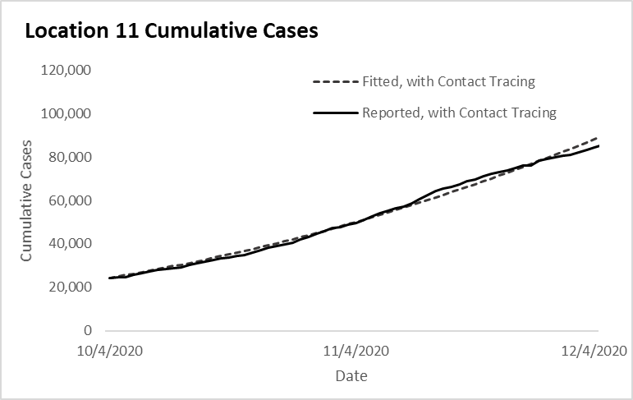 | 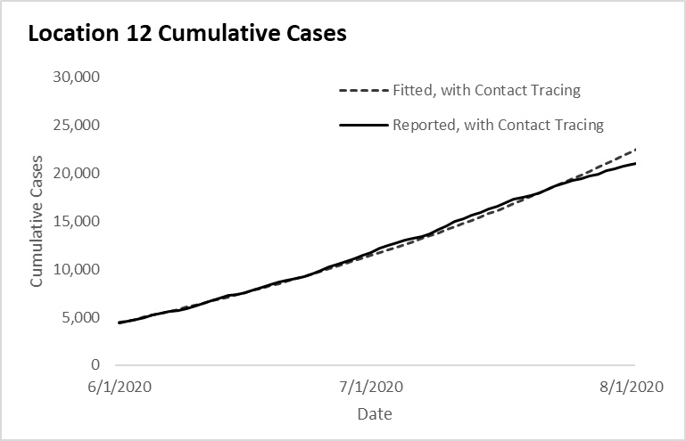
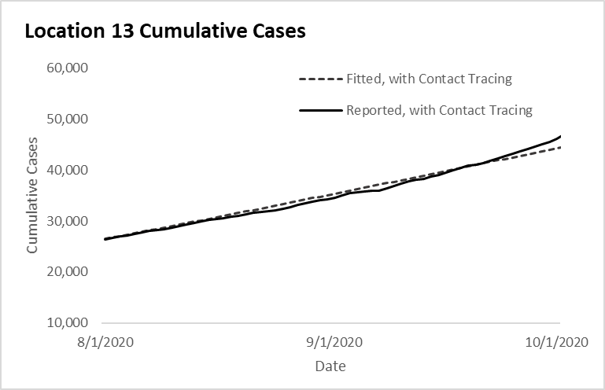 | 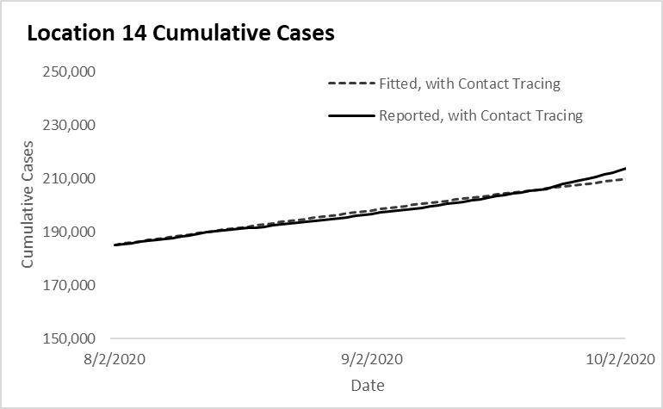

Case Investigation and Contact Tracing Effectiveness
The effectiveness of case investigation and contact tracing is determined by the proportion of cases and their contacts that are effectively isolated and quarantined, preventing further transmission in the susceptible population. The duration of quarantine and isolation is described in CDC’s interim guidance.¹⁰ We assumed that confirmed cases are effectively isolated following case interviews. We further assumed that contacts are quarantined upon either contact notification or through active monitoring. If infected contacts are left undetected, they will infect additional contacts (on average, 2.5 new infections per infected contact). Therefore, we calculated the average proportion of cases and contacts isolated and quarantined for each location as follows:

Equation 1:
Contacts are assumed to be quarantined upon notification (hereafter named as “high effectiveness”):
[% Cases interviewed + (R₀ * % Contacts identified * % Contacts notified)] / (1+R₀$)$

Equation 2:
Contacts are assumed to be quarantined through active monitoring (hereafter named as “low effectiveness”):
[% Cases interviewed + (R₀ * % Contacts identified * % Contacts monitored)] / (1+R₀$)$

where R₀ is the assumed number of new infections per case without any interventions and when the population is entirely susceptible to infection (Table A2). The % Cases interviewed, % Contacts notified, and % Contacts monitored were process metrics gathered in the evaluation study,¹ and % Contacts identified was an intermediate value calculated as the number of named contacts divided by the expected number of contacts per case:

# Contacts named / (# Cases reported * Average # Contacts per Case in each location)

In general, the % of Contacts notified was higher than the % of Contacts actively monitored. Therefore, the estimated effectiveness was higher when contacts were assumed to be quarantined upon notification. Likewise, the estimated effectiveness was lower when active monitoring was assumed to be required for contact quarantine.

In addition, reducing the time from case identification to effective isolation is critical for case investigation and contact tracing to succeed. The longer the cases and contacts interact with the susceptible population, the greater the opportunity for onward transmission. In practice, cases with no known exposure can be identified and isolated only after symptom onset, and cases with known exposures (i.e., contacts that eventually become infected cases) can begin quarantine upon contact notification (even potentially prior to symptom onset). We assumed asymptomatic cases can only be identified and isolated if they are notified through case investigation and contact tracing.
For the purposes of our study we assumed the proportions of cases with no known exposure and cases with known exposures were equal (i.e., 50/50 breakdown) since we didn’t have data on what prompted case identification in each location. Therefore, for each location the days to effective case isolation was determined by taking the average of the days to effective isolation between case groups with known and no known exposures. The time to effective case isolation for each of the two case groups was determined as follows:

For symptomatic cases with no known exposures (i.e., symptoms prompt identification):
We assumed cases experience a 5-day pre-symptomatic period (See Table A2), get tested the next day after symptom onset, wait the number of days observed by Lash et al.¹ to learn of their positive result, and begin effective isolation the day after learning this result. Our assumptions regarding the “next-day” timing of testing and entry into isolation are based on the fact that symptoms and notifications may begin or occur throughout the day, with a sizeable portion occurring sufficiently late enough in the day to prevent testing and entry into isolation the same evening. This assumption takes into account practical considerations such as time needed to find a testing site and arrange an appointment, and for notified individuals to prepare to isolate (e.g., purchasing food or medications, setting up childcare, handling work or other commitments). See the “Index Case” row in Figure A2 for a visual depiction of this timeline.

For cases with known exposures (i.e., those who were notified they were a contact and eventually became a case):
We assumed contacts quarantine the day after being notified as a contact and that these individuals could contribute to onward transmission based on when they were exposed. The “next-day” timing of entry into quarantine is based on the same practical reasoning as cases needing time to prepare to isolate once notified (described above). Since we did not have information on when exposures actually occurred, we assumed these individuals’ exposures occurred at the midpoint of their potential exposure window (in days). We identified the earliest date in this window as the first day of infectiousness among cases to which contacts were exposed. Based on our assumed 5-day pre-symptomatic period for symptomatic cases (described above), this was two days prior to the symptom onset date in cases exposing the contact. We identified the latest possible exposure date as the date the cases exposing them were notified of their positive case status (since they began isolation the next day). See both “Contacts” rows in Figure A2 for a visual depiction of this timeline.
The days between cases with known exposures becoming infected and their exposure notification can vary from what we assumed. For example, cases may take longer to become symptomatic, or get tested the same day they become symptomatic or begin their isolation on the same day as their results notification. Similarly, contacts which become cases may be exposed earlier or later than we assumed and may make up a larger or smaller share of the case pool. Table A6 shows the impact of varying our assumed time to case isolation by 1-day higher and lower prior to completing our fitting procedure for determining the share of transmission reductions attributable to CICT and other NPIs. The sensitivity analysis associated with 1-day changes described and shown in the main text (Figures 2 and A3) is different in that it shows the impact of varying notification speed when other NPI effects are held constant (i.e., given the originally derived share of transmission reductions attributable other NPIs, how speeding or slowing notification would have affected averted cases).

Figure A2. Illustrative example of the timing of case isolation and contact quarantine based on reported data from Location 1

 | Day 1 | Day 2 | Day 3 | Day 4 | Day 5 | Day 6 | Day 7 | Day 8 | Day 9 | Day 10 |  | Days from Exposure to Isolation
Index Case | Exposed |  |  | Begin Contagious |  | Symptom Onset | Tested |  | Results Notification | Begin Isolation |  | 9
Contacts  (Earliest possible exposure) |  |  |  | Exposed |  |  |  |  | Exposure Notification | Begin Quarantine |  | 6
Contacts  (Latest possible exposure) |  |  |  |  |  |  |  |  | Exposed | Begin Quarantine |  | 1
Notes: Location 1 reported 2 days from specimen collection to results notification and 2 days from specimen collection to contact notification (Table 1). The index case (symptomatic case with no known exposure) began showing symptoms on day 6 post-infection, got tested on day 7 and was notified of the positive test results on day 9. Its contacts (cases with known exposure) were exposed between days 4 to 9 and notified of their exposure on day 9. Therefore, both the index case and its contacts began isolation and quarantine on day 10. The days from exposure to isolation for contacts were calculated by taking the infectiousness-weighted average between 6 days (based on the earliest possible exposure) and 1 day (based on the latest possible exposure), which came down to 3.9 days. The final days from exposure to isolation for Location 1 was then calculated as the average between 9 days (index case) and 3.9 days (its contacts).

Compliance with Quarantine and Isolation Guidance
A review of multiple cross-sectional population surveys in the UK suggests 40-45% of people who had COVID-like symptoms self-reported fully complying with isolation guidance (i.e., did not depart home for the duration of their infectious period).¹¹ Another survey in the US found that 85% of respondents who had COVID-like symptoms or tested positive stayed home according to CDC guidelines except to get medical care.¹² These reviews, however, did not reliably allow us to infer the compliance levels among individuals for whom our study aimed to model CICT impacts: individuals provided guidance through personal communication with their health department and who were either COVID-19-positive or were informed of their exposure. Presumably, the compliance amongst individuals willing to speak with public health personnel and whom receive the guidance in a personal manner will have higher compliance (albeit an unknown amount). Additionally, while treating compliance as an all-or-nothing factor is a convenient simplification, doing so distorts CICT’s impacts since partial compliance still reduces further transmission to the general population to some extent. There is obvious need for additional research to improve our understanding of the actual efficacy of isolation and quarantine based on public compliance, specifically the roles of health departments in motivating such and known practical limitations (e.g., inadequate sick leave, caregiving responsibilities, support availability).
FIGURE A3. Effects of improvements and constraints to case investigation and contact tracing performance measures on the baseline percent cases averted by the program* when monitoring contacts is assumed necessary for effective quarantine (Low CICT effectiveness approach)
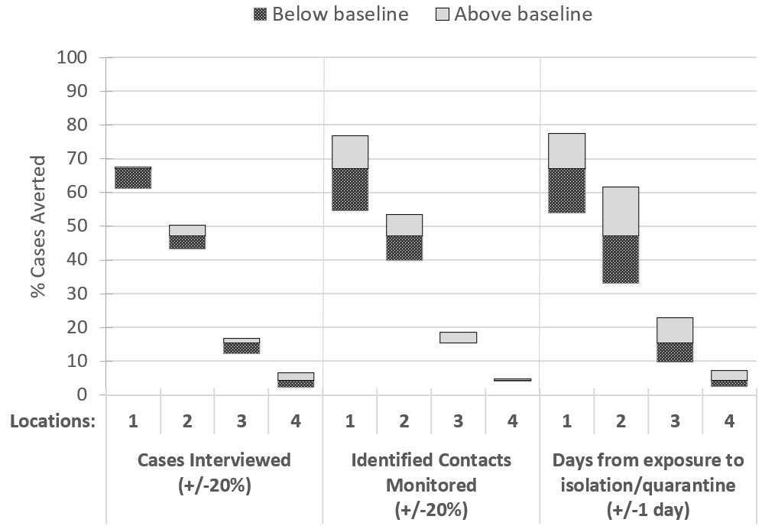
* Percent cases averted by cases investigated and contact tracing (CICT) calculated as percentage of total cases averted out of remaining cases after other nonpharmaceutical interventions (other NPIs) were implemented.
Notes. Baseline results shown in Table 2. Cases Interviewed and Contacts Monitored were capped at 100% and 0% when the baseline percentage interviewed was greater than 80% or less than 20%. Similar figure in the main text (Figure 2) is for the High CICT effectiveness scenario: when simply notifying contacts is assumed sufficient to trigger effective quarantine.

Table A4 (locations 1-7). Estimated impacts of case investigation and contact tracing (CICT), and other nonpharmaceutical interventions (other NPIs), by locationª over 60-day period after contact tracing evaluations initiated
 | Location 1 | Location 2 | Location 3 | Location 4 | Location 5 | Location 6 | Location 7
Scenario Inputs
Population  Start date of observation  COVID-19 cases  Total cases before the start of observation  Cases in the last 14 days  Trend in the last 14 days | Category B  7/26/2020  1 396  113  plateaued | Category A 8/1/2020  18 488  4 686  plateaued | Category C  7/30/2020  4 817  870  plateaued | Category A  7/5/2020  10 724  3 853  slowly increasing | Category C  8/23/2020  2 231  43  slowly decreasing | Category C  6/28/2020  13  5  slowly increasing | Category C  6/15/2020  453  33  plateaued
CICT Effectiveness  % of cases and contacts isolated^{b}  Days from infection to isolation^{c} | 39.5 – 86.0%  6 days | 52.7 – 55.0%  8 days | 26.1 – 50.5%  9 days | 11.8 – 12.1%  10 days | 76.6 – 81.4%  6 days | 70.3 – 71.0%  6 days | 21.4 – 30.2%  7 days
Scenario Results
Transmission Fraction  Reduction from CICT  Reduction from other NPIs^{d}  Remaining Transmission (100% minus above values) | 8.6 – 26.2%  54.6 – 36.6%  36.8 – 37.2% | 5.0 – 5.2%  57.6 – 57.3%  37.4 – 37.5% | 1.4 – 2.7%  - – 62.0%  35.1 – 35.3% | 0.4 – 0.4%  61.0 – 61.0%  38.6 – 38.6% | 28.7 – 31.7%  22.2 – 19.1%  49.1 – 49.2% | 27.8 – 28.1%  18.0 – 17.7%  54.2 – 54.2% | 4.8 – 7.0%  32.8 – 30.9%  62.4 – 62.1%
Additional Cases Averted by CICT (%), 60 days^{e} | 651 – 9 480  (67.1 – 96.8%) | 12 598 – 13 568 (47.1 – 48.8%) | 344 – 768  (15.4 – 28.8%) | 859 – 882  (4.4 – 4.5%) | 5 238 – 6 879  (96.1 – 97.0%) | 4 319 – 4 450  (93.8 – 94.0%) | 1 684 – 2 738  (38.3 – 50.0%)
Additional Hospitalizations Averted by CICT (%), 60 days^{e} | 16 – 233  (67.1 – 96.8%) | 310 – 333  (47.1 – 48.8%) | 8 – 19  (15.4 – 28.8%) | 21 – 22  (4.4 – 4.5%) | 129 – 160  (96.1 – 97.0%) | 106 – 109  (93.8 – 94.0%) | 41 – 67  (38.3 – 50.0%)
† To preserve anonymity, populations are categorized by population size as follows: Category A > 1 million; Category B >500 000 to ≤ 1 million; Category C: ≤ 500 000.
ªCase investigation and contact tracing implemented per scenarios in Table 4A and effects were assumed constant over 60 days.
^{b}Calculated as follows using values observed at locations during case investigation and contact tracing evaluations and an assumed R₀=2.5:
Low value assumes monitoring is required for effective quarantine of contacts:
[% Cases interviewed + (R₀ * % Contacts identified * % Contacts actively monitored)] /(1+R₀)
High value assumes contact notification is sufficient for effective quarantine of contacts:
[% Cases interviewed + (R₀ * % Contacts identified * % Contacts notified)] / (1+R₀)
^{c}The average length of time from infection to isolation (including contacts which later became cases). See CICT Effectiveness in the Appendix.
^{d} Other NPI interventions including masks use, social distancing, school and restaurant closures, etc. Low NPI effectiveness values were generated with the fitting process when CICT effectiveness was high; similarly, high NPI effectiveness values were generated when CICT effectiveness was low.
^{e} Percent calculated as (Total Cases when only other NPIs implemented - Total Cases when both CICT and other NPIs implemented) / (Total Cases when only other NPIs implemented). For example, for every 100 remaining cases after other NPIs were implemented in locations 1-4, CICT averted between 4.4 and 96.8 additional cases.
TABLE A4 Continued (locations 8-14). Estimated impacts of case investigation and contact tracing (CICT), and other nonpharmaceutical interventions (other NPIs), by locationª over 60-day period after contact tracing evaluations initiated
 | Location 8 | Location 9 | Location 10^{f} | Location 11 | Location 12 | Location 13 | Location 14
Scenario Inputs
Population  Start date of observation  COVID-19 cases  Total cases before the start of observation  Cases in the last 14 days  Trend in the last 14 days | Category C  6/15/2020  931  249  plateaued | Category C  6/21/2020  218  44  rapidly increasing | Category B  7/1/2020  9 237  2 221  plateaued | Category B  10/4/2020  23 988  5 545  slowly increasing | Category A  6/1/2020  4 307  1 685  slowly increasing | Category A 8/1/2020  26 211  3 850  plateaued | Category A 8/2/2020  184 358  5 835  plateaued
CICT Effectiveness  % of cases and contacts isolated^{b}  Days from infection to isolation^{c} | 50.6–52.7%  9 days | 54.5 – 61.1  7 days | 22.1 – 22.1%  Not Available | 21.3 – 30.8%  7 days | 43.4 – 43.9%  8 days | 22.2 – 52.7%  8 days | 32.2 – 35.6%  8 days
Scenario Results
Transmission Fraction  Reduction from CICT  Reduction from other NPIs^{d}  Remaining Transmission  (100% minus above values) | 3.3 – 3.5%  54.0–53.9%  42.7–42.6% | 11.7 – 13.4%  36.2 – 34.8%  52.1 – 51.8% |  | 3.6 – 5.4%  49.6 – 47.9%  46.8 – 46.7% | 4.7 – 4.8%  51.2 – 51.1%  44.1 – 44.1% | 2.2 – 5.5%  56.7 – 53.4%  41.1 – 41.1% | 3.1 – 3.5%  56.3 – 55.9%  40.6 – 40.6%
Additional Cases Averted by CICT (%), 60 days^{e} | 733 – 768  (33.3–34.5%) | 4 857–6 112  (70.0–74.7%) |  | 28 141–45 869  (31.0–42.2%) | 12 608–12 904  (42.0 – 42.4%) | 5 386–17 264  (23.2–49.3%) | 11 634–13 378  (32.3 – 35.3%)
Additional Hospitalizations Averted by CICT (%), 60 days^{e} | 18 – 19  (33.3–34.5%) | 119–150  (70.0–74.7%) |  | 692–1 127  (31.0–42.2%) | 310 – 317  (42.0 – 42.4%) | 132–424  (23.2–49.3%) | 286 – 329  (32.3 – 35.3%)
† To preserve anonymity, populations are categorized by population size as follows: Category A > 1 million; Category B >500 000 to ≤ 1 million; Category C: ≤ 500 000.
ªCase investigation and contact tracing implemented per scenarios in Table 4A and effects were assumed constant over 60 days.
^{b}Calculated as follows using values observed at locations during case investigation and contact tracing evaluations and an assumed R₀=2.5:
Low value assumes monitoring is required for effective quarantine of contacts:
[% Cases interviewed + (R₀ * % Contacts identified * % Contacts actively monitored)] /(1+R₀)
High value assumes contact notification is sufficient for effective quarantine of contacts:
[% Cases interviewed + (R₀ * % Contacts identified * % Contacts notified)] / (1+R₀)
^{c}The average length of time from infection to isolation (including contacts which later became cases). See CICT Effectiveness in the Appendix.
^{d} Other NPI interventions including masks use, social distancing, school and restaurant closures, etc. Low NPI effectiveness values were generated with the fitting process when CICT effectiveness was high; similarly, high NPI effectiveness values were generated when CICT effectiveness was low.
^{e} Percent calculated as (Total Cases when only other NPIs implemented - Total Cases when both CICT and other NPIs implemented) / (Total Cases when only other NPIs implemented). For example, for every 100 remaining cases after other NPIs were implemented in locations 1-4, CICT averted between 4.4 and 96.8 additional cases.
^{f} Location 10 did not report the median days from case identification to isolation, thus the impact of CICT could not be estimated.
TABLE A5(a). Estimated cases averted with improving and constraining case investigation and contact tracing performance measures relative to baseline, assuming contact notification is a sufficient trigger for contacts to effectively quarantine, by location, over 60-days after program evaluations were initiated
 | Location 1 | Location 2 | Location 3 | Location 4
Performance measure | Baseline Values:  Cases Interviewed = 99%  Contacts Notified = 95%  Days to isolation = 6 | Baseline Values:  Cases Interviewed = 83%  Contacts Notified = 61%  Days to isolation = 8 | Baseline Values:  Cases Interviewed = 91%  Contacts Notified = 85%  Days to isolation = 9 | Baseline Values:  Cases Interviewed = 33%  Contacts Notified = 54%  Days to isolation = 10
Cases Interviewed (%)
Baseline +20%ª | 9 486 (96.8%) | 14 431 (52.0%) | 856 (32.1%) | 1 286 (6.6%)
Baseline | 9 480 (96.8%) | 13 568 (48.8%) | 768 (28.8%) | 882 (4.5%)
Baseline -20% | 9 386 (95.8%) | 12 509 (45.0%) | 692 (26.0%) | 471 (2.4%)
Contacts Notified (%)
Baseline +20%ª | 9 525 (97.2%) | 15 314 (55.1%) | 824 (30.9%) | 953 (4.9%)
Baseline | 9 480 (96.8%) | 13 568 (48.8%) | 768 (28.8%) | 882 (4.5%)
Baseline -20% | 9 245 (94.4%) | 11 605 (41.8%) | 691 (25.9%) | 810 (4.2%)
Median days from cases being infected to their contacts isolated
3 days faster than Baseline | --^{b} | 23 479 (84.5%) | 1 775 (66.6%) | 3 289 (16.9%)
2 days faster than Baseline | --^{b} | 21 106 (76.0%) | 1 451 (54.5%) | 2 232 (11.5%)
1 day faster than Baseline | 9 703 (99.9%) | 17 667 (63.6%) | 1 096 (41.1%) | 1 435 (7.4%)
Baseline | 9 480 (96.8%) | 13 568 (48.8%) | 768 (28.8%) | 882 (4.5%)
1 day slower than Baseline | 8 753 (89.3%) | 9 572 (34.5%) | 504 (18.9%) | 520 (2.7%)
2 days slower than Baseline | 7 269 (74.2%) | 6 281 (22.6%) | 312 (11.7%) | 291 (1.5%)
3 days slower than Baseline | 5 343 (54.5%) | 3 879 (14.0%) | 181 (6.8%) | 145 (0.7%)
Notes
ªThis value was capped at 100% when the baseline percentage interviewed was greater than 80%.
^{b}This value not calculated since the minimum median days from case infection to contacts being isolated is six (5 days from infection to symptom onset + 1 day for testing).

TABLE A5(b). Estimated cases averted with improving and constraining case investigation and contact tracing performance measures relative to baseline, assuming active monitoring is required for effective contact quarantine, by location, over 60-days after program evaluations were initiated
 | Location 1 | Location 2 | Location 3 | Location 4
Performance measure | Baseline Values:  Cases Interviewed = 99%  Contacts Monitored = 19%  Days to isolation = 6 | Baseline Values:  Cases Interviewed = 83%  Contacts Monitored = 56%  Days to isolation = 8 | Baseline Values:  Cases Interviewed = 91%  Contacts Monitored = 0%  Days to isolation = 9 | Baseline Values:  Cases Interviewed = 33%  Contacts Monitored = 48%  Days to isolation = 10
Cases Interviewed (%)
Baseline +20%ª | 654 (67.5%) | 13 448 (50.3%) | 375 (16.7%) | 1 263 (6.5%)
Baseline | 651 (67.1%) | 12 598 (47.1%) | 344 (15.4%) | 859 (4.4%)
Baseline -20% | 594 (61.3%) | 11 555 (43.2%) | 273 (12.2%) | 448 (2.3%)
Contacts Quarantined (%)
Baseline +20%ª | 744 (76.8%) | 14 319 (53.5%) | 414 (18.5%) | 931 (4.8%)
Baseline | 651 (67.1%) | 12 598 (47.1%) | 344 (15.4%) | 859 (4.4%)
Baseline -20%^{b} | 529 (54.6%) | 10 664 (39.9%) | 344 (15.4%) | 787 (4.1%)
Median days from cases being infected to their contacts isolated
3 days faster than Baseline | --‡ | 22 207 (83.0%) | 934 (41.7%) | 3 209 (16.5%)
2 days faster than Baseline | --‡ | 19 843 (74.2%) | 715 (31.9%) | 2 177 (11.2%)
1 day faster than Baseline | 750 (77.4%) | 16 499 (61.7%) | 512 (22.8%) | 1 399 (7.2%)
Baseline | 651 (67.1%) | 12 598 (47.1%) | 344 (15.4%) | 859 (4.4%)
1 day slower than Baseline | 522 (53.9%) | 8 851 (33.1%) | 220 (9.8%) | 507 (2.6%)
2 days slower than Baseline | 386 (39.8%) | 5 794 (21.7%) | 135 (6.0%) | 283 (1.5%)
3 days slower than Baseline | 264 (27.2%) | 3 573 (13.4%) | 77 (3.5%) | 141 (0.7%)
Notes
ªThis value was capped at 100% when the baseline percentage interviewed was greater than 80%.
^{b}This value was kept at 0% when the baseline percentage monitored was less than 20%.
TABLE A6(a). Estimated impacts of case investigation and contact tracing and nonpharmaceutical interventions in Location 1 over 60-day period after program evaluations were initiated, varying the days from infection to isolation
Days from Infection to Isolation | 5 | 6 (default) | 7
Transmission Fraction  Reduction from CICT  Reduction from All Other Interventions (other NPIs)  Remaining Transmission  (100% minus above values) | 12.8 – 47.5%  50.5 – 15.2%  36.7 – 37.3% | 8.6 – 26.2%  54.6 – 36.6%  36.8 – 37.2% | 5.6 – 15.1%  57.6 – 47.9%  36.8 – 37.0%
Cases Averted by CICT (%),  60 days  Hospitalizations Averted by CICT (%), 60 days | 1 338 – 97 014  (80.8 – 99.7%)  33 – 2 433  (80.8 – 99.7%) | 651 – 9 480  (67.1 – 96.8%)  16 – 233  (67.1 – 96.8%) | 339 – 2 009  (51.4 – 86.3%)  8 – 49  (51.4 – 86.3%)

TABLE A6(b). Estimated impacts of case investigation and contact tracing and nonpharmaceutical interventions in Location 2 over 60-day period after program evaluations were initiated, varying the days from infection to isolation
Days from Infection to Isolation | 7 | 8 (default) | 9
Transmission Fraction  Reduction from CICT  Reduction from All Other Interventions (other NPIs)  Remaining Transmission  (100% minus above values) | 8.1 – 8.5%  54.5 – 54.0%  37.4 – 37.5% | 5.0 – 5.2%  57.6 – 57.3%  37.4 – 37.5% | 3.0 – 3.2%  59.6 – 59.4%  37.4 – 37.4%
Cases Averted by CICT (%),  60 days  Hospitalizations Averted by CICT (%), 60 days | 25 552 – 28 102 (64.4 – 66.4%)  628 – 691  (64.4 – 66.4%) | 12 598 – 13 568 (47.1 – 48.8%)  310 – 333  (47.1 – 48.8%) | 6 663 – 7 108  (32.0 – 33.3%)  164 – 175  (32.0 – 33.3%)

TABLE A6(c). Estimated impacts of case investigation and contact tracing and nonpharmaceutical interventions in Location 3 over 60-day period after program evaluations were initiated, varying the days from infection to isolation
Days from Infection to Isolation | 8 | 9 (default) | 10
Transmission Fraction  Reduction from CICT  Reduction from All Other Interventions (other NPIs)  Remaining Transmission  (100% minus above values) | 2.2 – 4.5%  62.7 – 60.2%  35.1 – 35.3% | 1.4 – 2.7%  - – 62.0%  35.1 – 35.3% | 0.8 – 1.6%  64.1 – 63.2%  35.1 – 35.2%
Cases Averted by CICT (%),  60 days  Hospitalizations Averted by CICT (%), 60 days | 573 – 1 407  (23.3 – 42.7%)  14 – 35  (23.3 – 42.7%) | 344 – 768  (15.4 – 28.8%)  8 – 19  (15.4 – 28.8%) | 203 – 427  (9.7 – 18.4%)  5 – 10  (9.7 – 18.4%)

TABLE A6(d). Estimated impacts of case investigation and contact tracing and nonpharmaceutical interventions in Location 4 over 60-day period after program evaluations were initiated, varying the days from infection to isolation
Days from Infection to Isolation | 9 | 10 (default) | 11
Transmission Fraction  Reduction from CICT  Reduction from All Other Interventions (other NPIs)  Remaining Transmission  (100% minus above values) | 0.7 – 0.7%  60.8 – 60.8%  38.5 – 38.5% | 0.4 – 0.4%  61.0 – 61.0%  38.6 – 38.6% | 0.2 – 0.2%  61.2 – 61.2%  38.6 – 38.6%
Cases Averted by CICT (%),  60 days  Hospitalizations Averted by CICT (%), 60 days | 1 438 – 1 476  (7.2 – 7.4%)  35 – 36  (7.2 – 7.4%) | 859 – 882  (4.4 – 4.5%)  21 – 22  (4.4 – 4.5%) | 493 – 506  (2.6 – 2.7%)  12 – 12  (2.6 – 2.7%)

Adjustment for Under-reported and Under-detected Cases
Table A7(a). Estimated impacts of case investigation and contact tracing and other nonpharmaceutical interventions over 60-day period after program evaluations were initiated, with and without adjustment for under-reported asymptomatic cases; Locations 1 and 2
 | Location 1 | Location 1 | Location 2 | Location 2
 | Baseline | Multiplying reported cases by x2 | Baseline | Multiplying reported cases by x2
Transmission Fraction  Reduction from CICT  Reduction from All Other Interventions (other NPIs)  Remaining Transmission  (100% minus above values) | 8.6 – 26.2%  54.6 – 36.6%  36.8 – 37.2% | 3.9 – 9.6%  59.4 – 53.5%  36.7 – 36.9% | 5.0 – 5.2%  57.6 – 57.3%  37.4 – 37.5% | 2.3 – 2.5%  60.1 – 60.0%  37.6 – 37.5%
Cases Averted by CICT (%),  60 days | 651 – 9 480  (67.1 – 96.8%) | 397 – 1 563  (38.4 – 71.0%) | 12 598 – 13 568 (47.1 – 48.8%) | 9 629 – 10 141 (25.3 – 26.4%)
Hospitalizations Averted by CICT (%), 60 days | 16 – 233  (67.1 – 96.8%) | 10 – 38  (38.4 – 71.0%) | 310 – 333  (47.1 – 48.8%) | 237 – 249  (25.3 – 26.4%)

Table A7(b). Estimated impacts of case investigation and contact tracing and other nonpharmaceutical interventions over 60-day period after program evaluations were initiated, with and without adjustment for under-reported asymptomatic cases; Locations 3 and 4
 | Location 3 | Location 3 | Location 4 | Location 4
 | Baseline | Multiplying reported cases by x2 | Baseline | Multiplying reported cases by x2
Transmission Fraction  Reduction from CICT  Reduction from All Other Interventions (other NPIs)  Remaining Transmission  (100% minus above values) | 1.4 – 2.7%  63.5 – 62.0%  35.1 – 35.3% | 0.7 – 1.3%  63.5 – 62.7%  35.8 – 36.0% | 0.4 – 0.4%  61.0 – 61.0%  - – 38.6% | 0.4 – 0.2%  60.6 – 60.6%  39.2 – 39.2%
Cases Averted by CICT (%),  60 days | 344 – 768  (15.4 – 28.8%) | 315 – 658  (7.7 – 14.8%) | 859 – 882  (4.4 – 4.5%) | 823 – 845  (2.2 – 2.2%)
Hospitalizations Averted by CICT (%), 60 days | 8 – 19  (15.4 – 28.8%) | 8 – 16  (7.7 – 14.8%) | 21 – 22  (4.4 – 4.5%) | 20 – 21  (2.2 – 2.2%)

References
1. Lash RR, Moonan PK, Byers BL, et al. COVID-19 contact tracing in the United States, 2020. JAMA Network Open. 2021;In Press
2. CDC COVID Data Tracker. https://covid.cdc.gov/covid-data-tracker/
3. COVIDTracer Advanced: A Planning Tool to Illustrate the Resources Needed to Conduct Contact Tracing and Monitoring of coronavirus disease 2019 (COVID-19) Cases and the Potential Impact of Community Interventions and Contact Tracing Efforts on the Spread of COVID-19 2020. https://www.cdc.gov/coronavirus/2019-ncov/php/contact-tracing/COVIDTracerTools.html
4. He X, Lau EHY, Wu P, et al. Temporal dynamics in viral shedding and transmissibility of COVID-19. Nature Medicine. 2020;26(5):672-675. doi:10.1038/s41591-020-0869-5
5. He X, Lau EHY, Wu P, et al. Author Correction: Temporal dynamics in viral shedding and transmissibility of COVID-19. Nature Medicine. 2020;26(9):1491-1493. doi:10.1038/s41591-020-1016-z
6. Ferretti L, Wymant C, Kendall M, et al. Quantifying SARS-CoV-2 transmission suggests epidemic control with digital contact tracing. Science. 2020;368(6491):eabb6936. doi:10.1126/science.abb6936
7. CDC. COVID-19 Pandemic Planning Scenarios. Feb 14, 2021. Updated Sep 10, 2020. https://www.cdc.gov/coronavirus/2019-ncov/hcp/planning-scenarios.html
8. CDC COVID-19 Response Team. Severe Outcomes Among Patients with Coronavirus Disease 2019 (COVID-19) — United States, February 12–March 16, 2020. Morbidity and Mortality Weekly Report. 2020;69(12):343-346.
9. Wu SL, Mertens AN, Crider YS, et al. Substantial underestimation of SARS-CoV-2 infection in the United States. Nature Communications. 2020;11(4507)doi:https://doi.org/10.1038/s41467-020-18272-4
10. CDC. Interim Guidance on Ending Isolation and Precautions for Adults with COVID-19. https://www.cdc.gov/coronavirus/2019-ncov/hcp/duration-isolation.html
11. Smith LE, Potts HWW, Amlôt R, Fear NT, Michie S, Rubin GJ. Adherence to the test, trace, and isolate system in the UK: results from 37 nationally representative surveys. BMJ. 2021;372:n608. doi:https://doi.org/10.1136/bmj.n608
12. Park CL, Russell BS, Fendrich M, Finkelstein-Fox L, Hutchison M, Becker J. Americans’ COVID-19 Stress, Coping, and Adherence o CDC Guidelines. Journal of General Internal Medicine. 2020;35:2296–2303.

