Additional files

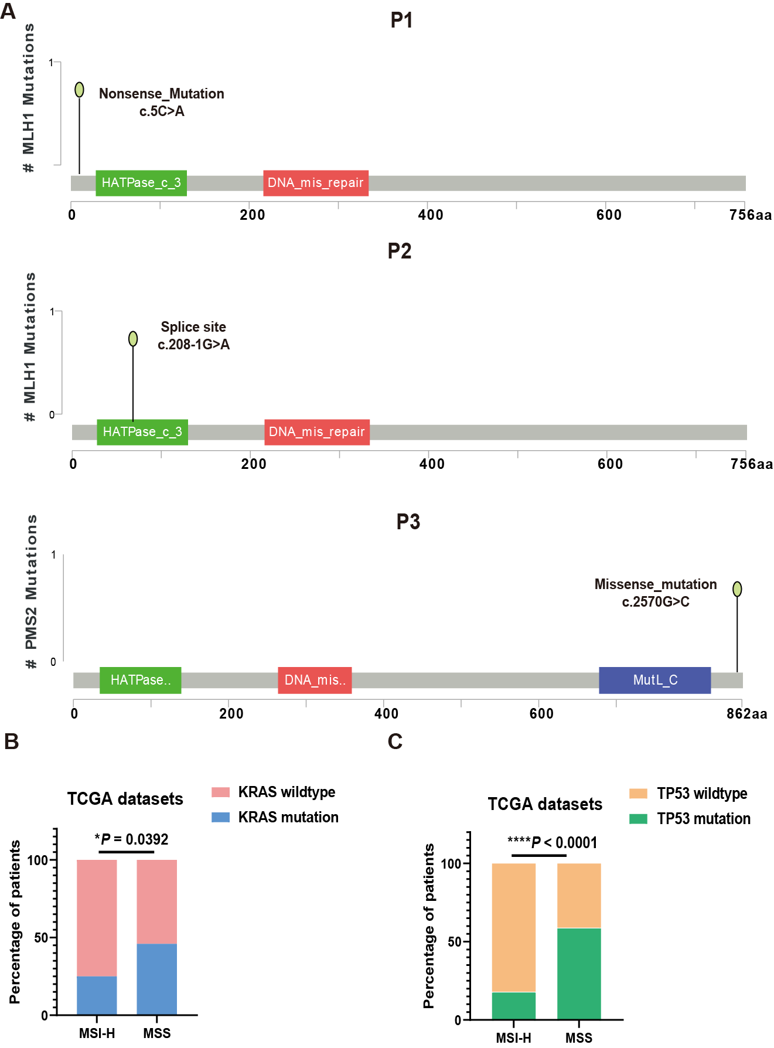
Additional Figure 1. The germline variations in DNA mismach repair genes, and the distribution of KRAS and TP53 mutation in TCGA dataset. (A) Germline variations in mismatch repair genes for P1 to P3 (cbioportal). Distributions of (B) KRAS mutations and (C) TP53 mutations in TCGA dataset. Fisher’s exact test, *P=0.0392, ****P<0.0001.

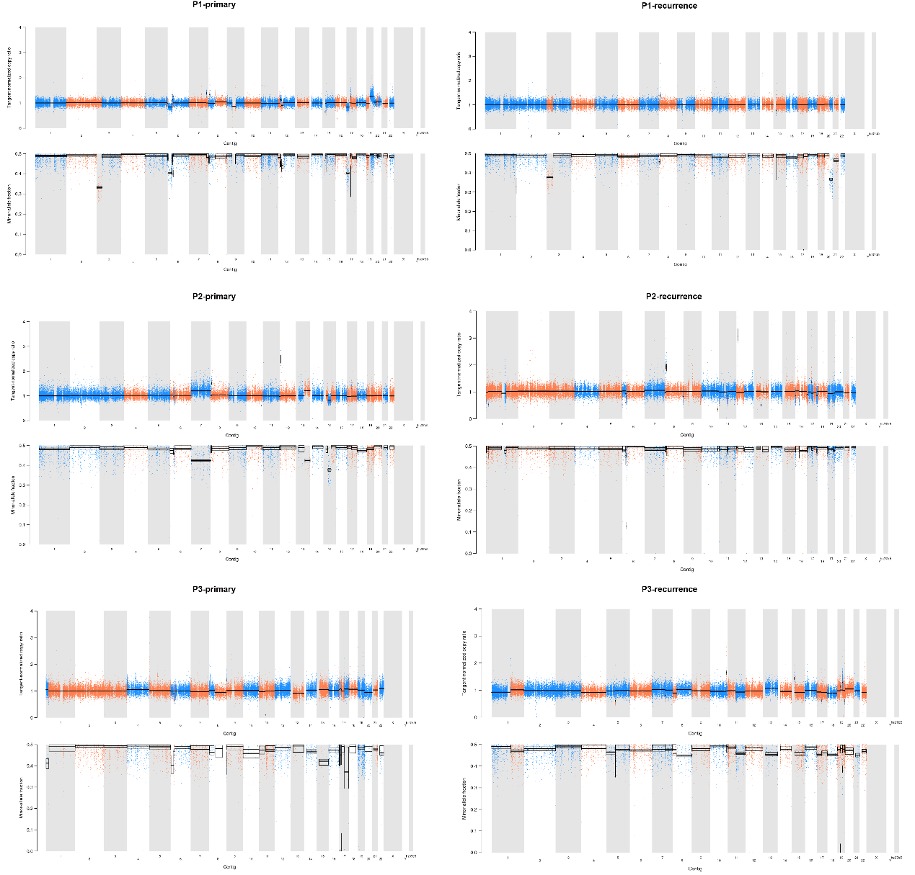
Additional Figure 2. CNVs for MSI-H patients (P1–P3). The less frequent CNV was presented in MSI-H patients. For each patient, the top panel indicates tangent-normalized copy ratio, and the bottom panel indicates minor allele frequency. CNV=Copy number variation, MSI-H=high microsatellite instability.

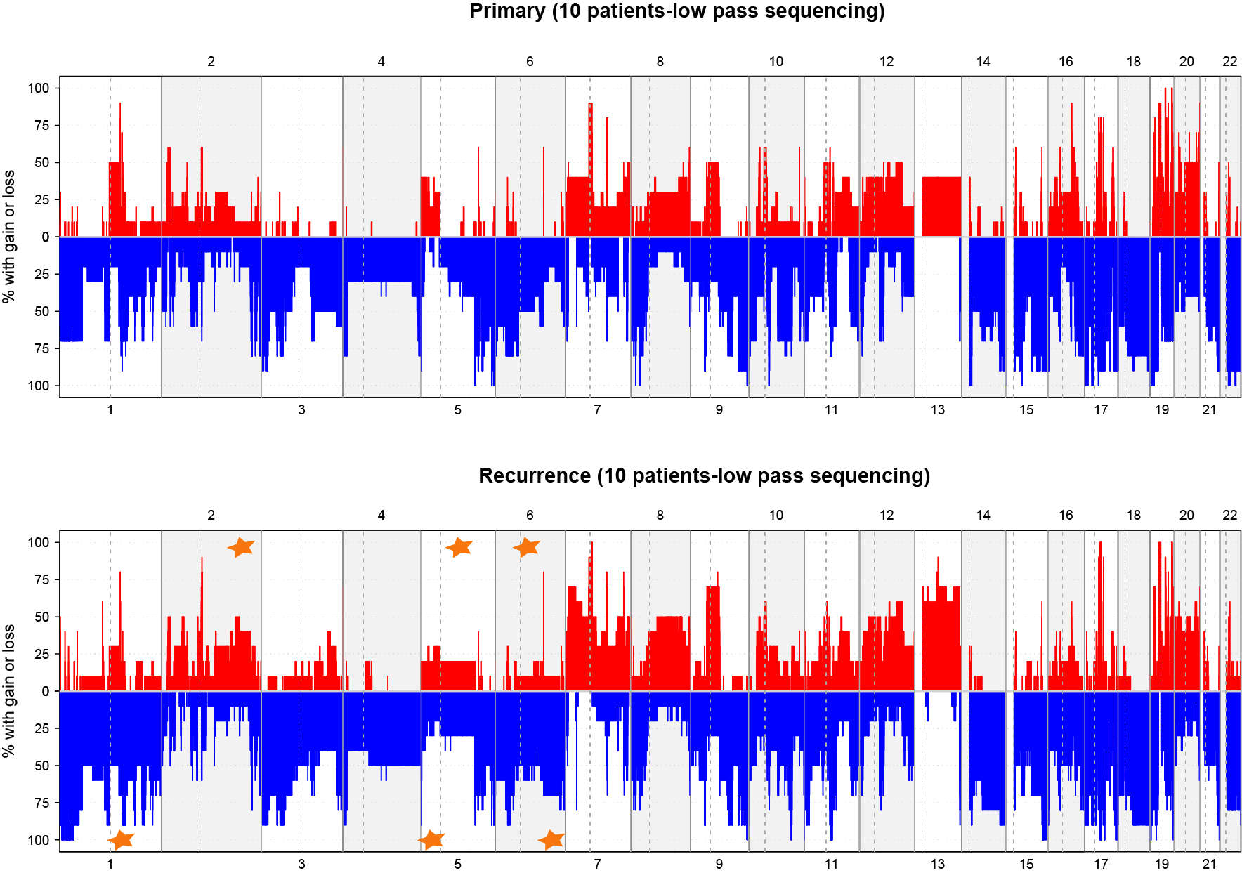
Additional Figure 3. Validation dataset of fragment variations between primary and LR lesions. X axis indicates chromosome number and Y axis indicates percentage of copy gain or loss; the red indicates copy gain of the fragment; The blue indicates copy loss of the fragment; the star indicates the significant gain or loss in LR lesions compare with primary lesions. LR=locoregional recurrence.

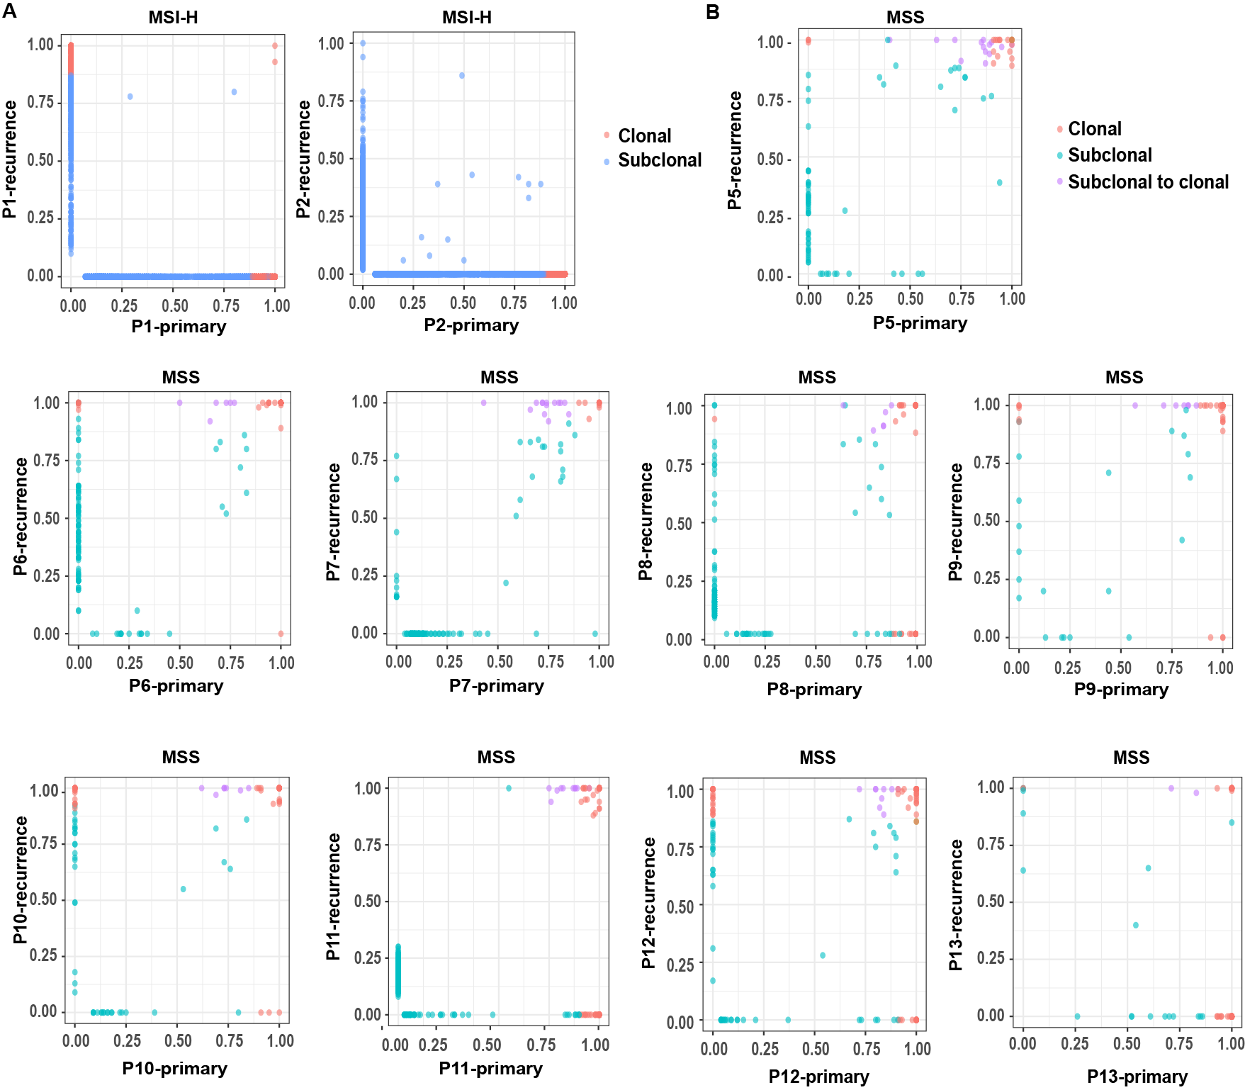
Additional Figure 4. CCF dynamics in (A) MSI-H and (B) MSS patients. The dots represent mutations in each patient. X axis indicates the CCF of primary lesions and Y axis indicates the CCF of LR lesions. CCF=cancer cell fraction, LR=locoregional recurrence, MSI-H=high microsatellite instability, MSS=microsatellite stable.

Additional Figure 5. The distribution of exclusive mutations in LR lesions and the pathway enrichment of these genes. (A) LR-specific mutation excess for each MSS patient. (B) Correlation between recurrence-specific mutation excess and time interval of DFS. (C, D) Significantly enriched pathways for mutations exclusive to LR lesions. DFS=disease free survival, LR=locoregional recurrence, MSS=microsatellite stable.

Additional Figure 6. Clusters of disseminating cells. The VAF dynamic of each MSS patient. Each line and dot pair represents the same disseminating cluster. MSS=microsatellite stable, VAF=variant allele frequency.

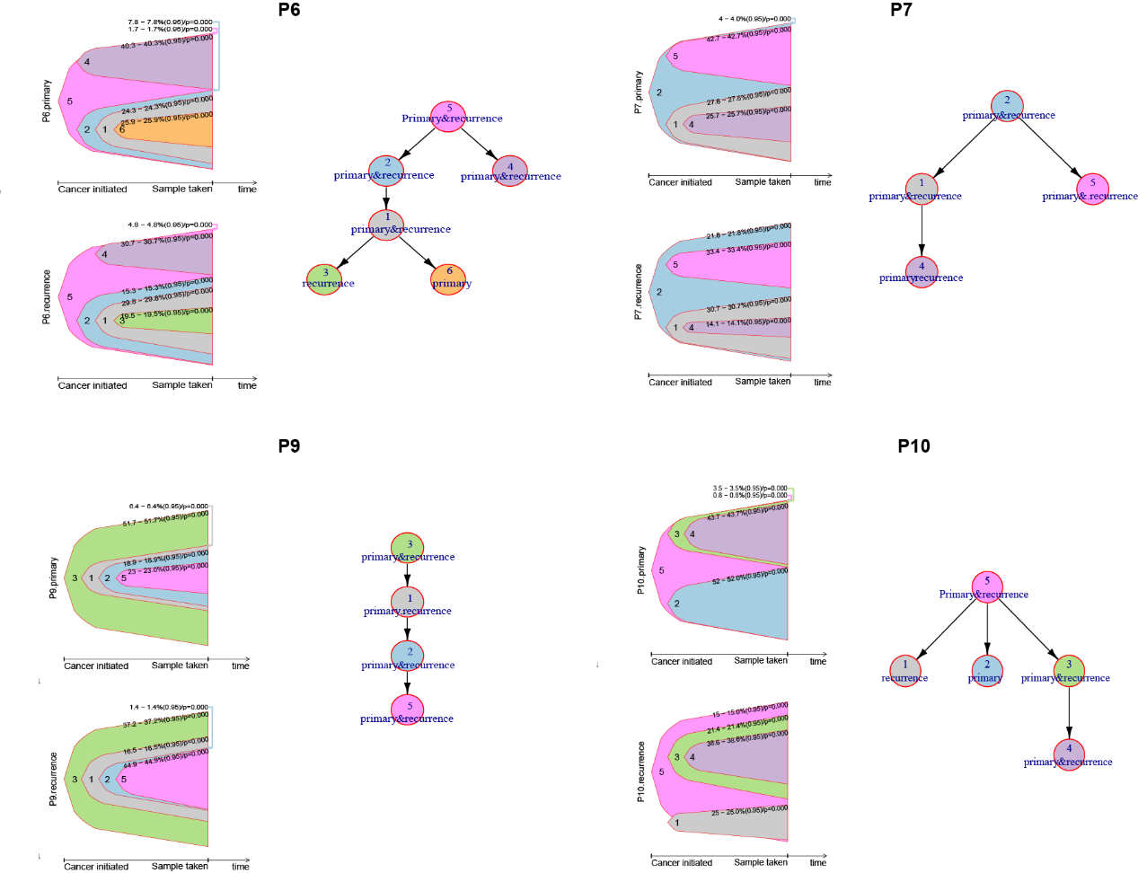
Additional Figure 7. Evolutionary models for representative patients. For each figure, the left panel indicates the clone evolved process in primary (top) and LR (bottom) lesion; The right panel indicates the hierarchical of each clone during the evolve process. LR=locoregional recurrence.

Additional Figure 8. The comparison of mutational characteristics for early- and late-recurrenced patients. (A, B) Significantly enriched pathways for patients with early and late recurrence. (C) Comparison of DFS between ID8-positive and -negative patients (ns, P=0.418; Wilcoxon test). (D) Comparison of DFS between ID4- or ID8-positive and double-negative patients (ns, P=0.094; Wilcoxon test). DFS=disease free survival, ID=indel, ns=not significant.

