Supplemental Figures 1 to 7
January 2022 Consultation Section

Supplemental Figure 1: OCT nerve fiber layer, highlighting thinning consistent with glaucomatous damage.

next page

Supplemental Figure 2: OCT ganglion cell analysis, noting thinning correlating to the nerve fiber loss.

next page

Supplemental Figure 3: Humphrey visual field, right eye. Note the significant dense superior arcuate visual field loss.

next page

Supplemental Figure 4: Humphrey visual field, left eye. Note the inferior arcuate defect.

next page

Supplemental Figure 5: Specular microscopy, both eyes, with normal endothelial density and configuration.

next page

Supplemental Figure 6. Intraoperative photo demonstrating the Posterior Sweep of Tenon (PoST) technique. (A) The GF microshunt spatula is between the gel stent and the sclera, prior to sweeping posteriorly. (B) One can appreciate Tenon capsule being swept posteriorly away from around the gel stent.

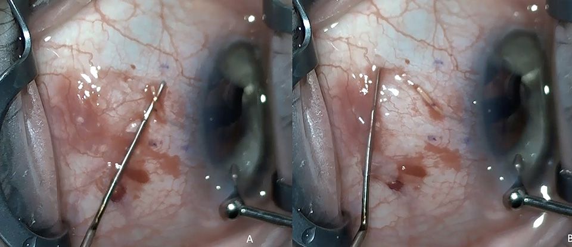

next page

Supplemental Figure 7. Intraoperative photo demonstrating injection of MMC into the Tenon tissue that has been swept posteriorly. Note the MMC is staying in Tenon tissue and not migrating anteriorly, thus sparing the limbus from exposure to MMC. MMC = mitomycin-C

