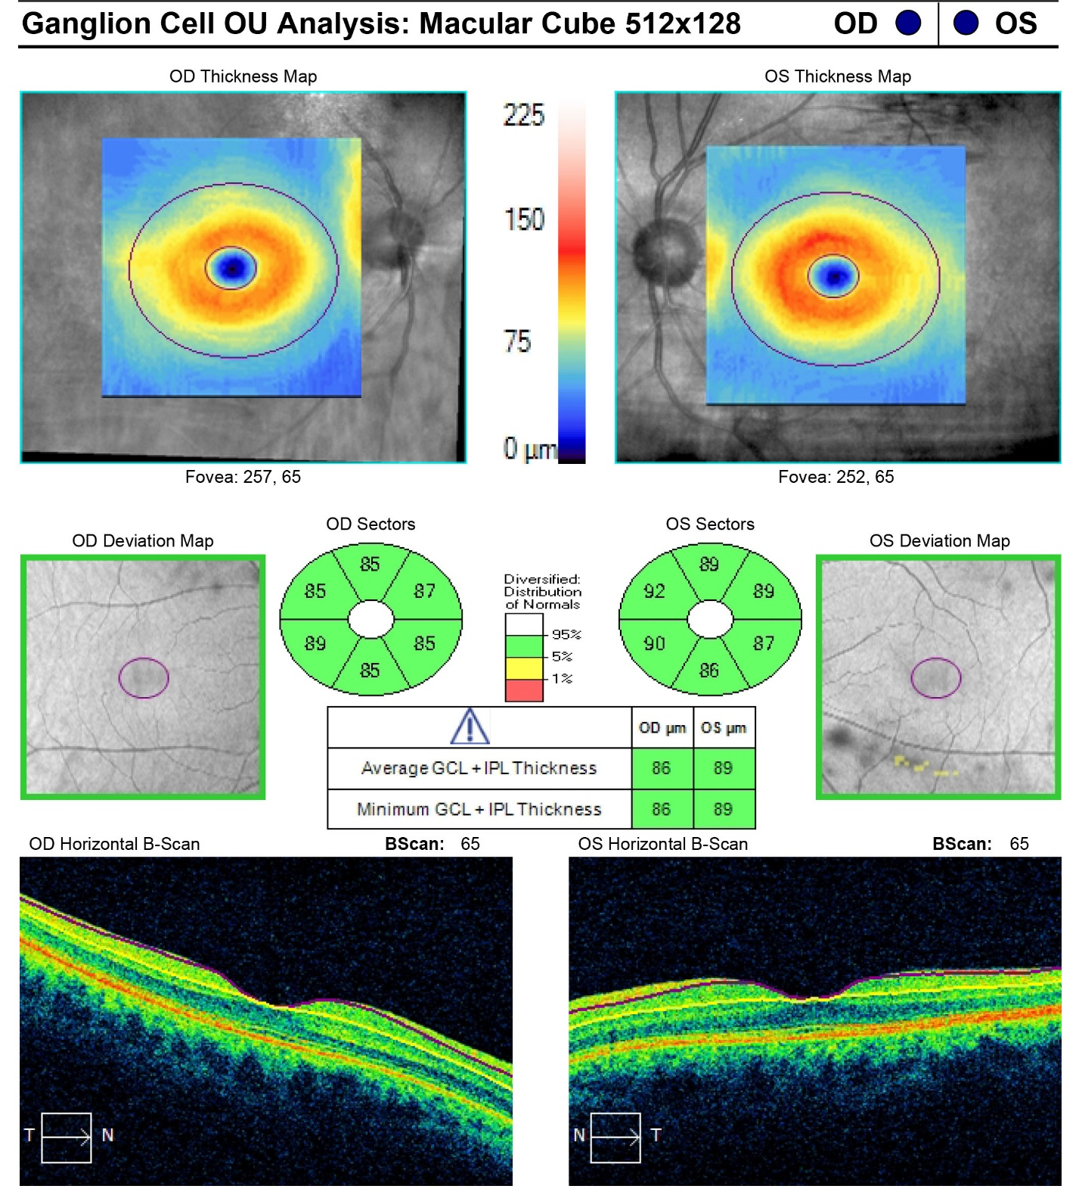

Supplemental Figure 4. Normal ganglion cell layer in each eye.

