Initial Heart Rate Prescription and Weekly Progression Plan for Adolescents with Concussion
MN Haider, MD, PhD

Data has been taken from the following pubished studies:
- Chizuk HM, Willer BS, Horn EC, Haider MN, Leddy JJ. Sex differences in the Buffalo Concussion Treadmill Test in adolescents with acute sport-related concussion. Journal of science and medicine in sport. 2021 Sep 1;24(9):876-80.
- Leddy JJ, Master CL, Mannix R, Wiebe DJ, Grady MF, Meehan WP, Storey EP, Vernau BT, Brown NJ, Hunt D, Mohammed F. Early targeted heart rate aerobic exercise versus placebo stretching for sport-related concussion in adolescents: a randomised controlled trial. The Lancet Child & Adolescent Health. 2021 Nov 1;5(11):792-9.

According to the first study, which was done on adolescents coming to a sports medicine clinic within 10 days of injury, males had a mean HRt of 134.7 ± 23 bpm and females had a mean HRt of 141.5 ± 25 bpm. These HRt are approximately a mean of 7 days since injury and are not applicable to the current study which aims to prescribe aerobic exercise from the day of injury.

To assess the effects of age, the HRt was plotted against age (Figure 1). From the figure, it does not seem like age affects the HRt at initial assessment and a Spearmans Correlation (Table 1) did not find a correlation.

Figure 1. HRt by age
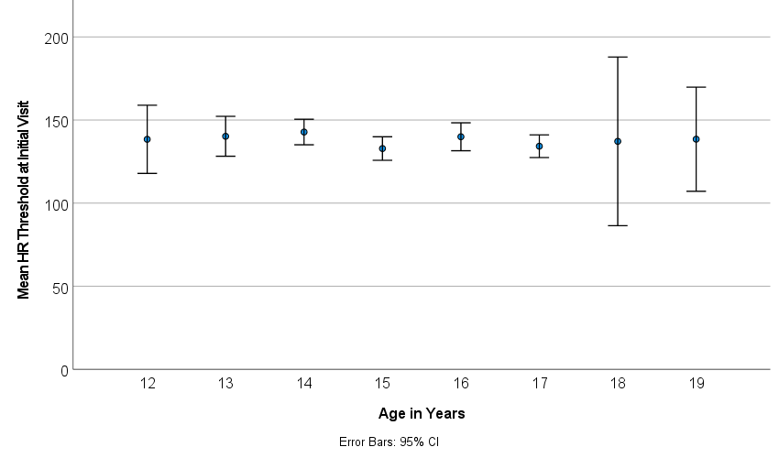

Table 1. Spearman’s Correlation between Age and Initial Visit HRt
 |  | HRt
Age | Correlation Coefficient | -0.062
 | Sig. (2-tailed) | 0.399
 | N | 190

A mixed model regression analysis was completed to identify the estimated HRt of adolescents with concussion at the day of injury and each subsequent weekly visit four up to 4 weeks. All included participants were prescribed aerobic exercise.. Data from the second study will be used which has a total of 244 BCTT results within 28 days since injury, from 61 unique participants. The scatterplot with line of best fit with 95% confidence limits is presented in Figure 2.

Figure 2. Max HR on BCTT by Days since Injury for upto 28 days since injury

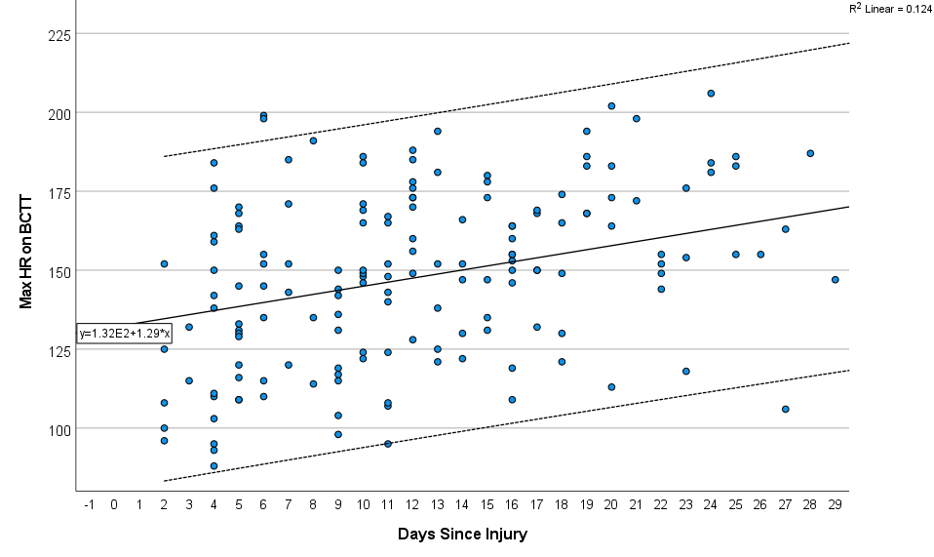

The equation for the line of best fit is the following:
$$Max HR on BCTT=1.29x+132$$

Hence, the HRt at the Day of Injury is around 132 bpm. This corresponds to a mean HR prescription of 119 bpm, which is around 58% of maximum age-predicted HR for a 15 year old. However, from the first study, it was found that females had an approximate 5 bpm higher HRt at their initial visit when compared to males, this difference was statistically significant (p = 0.05). From the second study’s data, a mixed model linear regression was performed between HRt and Days Since Injury with participant sex as an effect. The results of this regression are presented in Table 2.

Table 2. Mixed model regression with participant sex
Source | Type III Sum of Squares | df | Mean Square | F | Sig.
Corrected Model | 17314.854ª | 2 | 8657.427 | 13.200 | <.001
Intercept | 717528.629 | 1 | 717528.629 | 1094.038 | <.001
Days since injury | 15514.579 | 1 | 15514.579 | 23.656 | <.001
Sex | 2052.238 | 1 | 2052.238 | 3.129 | .079
Error | 105592.390 | 161 | 655.853
Total | 3751366.000 | 164
Corrected Total | 122907.244 | 163
a. R Squared = 0.141 (Adjusted R Squared = 0.130)

From the results of this model, it does seem that participant sex does have an effect on the Max HR achieved on the BCTT, even though it does not reach a level of significance below 0.05. Hence we will stratify the sample by sex and plot the HRt against days since injury and estimate a line of best fit. This is presented in Figure 3.

Figure 3. Max HR on BCTT by Days since Injury by participant Sex
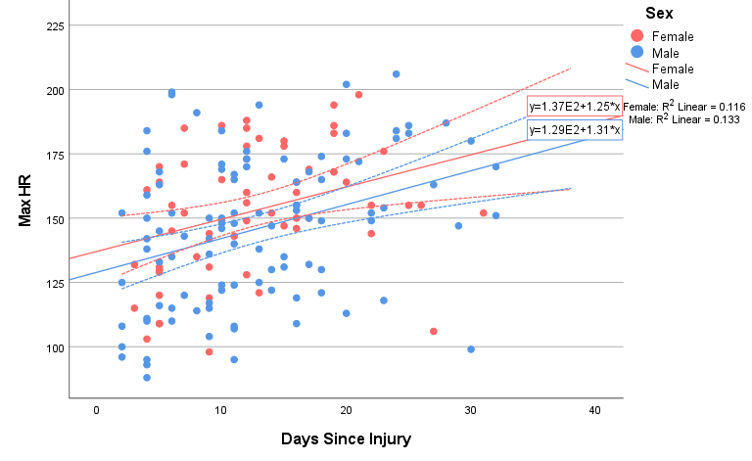
Results from this stratified model also show that females have a higher HR achieved on the BCTT by approximately 8 bpm and there is no intersection of the lines of best fit, which provides justification to have different HR prescriptions for each sex. This is concurrent with prior research suggesting that adolescent females have higher HRs than adolescent males. There is no intersection of the lines of best fit, which indicates the need to have different HR prescriptions for each sex. The line of best fit for females was $HRt=137+1.25x$ and for males was $HRt=129+1.31x$ where x is the number of days since injury.

