Supplementary data
Materials and methods
Calcium imaging
RPT cells were loaded with 3 μM Fura2/AM (Molecular Probes) at 37ºC for 1 h. Calcium measurements were performed at ~37ºC in a heated chamber (QE-1, Warner Instruments) with a cooled CCD camera (ORCA-ERG, Hamamatsu) mounted on an upright microscope (Axioskop 2 FS, Zeiss) with a 40x 0.8 NA water dipping lens. Excitation at 340 and 380 nm was performed with a monochromator (Polychrome IV, TILL Photonics). All devices were controlled and data was analyzed with computer software (MetaFluor, Molecular Devices). All experiments were performed in physiological buffer (100 mM NaCl, 4 mM KCl, 20 mM HEPES, 25 mM NaHCO3, 1.5 mM CaCl2, 1.1 mM MgCl2, 1 mM NaH2PO4, 10 mM D-Glucose, pH 7.4).
Cell morphology detection
For MGG (May-Grunwald stain) staining cells grown on 12mm glass coverslips were fixed with methanol for 5 min, washed and then incubated with MGG (10% in distilled water) for 40 min. After washing coverslips were mounted in Immu-Mount. Images were taken with digital camera attached to light microscope.
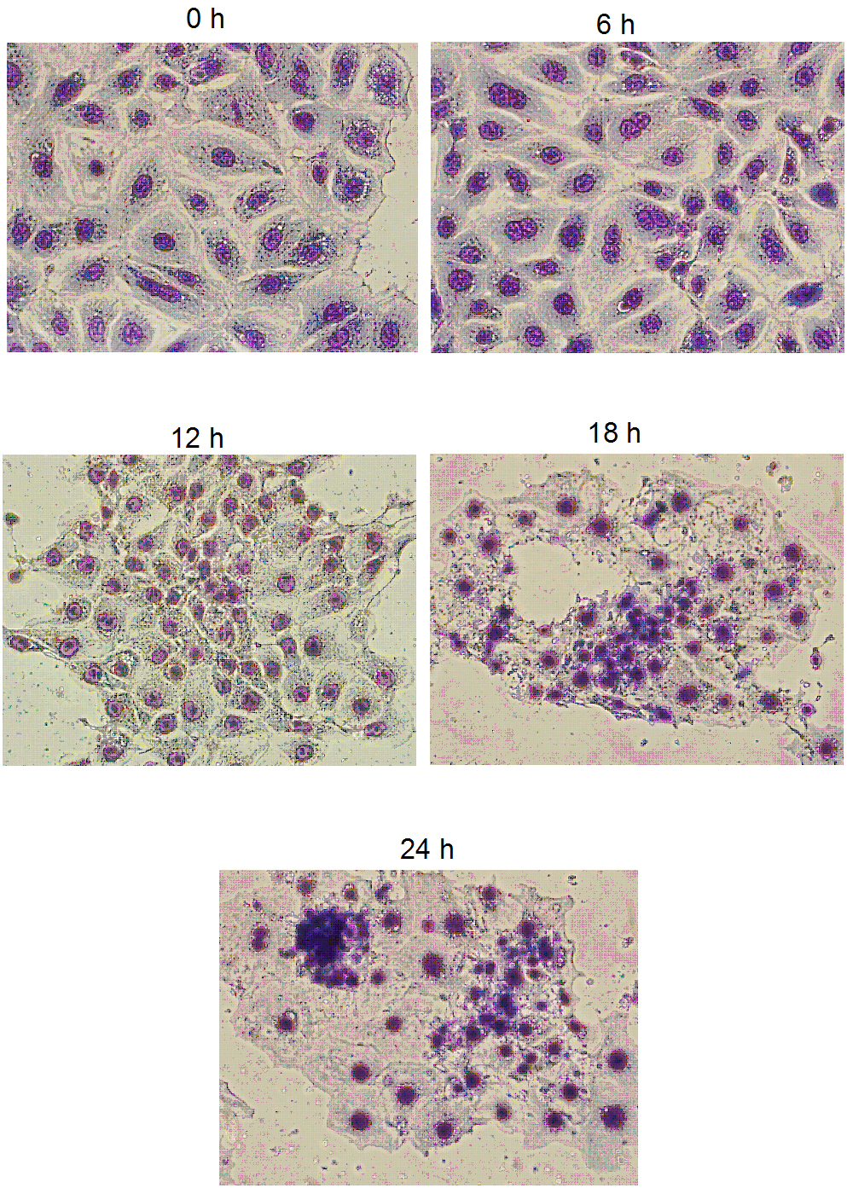
Fig 1 (supplementary data) The images of rat proximal tubule cells stained with MGG to asses time course changes in cell morphology in response to serum starvation.
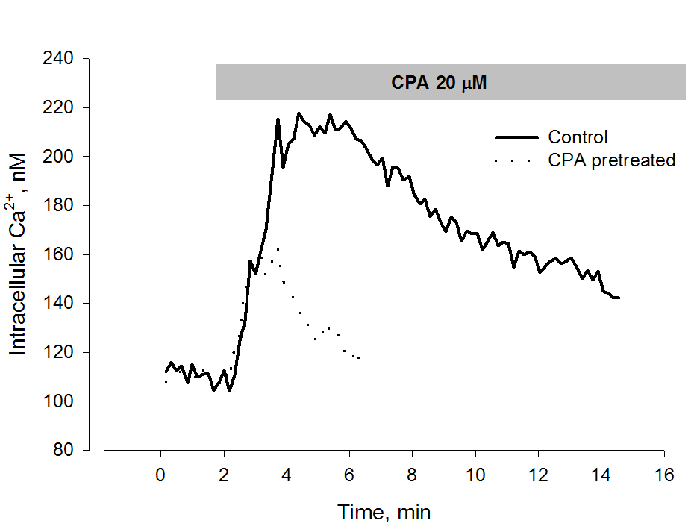
Fig 2 (supplementary data) CPA-induced [Ca²⁺]_{i} response in RPT cells
Typical [Ca²⁺]_{i} response in control (-) and cells pre-incubated with 0.5 μM CPA for 24 h, (--). Note that CPA-induced [Ca²⁺]_{i} increase was reduced in RPT cells pre-incubated with 0.5 μM CPA for 24 h, suggesting that ER [Ca²⁺]_{i} was lower in these cells.
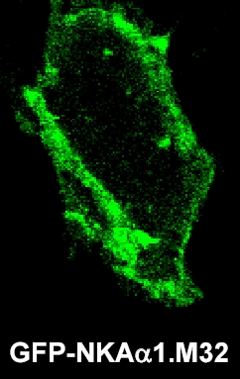
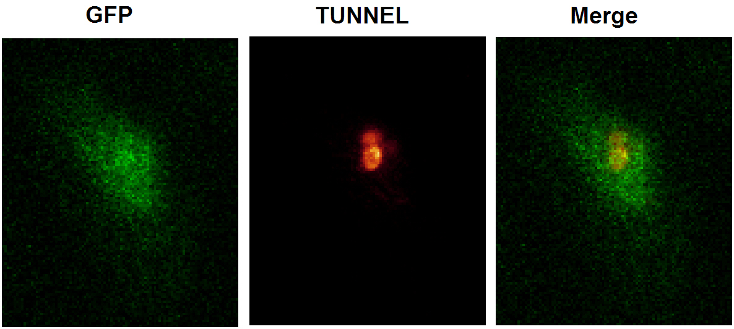
Fig 3 (supplementary data) The enlarge confocal images of RPT cells transfected with GFP-tagged Na,K-ATPase where N-terminus tail was partially truncated (ΝΚΑ_{α1}M32).
(A) Image was taken with smaller pin-hole and membrane staining is evident.
(B) Images showing that green signal (GFP) do colocalize with the red (TUNNEL) positive signal. Images were recorded with full opening of pin-hole to maximize the sensitivity for detection and of the GFP signal.

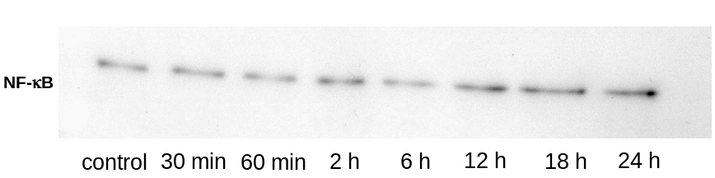
Fig 4 (supplementary data) Representative Western blot showing time course changes in nuclear NF-kB in cells exposed to 10nM ouabain.

