Poly(ADP-ribose) Polymerase-1 mediated glycolytic inhibition in ischemic kidneys
Kishor Devalaraja-Narashimha¹, and Babu J. Padanilam^{1,2}, ¹Department of Cellular and Integrative Physiology, ²Department of Internal Medicine, Section of Nephrology, University of Nebraska Medical Center, Omaha, Nebraska 68198

SUPPLEMENTARY DATA

LLCPK₁, a porcine-derived proximal tubular cell line, as an in vitro PST model of IRI: Having demonstrated GAPDH-poly(ADP-ribosyl)ation and the inhibition of its activity in vivo following IRI, we next sought to determine whether these mechanisms occur in the PST segment of the nephron following IRI. For this purpose, we have used a porcine derived LLCPK₁ cell line as an in vitro proximal tubular cell culture model of IRI. Cultured LLCPK₁ cells were probed for the expression of proximal tubule markers including AQP1 and AQP7 by immunofluoroscence. Our results showed that LLCPK₁ cells express both AQP1 (a proximal tubular marker) and AQP7 (a PST specific marker) (Figure S1A), supporting the use of this cell line as an in vitro model of IRI.
Effect of hypoxia on PAR expression in cultured LLCPK₁ cells: Next, we confirmed the validity of LLCPK₁ as an in vitro model for mimicking the in vivo scenario of PARP activation following ischemia. Hypoxia was used to simulate ischemic injury in cultured LLCPK₁ cells and PAR, a product of PARP activity, was detected by immunofluorescence. PAR levels were upregulated in cultured LLCPK₁ cells subjected to 6h hypoxia (Figure S1B: panel b). When LLCPK₁ cells were subjected to 6h hypoxia in the presence of GPI-15427 (20µM), a novel potent PARP inhibitor, the expression of PAR was completely inhibited (Figure S1B: panel c). Negligible level of PAR expression was observed in untreated control cells (Figure S1B: panel a).
We further confirmed that PARP is activated in hypoxic LLCPK₁ cells by examining PAR expression via immunoblot analysis. We performed in vitro biotinylation assay as described in Materials and Methods section using biotinylated NAD⁺. The activated PARP-1 transfers biotin-labeled ADP-ribose moieties from biotinylated NAD⁺ to different proteins including itself. Shown in the Figure S1C is the Western blot picture showing biotin expression, an indirect PAR expression. As in case of ischemic renal tissues, several poly(ADP-ribosyl)ated protein bands, including a band around 37 kDa, were observed at 6h hypoxia (Figure S1C: Lanes 3 and 4), suggesting potential PARP activation and GAPDH-poly(ADP-ribosyl)ation in LLCPK₁ cells following hypoxia. Very few PAR bands were observed in control lanes (Figure S1C: Lanes 1 and 2).

Inhibition of GAPDH activity by PARP-1 is due to its poly(ADP-ribosyl)ation:

The proteins from in vitro assay using cell-free system were subjected to SDS-PAGE gel and the PAR expression was detected by immunoblotting with anti-PAR antibody. Following PARP-1 activation, the expression of PAR appeared as a large smear, indicating PAR chains of variable length attached to GAPDH (37 kDa) or to PARP-1 (116 kDa) (Figure S2B: lanes 2-5) as previously reported (1). To further confirm this, we performed the in vitro assay using biotin-labeled NAD⁺ as a PARP-1 substrate and PAR-modified proteins were visualized by immunoblotting using streptavidin-HRP. Similar to our previous data, a large smear of PAR expression, indicating GAPDH or PARP-1 poly(ADP-ribosyl)ation, was found in the samples using activated PARP-1 (Figure S2C: lane 7), whereas, PARP-1 inhibition led to complete disappearance of the PAR expression (Figure S2C: lane 8). Figures S2D and E are the immunoblotting images showing the expression PARP-1 and GAPDH, respectively, at the end of in vitro cell-free assay using biotin-labeled NAD⁺.

Figure S1:
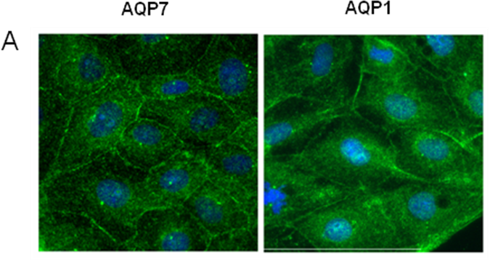

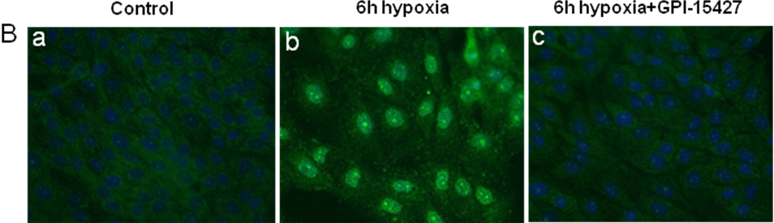

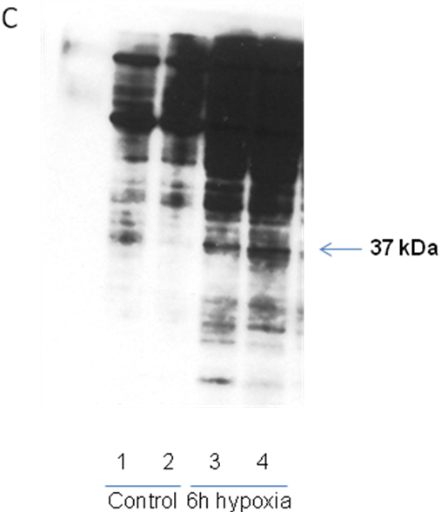

Figure S2:

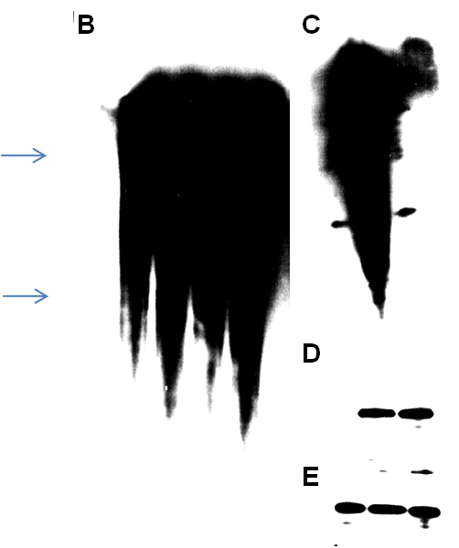
116 kDa
116 kDa
116 kDa
37 kDa
37 kDa
37 kDa
1
2
3
4
5
6
7
8

+
+
+
+
-
-
-
-
-
-
-
GPI-15427 20 µM:
+
-
+
+
+
+
-
PARP-1:
+
+
+
+
+
+
-
NAD + Activated DNA:
+
+
+
+
+
+
+
GAPDH:

Figure S3

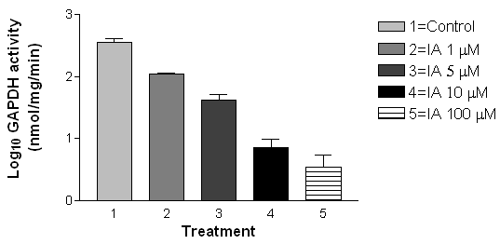
*
*
*
*
n=4
n=4
n=5
n=5
n=5
0 1 5 10 100
IA concentration µM

Figure legends:

Figure S1A: Immunofluorescent detection of AQP7 and AQP1 in confluent cultures of LLCPK₁ cells.
Figure S1B: Immunofluorescent detection of PAR in hypoxic LLCPK₁ cells: LLCPK₁ cells were subjected to hypoxic conditions with or without PARP inhibitor, GPI-15427, and were examined for the product of PARP activity, PAR. Panels a) control b) 6h hypoxia, and c) 6h hypoxia+GPI-15427.
Figure S1C: Western blotting analysis showing the expression of biotin/PAR in LLCPK₁ whole cell lysates (20 µg of protein was loaded). Lanes 1 and 2: Poly(ADP-ribosyl)ated proteins in control whole cell lysates. Lanes 3 and 4: Poly(ADP-ribosyl)ated proteins in whole cell lysates of LLC-PK1 cells subjected to 6h of hypoxia.

Figures S2B and C: Western blotting analysis showing poly(ADP-ribosyl)ation of GAPDH and PARP-1 in in vitro cell-free system. Figures S2D and E: Western blotting analysis showing the expression of PARP-1 and GAPDH in in vitro cell-free system respectively.

Figure S3: Effect of GAPDH inhibitor, IA, on GAPDH activity in LLCPK₁ cells. Each bar represents the mean ± SEM. *p < 0.0001 compared to control.

References:

1. Ditsworth D, Zong WX, Thompson CB. (2007) Activation of poly(ADP)-ribose polymerase (PARP-1) induces release of the pro-inflammatory mediator HMGB1 from the nucleus. J Biol Chem 282: 17845-17854

