Running text/explanation for the data in the supplementary section:
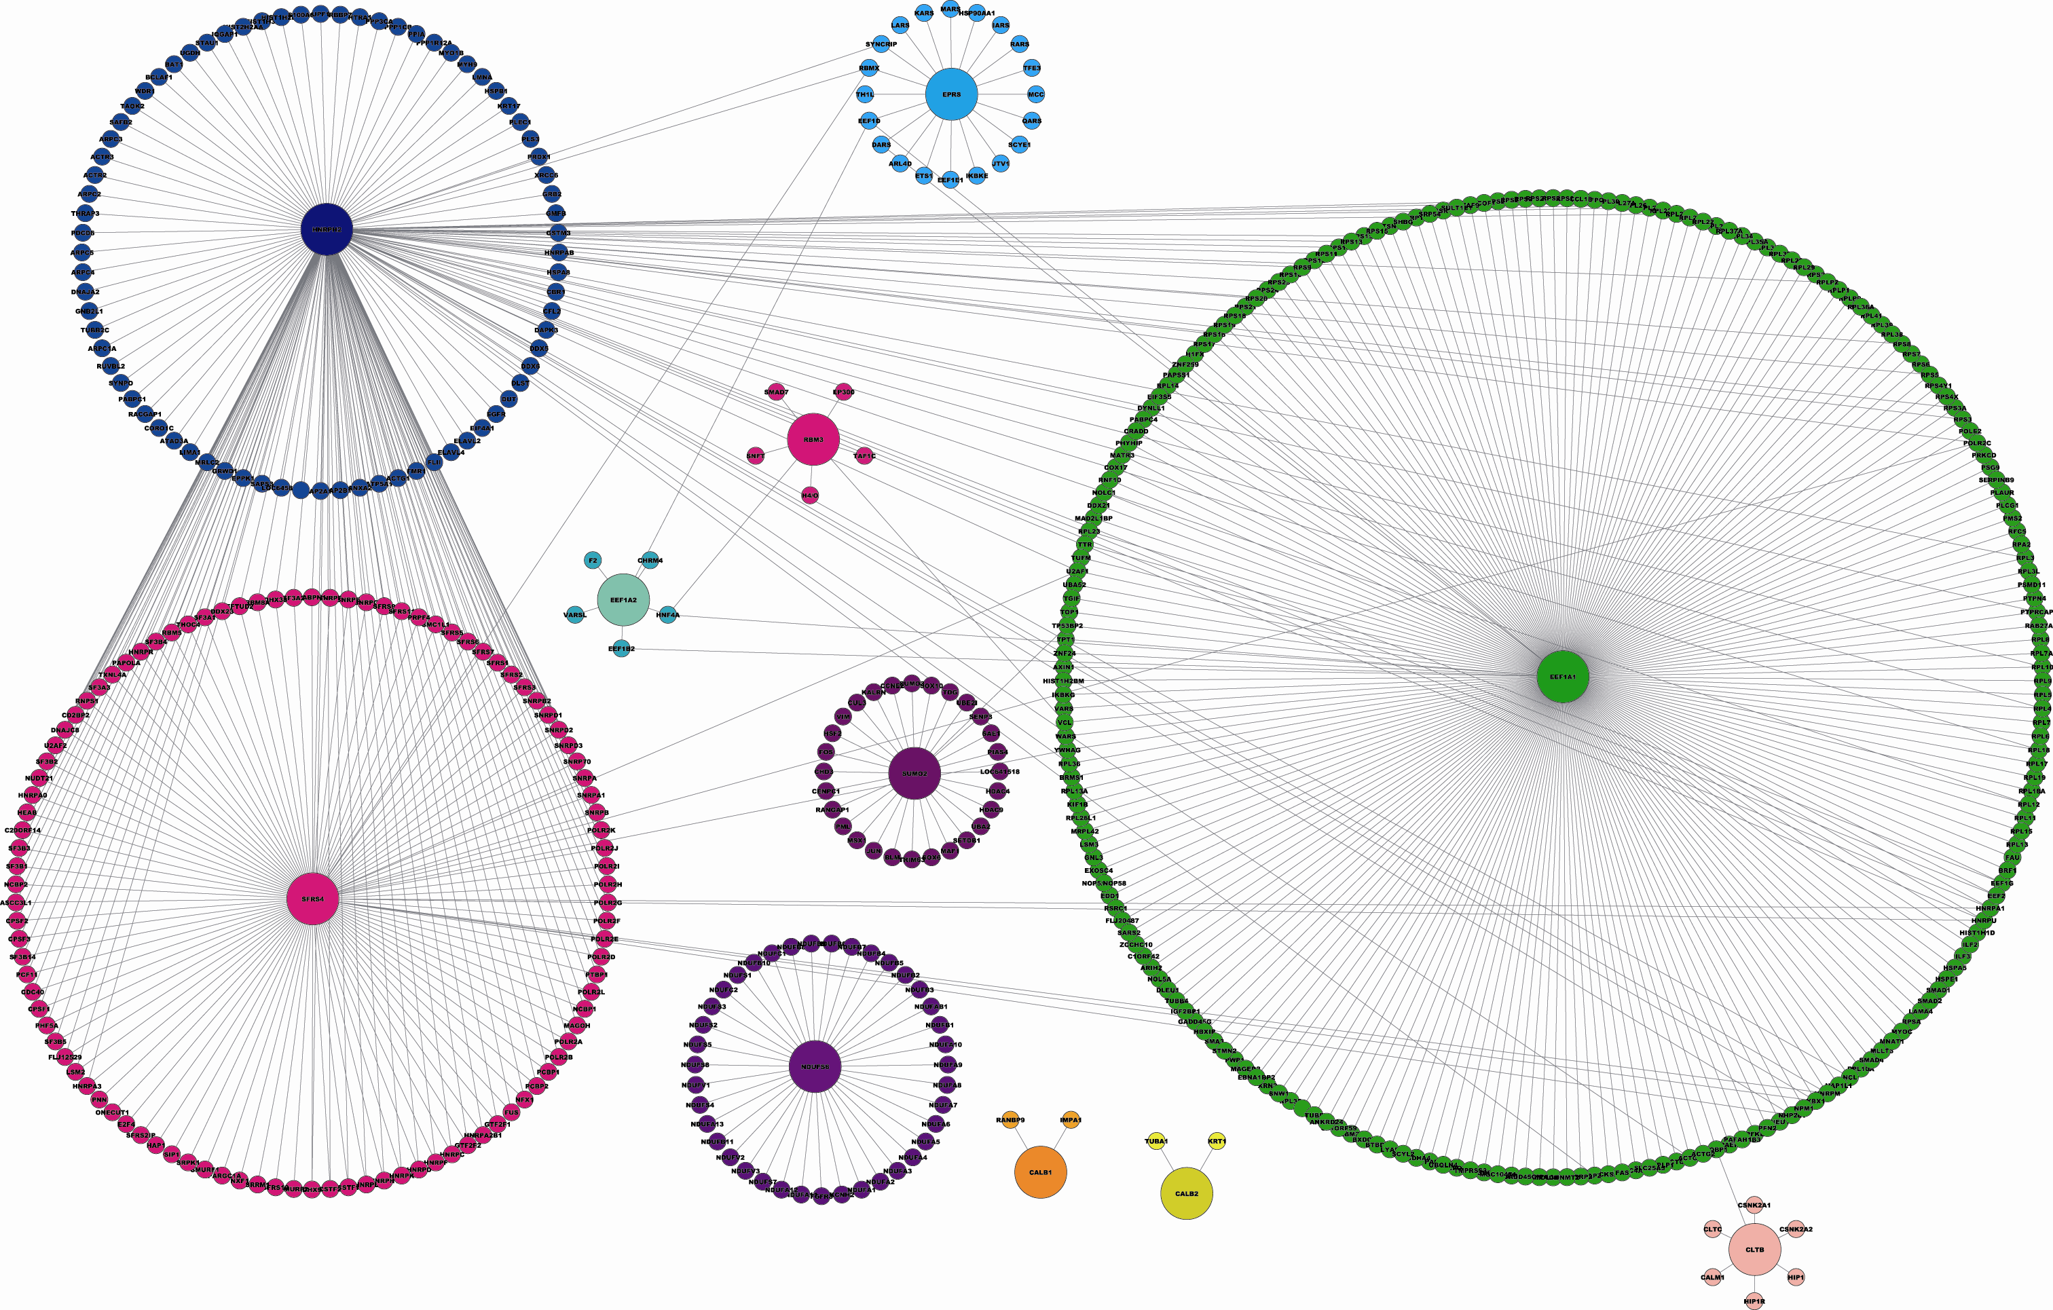
Gene Ontology and KEGG Pathway enrichment analysis of the pirfenidone-unique proteins and their interacting one was performed using the Functional Annotation Tool of the DAVID Knowledgebase available at http://david.abcc.ncifcrf.gov. (1, 2) In this analysis (Figure 7, Supplementary Figure 1 and Supplementary table 1) we consider significant only those ontology categories and KEGG pathways with and enrichment Fisher’s Exact P-value <0.05. The background proteins set used to calculated the enrichment scores and P-values was composed by the entire list of 518 proteins in the pirfenidone-centered network.

Supplementary Figure 1: Pirfenidone-unique proteins interaction network: 21 proteins were identified by LC-MS/MS to be unique to db/db diabetic mouse kidneys treated with pirfenidone (Table 3). Of these, 14 have clear human orthologs defined using the InParanoid Eukaryotic Ortholog Groups (http://inparanoid.sbc.su.se/cgi-bin/index.cgi)(3-6) (Table 4). 11 of the mouse/human ortholog proteins have at least one interaction in the corresponding human protein–protein interaction network. This results in a network composed by 518 proteins (nodes) and 655 interactions (edges). (Please see also Supplementary table 1). Networks are visualized using Cytoscape version 2.6 (www.cytoscape.org). (7)

The details of primers and probes used for quantitative RT-PCR:

Fibronectin (mus)
Forward; CAA GTC GAT GCC ATC CCA G
Reverse; CTG GCT GTA AAC CTG TAA TGG
Probe; Fam AT GGC CAG ACC CCA GTT CAG AGG A Tamra

Collagen TypeIa1 (mus)
Forward; AGA GCA TGA CCG ATG GAT TC
Reverse ; ATT AGG CGC AGG AAG GTC AG
Probe ; Fam CT CCG ACC CCG CCG ATG TCG Tamra

Collagen TypeIVa1 (mus)
Forward; GGC TAT TCC TTC GTG ATG CA
Reverse ; CTA AAC TCT TCC AGA CAG GAC
Probe ; Fam AG GTT CCG GCC AAG CCC TCG C Tamra

18S (mus)
Forward; AGA AAC GGC TAC CAC ATC CA
Reverse ; CTC GAA AGA GTC CTG TAT TGT
Probe ; Tet AG GCA GCA GGC GCG CAA ATT AC Tamra

References:
1. Joshi-Tope, G, Gillespie, M, Vastrik, I, D'Eustachio, P, Schmidt, E, de Bono, B, Jassal, B, Gopinath, GR, Wu, GR, Matthews, L, Lewis, S, Birney, E & Stein, L: Reactome: a knowledgebase of biological pathways. Nucleic Acids Res, 33: D428-32, 2005.
2. Vastrik, I, D'Eustachio, P, Schmidt, E, Joshi-Tope, G, Gopinath, G, Croft, D, de Bono, B, Gillespie, M, Jassal, B, Lewis, S, Matthews, L, Wu, G, Birney, E & Stein, L: Reactome: a knowledge base of biologic pathways and processes. Genome Biol, 8: R39, 2007.
3. Peri, S, Navarro, JD, Amanchy, R, Kristiansen, TZ, Jonnalagadda, CK, Surendranath, V, Niranjan, V, Muthusamy, B, Gandhi, TK, Gronborg, M, Ibarrola, N, Deshpande, N, Shanker, K, Shivashankar, HN, Rashmi, BP, Ramya, MA, Zhao, Z, Chandrika, KN, Padma, N, Harsha, HC, Yatish, AJ, Kavitha, MP, Menezes, M, Choudhury, DR, Suresh, S, Ghosh, N, Saravana, R, Chandran, S, Krishna, S, Joy, M, Anand, SK, Madavan, V, Joseph, A, Wong, GW, Schiemann, WP, Constantinescu, SN, Huang, L, Khosravi-Far, R, Steen, H, Tewari, M, Ghaffari, S, Blobe, GC, Dang, CV, Garcia, JG, Pevsner, J, Jensen, ON, Roepstorff, P, Deshpande, KS, Chinnaiyan, AM, Hamosh, A, Chakravarti, A & Pandey, A: Development of human protein reference database as an initial platform for approaching systems biology in humans. Genome Res, 13: 2363-71, 2003.
4. Ramani, AK, Bunescu, RC, Mooney, RJ & Marcotte, EM: Consolidating the set of known human protein-protein interactions in preparation for large-scale mapping of the human interactome. Genome Biol, 6: R40, 2005.
5. Rual, JF, Venkatesan, K, Hao, T, Hirozane-Kishikawa, T, Dricot, A, Li, N, Berriz, GF, Gibbons, FD, Dreze, M, Ayivi-Guedehoussou, N, Klitgord, N, Simon, C, Boxem, M, Milstein, S, Rosenberg, J, Goldberg, DS, Zhang, LV, Wong, SL, Franklin, G, Li, S, Albala, JS, Lim, J, Fraughton, C, Llamosas, E, Cevik, S, Bex, C, Lamesch, P, Sikorski, RS, Vandenhaute, J, Zoghbi, HY, Smolyar, A, Bosak, S, Sequerra, R, Doucette-Stamm, L, Cusick, ME, Hill, DE, Roth, FP & Vidal, M: Towards a proteome-scale map of the human protein-protein interaction network. Nature, 437: 1173-8, 2005.
6. Stelzl, U, Worm, U, Lalowski, M, Haenig, C, Brembeck, FH, Goehler, H, Stroedicke, M, Zenkner, M, Schoenherr, A, Koeppen, S, Timm, J, Mintzlaff, S, Abraham, C, Bock, N, Kietzmann, S, Goedde, A, Toksoz, E, Droege, A, Krobitsch, S, Korn, B, Birchmeier, W, Lehrach, H & Wanker, EE: A human protein-protein interaction network: a resource for annotating the proteome. Cell, 122: 957-68, 2005.
7. Shannon, P, Markiel, A, Ozier, O, Baliga, NS, Wang, JT, Ramage, D, Amin, N, Schwikowski, B & Ideker, T: Cytoscape: a software environment for integrated models of biomolecular interaction networks. Genome Res, 13: 2498-504, 2003.

