Supporting Materials and Methods

RNA Purification and Quality Control
Total RNA from microcollected CCD/CNT was purified using RNeasy Micro Kit (Qiagen). The RNA samples were tested for quality using an Agilent 2100 Bioanalyzer® (PicoChip®, Agilent Technologies) and for quantity using the ND-1000 NanoDrop® UV-spectrophotometer (NanoDrop Technologies). Only samples showing a 28S/18S ribosomal RNA ratio ≥1 or a RNA Integrity Number (RIN; Agilent Technologies) >7 (range 1-10 with 10 for best RNA quality) were used for target cRNA preparation.

Microarray Target cRNA Preparation
RNA amplification and labeling was performed according to a two-cycle cDNA synthesis protocol. Briefly, ≥30 ng of total RNA was concentrated to a volume of approximately 3 μl using a speed-vac system and used for first and second strand cDNA synthesis with the GeneChip® Two-Cycle cDNA Synthesis Kit (Affymetrix) in the presence of an oligo-dT primer containing a T7 RNA polymerase promoter site. cRNA was prepared by in vitro transcription using the MEGAscript T7 Kit (Ambion). The resulting cRNA was used for a second round of first-strand cDNA synthesis with random hexamer primers, followed by second strand cDNA synthesis with the same kit as above. Labeled target cRNA was then prepared in a second round of in vitro transcription using biotin-labeled UTP (GeneChip® IVT Labeling Kit, Affymetrix). After each round of amplification the cRNA were tested for quality using an Agilent 2100 Bioanalyzer® (PicoChip®, Agilent Technologies) and for quantity using the ND-1000 NanoDrop® UV-spectrophotometer (NanoDrop Technologies). Only samples showing labeled cRNA average size distribution higher than 0.5 kb were accepted for hybridization.

Target cRNA Hybridization and GeneChip® Scanning
Biotin-labeled cRNA samples (15 μg) were fragmented randomly to 35-200bp at 94°C for 35 min in presence of Fragmentation Buffer (Affymetrix) and were mixed in 300 μl of hybridization buffer containing Eukaryotic hybridization control mix (Affymetrix) and Control Oligo B2 (Affymetrix), 0.1 mg/ml herring sperm DNA and 0.5 mg/ml acetylated bovine serum albumin in 2-(4-morpholino)-ethane sulfonic acid (MES) buffer, pH 6.7, before hybridization to GeneChip® MOE 430 2.0 arrays. Hybridizations were carried out at 45°C for 16 h at constant rotation (60 rpm). Subsequent washing and staining steps were performed using the Affymetrix Fluidics Station 450 EukGE-WS2v5_450 washing protocol (Affymetrix). Stained arrays were scanned using an Affymetrix® GeneChip® Scanner 3000 (Affymetrix), and the probe set intensity values for each gene were calculated by Affymetrix GeneChip® Operating System Software (GCOS 1.0, Affymetrix).

Real-Time RT-PCR
Samples of 3 μl RNA (out of 60 μl) were used as templates for reverse transcription using TaqMan® Reverse Transcription Kit (Applied Biosystems) in the presence of 2.5 μM random hexamer primers (Applied Biosystems). Real-time PCR was performed using 3.5 μl of the cDNA as template using the TaqMan® Universal PCR master mix (Applied Biosystems). Primers and probes were designed using Primer Express 2.0 software (Applied Biosystems) to result in amplicons of 70-100 bp that span intron-exon boundaries. Each primer pair (Table S1) was first tested on mouse kidney cDNA and resulted in a single product of the expected size (data not shown). Probes (Table S1) were labelled with reporter dye FAM at the 5’ end and the quencher dye TAMRA at the 3’ end (Microsynth). Reactions were run in 96-well optical reaction plates using a Prism 7700 cycler (Applied Biosystems). Thermal cycles were set at 95°C (10 minutes) and the 40 cycles at 95°C (15 seconds) and 60°C (1 minute) with auto ramp time. To analyze the data, the threshold was set to 0.06 (value in the linear range of amplification curves). All reactions were run in triplicates and the abundance of the target mRNAs was calculated relative to a reference mRNA (mouse  β-actin). Assuming an efficiency value of 2 (fold-increase in input mRNA required to decrease the cycle number by 1), relative expression ratios were calculated as R = 2^{(Ct(β-actin) – Ct(test))}, where Ct is the cycle number at the threshold and test stands for the tested mRNAs. Based on this analysis, some samples (<1/3) were excluded from microarray target RNA synthesis because of high Na⁺/K⁺/2Cl⁻-cotransporter (Nkcc2) contamination, a relatively low enrichment in α- and βENaC mRNA or, for aldosterone-treated mice, a Sgk1 upregulation <2-fold. Real-time RT-PCR was performed similarly for controlling the regulation of 8 mRNAs considered as highly regulated by microarray.

Quality Control of Microarrays and Statistical Analysis
Per condition, six GeneChips® were used for hybridization. Each hybridization was performed with target RNA from individual mice. Array images were inspected visually for artefacts and B2 Oligo performance. Raw data processing was performed using the Affymetrix Gene Chip Operating System Software (GCOS 1.0, Affymetrix) and the GCRMA preprocessor of the Genespring software 7.1 (Silicongenetics), respectively. Summarization for the respective probe sets giving rise to the actual expression values was carried out in two independent approaches using different algorithms; MAS5 and GCRMA.
To assess the significance of differential gene expression between the conditions tested, we applied statistical parametric methods based on the comparisons between the groups of replicates analyzed. Unreliable genes were filtered out using the absent/present calls resulting from the MAS5 analysis. Unequal variance t-test was applied to detect genes that were significantly differentially expressed with a significance level of P ≤0.05. Finally, the resulting significant genes were filtered for fold changes between the conditions of ≥ 2.

Prediction of Mineralocorticoid Hormone Response Elements in the Promoter Region of the Mouse Usp2-45 Gene
Consensus steroid hormone response elements contain symmetric imperfect direct, palindromic or inverted palindromic (everted) repeats of hexameric halfsite sequences such as 5’-AGAACA-3’ that are usually divided by 3 bp-long spacers. In order to predict potential binding sites for mineralocorticoid hormone response elements, we analyzed the promoter region -6.5 kb upstream of the ATG start codon of the mouse Usp2-45 gene by using the computational statistic models Position Weight Matrix (PWM) and Hidden-Markov-Model (HMM) implemented in the web-based program Tiger SHRE Finder 1.0 (http://birc.ntu.edu.sg/%7epmaria/ (1)). Within this region we found 13 HRE binding sites predicted by PWM (similarity coefficient bigger than 0.85) and 5 HRE by HMM (similarity coefficient bigger than 0.33). For better sensitivity, accuracy and avoiding false positive results both methods were taken together and 4 HRE sequences were predicted by both methods (Figure S2).

Western Blotting of Usp2-45 in Microcollected Mouse Kidney Connecting Tubule and Collecting Duct
Mouse treatment, kidney dissection and tubule microcollection were performed as described above for RNA preparation, but tubule segments (75-85) were transferred into RIPA buffer for lysis. Two μg total proteins were loaded per lane on a 10% SDS-polyacrylamide gel and subsequently transferred electrophoretically to a PVDF-membrane (Immobilon-P, Millipore). Blots were blocked and incubated with primary antibody as described below under “Western blot in mpkCCD_{c14} Cells” using 10 μg/ml anti-Usp2-45 antibody and monoclonal anti-β-actin antibody (1:5000, Sigma). In the peptide competition experiment the primary antibody was preincubated for 1 h at room temperature with the immunizing peptide at a 1:100 molar ratio (AB:peptide). The anti-Usp2-45 antibody, blot incubation conditions and washes are described below in “Westen blot in mpkCCD_{c14} Cells”. The specific bands were quantified by using the AIDA Image Analyzer 3.44 program (raytest Inc.).

Cloning of Mouse Usp2-45, Usp2-69, Usp15, Site-Directed Mutatgenesis and cRNA Preparation
Mouse kidney or heart (Usp2-69) RNA was isolated with RNeasy Mini Kit according to the manufacturer’s protocol (Qiagen) and reverse transcribed (oligoDT primers) using the TaqMan Reverse Transcription Kit (Applied Biosystem). The Usp2-45 (RefSeq No NM_198091) and Usp15 (RefSeq No NM_027604) cDNAs were amplified by PCR using 2.5 U of a proofreading polymerase (Pfu, Promega), 1x Pfu-reaction buffer (Promega) 2mM dNTPs, 0.5μM 5’-Primer, 0.5 μM 3’-Primer for 40 cycles (45 seconds 96°C, 1 minute 50-70°C, 5 minutes 72°C). The primers for PCR included restriction sites for cloning (each 5’XhoI, HindIII3’) and were ordered from Microsynth (Usp2-45: 5’-AAAACTCGAGCCGCGTTGGGTTTGGGGCATAG-3’, 5’-AAAAAAGCTTGGGGCCACCACAGGGAAGAG-3’, Usp15: 5’-AAAACTCGAGGCTAGTGGAAGAAGATGGCGGAAG-3’, 5’-AAAAAAGCTTGGGATTTATTTGGGATTTCCT-3’, Usp2-69: 5’-AAAACTCGAGCCCATGAGGCTCCCAGTACC-3’, 5’-AAAAAAGCTTGGCCACCACAGGGAAGAGGGAAG-3’). The amplified PCR fragments were sub/cloned in the pSDeasy vector. Xenopus laevis ENaC subunit (αβγXENaC) and Xenopus laevis Sgk cDNAs (XSgk) were used (2, 3). For changing cysteine 67 of Usp2-45 to alanine the QuickChange® site directed mutagenesis kit (Stratagene) was used with following primer pair: 5’-AACCTTGGGAACACGGCTTTCATGAACTCAATT-3’; 5’-AATTGAGTTCATGAAAGCCGTGTTCCCAAGGTT-3’. To generate the rENaC-Km mutant missing all potential ubiquitylation sites, all cytoplasmic lysines of rat α-, β-, or γENaC (4) were mutated to arginine using the Quickchange® kit (Stratagene). For cRNA synthesis, mUsp2-45, XSgk, βXENaC, αrENaC and βrENaC plasmids were linearized with BglII, α- and γXENaC with AflIII (Promega), γrENaC with PvuII and used as template for RNA synthesis with mMESSAGE mMACHINE™ kit (Ambion).

Coexpression of mUsp2-45, mUsp2-69, mUsp15, αβγXENaC and XSgk in Xenopus laevis Oocytes
Stage V and VI oocytes were injected with 10 to 36 ng of Usp2-45, Usp2-45mut, Usp2-69, Usp15, 0.005 ng of each α-, β- and γXENaC subunit and 5 ng of XSgk cRNA in 100 nl of nuclease free water. Oocytes injected with αβγXENaC cRNA were incubated for 2 days at 16°C in ND10 buffer (10 mM NaCl, 2 mM KCl, 1 mM MgCl₂, 1.8 mM CaCl₂, 86 mM N-methyl-D-glucamine (NMDG)-Cl and 5 mM HEPES, pH 7.4 adjusted with 1 M Tris, and 50 mg/l tetracycline), whereas oocytes not injected with XENaC cRNA were kept in ND96 buffer (NaCl instead of NMDG).

Two-Electrode Voltage Clamp on Xenopus Oocytes
The two-electrode voltage clamp technique was used for the recording of whole-cell currents from Xenopus laevis oocytes at room temperature 40-48 h after injection with αβγXENaC, XSgk, mUsp15, mUsp2-69 and mUsp2-45 cRNA using a commercial two electrode voltage-clamp (Oocytes Clamp OC725C, Warner Instrument Corp.) connected to data acquisition hardware (Digidata 11322A, Axon Instruments). A computer running pClamp8 software (Axon instruments) was used to control the clamp, the valves switching the solutions, and to record currents, as previously described (5). For current-voltage (I-V) recordings, oocytes were clamped (Vh = -50 mV) and step changes in membrane holding potential were applied (-140 to +20 mV in 20 mV increments). At each membrane potential four pulses of 80 ms duration were averaged. Recordings were made in ND10 and ND96 solutions and 10 μM amiloride was added to the ND96 solution to obtain the amiloride-sensitive current. Calculations and graphs were made using GraphPad Prism™ Version 4.0 (GraphPad Inc.) and significance was tested using the Kruskal-Wallis or Mann-Whitney test if not stated otherwise.

Ubiquitylation of ENaC in Hek293 Cells
Hek293 cells, grown on 75 cm² dishes were transfected by the calcium phosphate technique with 4.5 μg of the plasmids encoding rat ENaC subunits (HA-tagged αENaC, βENaC (6), Flag-tagged γENaC (2)), 13.5 μg of Usp2-45 and 2 μg of hNedd4-2 (wild-type or inactive mutant; as indicated (7)). After 24 hours, cells were washed with 10 ml of PBS and dissociated in 1 ml of dissociation buffer (5% glycerol, 1 mM EDTA, and 1 mM EGTA, pH 8.0). Cells were recovered with 10 ml PBS, centrifuged for 2 min at 4°C and 1500 g and pellets frozen at -70 °C. Cells were lysed in 1 ml buffer containing 50 mM HEPES, pH 8.0, 150 mM NaCl, 1 mM EGTA, 10 % glycerol, 1 % Triton X-100, 1 mM dithiothreitol, 100 mM NaF, 10 mM di-Na-pyrophosphate, 1 mM PMSF, 1 x protease cocktail (Roche) and then centrifuged for 15 minutes at 21’500g (4°C). Supernatants were recovered and immunoprecipitations carried out with anti-HA antibodies (recognizing HA-tagged αrENaC; Santa Cruz) or anti Flag antibodies (recognizing flag-tagged γrENaC; M2, Sigma) for 2.5 h. Immunocomplexes were recovered with protein G sepharose during 1.25 h at 4°C on a rotating wheel. Protein G sepharose was washed with washing buffer (50 mM HEPES, pH 8.0, 150 mM NaCl, 1 mM EGTA, 10 % glycerol, 0.2 % Triton X-100, 1.5 mM MgCl₂, and 1 mM PMSF) and the immune complexes recovered in SDS-PAGE sample buffer. The samples were analyzed on 8 % or 5-15 % SDS-PAGE and Western blotting using anti αrENaC, γrENaC antibodies (8), or anti-ubiquitin antibodies (FK2, Affinity).

Culture and Retroviral Transduction of mpkCCD Cells
The mouse kidney cell line mpkCCD_{cl4} and its culture was originally described by Bens et al. (9). For electrophysiological and RNA expression measurements, mpkCCD_{cl4} cells were seeded respectively on 12 mm diameter Snapwell filters or 24 mm diameter 24-well plastic plates (Corning Costar). After 5–7 days of culture in standard medium and for electrophysiology an additional 2-7 days in filter medium (growth medium without serum, Apo-transferrine and EGF) cells were transferred into serum- and hormone-deprived medium 12 – 20 h prior to the experiments (10). Because of the lack of sufficient mineralocorticoid receptor expression in mpkCCD_{c14} cells, aldosterone was used at 0.3 or 1.0 x 10⁻⁶ M to obtain near-maximal effects via the glucocorticoid receptor (10).
Stable populations of mpkCCD_{c14} cells expressing Usp2-45, and Usp-2-45mut were obtained according to the protocol provided on the website http://www.stanford.edu/group/nolan/ with slight modifications (11). Briefly, ecotropic pseudoretroviral producer cells (Phoenix) were plated 24 h prior to transfection at 50% density on 60 mm plates. The next day, 5 μg of the retroviral construct encoding Usp2-45 or Usp2-mut were applied using FuGENE6 (Roche) according to the manufacturers recommendation. The medium was replaced after 24 h and the cells subsequently kept at 32°C. The pseudoretrovirus-containing supernatant was harvested after 24 h and filtered through a 45 μm sterile filter. After addition of Polybrene at a final concentration of 4 μM, the entire supernatant (3 ml) was given to 5% confluent mpkCCD_{cl4} cells plated the day before on 6-well plates (35 mm diameter). The cells were centrifuged at 130 g and 32°C for 30 min and then kept for 6 h at 32°C (5% CO₂) before the supernatant was replaced by usual medium. The procedure was repeated the next day using fresh retroviral supernatant harvested from the same Phoenix cells. A transduction efficiency of 70–100% was achieved when using EGFP (enhanced green fluorescent protein) as a marker. This protocol was repeated 2 times to achieve maximal expression. The resulting multiclonal cell populations were then kept under selective pressure with 1 μg ml⁻¹ puromycin.

Western Blotting and Real-Time PCR of Usp2-45 in mpkCCD_{c14} Cells
An antibody selective for the Usp2-45 isoform of mouse Usp2 was raised against a NH₂-terminal epitope (MRTSYTVTLPEEPAAC) (Pineda) and affinity purified on antigen peptide using the SulfoLink® Kit (Pierce/Perbio) according to the manufacturer protocol. The antibody against both, Usp2-45 and Usp2-69 was ordered from Abgent (Cat.Nr.:AP2131c) mpkCCD_{c14} cells were harvested from plastic cultures and lysed in RIPA buffer (150mM NaCl, 1% IPGAL, 0.5%DOC, 0.1% SDS, 50mM Tris, pH7.5) by passing them 10 times through a 25 G needle and Xenopus oocytes were lysed in buffer (10 μl per oocyte) containing 250 mM sucrose, 0.5 mM EDTA, 5 mM Tris-HCl, pH 6.9, 1 mM PMSF, and 1 mg/ml of leupept also by passing them 10 times through a 25 G needle. Oocyte debris were pelleted by two consecutive centrifugations at 100 g for 10 min. Equal amounts of proteins derived from mpkCCD_{c14} cells and a smaller amount from oocyte expressing Usp2-45, Usp2-69 and/or ENaC were loaded on a 10% SDS PAGE and subsequently transferred electrophoretically to a PVDF-membrane (Immobilon-P, Millipore). After blocking with 3-5% milk in Tris-buffered saline/ 0.1% Triton X-100 (Sigma-Aldrich) overnight at 4°C or 2 h at room temperature, the blots were incubated with primary antibody (10 μg/ml anti-Usp2-45) for 2 h at room temperature or over night at 4°C. After washing and subsequent blocking for 1 h at room temperature, blots were incubated with goat anti-rabbit secondary antibody conjugated with horseradish peroxidase (1:10,000; BD Transduction Laboratories) for 1 h at room temperature. Antibody binding was detected with the Super-Signal1 West Pico Substrate (Pierce). Chemiluminescence was detected with a DIANA III camera (Raytest). RNA extraction and TaqMan® real time RT PCR were performed as indicated for mouse kidney and tubules. The Usp2 isoform-specific primers and probes are indicated in Table S1.

Transepithelial Electrophysiological Measurements
A transepithelial resistance of 2 kOhm x cm² was considered as prerequisite for using the filter cultures for further electrophysiological measurements. Filters were mounted in a multichannel voltage current clamp device (Model VCC MC6 Revision B, Physiological Instruments) and monolayers maintained under current clamp conditions at a DC clamp level of 0 μA. Bipolar pulses of 5 μA were given for 620 ms every 60 sec. After 90 min, aldosterone (300 nM) was added to the medium. The ENaC-mediated sodium current was specifically blocked by 10 μM amiloride after another 150 min and calculated as the difference in short circuit current before and 15 min after amiloride addition.
Supporting Figure Legends

Figure S1. Scatter plot and hierarchical clustering of aldosterone-regulated mRNA. (A) Scatter plot calculated by the GCRMA method. The left panel shows the expression values (GCRMA values) of the 90 gene products of the cumulative list (2-fold regulation, P<0.05, with GCRMA or MAS5 algorithm). The right panel shows the 22 genes that fulfill the selection criteria for both methods. The expression values range within more than two orders of magnitude and the absolute highest signal is that of the Sgk1 mRNA. (B) Hierarchical clustering of the tested mice based on the cumulative list of genes. This graphical view of the GCRMA data visualizes the individual variability of expression of some mRNAs in particular in the non-treated mice.

Figure S2. Predicted hormone response elements located in the promoter region of the mouse Usp2 gene. The HRE’s predicted only by using the computational statistic models Position Weight Matrix (PWM) are indicated as red segments and the ones predicted by both PWM and the Hidden-Markov-Model (HMM) are indicated as blue segments (1).

Figure S3. Usp2-45 increases I_{amil} carried by coexpressed αβγXENaC. (A) Typical recordings of XENaC-mediated amiloride-sensitive Na⁺ current (I_{amil}) with or without coexpression of XSgk1 and/or Usp2-45 in Xenopus laevis oocytes clamped at -50 mV. Bath sodium concentrations and the presence of 10 μM amiloride are indicated. Switching from 10 to 96 mM Na⁺ increased inward current that was blocked with 10 μM amiloride. (B) Current-voltage (I-V) relationships of the amiloride-sensitive current (n = 23 - 27 oocytes from 4 - 5 batches). (C) and (D) Characterization of Usp2-45 stimulatory effect on I_{amil} in Xenopus oocytes. (C) Cys67Ala protease dead Usp2-45 mutant (Usp2-45mut) does not stimulate XENaC current, current-voltage (I-V) relationship (n = 12 – 15). (D) Another Usp (Usp15) does not stimulate XENaC-mediated I_{amil}. Current-voltage (I-V) relationship, (n = 20 – 24).

Figure S4. Expression of endogenous and exogenous Usp2-45 in mpkCCD_{cl4} cells. Western blotting of Usp2-45 in mpkCCD_{c14} cells. In transduced mpkCCD_{c14} cells, Usp2-45 wild type (lane 2) and protease dead mutant (lane 3) appear as ~41 kDa bands (arrow head) of similar intensity. Endogenous Usp2-45 is not clearly visible in wild type and vector-transduced mpkCCD_{cl4} cells (lane 4 and 5). Lane 1 shows Usp2-45 expressed in Xenopus laevis oocytes. The band at ~36 kDa in lane 2 - 5 (mpkCCD_{c14} lysate) is unspecific.
Supporting Figures and Tables

Figure S1.

A
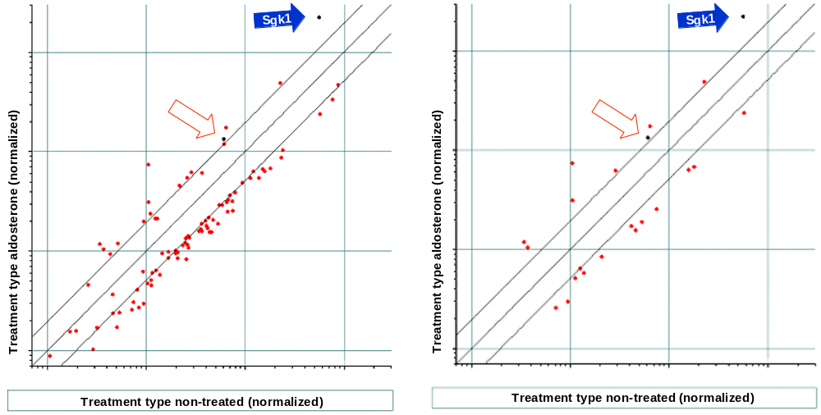

B
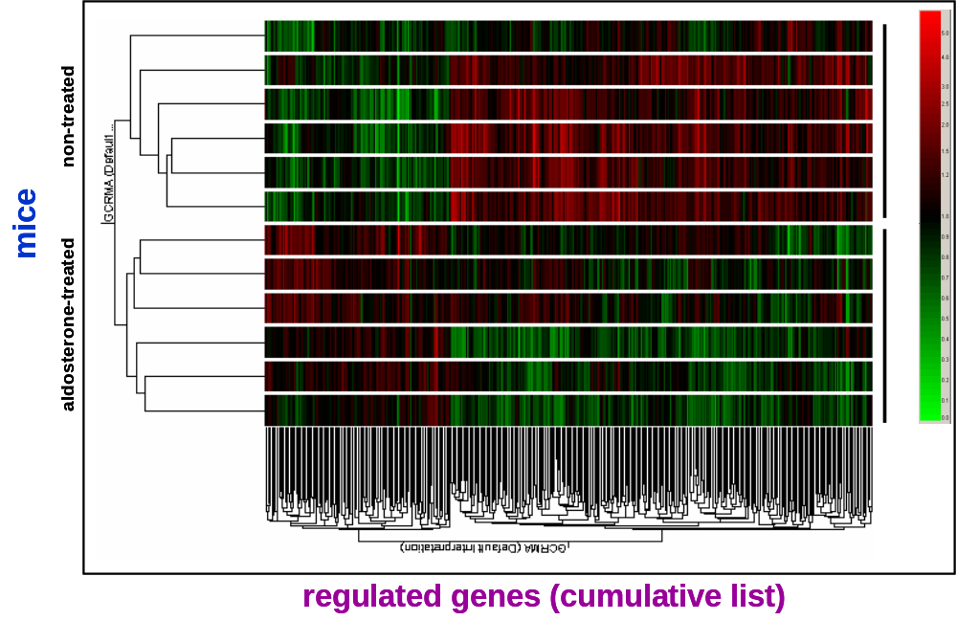

Figure S2.

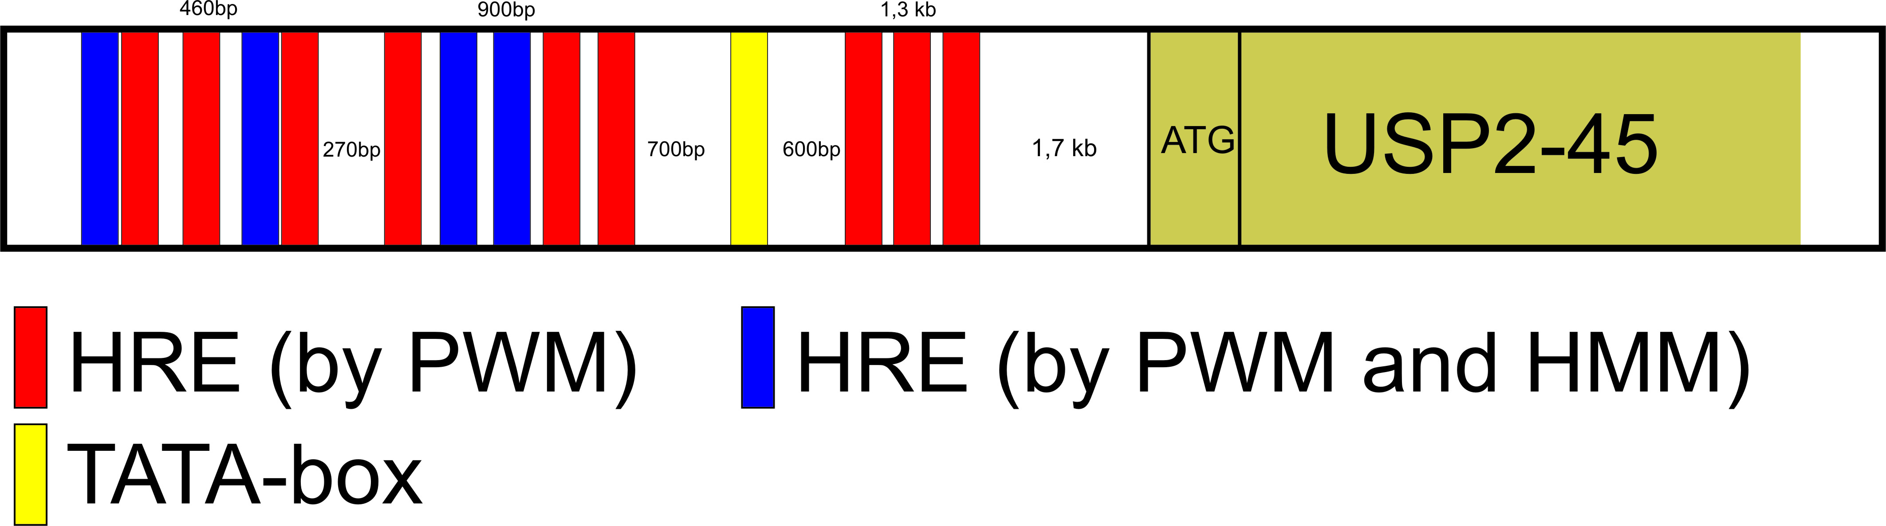

Figure S3.
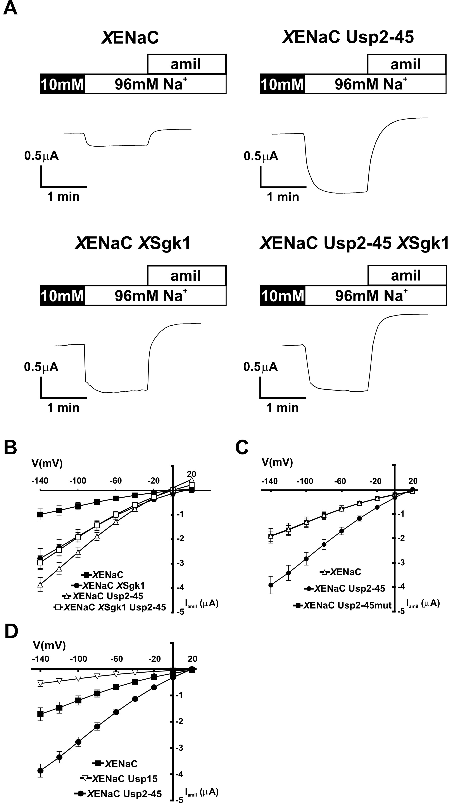

Figure S4.

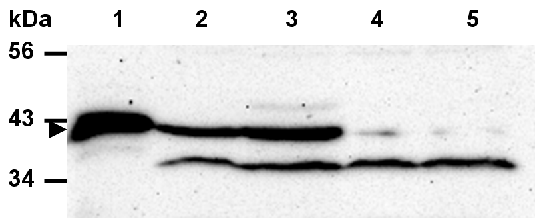

Table S1. Primers and probes used for real-time RT-PCR
gene | sense primer (5’-3)’ | probe (5’-3’) | anti-sense primer (5’-3’)
Grem2 | Mm00501909_m1*
Sgk1 | GAG GGA GCG CTG CTT CCT | ACC ACG GGC TCG ATT CTA CGC AGC | GCA GAT AGC CCA GGG CAC T
Atf3 | AGA CCC CTG GAG ATG TCA GTC A | CAA GTC TGA GGC GGC CCC TGA A | CGC CTC CTT TTC CTC TCA TCT T
Crem | TTG GGA ATA CCA GGC ACA TCA | AAA GTT CAT TCA GTA TTT TTC TAT ATG AGG GTC TTC GTG A | TGA TTC GCA TAA ACG TAG AGA AAT TCT
Usp2-45 | TCT GTC CCC GTC CCT GC | TGC TCA ACA AAG CCA AGA ATT CAA AGA GTG C | AAG GTT TCG AAG ACC AGC CAG
Usp2-69 | AGG AGA GCT GGG ACA TCC TTC | TAC TGG GAG CCT CAT GGG CTG CCT | ACT CGT CCA TCC TCC GAG AA
H⁺/K⁺-ATPase | Mm00446786_m1*
Slc22a8 | TGC TTG GAT GGC TGG ATC TAC | CAT TGT GAC AGA GTG GGA CTT GGT ATG CG | TGC CAT CTC CTT CAG TTT GTT G
G0s2 | AAG TGC TGC CTC TCT TCC CAC | CACA CCT AGG CCC AGC CAC CCA | TTC CAT CTG AGC TCT GGG CT
β-actin | CCA CCG ATC CAC ACA GAG TAC TT | AGG AGG AGC AAT GAT CTT GAT CTT CAT GG | GAC AGG ATG CAG AAG GAG ATT ACT G
αENaC | GGT GCA CGG TCA GGA TGA G | CTG CTT TTA TGG ATG ATG GTG GCT TCA A | TAG TTG CCT CCG AGG CTG TC
βENaC | TCC TAG CTT GCC TGT TTG GAA | AGA GCC CTG CAG TCA TCG GAA CTT CA | CAG TTG CCA TAA TCA GGG TAG AAG AT
NKCC2 | TCA CCA CCG TGG CCT ACA TA | CTA TTT GCG TAG CCG CCT GTG TGG TC | GGT GCA CGG TCA GGA TGA G
*Applied Biosystems TaqMan® Gene Expression Assays ID

Supporting References

1. Stepanova M, Lin F, and Lin VC: Establishing a statistic model for recognition of steroid hormone response elements. Comput Biol Chem 30: 339-347, 2006
2. Firsov D, Schild L, Gautschi I, Merillat AM, Schneeberger E, and Rossier BC: Cell surface expression of the epithelial Na channel and a mutant causing Liddle syndrome - a quantitative approach. Proc. Natl. Acad. Sci. USA 93: 15370-15375, 1996
3. Mastroberardino L, Spindler B, Forster I, Loffing J, Assandri R, May A, and Verrey F: Ras pathway activates epithelial Na+ channel and decreases its surface expression in Xenopus oocytes. Mol. Biol. Cell 9: 3417-3427, 1998
4. Canessa CM, Schild L, Buell G, Thorens B, Gautschi I, Horisberger JD, and Rossier BC: Amiloride-sensitive epithelial Na+ channel is made of three homologous subunits. Nature 367: 463-467, 1994
5. Forster IC, Wagner CA, Busch AE, Lang F, Biber J, Hernando N, Murer H, and Werner A: Electrophysiological characterization of the flounder type II Na+/Pi cotransporter (NaPi-5) expressed in Xenopus laevis oocytes. J. Membrane Biol. 160: 9-25, 1997
6. Staub O, Gautschi I, Ishikawa T, Breitschopf K, Ciechanover A, Schild L, and Rotin D: Regulation of stability and function of the epithelial Na+ channel (ENaC) by ubiquitination. EMBO J. 16: 6325-6336, 1997
7. van Bemmelen MX, Rougier JS, Gavillet B, Apotheloz F, Daidie D, Tateyama M, Rivolta I, Thomas MA, Kass RS, Staub O, et al.: Cardiac voltage-gated sodium channel Nav1.5 is regulated by Nedd4-2 mediated ubiquitination. Circ. Res. 95: 284-291, 2004
8. Staub O, Gautschi I, Ishikawa T, Breitschopf K, Ciechanover A, Schild L, and Rotin D: Regulation of stability and function of the epithelial Na+ channel (ENaC) by ubiquitination. Embo J 16: 6325-6336, 1997
9. Bens M, Vallet V, Cluzeaud F, Pascual-Letallec L, Kahn A, Rafestin-Oblin ME, Rossier BC, and Vandewalle A: Corticosteroid-dependent sodium transport in a novel immortalized mouse collecting duct principal cell line. J. Am. Soc. Nephrol. 10: 923-934, 1999
10. Summa V, Mordasini D, Roger F, Bens M, Martin PY, Vandewalle A, Verrey F, and Feraille E: Short term effect of aldosterone on Na,K-ATPase cell surface expression in kidney collecting duct cells. J. Biol. Chem. 276: 47087-47093, 2001
11. Summa V, Camargo SM, Bauch C, Zecevic M, and Verrey F: Isoform specificity of human Na+, K+-ATPase localization and aldosterone regulation in mouse kidney cells. J. Physiol. 555: 355-364, 2004

