Supplementary Tables and Figures
Table of Contents:
Supplementary Table S1. Comparison of AGP proteins measurements performed by SOMAscan
platform with measurements of AGP proteins performed by OLINK platform.

Supplementary Table S2. Assessment of importance of clinical covariates for time to onset of ESKD in combined 4 cohorts.
Supplementary Figure S1. Ratios of median plasma concentration of each miRNA at baseline in subjects who did and did not develop ESKD during 10-year follow-up.
Supplementary Figure S2. Matrix of Spearman correlations among 17 candidate miRNAs in subjects with late DKD (n=375).
Supplementary Table S3. Association of plasma levels of 17 candidate miRNAs measured at baseline with time to onset of ESKD during 10-year follow-up in subjects with late DKD.
Supplementary Table S4. Statistical data for comparison of cumulative incidence of progression to ESKD during 10-year follow-up according to baseline plasma levels of miR-1287-5p and miR-339-5p grouped into risk categories (discrete variable) in subjects with late DKD.
Supplementary Table S5. List of 23 pathways enriched in genes predicted to be targeted by the 4 exemplar miRNAs.
Supplementary Table S6. Number of proteins in Ras, MAPK and HIF-1 signaling pathways present on SOMAscan platform and their association with risk of ESKD according to study cohorts.
Supplementary Table S7. Hazard Ratios per 1-SD increase in AGP proteins levels for time to onset of ESKD during a 10-year follow-up.
Supplementary Table S8. List of 36 AGP proteins present on SOMAscan platform that were not associated with risk of ESKD or not confirmed in study cohorts.
Supplementary Table S9. Effects of exemplar miRNAs on ESKD risk during 10-year follow-up according to plasma levels of AGP proteins (mediators).
Supplementary Table S10. Baseline characteristics of ACCORD participants in whom serum EFNA4 and EPHA2 were measured.

Supplementary Table S11. List of circulating miRNAs previously reported as ones associated with DKD.
Supplementary Table S12. Current and future clinical treatments using ephrin and netrin receptors for any other indications.

Supplementary Figure S3. Distributions of levels of 4 miRNAs in the late DKD cohorts.

Supplementary Figure S4. Distributions of levels of 6 AGP proteins in the 4 cohorts.

Supplementary Table S1. Comparison of AGP proteins measurements performed by SOMAscan
platform with measurements of AGP proteins performed by OLINK platform.

 | Spearman correlation coefficient (SOMAscan vs. OLINK)¶ |  |  |  | Cox model* for SOMAscan |  | Cox model* for OLINK
Gene | r | P |  |  | HR | P | HR | P
EFNA4 | 0.56 | 4.0x10⁻⁷ |  |  | 1.31 | 1.5x10⁻¹ | 1.91 | 1.3x10⁻³
EPHA2 | 0.68 | 1.3x10⁻¹¹ |  |  | 1.57 | 1.8x10⁻² | 1.86 | 1.2x10⁻³
EPHB6 | 0.60 | 2.8x10⁻⁸ |  |  | 1.93 | 1.0x10⁻³ | 2.12 | 2.2x10⁻⁴
UNC5C | 0.68 | 4.1x10⁻¹¹ |  |  | 1.49 | 2.9x10⁻² | 1.33 | 1.3x10⁻¹
¶ Correlation between AGP protein concentrations measured by SOMAscan and OLINK platforms in the same serum specimens in 75 subjects from Pima cohort.
*Univariate analysis for time to onset of ESKD during 10-year follow-up. HR (hazard ratio) was computed for a 1-quartile increase in concentration of AGP proteins. Pima cohort included 36 subjects who progressed to ESKD and 39 who did not.

Supplementary Table S2. Assessment of importance of clinical covariates for time to onset of ESKD in combined 4 cohorts. Results of Cox multivariable regression analyses with ACR absent and present in model.
 | Etiological model without ACR* |  |  |  |  | Prognostic model with ACR**
Parameter | HR | LCI | UCI | P |  | HR | LCI | UCI | P
Diastolic BP /10 (mm/Hg) | - | - | - | 3.3x10⁻¹ |  | - | - | - | 6.2x10⁻¹
Sex (Female) | 0.74 | 0.57 | 0.97 | 3.1x10⁻² |  | - | - | - | 1.8x10⁻¹
Duration of diabetes (year) | 0.98 | 0.97 | 1.00 | 3.6x10⁻² |  | - | - | - | 1.3x10⁻¹
Systolic BP /10 (mm/Hg) | 1.10 | 1.02 | 1.19 | 1.1x10⁻² |  | - | - | - | 2.7x10⁻¹
HbA1c (%) | 1.35 | 1.26 | 1.43 | 4.5x10⁻²⁰ |  | 1.25 | 1.16 | 1.34 | 1.8x10⁻⁹
eGFR /10 (ml/min/1.73m²) | 0.80 | 0.74 | 0.86 | 1.1x10⁻⁹ |  | 0.86 | 0.79 | 0.92 | 5.3x10⁻⁵
log₂ACR (mg/g) | Not included | - | - | - |  | 1.37 | 1.29 | 1.46 | 9.4x10⁻²³
HR - Hazard Ratios for time to onset of ESKD during a 10-year follow-up in combined 4 cohorts (n=745).
*In etiological model, important covariates were selected by backward elimination from among all clinical covariates excluding ACR.
**In prognostic model, important covariates were selected by backward elimination from among all clinical covariates including ACR.

B
A
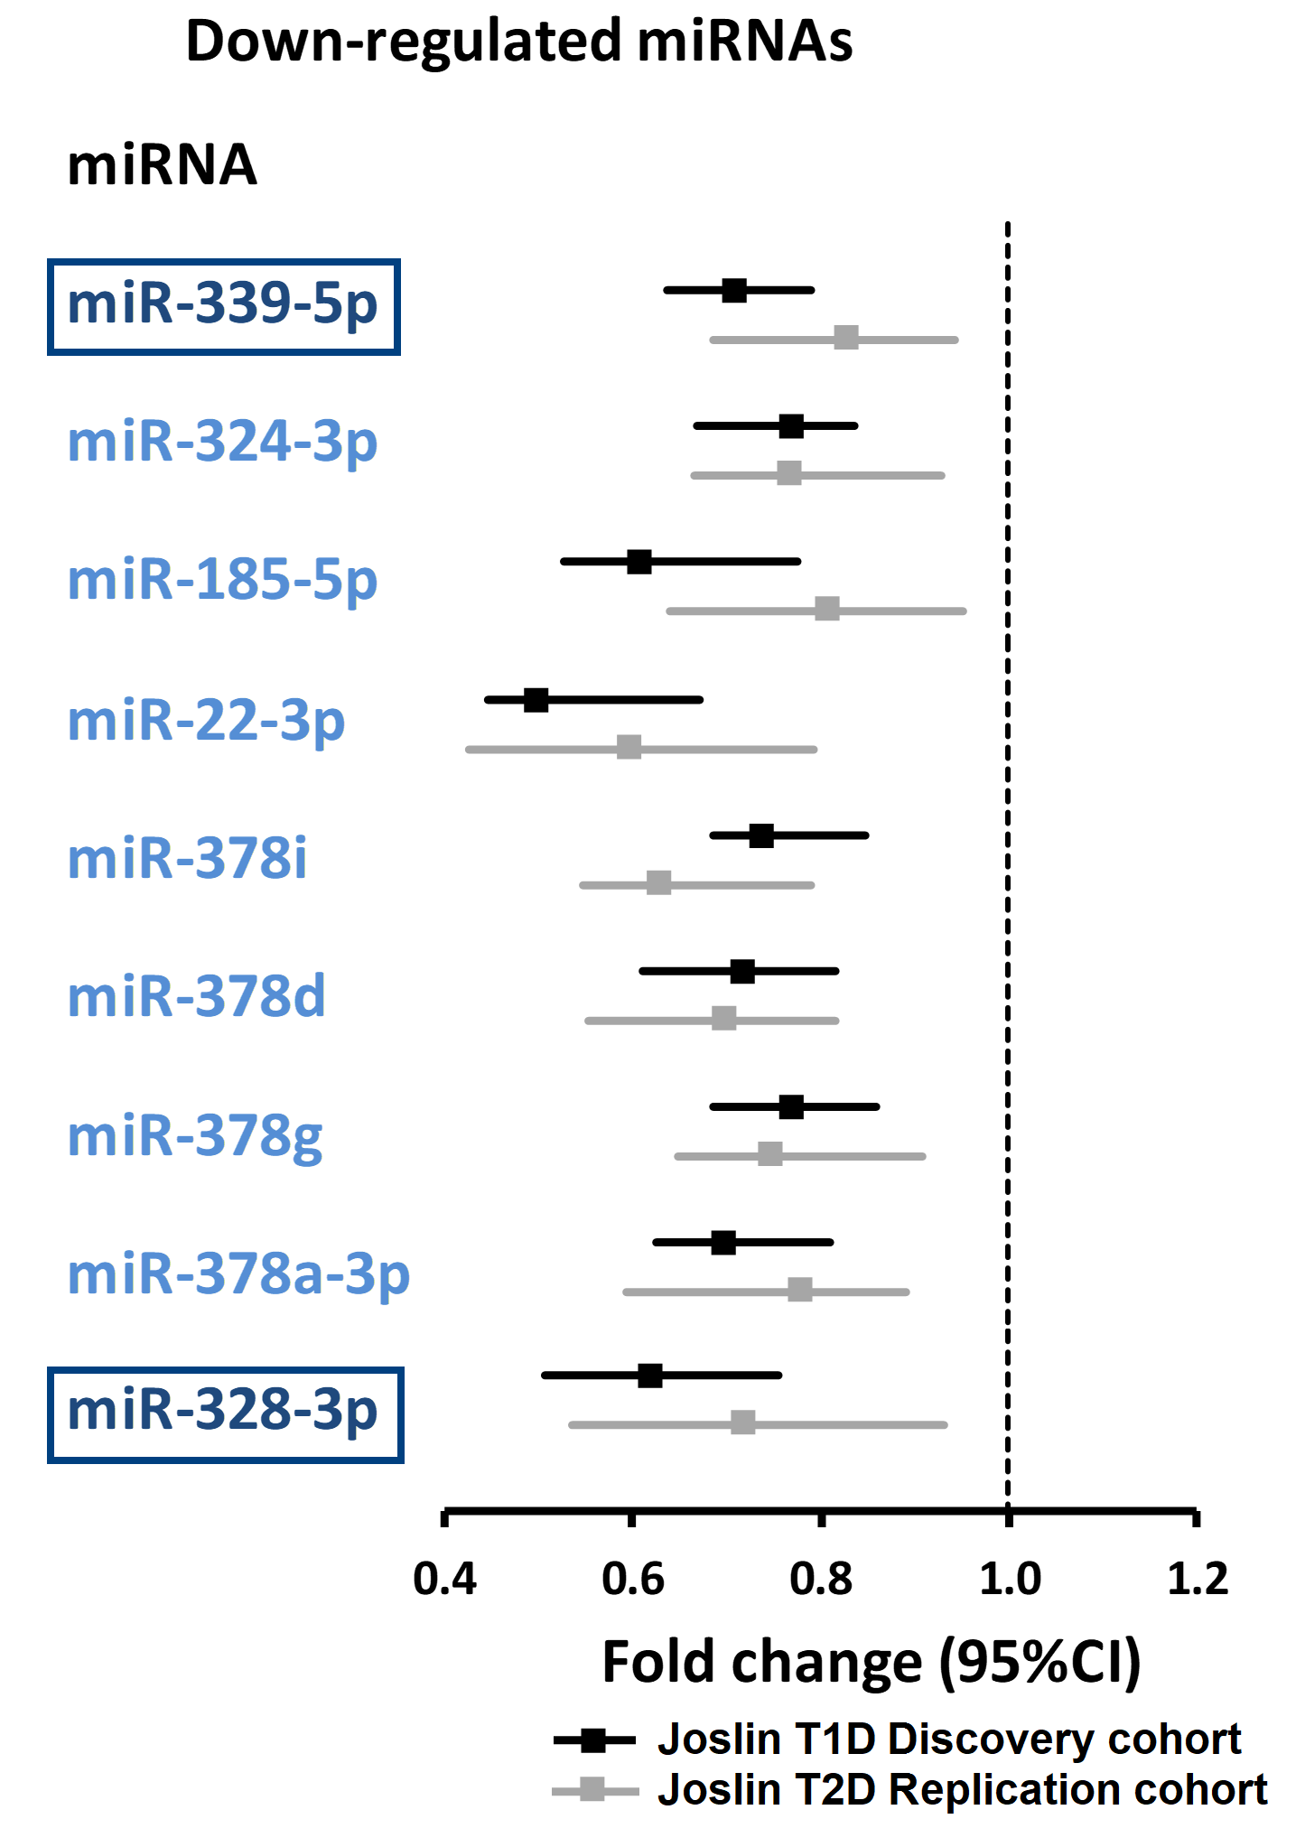
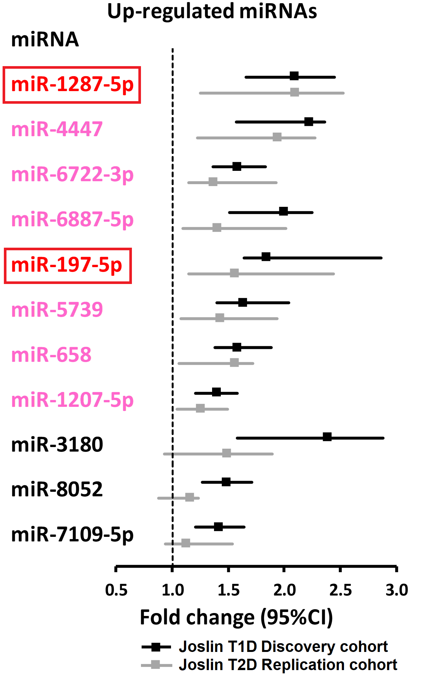

Supplementary Figure S1. Ratios of median plasma concentration of each miRNA at baseline in subjects who did and did not develop ESKD during 10-year follow-up. Among 21 miRNAs, 12 were up-regulated in T1D Discovery cohort (panel A), 9 were down-regulated (panel B). All down-regulated miRNAs were confirmed in T2D Replication cohort (names in blue), while 8 up-regulated were replicated in T2D Replication cohort (names shown in red). Four miRNAs were not confirmed in T2D Joslin cohort (black in panel A). In boxes are names of exemplar miRNAs.

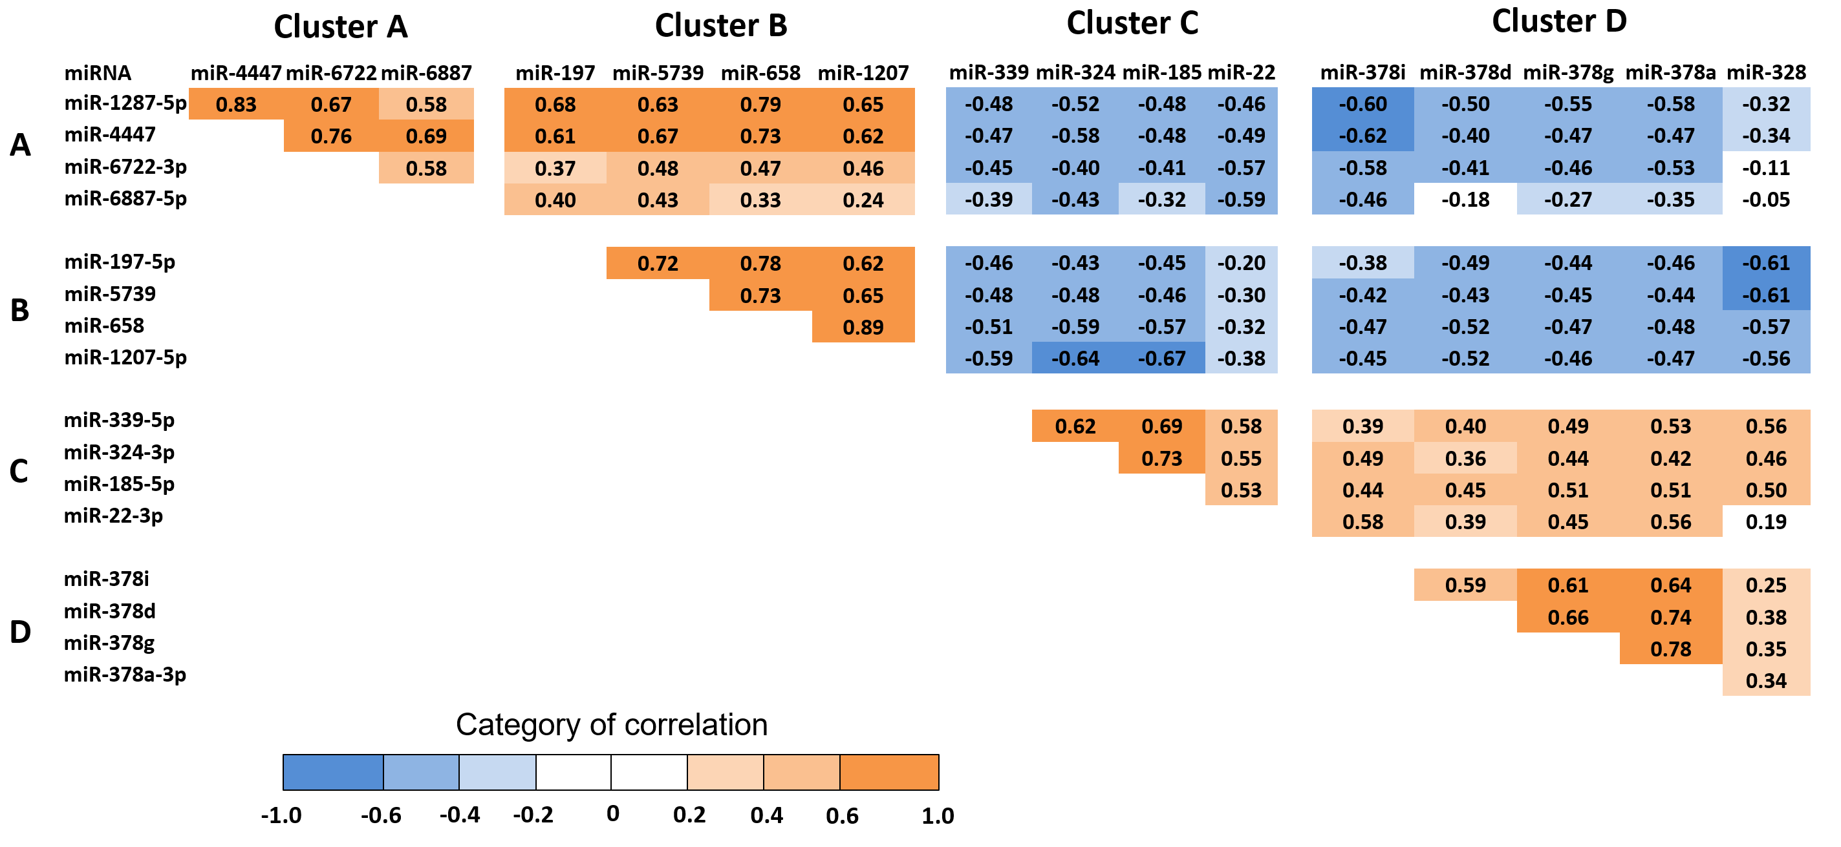

Supplementary Figure S2. Matrix of Spearman correlations among 17 candidate miRNAs in subjects with late DKD (n=375). Coefficients (r) are shown as numbers and additionally coded with colors, as shown in the scale bar (bottom left) (|r|=0-0.19: very weak, 0.20-0.39: weak, 0.40-0.59: moderate, 0.60-1.0: strong). Coefficients in very weak category were not statistically significant, all others were significant at P<0.001.

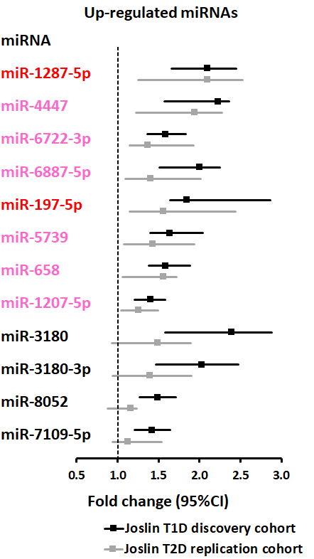
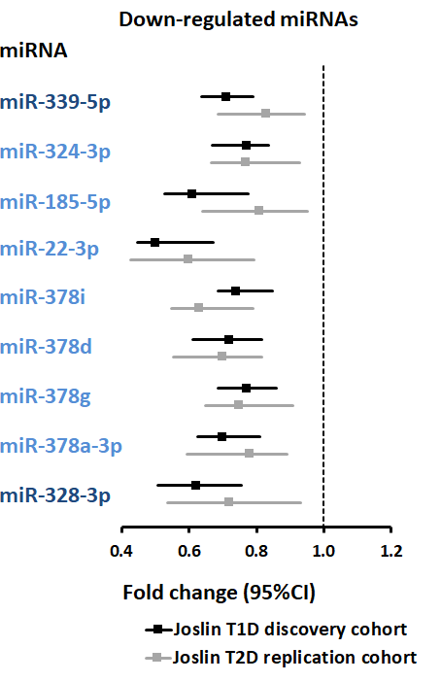
Supplementary Table S3. Association of plasma levels of 17 candidate miRNAs measured at baseline with time to onset of ESKD during 10-year follow-up in subjects with late DKD. Result of Cox regression analysis.
A.
A.
 |  | Univariate models |  |  |  |  |  |  | Multivariable adjusted models
 |  | Late DKD |  |  |  |  |  |  | Etiological model |  |  |  | Prognostic model
 |  | T1D Discovery cohort |  |  | T2D Replication cohort |  |  |  | Late DKD  Model 1* |  | Late DKD  Model 2** |  | Late DKD  Model 3#
Cluster/miRNA |  | HR | P |  | HR | P |  |  | HR | P | HR | P | HR | P
Cluster A
miR-1287-5p |  | 1.80 | 1.0x10⁻¹¹ |  | 1.60 | 1.9x10⁻³ |  |  | 1.48 | 8.0x10⁻⁷ | 1.32 | 1.6x10⁻³ | 1.39 | 4.7x10⁻⁵
miR-4447 |  | 1.70 | 4.9x10⁻¹⁰ |  | 1.58 | 1.1x10⁻³ |  |  | 1.46 | 1.3x10⁻⁷ | - |  | 1.34 | 2.2x10⁻⁴
miR-6722-3p |  | 1.57 | 1.1x10⁻⁷ |  | 1.40 | 1.7x10⁻² |  |  | 1.27 | 1.8x10⁻³ | - |  | 1.21 | 1.6x10⁻²
miR-6887-5p |  | 1.79 | 2.5x10⁻¹¹ |  | 1.28 | 7.7x10⁻² |  |  | 1.39 | 5.8x10⁻⁵ | - |  | 1.34 | 1.6x10⁻⁴
Cluster B
miR-197-5p |  | 1.77 | 3.9x10⁻¹⁰ |  | 1.54 | 3.5x10⁻³ |  |  | 1.47 | 3.3x10⁻⁶ | - |  | 1.25 | 9.1x10⁻³
miR-5739 |  | 1.62 | 1.6x10⁻⁸ |  | 1.49 | 8.3x10⁻³ |  |  | 1.36 | 6.1x10⁻⁵ | - |  | 1.21 | 1.6x10⁻²
miR-658 |  | 1.60 | 3.1x10⁻⁸ |  | 1.30 | 7.1x10⁻² |  |  | 1.35 | 7.6x10⁻⁵ | - |  | 1.16 | 5.9x10⁻²
miR-1207-5p |  | 1.42 | 2.7x10⁻⁵ |  | 1.35 | 4.1x10⁻² |  |  | 1.38 | 3.1x10⁻⁵ | - |  | 1.16 | 7.6x10⁻²
Cluster C
miR-339-5p |  | 0.61 | 4.6x10⁻⁹ |  | 0.73 | 2.4x10⁻² |  |  | 0.69 | 6.5x10⁻⁷ | 0.76 | 1.1x10⁻³ | 0.80 | 2.9x10⁻³
miR-324-3p |  | 0.71 | 5.1x10⁻⁵ |  | 0.71 | 1.5x10⁻² |  |  | 0.80 | 2.2x10⁻³ | - | - | 0.91 | 2.2x10⁻¹
miR-185-5p |  | 0.71 | 5.9x10⁻⁵ |  | 0.76 | 5.2x10⁻² |  |  | 0.77 | 4.6x10⁻⁴ | - | - | 0.88 | 7.7x10⁻²
miR-22-3p |  | 0.67 | 1.0x10⁻⁶ |  | 0.68 | 7.2x10⁻³ |  |  | 0.75 | 2.0x10⁻⁴ | - | - | 0.85 | 2.4x10⁻²
Cluster D
miR-378i |  | 0.71 | 4.1x10⁻⁵ |  | 0.56 | 1.4x10⁻⁴ |  |  | 0.84 | 2.3x10⁻² | - | - | 0.89 | 1.2x10⁻¹
miR-378d |  | 0.67 | 1.8x10⁻⁶ |  | 0.61 | 1.0x10⁻³ |  |  | 0.76 | 6.7x10⁻⁴ | - | - | 0.87 | 7.9x10⁻²
miR-378g |  | 0.71 | 4.1x10⁻⁵ |  | 0.72 | 2.2x10⁻² |  |  | 0.85 | 3.6x10⁻² | - | - | 0.96 | 5.5x10⁻¹
miR-378a-3p |  | 0.70 | 1.3x10⁻⁵ |  | 0.63 | 1.4x10⁻³ |  |  | 0.83 | 1.5x10⁻² | - | - | 0.95 | 4.7x10⁻¹
miR-328-3p |  | 0.69 | 9.8x10⁻⁶ |  | 0.71 | 1.5x10⁻² |  |  | 0.76 | 1.9x10⁻⁴ |  |  | 0.94 | 4.1x10⁻¹

HR- Hazard Ratios are expressed for one quartile increase (continuous variable) in CPM (count per million) of miRNA. Exemplar miRNAs in bold were selected in from each cluster (A to D) based on their effect size (HR) and statistical significance in univariate and multivariable Cox models. Because the CPMs of miRNAs were not normally distributed, we stratified markers into quartiles.
*Model 1: Cox etiological models were adjusted for significant clinical covariates: sex, duration of diabetes, systolic blood pressure, HbA1c, eGFR and stratified by variable indicator cohort without including ACR.
**Model 2: Cox etiological model was developed by backward elimination of insignificant covariates from among clinical covariates (without ACR) and 4 exemplar miRNAs.
#Model 3: Cox prognostic models were adjusting for significant clinical covariates (baseline HbA1c, eGFR and ACR) and by variable indicating cohort.

Supplementary Table S4. Statistical data for comparison of cumulative incidence of progression to ESKD during 10-year follow-up according to baseline plasma levels of miR-1287-5p and miR-339-5p grouped into risk categories (discrete variable) in subjects with late DKD.
 |  |  | Etiological model# |  | Prognostic model##
Risk category* | Number of subjects | Events of ESKD (n (%)) | HR (95% CI) | P | HR (95% CI) | P | Cumulative incidence of ESKD (% (95% CI))
High | 124 | 83 (66.9%) | 3.37 (2.12-5.36) | 2.7x10⁻⁷ | 2.54 (1.59- 4.06) | 9.5x10⁻⁵ | 76.8 (66.0, 84.5)
Moderate | 129 | 59 (45.7%) | 2.32 (1.46-3.66) | 3.3x10⁻⁴ | 1.96 (1.23-3.12) | 4.7x10⁻³ | 52.0 (42.1, 61.0)
Low risk | 122 | 28 (23.0%) | 1.0 (reference) | - | 1.0 (reference) | - | 30.1 (20.4, 40.3)

*High risk: Subjects with above (inclusive) median miR-1287-5p and below median miR-339-5p, Low risk: Subjects with below median miR-1287-5p and above (inclusive) median miR-339-5p, Moderate risk: all other subjects.
#Adjusted for sex, duration of diabetes, systolic blood pressure, eGFR and HbA1c stratified by type of diabetes (etiological model).
##Adjusted for eGFR, HbA1c and ACR stratified by type of diabetes (prognostic model).
HR - Hazard ratio; CI – Confidence Interval.

Supplementary Table S5. List of 23 pathways enriched in genes predicted to be targeted by the 4 exemplar miRNAs.
miRNAs | KEGG pathway | Total genes in KEGG | Targeted by miRNA(s) | Expected numbers | P
All four miRNAs | Axon guidance pathway  Ras signaling pathway | 127  226 | 64  87 | 29.5  52.5 | 5.6x10⁻¹¹  2.7 x10⁻⁷
miR-1287-5p, miR-339-5p & miR-328-3p | MAPK signaling pathway | 253 | 92 | 58.8 | 2.2 x10⁻⁶
miR-1287-5p, miR-197-5p & miR-328-3p | Regulation of actin cytoskeleton | 210 | 76 | 48.8 | 2.2 x10⁻⁵
miR-1287-5p & miR-197-5p | PI3K-Akt signaling pathway | 345 | 112 | 80.2 | 6.1 x10⁻⁵
miR-1287-5p & miR-339-5p | ErbB signaling pathway | 87 | 42 | 20.2 | 7.6 x10⁻⁷
 | Other types of O-glycan biosynthesis | 22 | 17 | 5.1 | 1.2 x10⁻⁶
 | FoxO signaling pathway | 134 | 54 | 31.1 | 1.5 x10⁻⁵
miR-1287-5p & miR-328-3p | Focal adhesion | 206 | 73 | 47.9 | 7.3 x10⁻⁵
 | Insulin resistance | 108 | 43 | 25.1 | 1.8 x10⁻⁴
miR-339-5p & miR-328-3p | Phosphatidylinositol signaling system | 98 | 43 | 22.8 | 1.2 x10⁻⁵
 | Rap1 signaling pathway | 210 | 74 | 48.8 | 8.0 x10⁻⁵
 | Morphine addiction | 91 | 37 | 21.2 | 3.4 x10⁻⁴
miR-1287-5p | HIF-1 signaling pathway | 96 | 40 | 22.3 | 9.9 x10⁻⁵
 | Neurotrophin signaling pathway | 120 | 44 | 27.9 | 1.1 x10⁻³
 | Type II diabetes mellitus | 48 | 22 | 11.2 | 1.3 x10⁻³
 | T cell receptor signaling pathway | 100 | 37 | 23.2 | 2.5 x10⁻³
miR-197-5p | Fc epsilon RI signaling pathway | 68 | 26 | 15.8 | 8.0 x10⁻³
miR-328-3p | Glutamatergic synapse | 114 | 45 | 26.5 | 1.5 x10⁻⁴
 | Fc gamma R-mediated phagocytosis | 84 | 33 | 19.5 | 1.5 x10⁻³
 | mTOR signaling pathway | 58 | 25 | 13.5 | 1.5 x10⁻³
 | Oxytocin signaling pathway | 150 | 52 | 34.9 | 1.6 x10⁻³
 | Hypertrophic cardiomyopathy (HCM) | 78 | 30 | 18.1 | 3.7 x10⁻³

Supplementary Table S6. Number of proteins in Ras, MAPK and HIF-1 signaling pathways present on SOMAscan platform and their association with risk of ESKD according to study cohorts.
Pathway | Proteins on SOMAscan | # proteins associated with ESKD  in Discovery cohort | # proteins associated with ESKD confirmed in other cohorts | # Proteins confirmed but overlapping with AGP
Ras signaling | 83 | 8 | 3 | 3 (EFNA4, EFNA5 & EPHA2)
MAPK signaling | 104 | 5 | 5 | 3 (EFNA4, EFNA5 & EPHA2)
HIF-1 signaling | 42 | 0 | 0 | ----

Supplementary Table S7. Hazard Ratios per 1-SD increase in AGP proteins levels for time to onset of ESKD during a 10-year follow-up.
 | Late DKD |  |  |  | Early DKD
 | T1D Discovery cohort (n=213) |  | T2D Replication cohort (n=136) |  | T1D Validation cohort (n=243) |  | T2D Validation cohort (n=153) |  | Combined cohorts (n=745)
Gene | HR | P | HR | P | HR | P | HR | P | HR | P
EFNA4 | 2.27  (1.85-2.78) | 3.0x10⁻¹⁵ | 1.69  (1.25-2.30) | 7.7x10⁻⁴ | 2.02  (1.50-2.71) | 3.5x10⁻⁶ | 1.73  (1.22-2.45) | 2.2x10⁻³ | 1.91  (1.65-2.20) | 1.3x10⁻¹⁸
EFNA5 | 1.86  (1.52-2.29) | 3.2x10⁻⁹ | 1.85  (1.36-2.53) | 1.1x10⁻⁴ | 1.58  (1.20-2.07) | 9.7x10⁻⁴ | 2.29  (1.57-3.34) | 1.7x10⁻⁵ | 1.67  (1.45-1.93) | 2.3x10⁻¹²
EPHA2 | 2.40  (1.94-2.98) | 1.1x10⁻¹⁵ | 2.23  (1.59-3.12) | 2.9x10⁻⁶ | 1.84  (1.38-2.445) | 3.5x10⁻⁵ | 2.02  (1.43-2.85) | 7.2x10⁻⁵ | 2.29  (1.96-2.68) | 2.1x10⁻²⁵
EPHB2 | 1.58  (1.30-1.93) | 5.7x10⁻⁶ | 1.52  (1.12-2.06) | 6.6x10⁻³ | 1.40  (1.06-1.85) | 1.8x10⁻² | 1.66  (1.18-2.32) | 3.3x10⁻³ | 1.64  (1.43-1.88) | 3.1x10⁻¹²
EPHB6 | 1.84  (1.50-2.24) | 3.1x10⁻⁹ | 1.97  (1.46-2.66) | 8.3x10⁻⁶ | 1.51  (1.13-2.02) | 4.9x10⁻³ | 2.23  (1.57-3.34) | 9.0x10⁻⁶ | 1.99  (1.70-2.34) | 1.5x10⁻¹⁷
UNC5C | 2.22  (1.79-2.75) | 2.9x10⁻¹³ | 1.59  (1.17-2.17) | 2.9x10⁻³ | 1.89  (1.40-2.57) | 3.7x10⁻⁵ | 1.67  (1.19-2.34) | 3.3x10⁻³ | 1.91  (1.64-2.22) | 1.1x10⁻¹⁶
Results are presented for individual and combined cohorts for etiologic model.
*Etiologic model was adjusted for sex, duration of diabetes, systolic blood pressure, HbA1c and eGFR with stratification by variable indicating cohort.
HR was computed for a 1-SD increase in concentration of AGP proteins.
HR – Hazard ratio.

Supplementary Table S8. List of 36 AGP proteins present on SOMAscan platform that were not associated with risk of ESKD or not confirmed in study cohorts.
Gene | Target proteins | HR per 1-quartile# | P* | HR per  1-SD## | P | Other cohorts
EPHA1 | Ephrin type-A receptor 1 | 1.52 | 2.0x10⁻⁶ | 1.60 | 1.3x10⁻⁶ | Not confirmed
UNC5D | Netrin Receptor UNC5D | 1.48 | 1.4x10⁻⁵ | 1.65 | 1.7x10⁻⁶ | Not confirmed
EPHA5 | Ephrin type-A receptor 5 | 1.34 | 8.5x10⁻⁴ | 1.31 | 3.7x10⁻³ | -
EPHB4 | Ephrin type-B receptor 4 | 0.79 | 7.4x10⁻³ | 0.82 | 3.5x10⁻² | -
EFNB3 | Ephrin-B3 | 1.25 | 9.4x10⁻³ | 1.23 | 2.2x10⁻² | -
PPP3R1 | Calcineurin B alpha isoform | 0.77 | 2.2x10⁻² | 0.74 | 2.6x10⁻² | -
PAK5 | PAK7 | 0.77 | 2.6x10⁻² | 0.77 | 5.3x10⁻² | -
CXCL12 | SDF-1 | 0.85 | 5.0x10⁻² | 0.80 | 2.5x10⁻² | -
SEMA3A | Semaphorin 3A | 1.17 | 6.5x10⁻² | 1.14 | 1.7x10⁻¹ | -
RAC1 | RAC1 | 0.86 | 7.8x10⁻² | 0.85 | 7.1x10⁻² | -
SEMA6A | Semaphorin-6A | 1.17 | 7.8x10⁻² | 1.18 | 9.0x10⁻² | -
NRP1 | NRP1 | 1.23 | 9.4x10⁻² | 1.20 | 1.8x10⁻¹ | -
CFL1 | Cofilin-1 | 0.87 | 1.1x10⁻¹ | 0.87 | 1.4x10⁻¹ | -
NTN4 | NET4 | 1.21 | 1.1x10⁻¹ | 1.27 | 8.9x10⁻² | -
MAPK1 | MK01 | 0.88 | 1.2x10⁻¹ | 0.89 | 2.1x10⁻¹ | -
GSK3B | GSK-3 beta | 0.88 | 1.3x10⁻¹ | 0.81 | 3.2x10⁻² | -
FYN | FYN | 0.89 | 1.6x10⁻¹ | 0.90 | 2.6x10⁻¹ | -
PPP3CA | Calcineurin | 0.90 | 1.7x10⁻¹ | 0.90 | 2.3x10⁻¹ | -
PPP3R1 | Calcineurin | 0.90 | 1.7x10⁻¹ | 0.90 | 2.3x10⁻¹ | -
PAK6 | PAK6 | 0.86 | 1.8x10⁻¹ | 0.87 | 2.6x10⁻¹ | -
PTK2 | FAK1 | 0.86 | 1.9x10⁻¹ | 0.80 | 1.1x10⁻¹ | -
MAPK3 | ERK-1 | 0.90 | 2.1x10⁻¹ | 0.90 | 2.6x10⁻¹ | -
SEMA3E | Semaphorin 3E | 0.88 | 2.7x10⁻¹ | 0.82 | 1.7x10⁻¹ | -
RASA1 | RASA1 | 0.89 | 3.3x10⁻¹ | 0.87 | 2.7x10⁻¹ | -
KRAS | K-ras | 1.08 | 5.2x10⁻¹ | 1.15 | 3.4x10⁻¹ | -
MET | Met | 0.95 | 5.3x10⁻¹ | 0.92 | 3.7x10⁻¹ | -
ROBO3 | ROBO3 | 0.95 | 6.8x10⁻¹ | 0.98 | 8.7x10⁻¹ | -
ROBO2 | ROBO2 | 1.03 | 7.0x10⁻¹ | 1.02 | 8.2x10⁻¹ | -
NCK1 | NCK1 | 0.97 | 7.7x10⁻¹ | 0.98 | 8.5x10⁻¹ | -
PAK3 | PAK3 | 1.02 | 8.0x10⁻¹ | 1.04 | 6.9x10⁻¹ | -
PLXNC1 | PLXC1 | 1.03 | 8.4x10⁻¹ | 1.02 | 8.9x10⁻¹ | -
L1CAM | NCAM-L1 | 0.99 | 8.8x10⁻¹ | 0.96 | 6.4x10⁻¹ | -
ABL1 | ABL1 | 1.01 | 9.1x10⁻¹ | 1.00 | 9.7x10⁻¹ | -
EPHA3 | Ephrin type-A receptor 3 | 1.01 | 9.4x10⁻¹ | 0.96 | 6.9x10⁻¹ | -
ITGB1 | Integrin beta-1 | 1.00 | 9.9x10⁻¹ | 1.03 | 7.3x10⁻¹ | -
CDK5 | CDK5 | 1.00 | 1 | 0.99 | 9.1x10⁻¹ | -

#HR per 1-quartile increase in concentration of AGP proteins was considered.
##HR per 1-SD increase was considered.
*Bonferroni correction for the available proteins on the SOMAscan platform was applied for the T1D Discovery cohort (P<4.4x10⁻⁵).

Supplementary Table S9. Effects of exemplar miRNAs on ESKD risk during 10-year follow-up according to plasma levels of AGP proteins (mediators).
 |  |  | TE |  | NDE |  | NIE
 | Exposure | Mediator | HR | P | HR | P | HR | P | PM (%) | P
 | miR-1287-5p | EFNA4 | 1.51 | 1.0x10⁻⁶ | 1.36 | 3.9x10⁻⁴ | 1.11 | 2.4x10⁻³ | 25.0 | 8.3x10⁻³
* | miR-1287-5p | EPHA2 | 1.51 | 1.0x10⁻⁶ | 1.31 | 2.0x10⁻³ | 1.15 | 1.1x10⁻³ | 34.2 | 2.8x10⁻⁴
 | miR-197-5p | EFNA4 | 1.30 | 1.4x10⁻³ | 1.12 | 2.1x10⁻¹ | 1.17 | 8.6x10⁻⁴ | 58.8 | 2.7x10⁻⁴
* | miR-197-5p | EPHA2 | 1.30 | 1.4x10⁻³ | 1.08 | 4.1x10⁻¹ | 1.21 | 4.4x10⁻⁴ | 72.9 | 6.9x10⁻⁵
 | miR-339-5p | EFNA4 | 0.71 | 1.1x10⁻⁵ | 0.79 | 5.4x10⁻³ | 0.89 | 6.6x10⁻³ | 32.4 | 7.2x10⁻⁴
* | miR-339-5p | EPHA2 | 0.71 | 1.1x10⁻⁵ | 0.80 | 6.8x10⁻³ | 0.89 | 5.3x10⁻³ | 34.9 | 1.3x10⁻³
 | miR-328-3p | EFNA4 | 0.79 | 2.0x10⁻³ | 0.94 | 4.8x10⁻¹ | 0.84 | 7.8x10⁻⁴ | 74.8 | 6.5x10⁻⁵
* | miR-328-3p | EPHA2 | 0.79 | 2.0x10⁻³ | 0.97 | 7.2x10⁻¹ | 0.81 | 5.2x10⁻⁴ | 87.6 | 1.5x10⁻⁵
Results were obtained in the combined T1D Discovery and T2D Replication cohorts (n= 349) using Cox regression models adjusting for clinical covariates.
HR - Hazard ratio; TE - Total effect; NDE - Natural direct (not mediated) effect; NIE- Natural indirect (mediated through AGP protein) effect; PM – Percent of mediated effect. *Results are presented in Figure 3.

Supplementary Table S10. Baseline characteristics of ACCORD participants in whom serum EFNA4 and EPHA2 were measured.

Baseline Characteristics | Standard Glycemic Treatment | Intensive Glycemic Treatment
N | 100 | 100
Female (n [%]) | 51 (51) | 42 (42)
Age (years) | 61.6 ± 6.1 | 60.8 ± 5.5
Duration of DM (years) | 10.4 ± 6.3 | 9.5 ± 7.3
BMI (kg/m²) | 33.5 ± 5.8 | 31.8 ± 5.3
Systolic blood pressure (mmHg) | 132 ± 16 | 134 ± 16
Diastolic blood pressure (mmHg) | 73 ± 9 | 75 ± 10
Fasting plasma glucose (mg/dl) | 174 ± 59 | 175 ± 52
HbA1c (%) | 8.2 ± 0.9 | 8.2 ± 1.0
eGFR (ml/min/1.73 m²) | 94.1 ± 22 | 93.9 ± 22
Previous CV event (n [%]) | 29 (29) | 27 (27)
EFNA4 (pg/ml) | 81.9 (73, 96) | 82.1 (73, 92)
EPHA2 (pg/ml) | 14.1 (11, 18) | 13.9 (11, 18)
AGP proteins were measured by OLINK platform. Data are expressed as mean ± SD or median (first quartile, third quartile). DM - Diabetes mellitus; BMI - Body mass index; CV - Cardiovascular.

Supplementary Table S11. List of circulating miRNAs previously reported as ones associated with DKD.
 | Previously reported |  |  | Results in Current study*
miRNA | Sample type | Up/Down | Publications | Fold change (T1D) | P | Fold change (T2D) | P
let-7a-3p | Whole blood | Down ↓ | Zhou (1), Peng (2) | 1.03 | 8.4x10⁻¹ | 1.01 | 7.4 x10⁻¹
let-7b-5p | Plasma | Up ↑ | Pezzolesi (3) | 0.97 | 3.2 x10⁻¹ | 0.88 | 3.0 x10⁻¹
let-7c-5p | Plasma | Down ↓ | Pezzolesi (3) | 0.97 | 3.7 x10⁻¹ | 0.95 | 4.8 x10⁻¹
miR-126-3p | Whole blood | Down ↓ | Al-Kafaji (4) | 1.00 | 9.7 x10⁻¹ | 0.86 | 4.3 x10⁻¹
miR-130b-3p | Serum/Plasma | Down ↓ | Lv (5), Bai (6) | 0.66 | 3.0 x10⁻⁵ | 0.59 | 1.7 x10⁻³
miR-192-5p | Serum | Down ↓ | Ma (7) | 1.02 | 6.4 x10⁻¹ | 0.89 | 1.5 x10⁻¹
miR-21-5p | Serum | Up ↑ | Chien (8) | 0.81 | 3.6 x10⁻² | 0.55 | 1.8 x10⁻¹
miR-217 | Serum | Up ↑ | Shao (9) | 1.11 | 6.9 x10⁻² | 1.06 | 5.4 x10⁻¹
miR-29a-3p | Plasma/Serum | Down↓/Up↑ | Pezzolesi (3), Chien (8) | 0.90 | 5.4 x10⁻¹ | 0.74 | 2.4 x10⁻¹
miR-29b-3p | Serum | Up↑ | Chien (8) | 0.91 | 2.5 x10⁻¹ | 0.89 | 1.4 x10⁻¹
miR-29c-3p | Plasma/Serum | Up↑ | Pezzolesi (3), Chien (8) | 0.81 | 4.6 x10⁻³ | 0.64 | 6.8 x10⁻²
*Similar analyses were performed as for the results shown in supplementary Figure S1.
References for Supplementary Table S11:
- Zhou J, Peng R, Li T, Luo X, Peng H, Zha H, et al.: A potentially functional polymorphism in the regulatory region of let-7a-1 is associated with an increased risk for diabetic nephropathy. Gene 527:456-461, 2013.
- Peng R, Liu H, Peng H, Zhou J, Zha H, Chen X, et al.: Promoter hypermethylation of let-7a-3 is relevant to its down-expression in diabetic nephropathy by targeting UHRF1. Gene 570:57-63, 2015.
- Pezzolesi MG, Satake E, McDonnell KP, Major M, Smiles AM, Krolewski AS. Circulating TGF-beta1-regulated miRNAs and the risk of rapid progression to ESRD in type 1 diabetes. Diabetes 64:3285-3293, 2015.
- Al-Kafaji G, AI-Mahroos G, AI-Muhtaresh HA, Skrypnyk C, Sabry MA, Ramadan AR. Decreased expression of circulating microRNA-126 in patients with type 2 diabetic nephropathy: a potential blood-based biomarker. Exp Ther Med 12:815-822, 2016.
- LV C, Zhou YH, Wu C, Shao Y, Lu CL, Wang QY. The changes in miR-130b levels in human serum and the correlation with the severity of diabetic nephropathy. Diabetes Metab Res Rev 31:717-724, 2015.
- Bai X, Geng J, Zhou Z, Tian J, Li X. MicroRNA-130b improves renal tubulointerstitial fibrosis via repression of Snail-induced epithelial-mesenchymal transition in diabetic nephropathy. Sci Rep 6:P20475, 2016
- Ma X, Lu C, Lv C, Wu C, Wang Q. The expression of miR-192 and its significance in diabetic nephropathy patients with different urine albumin creatinine ratio. J Diabetes Res:6789402, 2016.
- Chien HY, Chen CY, Chiu YH, Lin YC, Li WC. Differential microRNA profiles predict diabetic nephropathy progression in Taiwan. Int J Med Sci 13:457-465, 2016.
- Shao Y, Ren H, Lv C, Ma X, Wu C, Wang Q. Changes of serum Mir-217 and the correlation with the severity in type 2 diabetes patients with different stages of diabetic kidney disease. Endocrine 55:130-138, 2017.

Supplementary Table S12. Current and future clinical treatments using ephrin and netrin receptors for any other indications. Human interventional studies on compounds studied/approved for clinical indications. (www.clinicaltrials.gov accessed on December 28, 2020);

Target | DRUG | Indications | Status | References for human interventional studies
EphA2 | Dasatinib  (BMS-354835) | Ph+ chronic myeloid leukemia and Ph+ acute lymphoblastic leukemia | FDA approved Marketed Drug | Many studies sponsored by Bristol-Myers Squibb Company
EphA2 | MM-310 | Solid Tumors | Recruiting phase 1 | NCT03076372
EphA2 | EphA2 siRNA | Solid Tumors | Recruiting phase 1 | NCT01591356
EphA2 | BT5528-100 | Solid Tumors | Recruiting phase 1 | NCT04180371
EphA3 | KB004 | Glioblastoma | Active, not recruiting phase 1 | NCT03374943
EphB4 | JI-101 | Solid Tumors | Completed phase ½ | NCT00842335
Netrin1 | NP137 | Solid Tumors | Recruiting phase 1 | NCT02977195

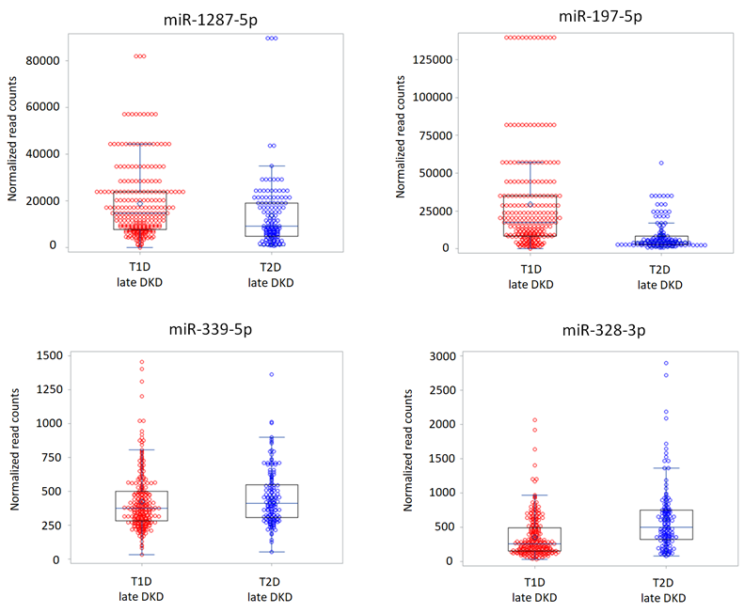

Supplementary Figure S3. Distributions of levels of 4 miRNAs in the late DKD cohorts. Circulating levels of the 4 exemplar miRNAs in normalized read counts are shown for each cohort.

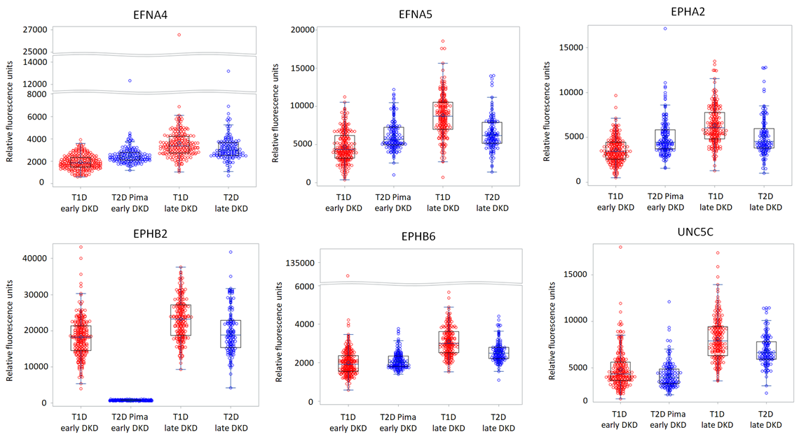

Supplementary Figure S4. Distributions of levels of 6 AGP proteins in the 4 cohorts. The samples were diluted with three serial dilutions (40%, 1% and 0.005%) and measured by SOMAscan platform. According to the range of levels of proteins, levels with 40% dilution (EFNA4, EFNA5 and EPHA2) and 1% dilution (EPHB2, EPHB6 and UNC5C) in relative fluorescence unit (RFU) are shown.

