Antibody Status, Disease History, and Incidence of SARS-CoV-2 Infection Among Patients on Chronic Dialysis

Dena E. Cohen, PhD¹; Scott Sibbel, PhD¹; Gilbert Marlowe, BS¹; Kelsey Bludorn, BBA¹; Dawn Miller, MBA²; Tara Kelley, MBA¹; Jeffrey Connaire, MD¹; Amy Young, BS¹; Francesca Tentori, MD^{1,3}; Steven M. Brunelli, MD^{1,3,4}

Supplemental Material Table of Contents
- Supplemental Methods
- Figure S1: Antibody levels at baseline by time since first documented positive SARS-CoV-2 PCR Test
- Figure S2. Timeline of Study Events: Sensitivity Analysis Eliminating Infection-Free Period.
- Table S1: Adjusted relative risk of Any SARS-CoV-2 Infection by IgG Status and Demographic Characteristics
- Table S2: Sensitivity analysis eliminating infection-free period: outcome events during follow-up by exposure status

Supplemental Methods
In order to account for any impact of the requirement of the disease-free period between Visit 1 and Visit 2 in the main analysis, a sensitivity analysis was conducted as follows. Beginning with the same cohort of 2530 patients who met study inclusion/exclusion criteria and gave informed consent, patients were excluded if they had missing IgG information as of Visit 1 (n=98) or if they had evidence of a positive PCR test for SARS-CoV-2 in the 30 days prior to Visit 1 (n=13, Supplemental Figure 2), yielding a cohort of 2419 patients. The outcome period considered began on the day immediately following Visit 1 and continued through the earliest of study withdrawal, death, or completion of the follow-up period. Exposure was ascribed on the basis of IgG status as of Visit 1, and outcome was considered as any SARS-CoV-2 infection, whether detected during routine clinical surveillance or via a protocolized PCR test at Visits 2, 3, 4, or 5. Analysis was conducted as described in the main methods.

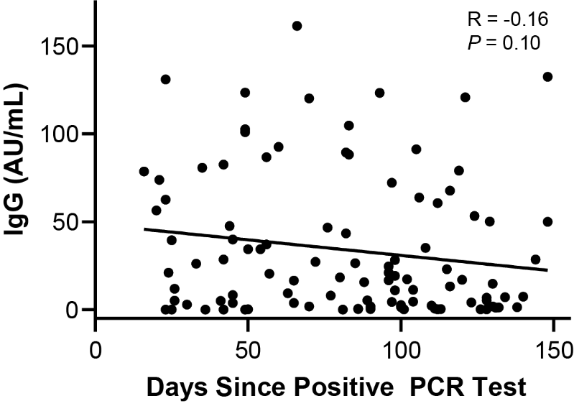
Figure S1: Antibody levels at baseline by time since first documented positive SARS-CoV-2 PCR Test. Serum IgG levels as of Visit 1 are shown for those subjects (N=104) with a documented history of SARS-CoV-2 infection prior to study enrollment. The x-axis indicates the time (in days) between each subject’s first recorded positive PCR test and study Visit 1 (the date on which IgG was measured). The –y axis indicates that quantitative value of anti-SARS-CoV-2 at baseline (ie, at study Visit 1). The Pearson correlation coefficient (R) and corresponding p-value are shown.
Abbreviations: AU, arbitrary units; IgG, immunoglobulin G; PCR, polymerase chain reaction.

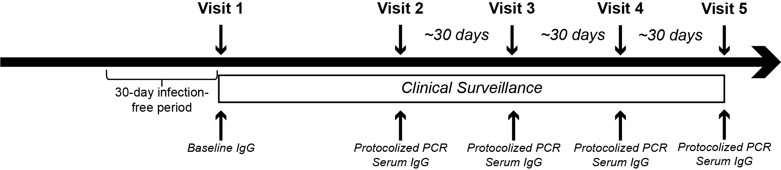
Figure S2. Timeline of Study Events: Sensitivity Analysis Eliminating Infection-Free Period. Baseline IgG serostatus is based on serologic testing at Visit 1. Baseline history of COVID-19 considers all data up through Visit 1. Participants who manifested COVID-19 during the 30-day disease-free period prior to Visits 1 were excluded from analysis. Follow-up began immediately following Visit 1. Participants were followed for clinical evidence of disease through the first of withdrawal, death, or end of study (Visit 5). Participants underwent protocolized PCR testing at Visits 2, 3, 4, and 5 except for those who were known to have COVID-19 at the corresponding time point or who declined/were unable to provide a sample for PCR analysis.
Abbreviations: IgG, immunoglobulin G; PCR, polymerase chain reaction

Table S1: Adjusted relative risk of Any SARS-CoV-2 Infection by IgG Status and Demographic Characteristics
 | Referent | aIRR (95% CI)
IgG+ | IgG- | 0.55 (0.32, 0.95)
Race  Black  Hispanic  Asian  Other/Unknown | White | 0.87 (0.57, 1.07)  1.32 (0.96, 1.81)  0.50 (0.12, 2.06)  1.11 (0.65, 1.92)
Sex  Female | Male | 0.99 (0.77, 1.29)
Age  Per 1 year older | N/A | 0.99 (0.98, 1.01)
Dialysis vintage  Per 1 month longer | N/A | 1.00 (1.00, 1.00)
Charlson comorbidity index  Per 1 unit higher | N/A | 1.03 (0.90, 1.18)
Body weight  Per 1 kg heavier | N/A | 1.01 (1.00, 1.01)
Estimates are derived from a multivariable generalized linear model (Poisson distribution) in which all variables depicted were included as independent variables; estimates are thus mutually adjusted.
Table S2: Sensitivity analysis eliminating infection-free period: outcome events during follow-up by exposure status
 | N | At-risk time  (pt-mo) | Any SARS-CoV-2 Infection |  |  |  |  | Clinically Manifest COVID-19
 |  |  | n | Rate ª |  |  | IRR  (95% CI) | n |  | Rate ª | IRR  (95% CI)
Baseline IgG+ vs IgG-
IgG+ | 219 | 1114 | 15 |  | 1.3 | 0.51  (0.30, 0.85) |  | 5 | 0.4 |  |  | 0.31  (0.13, 0.75)
IgG- | 2200 | 11,428 | 304 |  | 2.7 | ref |  | 166 | 1.4 |  |  | ref
CI, confidence interval; Hx, history of SARS-CoV-2 infection; IgG, immunoglobulin G against SARS-CoV-2; IRR, incidence rate ratio; pt-mo, patient months; ref, referent.

ª Expressed as events per 100 patient-months

