**Supplemental material**

**Kidney Outcomes in Long COVID**

**Benjamin Bowe, Yan Xie, Evan Xu, and Ziyad Al-Aly**

**Supplemental Material Table of Contents**

|  |  |
| --- | --- |
| **Content** | **Page** |
| **Supplemental Table 1:** Median time to outcomes in the VHA user groups, those with COVID-19, and those with COVID-19 that were non-hospitalized, hospitalized, and admitted to the ICU. | **3** |
| **Supplemental Table 2:** Characteristics and standardized mean differences of predefined covariates between COVID-19 and VHA user groups before and after weighting. | **4-5** |
| **Supplemental Table 3:** Risk and excess burden of post-acute COVID-19 adverse kidney events in models adjusted for only predefined covariates. | **6** |
| **Supplemental Table 4:** Characteristics and standardized mean differences of predefined covariates by COVID-19 non-hospitalized and VHA user groups before and after weighting. | **7-8** |
| **Supplemental Table 5:** Characteristics and standardized mean differences of predefined covariates by COVID-19 hospitalized and VHA user groups before and after weighting. | **9-10** |
| **Supplemental Table 6:** Characteristics and standardized mean differences of predefined covariates by COVID-19 admitted to the ICU and VHA user groups before and after weighting. | **11-12** |
| **Supplemental Table 7:** Characteristics and standardized mean differences of predefined covariates by COVID-19 non-hospitalized and COVID-19 hospitalized groups before and after weighting. | **13-14** |
| **Supplemental Table 8:** Characteristics and standardized mean differences of predefined covariates by COVID-19 non-hospitalized and COVID-19 admitted to the ICU groups before and after weighting. | **15-16** |
| **Supplemental Table 9:** Characteristics and standardized mean differences of predefined covariates by COVID-19 hospitalized and COVID-19 admitted to the ICU groups before and after weighting. | **17-18** |
| **Supplemental Table 10:** Pairwise comparison among COVID-19 positive individuals of excess burden of PASC kidney disease by severity of the acute COVID-19 infection. | **19** |
| **Supplemental Table 11a:** Pairwise comparison among COVID-19 positive individuals of excess burden of PASC kidney disease by severity of the acute COVID-19 infection adjusting for predefined covariates only. | **20** |
| **Supplemental Table 11b:** Pairwise comparison among COVID-19 positive individuals of excess burden of PASC kidney disease by severity of the acute COVID-19 infection adjusting for predefined covariates only. | **21** |
| **Supplemental Table 12:** Characteristics and standardized mean differences of predefined covariates by COVID-19 non-hospitalized and VHA user groups before and after weighting in analyses of risks by AKI status during the acute COVID-19 infection. | **22-23** |
| **Supplemental Table 13:** Characteristics and standardized mean differences of predefined covariates by COVID-19 hospitalized with no AKI and VHA user groups before and after weighting in analyses of risks by AKI status during the acute COVID-19 infection. | **24-25** |
| **Supplemental Table 14:** Characteristics and standardized mean differences of predefined covariates by COVID-19 hospitalized with AKI and VHA user groups before and after weighting in analyses of risks by AKI status during the acute COVID-19 infection. | **26-27** |
| **Supplemental Table 15:** Characteristics and standardized mean differences of predefined covariates in COVID-19 non-hospitalized and COVID-19 hospitalized with no AKI groups before and after weighting in analyses of risks by AKI status during the acute COVID-19 infection. | **28-29** |
| **Supplemental Table 16:** Characteristics and standardized mean differences of predefined covariates in COVID-19 non-hospitalized and COVID-19 hospitalized with an AKI groups before and after weighting in analyses of risks by AKI status during the acute COVID-19 infection. | **30-31** |
| **Supplemental Table 17:** Characteristics and standardized mean differences of predefined covariates in COVID-19 hospitalized with no AKI and COVID-19 hospitalized with an AKI groups before and after weighting in analyses of risks by AKI status during the acute COVID-19 infection. | **32-33** |
| **Supplemental Table 18:** Pairwise comparisons of risk and excess burden of adverse risks by AKI status during the acute COVID-19 infection. | **34** |
| **Supplemental Table 19a:** Pairwise comparisons of risk and excess burden of adverse kidney outcomes to VHA users risks by AKI status during the acute COVID-19 infection adjusting only for predefined covariates. | **35** |
| **Supplemental Table 19b:** Pairwise comparisons of risk and excess burden of adverse kidney outcomes to VHA users by AKI status during the acute COVID-19 infection adjusting only for predefined covariates. | **36** |
| **Supplemental Table 20:** Outcome controls for the comparison of COVID-19 positive Veterans vs. VHA users. | **37** |
| **Supplemental Figure 1:** Cohort flow chart | **38** |
| **Supplemental Figure 2:** Covariate balance in the comparison of COVID-19 positive Veterans with VHA users. | **39** |
| **Supplemental Figure 3:** Covariate balance in the comparison of COVID-19 positive Veterans by severity of the acute infection with non-hospitalized VHA users. | **40** |
| **Supplemental Figure 4:** Covariate balance in the comparison of COVID-19 positive Veterans by severity AKI status during the acute phase of the illness. | **41** |
| **Supplemental Figure 5:** Excess decline in eGFR in post-acute COVID-19 adjusting for predefined covariates. | **42** |
| **Supplemental Figure 6:** Excess decline in eGFR in post-acute COVID-19 by AKI status during the acute phase of the illness adjusting for only predefined covariates. | **43** |

**Supplemental Table 1:** Median time to outcomes (days) in the VHA user group, those with COVID-19, and those with COVID-19 that were non-hospitalized, hospitalized, and admitted to the ICU.

|  |  |  |  |  |  |
| --- | --- | --- | --- | --- | --- |
| **Outcome** | **VHA Users** | **COVID-19** | **COVID-19 non-Hospitalized** | **COVID-19 Hospitalized** | **COVID-19 ICU** |
| ***Median time to outcome (IQR) (days)*** | | | | | |
| **AKI** | 106  (67-166) | 84  (45-1467) | 107  (65-174) | 75  (41-136) | 48  (32-110) |
| **eGFR decline 30** | 106  (67-167) | 98  (55-158) | 107  (67-169) | 85  (44-146) | 68  (35-127) |
| **eGFR decline 40** | 109  (69-172) | 95  (52-160) | 109  (69-175) | 85  (43-144) | 59  (35-123) |
| **eGFR decline 50** | 112  (70-176) | 92  (46-161) | 114  (70-182) | 81  (40-144) | 56  (35-122) |
| **ESKD** | 112  (73-176) | 92  (57-146) | 108  (77-160) | 88  (60-151) | 54  (36-110) |
| **MAKE** | 134  (86-208) | 99  (56-164) | 119  (78-192) | 94  (54-155) | 62  (37-117) |
| AKI, acute kidney injury; ESKD, end-stage kidney disease; MAKE, major adverse kidney events; IQR, inter-quartile range.  Time to outcomes were assessed as days from T0. | | | | | |

**Supplemental Table 2:** Characteristics and standardized mean differences of predefined covariates between COVID-19 and VHA user groups before and after weighting.

|  |  |  |  |  |  |  |
| --- | --- | --- | --- | --- | --- | --- |
| **Characteristics** | **Before Weighting** | | | **After Weighting** | | |
| **COVID-19** | **VHA Users** | **Standardized Mean Difference** | **COVID-19** | **VHA Users** | **Standardized Mean Difference** |
| Age, mean (std), yr | 65.5 (14.3) | 68.7 (14.3) | 0.152 | 66.0 (12.6) | 66.1 (13.2) | 0.008 |
| Race, no. (%) |  |  |  |  |  |  |
| White | 60508 (67.8) | 1206583 (73.7) | 0.129 | 47542 (71.6) | 891316 (72.1) | 0.012 |
| Black | 21934 (24.6) | 308003 (18.8) | 0.141 | 13830 (20.8) | 251888 (20.4) | 0.011 |
| Other | 6774 (7.6) | 122881 (7.5) | 0.003 | 5055 (7.6) | 93361 (7.6) | 0.002 |
| Sex, no. (%), men | 80399 (90.1) | 1494986 (91.3) | 0.041 | 60675 (91.3) | 1133559 (91.7) | 0.012 |
| ADI, mean (std) | 54.6 (15.1) | 55.0 (15.6) | 0.006 | 53.7 (14.8) | 53.7 (15.7) | <0.001 |
| Smoking status, no. (%) |  |  |  |  |  |  |
| Never smoked | 51356 (57.6) | 864427 (52.8) | 0.096 | 34190 (51.5) | 637944 (51.6) | 0.002 |
| Former smoker | 22607 (25.3) | 390430 (23.8) | 0.035 | 16527 (24.9) | 306545 (24.8) | 0.002 |
| Current smoker | 15253 (17.1) | 382610 (23.4) | 0.157 | 15710 (23.7) | 292077 (23.6) | 0.001 |
| Long-term care | 2982 (3.3) | 12979 (0.8) | 0.180 | 757 (1.1) | 12118 (1.0) | 0.016 |
| **Clinical Characteristics** |  |  |  |  |  |  |
| eGFR, mean (std) (ml/min/1.73m2) (n=1672359) | 77.9 (21.5) | 76.9 (21.1) | 0.046 | 74.9 (20.1) | 74.9 (21.1) | <0.001 |
| BMI (std) (n=1719839) | 32.4 (6.4) | 31.3 (6.1) | 0.006 | 31.3 (5.8) | 31.8 (6.2) | 0.003 |
| Systolic blood pressure, mean (std) (mmHG) (n=1709598) | 133.3 (12.5) | 133.2 (13.2) | 0.008 | 134.0 (12.3) | 134.1 (13.1) | 0.006 |
| Diastolic blood pressure, mean (std) (mmHG) (n=1709598) | 78.0 (7.7) | 77.3 (8.0) | 0.096 | 77.5 (7.5) | 77.5 (7.9) | 0.002 |
| Number of eGFR measurements in the 2-years prior, mean (std) | 2.0 (6.1) | 2.0 (4.1) | 0.208 | 3.0 (4.6) | 3.0 (4.6) | 0.029 |
| Cancer | 9487 (10.6) | 155323 (9.5) | 0.038 | 7287 (11.0) | 130705 (10.6) | 0.013 |
| Cardiovascular disease | 18154 (20.4) | 292143 (17.8) | 0.064 | 14408 (21.7) | 262275 (21.2) | 0.012 |
| Cerebrovascular disease | 6397 (7.2) | 94879 (5.8) | 0.056 | 4690 (7.1) | 84705 (6.9) | 0.008 |
| Chronic lung disease | 15530 (17.4) | 246116 (15.0) | 0.065 | 11791 (17.8) | 210711 (17.0) | 0.019 |
| Dementia | 3366 (3.8) | 35487 (2.2) | 0.094 | 1641 (2.5) | 29307 (2.4) | 0.007 |
| Diabetes mellitus type 2 | 35120 (39.4) | 545960 (33.3) | 0.126 | 25933 (39.0) | 479787 (38.8) | 0.005 |
| HIV | 871 (1.0) | 11057 (0.7) | 0.033 | 518 (0.8) | 9398 (0.8) | 0.002 |
| Peripheral artery disease | 1654 (1.9) | 23704 (1.5) | 0.031 | 1242 (1.9) | 22135 (1.8) | 0.006 |
| **Medications** |  |  |  |  |  |  |
| ACE/ARB | 38337 (43.0) | 644314 (39.4) | 0.074 | 34609 (52.1) | 647466 (52.4) | 0.005 |
| Antibiotics | 8169 (9.2) | 101537 (92.6) | 0.111 | 5879 (8.9) | 104119 (8.4) | 0.015 |
| Antivirals | 3629 (4.1) | 47430 (2.9) | 0.064 | 2690 (4.1) | 48473 (3.9) | 0.007 |
| Aspirin | 16475 (18.5) | 241233 (14.7) | 0.101 | 13418 (20.2) | 244593 (19.8) | 0.011 |
| Beta-blockers | 29506 (33.1) | 490361 (30.0) | 0.067 | 26803 (40.4) | 493142 (39.9) | 0.010 |
| Chemotherapeutic agents | 1151 (1.3) | 17993 (1.1) | 0.017 | 1016 (1.5) | 18178 (1.5) | 0.005 |
| Diuretics | 14364 (16.1) | 230481 (14.1) | 0.056 | 12535 (18.9) | 232227 (18.8) | 0.002 |
| Immunosuppressants | 1322 (1.5) | 20166 (1.2) | 0.022 | 1149 (1.7) | 20403 (1.7) | 0.006 |
| NSAIDs | 35616 (39.9) | 510808 (31.2) | 0.183 | 28252 (42.5) | 518368 (41.9) | 0.012 |
| PPI | 30583 (34.3) | 46443 (28.4) | 0.128 | 25668 (38.6) | 469647 (38.0) | 0.014 |
| std, standard deviation; ADI, Area Deprivation Index; BMI, body mass index; eGFR, estimated glomerular filtration rate; ACE/ARB, angiotensin converting enzyme inhibitors/angiotensin II receptor blockers; NSAID, nonsteroidal anti-inflammatory drugs; PPI, proton pump inhibitor. | | | | | | |

**Supplemental Table 3:** Risk and excess burden of post-acute COVID-19 adverse kidney events in models adjusted for only predefined covariates.

|  |  |  |
| --- | --- | --- |
| **Outcome** | **HR (95% CI)** | **Excess Burden per 1000 personsa (95% CI)** |
| **AKI** | 1.80 (1.71-1.89) | 37.52 (37.12-37.89) |
| **eGFR decline ≥ 30%** | 1.27 (1.23-1.32) | 31.54 (30.45-32.60) |
| **eGFR decline ≥ 40%** | 1.40 (1.33-1.47) | 21.17 (20.54-21.78) |
| **eGFR decline ≥ 50%** | 1.54 (1.44-1.65) | 14.41 (14.03-14.77) |
| **ESKD** | 2.52 (2.14-2.98) | 5.30 (5.23-5.35) |
| **MAKE** | 1.54 (1.47-1.62) | 28.21 (27.68-28.72) |
| Adjusted for age, Area Deprivation Index, race, sex, smoking status, baseline eGFR, systolic and diastolic blood pressure, body mass index, and history of cancer, cardiovascular disease, cerebrovascular disease, chronic lung disease, dementia, diabetes mellitus type 2, peripheral artery disease, angiotensin converting enzyme inhibitors /angiotensin II receptor blockers, antibiotics, anticoagulants, antivirals, aspirin, beta-blockers, chemotherapeutic agents, diuretics, immunosuppressants, nonsteroidal anti-inflammatory drugs, proton pump inhibitors, residence at a long-term care facility, and the number of eGFR measurements in the year prior to T0.  aBurden estimated at 6 months following a COVID-19 positive test.  AKI, acute kidney injury; ESKD, end-stage kidney disease; MAKE, major adverse kidney outcomes; eGFR, estimated glomerular filtration rate; HR, hazard ratio; CI, confidence interval | | |

**Supplemental Table 4:** Characteristics and standardized mean differences of predefined covariates by COVID-19 non-hospitalized and VHA user groups before and after weighting.

|  |  |  |  |  |  |  |
| --- | --- | --- | --- | --- | --- | --- |
| **Characteristics** | **Before Weighting** | | | **After Weighting** | | |
| **COVID-19 Positive** | **VHA Users** | **Standardized Mean Difference** | **COVID-19 Positive** | **VHA Users** | **Standardized Mean Difference** |
| Age, mean (std), yr | 61.8 (14.4) | 68.7 (14.3) | 0.242 | 66.1 (12.7) | 66.1 (13.2) | 0.002 |
| Race, no. (%) |  |  |  |  |  |  |
| White | 50235 (69.1) | 1206583 (73.7) | 0.102 | 39079 (71.7) | 891436 (72.1) | 0.008 |
| Black | 17021 (23.4) | 308003 (18.8) | 0.113 | 11289 (20.7) | 252276 (20.4) | 0.008 |
| Other | 5438 (7.5) | 122881 (7.5) | 0.001 | 4131 (7.6) | 93457 (7.6) | 0.001 |
| Sex, no. (%), men | 64816 (89.2) | 1494986 (91.3) | 0.072 | 49834 (91.4) | 1134069 (91.7) | 0.009 |
| ADI, mean (std) | 53.5 (15.2) | 55.0 (15.6) | 0.008 | 53.8 (14.9) | 53.7 (15.7) | 0.001 |
| Smoking status, no. (%) |  |  |  |  |  |  |
| Never smoked | 42506 (58.5) | 864427 (52.8) | 0.115 | 27987 (51.4) | 638325 (51.6) | 0.005 |
| Former smoker | 18011 (24.8) | 390430 (23.8) | 0.022 | 13577 (24.9) | 306751 (24.8) | 0.003 |
| Current smoker | 12177 (16.8) | 382610 (23.4) | 0.166 | 12935 (23.7) | 292092 (23.6) | 0.003 |
| Long-term care | 1419 (2.0) | 12979 (0.8) | 0.100 | 649 (1.2) | 12267 (1.0) | 0.019 |
| **Clinical Characteristics** |  |  |  |  |  |  |
| eGFR, mean (std) (ml/min/1.73m2) (n=1672359) | 78.5 (21.1) | 76.9 (21.1) | 0.110 | 74.8 (20.2) | 74.9 (21.1) | 0.004 |
| BMI (std) (n=1719839) | 32.4 (6.2) | 31.3 (6.1) | 0.006 | 31.5 (5.8) | 31.8 (6.2) | 0.002 |
| Systolic blood pressure, mean (std) (mmHG) (n=1709598) | 133.1 (12.4) | 133.2 (13.2) | 0.008 | 134 (12.4) | 134.1 (13.1) | 0.007 |
| Diastolic blood pressure, mean (std) (mmHG) (n=1709598) | 78.3 (7.7) | 77.3 (8.0) | 0.135 | 77.4 (7.5) | 77.5 (7.9) | 0.006 |
| Number of eGFR measurements in the 2-years prior, mean (std) | 3.0 (4.4) | 2 (4.1) | 0.085 | 3.2 (4.6) | 3.0 (4.6) | 0.032 |
| Cancer | 6838 (9.4) | 155323 (9.5) | 0.003 | 5972 (11.0) | 130787 (10.6) | 0.013 |
| Cardiovascular disease | 12879 (17.7) | 292143 (17.8) | 0.003 | 11794 (21.6) | 262601 (21.2) | 0.010 |
| Cerebrovascular disease | 4272 (5.9) | 94879 (5.8) | 0.004 | 3856 (7.1) | 84812 (6.9) | 0.008 |
| Chronic lung disease | 11218 (15.4) | 246116 (15.0) | 0.011 | 9671 (17.7) | 210951 (17.1) | 0.018 |
| Dementia | 1929 (2.7) | 35487 (2.2) | 0.031 | 1389 (2.6) | 29385 (2.4) | 0.011 |
| Diabetes mellitus type 2 | 27030 (37.2) | 545960 (33.3) | 0.080 | 21273 (39.0) | 480172 (38.8) | 0.004 |
| HIV | 669 (0.9) | 11057 (0.7) | 0.027 | 419 (0.8) | 9378 (0.8) | 0.001 |
| Peripheral artery disease | 1065 (1.5) | 23704 (1.5) | 0.002 | 1036 (1.9) | 22168 (1.8) | 0.008 |
| **Medications** |  |  |  |  |  |  |
| ACE/ARB | 30364 (41.8) | 644314 (39.4) | 0.049 | 28411 (52.1) | 647771 (52.4) | 0.005 |
| Antibiotics | 6008 (8.3) | 101537 (92.6) | 0.080 | 4755 (8.7) | 104308 (8.4) | 0.011 |
| Antivirals | 3015 (4.2) | 47430 (2.9) | 0.068 | 2179 (4.0) | 48517 (3.9) | 0.004 |
| Aspirin | 12083 (16.6) | 241233 (14.7) | 0.052 | 11008 (20.2) | 244861 (19.8) | 0.010 |
| Beta-blockers | 22427 (30.9) | 490361 (30.0) | 0.020 | 22005 (40.4) | 493494 (39.9) | 0.010 |
| Chemotherapeutic agents | 889 (1.2) | 17993 (1.1) | 0.011 | 835 (1.5) | 18237 (1.5) | 0.005 |
| Diuretics | 11196 (15.4) | 230481 (14.1) | 0.037 | 10249 (18.8) | 232452 (18.8) | 0.001 |
| Immunosuppressants | 1059 (1.5) | 20166 (1.2) | 0.020 | 941 (1.7) | 20434 (1.7) | 0.006 |
| NSAIDs | 29329 (40.4) | 510808 (31.2) | 0.192 | 23082 (42.4) | 518859 (42.0) | 0.008 |
| PPI | 24341 (33.5) | 46443 (28.4) | 0.111 | 21016 (38.6) | 470163 (38.0) | 0.011 |
| std, standard deviation; ADI, Area Deprivation Index; BMI, body mass index; eGFR, estimated glomerular filtration rate; ACE/ARB, angiotensin converting enzyme inhibitors/angiotensin II receptor blockers; NSAID, nonsteroidal anti-inflammatory drugs; PPI, proton pump inhibitor. | | | | | | |

**Supplemental Table 5:** Characteristics and standardized mean differences of predefined covariates by COVID-19 hospitalized and VHA user groups before and after weighting.

|  |  |  |  |  |  |  |
| --- | --- | --- | --- | --- | --- | --- |
| **Characteristics** | **Before Weighting** | | | **After Weighting** | | |
| **COVID-19 Hospitalized** | **VHA Users** | **Standardized Mean Difference** | **COVID-19 Hospitalized** | **VHA Users** | **Standardized Mean Difference** |
| Age, mean (std), yr | 68.7 (12.8) | 68.7 (14.3) | 0.255 | 66.7 (6.8) | 66.1 (13.2) | 0.045 |
| Race, no. (%) |  |  |  |  |  |  |
| White | 7715 (62.3) | 1206583 (73.7) | 0.245 | 1999 (69.4) | 891436 (72.1) | 0.058 |
| Black | 3666 (29.6) | 308003 (18.8) | 0.254 | 648 (22.5) | 252276 (20.4) | 0.051 |
| Other | 995 (8) | 122881 (7.5) | 0.020 | 232 (8.1) | 93457 (7.6) | 0.018 |
| Sex, no. (%), men | 11656 (94.2) | 1494986 (91.3) | 0.111 | 2638 (91.7) | 1134069 (91.7) | 0.001 |
| ADI, mean (std) | 52.1 (15) | 55.0 (15.6) | 0.086 | 53.5 (8.1) | 53.7 (15.7) | 0.016 |
| Smoking status, no. (%) |  |  |  |  |  |  |
| Never smoked | 6607 (53.4) | 864427 (52.8) | 0.012 | 1511 (52.5) | 638325 (51.6) | 0.017 |
| Former smoker | 3438 (27.8) | 390430 (23.8) | 0.090 | 718 (25.0) | 306751 (24.8) | 0.004 |
| Current smoker | 2331 (18.8) | 382610 (23.4) | 0.111 | 649 (22.6) | 292092 (23.6) | 0.025 |
| Long-term care | 1214 (9.8) | 12979 (0.8) | 0.411 | 42 (1.5) | 12267 (1.0) | 0.044 |
| **Clinical Characteristics** |  |  |  |  |  |  |
| eGFR, mean (std) (ml/min/1.73m2) (n=1672359) | 71.3 (22.8) | 76.9 (21.1) | 0.221 | 74.2 (11.2) | 74.9 (21.1) | 0.033 |
| BMI (std) (n=1719839) | 32.7 (6.8) | 31.3 (6.1) | 0.008 | 31.3 (3.5) | 31.8 (6.2) | 0.003 |
| Systolic blood pressure, mean (std) (mmHG) (n=1709598) | 134.3 (12.5) | 133.2 (13.2) | 0.089 | 134.6 (6.7) | 134.1 (13.1) | 0.041 |
| Diastolic blood pressure, mean (std) (mmHG) (n=1709598) | 76.8 (7.7) | 77.3 (8.0) | 0.065 | 77.5 (4.1) | 77.5 (7.9) | 0.004 |
| Number of eGFR measurements in the 2-years prior, mean (std) | 6.9 (10.2) | 2.0 (4.1) | 0.536 | 3.4 (2.8) | 3.0 (4.6) | 0.068 |
| Cancer | 2007 (16.2) | 155323 (9.5) | 0.202 | 339 (11.8) | 130787 (10.6) | 0.038 |
| Cardiovascular disease | 3867 (31.3) | 292143 (17.8) | 0.315 | 676 (23.5) | 262601 (21.2) | 0.054 |
| Cerebrovascular disease | 1646 (13.3) | 94879 (5.8) | 0.258 | 225 (7.8) | 84812 (6.9) | 0.036 |
| Chronic lung disease | 3138 (25.4) | 246116 (15.0) | 0.259 | 552 (19.2) | 210951 (17.1) | 0.055 |
| Dementia | 1155 (9.3) | 35487 (2.2) | 0.311 | 85 (3.0) | 29385 (2.4) | 0.036 |
| Diabetes mellitus type 2 | 5973 (48.3) | 545960 (33.3) | 0.307 | 1186 (41.2) | 480172 (38.8) | 0.049 |
| HIV | 162 (1.3) | 11057 (0.7) | 0.064 | 26 (0.9) | 9378 (0.8) | 0.016 |
| Peripheral artery disease | 445 (3.6) | 23704 (1.5) | 0.137 | 60 (2.1) | 22168 (1.8) | 0.022 |
| **Medications** |  |  |  |  |  |  |
| ACE/ARB | 5880 (47.5) | 644314 (39.4) | 0.165 | 1524 (53) | 647771 (52.4) | 0.012 |
| Antibiotics | 1655 (13.4) | 101537 (92.6) | 0.243 | 282 (9.8) | 104308 (8.4) | 0.047 |
| Antivirals | 485 (3.9) | 47430 (2.9) | 0.056 | 116 (4.0) | 48517 (3.9) | 0.005 |
| Aspirin | 3337 (27.0) | 241233 (14.7) | 0.305 | 628 (21.8) | 244861 (19.8) | 0.050 |
| Beta-blockers | 5252 (42.4) | 490361 (30.0) | 0.262 | 1213 (42.2) | 493494 (39.9) | 0.046 |
| Chemotherapeutic agents | 197 (1.6) | 17993 (1.1) | 0.043 | 46 (1.6) | 18237 (1.5) | 0.011 |
| Diuretics | 2282 (18.4) | 230481 (14.1) | 0.118 | 573 (19.9) | 232452 (18.8) | 0.028 |
| Immunosuppressants | 200 (1.6) | 20166 (1.2) | 0.033 | 50 (1.8) | 20434 (1.7) | 0.008 |
| NSAIDs | 4785 (38.7) | 510808 (31.2) | 0.157 | 1249 (43.4) | 518859 (42.0) | 0.029 |
| PPI | 4685 (37.9) | 46443 (28.4) | 0.203 | 1147 (39.8) | 470163 (38.0) | 0.037 |
| std, standard deviation; ADI, Area Deprivation Index; BMI, body mass index; eGFR, estimated glomerular filtration rate; ACE/ARB, angiotensin converting enzyme inhibitors/angiotensin II receptor blockers; NSAID, nonsteroidal anti-inflammatory drugs; PPI, proton pump inhibitor. | | | | | | |

**Supplemental Table 6:** Characteristics and standardized mean differences of predefined covariates by COVID-19 admitted to ICU and VHA user groups before and after weighting.

|  |  |  |  |  |  |  |
| --- | --- | --- | --- | --- | --- | --- |
| **Characteristics** | **Before Weighting** | | | **After Weighting** | | |
| **COVID-19 ICU** | **VHA Users** | **Standardized Mean Difference** | **COVID-19 ICU** | **VHA Users** | **Standardized Mean Difference** |
| Age, mean (std), yr | 68.9 (11.6) | 68.7 (14.3) | 0.277 | 67.1 (20.1) | 66.1 (13.2) | 0.071 |
| Race, no. (%) |  |  |  |  |  |  |
| White | 2558 (61.7) | 1206583 (73.7) | 0.259 | 6126 (71.4) | 891436 (72.1) | 0.016 |
| Black | 1247 (30.1) | 308003 (18.8) | 0.265 | 1775 (20.7) | 252276 (20.4) | 0.007 |
| Other | 341 (8.2) | 122881 (7.5) | 0.027 | 682 (8.0) | 93457 (7.6) | 0.015 |
| Sex, no. (%), men | 3927 (94.7) | 1494986 (91.3) | 0.134 | 7941 (92.5) | 1134069 (91.7) | 0.031 |
| ADI, mean (std) | 53.0 (14.8) | 55.0 (15.6) | 0.023 | 53.2 (23.9) | 53.7 (15.7) | 0.036 |
| Smoking status, no. (%) |  |  |  |  |  |  |
| Never smoked | 2243 (54.1) | 864427 (52.8) | 0.026 | 4575 (53.3) | 638325 (51.6) | 0.034 |
| Former smoker | 1158 (27.9) | 390430 (23.8) | 0.093 | 2171 (25.3) | 306751 (24.8) | 0.012 |
| Current smoker | 745 (18) | 382610 (23.4) | 0.134 | 1837 (21.4) | 292092 (23.6) | 0.053 |
| Long-term care | 349 (8.4) | 12979 (0.8) | 0.370 | 150 (1.8) | 12267 (1.0) | 0.065 |
| **Clinical Characteristics** |  |  |  |  |  |  |
| eGFR, mean (std) (ml/min/1.73m2) (n=1672359) | 71.0 (22.1) | 76.9 (21.1) | 0.236 | 73.8 (33.4) | 74.9 (21.1) | 0.053 |
| BMI (std) (n=1719839) | 31.7 (6.8) | 31.3 (6.1) | 0.003 | 32.3 (10.3) | 31.8 (6.2) | 0.003 |
| Systolic blood pressure, mean (std) (mmHG) (n=1709598) | 133.8 (12.9) | 133.2 (13.2) | 0.046 | 134.6 (20.3) | 134.1 (13.1) | 0.036 |
| Diastolic blood pressure, mean (std) (mmHG) (n=1709598) | 76.5 (7.8) | 77.3 (8.0) | 0.104 | 77.4 (12.3) | 77.5 (7.9) | 0.014 |
| Number of eGFR measurements in the 2-years prior, mean (std) | 7.2 (10.8) | 2.0 (4.1) | 0.558 | 3.5 (8.7) | 3.0 (4.6) | 0.082 |
| Cancer | 642 (15.5) | 155323 (9.5) | 0.182 | 1010 (11.8) | 130787 (10.6) | 0.038 |
| Cardiovascular disease | 1408 (34) | 292143 (17.8) | 0.374 | 2037 (23.7) | 262601 (21.2) | 0.060 |
| Cerebrovascular disease | 479 (11.6) | 94879 (5.8) | 0.206 | 675 (7.9) | 84812 (6.9) | 0.039 |
| Chronic lung disease | 1174 (28.3) | 246116 (15.0) | 0.327 | 1693 (19.7) | 210951 (17.1) | 0.069 |
| Dementia | 282 (6.8) | 35487 (2.2) | 0.225 | 256 (3.0) | 29385 (2.4) | 0.037 |
| Diabetes mellitus type 2 | 2117 (51.1) | 545960 (33.3) | 0.365 | 3519 (41) | 480172 (38.8) | 0.045 |
| HIV | 40 (1.0) | 11057 (0.7) | 0.031 | 58 (0.7) | 9378 (0.8) | 0.011 |
| Peripheral artery disease | 144 (3.5) | 23704 (1.5) | 0.131 | 150 (1.7) | 22168 (1.8) | 0.004 |
| **Medications** |  |  |  |  |  |  |
| ACE/ARB | 2093 (50.5) | 644314 (39.4) | 0.225 | 4684 (54.6) | 647771 (52.4) | 0.044 |
| Antibiotics | 506 (12.2) | 101537 (92.6) | 0.209 | 875 (10.2) | 104308 (8.4) | 0.061 |
| Antivirals | 129 (3.1) | 47430 (2.9) | 0.012 | 362 (4.2) | 48517 (3.9) | 0.015 |
| Aspirin | 1055 (25.5) | 241233 (14.7) | 0.270 | 1860 (21.7) | 244861 (19.8) | 0.046 |
| Beta-blockers | 1827 (44.1) | 490361 (30.0) | 0.296 | 3658 (42.6) | 493494 (39.9) | 0.055 |
| Chemotherapeutic agents | 65 (1.6) | 17993 (1.1) | 0.041 | 134 (1.6) | 18237 (1.5) | 0.007 |
| Diuretics | 886 (21.4) | 230481 (14.1) | 0.192 | 1705 (19.9) | 232452 (18.8) | 0.027 |
| Immunosuppressants | 63 (1.5) | 20166 (1.2) | 0.025 | 125 (1.5) | 20434 (1.7) | 0.015 |
| NSAIDs | 1502 (36.2) | 510808 (31.2) | 0.107 | 3609 (42.1) | 518859 (42.0) | 0.002 |
| PPI | 1557 (37.6) | 46443 (28.4) | 0.196 | 3399 (39.6) | 470163 (38.0) | 0.033 |
| std, standard deviation; ADI, Area Deprivation Index; BMI, body mass index; eGFR, estimated glomerular filtration rate; ACE/ARB, angiotensin converting enzyme inhibitors/angiotensin II receptor blockers; NSAID, nonsteroidal anti-inflammatory drugs; PPI, proton pump inhibitor. | | | | | | |

**Supplemental Table 7:** Characteristics and standardized mean differences of predefined covariates by COVID-19 non-hospitalized and COVID-19 hospitalized groups before and after weighting.

|  |  |  |  |  |  |  |
| --- | --- | --- | --- | --- | --- | --- |
| **Characteristics** | **Before Weighting** | | | **After Weighting** | | |
| **COVID-19 Positive** | **COVID-19 Hospitalized** | **Standardized Mean Difference** | **COVID-19 Positive** | **COVID-19 Hospitalized** | **Standardized Mean Difference** |
| Age, mean (std), yr | 61.8 (14.4) | 68.7 (12.8) | 0.508 | 66.1 (12.7) | 66.7 (6.8) | 0.047 |
| Race, no. (%) |  |  |  |  |  |  |
| White | 50235 (69.1) | 7715 (62.3) | 0.143 | 39079 (71.7) | 1999 (69.4) | 0.050 |
| Black | 17021 (23.4) | 3666 (29.6) | 0.141 | 11289 (20.7) | 648 (22.5) | 0.044 |
| Other | 5438 (7.5) | 995 (8) | 0.021 | 4131 (7.6) | 232 (8.1) | 0.018 |
| Sex, no. (%), men | 64816 (89.2) | 11656 (94.2) | 0.182 | 49834 (91.4) | 2638 (91.7) | 0.008 |
| ADI, mean (std) | 53.5 (15.2) | 52.1 (15) | 0.096 | 53.8 (14.9) | 53.5 (8.1) | 0.017 |
| Smoking status, no. (%) |  |  |  |  |  |  |
| Never smoked | 42506 (58.5) | 6607 (53.4) | 0.102 | 27987 (51.4) | 1511 (52.5) | 0.023 |
| Former smoker | 18011 (24.8) | 3438 (27.8) | 0.068 | 13577 (24.9) | 718 (25.0) | 0.001 |
| Current smoker | 12177 (16.8) | 2331 (18.8) | 0.054 | 12935 (23.7) | 649 (22.6) | 0.028 |
| Long-term care | 1419 (2.0) | 1214 (9.8) | 0.339 | 649 (1.2) | 42 (1.5) | 0.025 |
| **Clinical Characteristics** |  |  |  |  |  |  |
| eGFR, mean (std) (ml/min/1.73m2) (n=1672359) | 78.5 (21.1) | 71.3 (22.8) | 0.327 | 74.8 (20.2) | 74.2 (11.2) | 0.028 |
| BMI (std) (n=1719839) | 32.4 (6.2) | 32.7 (6.8) | 0.004 | 31.5 (5.8) | 31.3 (3.5) | 0.004 |
| Systolic blood pressure, mean (std) (mmHG) (n=1709598) | 133.1 (12.4) | 134.3 (12.5) | 0.101 | 134 (12.4) | 134.6 (6.7) | 0.048 |
| Diastolic blood pressure, mean (std) (mmHG) (n=1709598) | 78.3 (7.7) | 76.8 (7.7) | 0.204 | 77.4 (7.5) | 77.5 (4.1) | 0.010 |
| Number of eGFR measurements in the 2-years prior, mean (std) | 3.0 (4.4) | 6.9 (10.2) | 0.485 | 3.2 (4.6) | 3.4 (2.8) | 0.036 |
| Cancer | 6838 (9.4) | 2007 (16.2) | 0.205 | 5972 (11.0) | 339 (11.8) | 0.025 |
| Cardiovascular disease | 12879 (17.7) | 3867 (31.3) | 0.319 | 11794 (21.6) | 676 (23.5) | 0.044 |
| Cerebrovascular disease | 4272 (5.9) | 1646 (13.3) | 0.254 | 3856 (7.1) | 225 (7.8) | 0.028 |
| Chronic lung disease | 11218 (15.4) | 3138 (25.4) | 0.248 | 9671 (17.7) | 552 (19.2) | 0.037 |
| Dementia | 1929 (2.7) | 1155 (9.3) | 0.284 | 1389 (2.6) | 85 (3.0) | 0.025 |
| Diabetes mellitus type 2 | 27030 (37.2) | 5973 (48.3) | 0.225 | 21273 (39.0) | 1186 (41.2) | 0.044 |
| HIV | 669 (0.9) | 162 (1.3) | 0.037 | 419 (0.8) | 26 (0.9) | 0.015 |
| Peripheral artery disease | 1065 (1.5) | 445 (3.6) | 0.136 | 1036 (1.9) | 60 (2.1) | 0.014 |
| **Medications** |  |  |  |  |  |  |
| ACE/ARB | 30364 (41.8) | 5880 (47.5) | 0.116 | 28411 (52.1) | 1524 (53) | 0.017 |
| Antibiotics | 6008 (8.3) | 1655 (13.4) | 0.165 | 4755 (8.7) | 282 (9.8) | 0.037 |
| Antivirals | 3015 (4.2) | 485 (3.9) | 0.012 | 2179 (4.0) | 116 (4.0) | 0.001 |
| Aspirin | 12083 (16.6) | 3337 (27.0) | 0.252 | 11008 (20.2) | 628 (21.8) | 0.040 |
| Beta-blockers | 22427 (30.9) | 5252 (42.4) | 0.242 | 22005 (40.4) | 1213 (42.2) | 0.036 |
| Chemotherapeutic agents | 889 (1.2) | 197 (1.6) | 0.031 | 835 (1.5) | 46 (1.6) | 0.006 |
| Diuretics | 11196 (15.4) | 2282 (18.4) | 0.081 | 10249 (18.8) | 573 (19.9) | 0.028 |
| Immunosuppressants | 1059 (1.5) | 200 (1.6) | 0.013 | 941 (1.7) | 50 (1.8) | 0.002 |
| NSAIDs | 29329 (40.4) | 4785 (38.7) | 0.035 | 23082 (42.4) | 1249 (43.4) | 0.021 |
| PPI | 24341 (33.5) | 4685 (37.9) | 0.092 | 21016 (38.6) | 1147 (39.8) | 0.026 |
| std, standard deviation; ADI, Area Deprivation Index; BMI, body mass index; eGFR, estimated glomerular filtration rate; ACE/ARB, angiotensin converting enzyme inhibitors/angiotensin II receptor blockers; NSAID, nonsteroidal anti-inflammatory drugs; PPI, proton pump inhibitor. | | | | | | |

**Supplemental Table 8:** Characteristics and standardized mean differences of predefined covariates by COVID-19 non-hospitalized and COVID-19 admitted to ICU groups before and after weighting.

|  |  |  |  |  |  |  |
| --- | --- | --- | --- | --- | --- | --- |
| **Characteristics** | **Before Weighting** | | | **After Weighting** | | |
| **COVID-19 Positive** | **COVID-19 ICU** | **Standardized Mean Difference** | **COVID-19 Positive** | **COVID-19 ICU** | **Standardized Mean Difference** |
| Age, mean (std), yr | 61.8 (14.4) | 68.9 (11.6) | 0.275 | 66.1 (12.7) | 67.1 (20.1) | 0.070 |
| Race, no. (%) |  |  |  |  |  |  |
| White | 50235 (69.1) | 2558 (61.7) | 0.156 | 39079 (71.7) | 6126 (71.4) | 0.008 |
| Black | 17021 (23.4) | 1247 (30.1) | 0.151 | 11289 (20.7) | 1775 (20.7) | 0.001 |
| Other | 5438 (7.5) | 341 (8.2) | 0.028 | 4131 (7.6) | 682 (8.0) | 0.014 |
| Sex, no. (%), men | 64816 (89.2) | 3927 (94.7) | 0.205 | 49834 (91.4) | 7941 (92.5) | 0.040 |
| ADI, mean (std) | 53.5 (15.2) | 53.0 (14.8) | 0.023 | 53.8 (14.9) | 53.2 (23.9) | 0.036 |
| Smoking status, no. (%) |  |  |  |  |  |  |
| Never smoked | 42506 (58.5) | 2243 (54.1) | 0.088 | 27987 (51.4) | 4575 (53.3) | 0.039 |
| Former smoker | 18011 (24.8) | 1158 (27.9) | 0.072 | 13577 (24.9) | 2171 (25.3) | 0.009 |
| Current smoker | 12177 (16.8) | 745 (18) | 0.032 | 12935 (23.7) | 1837 (21.4) | 0.056 |
| Long-term care | 1419 (2.0) | 349 (8.4) | 0.295 | 649 (1.2) | 150 (1.8) | 0.047 |
| **Clinical Characteristics** |  |  |  |  |  |  |
| eGFR, mean (std) (ml/min/1.73m2) (n=1672359) | 78.5 (21.1) | 71.0 (22.1) | 0.236 | 74.8 (20.2) | 73.8 (33.4) | 0.053 |
| BMI (std) (n=1719839) | 32.4 (6.2) | 31.7 (6.8) | 0.011 | 31.5 (5.8) | 32.3 (10.3) | 0.011 |
| Systolic blood pressure, mean (std) (mmHG) (n=1709598) | 133.1 (12.4) | 133.8 (12.9) | 0.047 | 134 (12.4) | 134.6 (20.3) | 0.036 |
| Diastolic blood pressure, mean (std) (mmHG) (n=1709598) | 78.3 (7.7) | 76.5 (7.8) | 0.106 | 77.4 (7.5) | 77.4 (12.3) | 0.014 |
| Number of eGFR measurements in the 2-years prior, mean (std) | 3.0 (4.4) | 7.2 (10.8) | 0.552 | 3.2 (4.6) | 3.5 (8.7) | 0.080 |
| Cancer | 6838 (9.4) | 642 (15.5) | 0.185 | 5972 (11.0) | 1010 (11.8) | 0.026 |
| Cardiovascular disease | 12879 (17.7) | 1408 (34) | 0.378 | 11794 (21.6) | 2037 (23.7) | 0.050 |
| Cerebrovascular disease | 4272 (5.9) | 479 (11.6) | 0.202 | 3856 (7.1) | 675 (7.9) | 0.030 |
| Chronic lung disease | 11218 (15.4) | 1174 (28.3) | 0.316 | 9671 (17.7) | 1693 (19.7) | 0.051 |
| Dementia | 1929 (2.7) | 282 (6.8) | 0.197 | 1389 (2.6) | 256 (3.0) | 0.026 |
| Diabetes mellitus type 2 | 27030 (37.2) | 2117 (51.1) | 0.282 | 21273 (39.0) | 3519 (41) | 0.040 |
| HIV | 669 (0.9) | 40 (1.0) | 0.004 | 419 (0.8) | 58 (0.7) | 0.012 |
| Peripheral artery disease | 1065 (1.5) | 144 (3.5) | 0.129 | 1036 (1.9) | 150 (1.7) | 0.012 |
| **Medications** |  |  |  |  |  |  |
| ACE/ARB | 30364 (41.8) | 2093 (50.5) | 0.175 | 28411 (52.1) | 4684 (54.6) | 0.049 |
| Antibiotics | 6008 (8.3) | 506 (12.2) | 0.130 | 4755 (8.7) | 875 (10.2) | 0.050 |
| Antivirals | 3015 (4.2) | 129 (3.1) | 0.056 | 2179 (4.0) | 362 (4.2) | 0.011 |
| Aspirin | 12083 (16.6) | 1055 (25.5) | 0.218 | 11008 (20.2) | 1860 (21.7) | 0.036 |
| Beta-blockers | 22427 (30.9) | 1827 (44.1) | 0.276 | 22005 (40.4) | 3658 (42.6) | 0.045 |
| Chemotherapeutic agents | 889 (1.2) | 65 (1.6) | 0.030 | 835 (1.5) | 134 (1.6) | 0.002 |
| Diuretics | 11196 (15.4) | 886 (21.4) | 0.155 | 10249 (18.8) | 1705 (19.9) | 0.027 |
| Immunosuppressants | 1059 (1.5) | 63 (1.5) | 0.005 | 941 (1.7) | 125 (1.5) | 0.022 |
| NSAIDs | 29329 (40.4) | 1502 (36.2) | 0.085 | 23082 (42.4) | 3609 (42.1) | 0.006 |
| PPI | 24341 (33.5) | 1557 (37.6) | 0.085 | 21016 (38.6) | 3399 (39.6) | 0.021 |
| std, standard deviation; ADI, Area Deprivation Index; BMI, body mass index; eGFR, estimated glomerular filtration rate; ACE/ARB, angiotensin converting enzyme inhibitors/angiotensin II receptor blockers; NSAID, nonsteroidal anti-inflammatory drugs; PPI, proton pump inhibitor. | | | | | | |

**Supplemental Table 9:** Characteristics and standardized mean differences of predefined covariates by COVID-19 hospitalized and COVID-19 ICU admitted to groups before and after weighting.

|  |  |  |  |  |  |  |
| --- | --- | --- | --- | --- | --- | --- |
| **Characteristics** | **Before Weighting** | | | **After Weighting** | | |
| **COVID-19 Hospitalized** | **COVID-19 ICU** | **Standardized Mean Difference** | **COVID-19 Hospitalized** | **COVID-19 ICU** | **Standardized Mean Difference** |
| Age, mean (std), yr | 68.7 (12.8) | 68.9 (11.6) | 0.012 | 66.7 (6.8) | 67.1 (20.1) | 0.026 |
| Race, no. (%) |  |  |  |  |  |  |
| White | 7715 (62.3) | 2558 (61.7) | 0.013 | 1999 (69.4) | 6126 (71.4) | 0.042 |
| Black | 3666 (29.6) | 1247 (30.1) | 0.010 | 648 (22.5) | 1775 (20.7) | 0.044 |
| Other | 995 (8) | 341 (8.2) | 0.007 | 232 (8.1) | 682 (8.0) | 0.004 |
| Sex, no. (%), men | 11656 (94.2) | 3927 (94.7) | 0.024 | 2638 (91.7) | 7941 (92.5) | 0.033 |
| ADI, mean (std) | 52.1 (15) | 53.0 (14.8) | 0.065 | 53.5 (8.1) | 53.2 (23.9) | 0.020 |
| Smoking status, no. (%) |  |  |  |  |  |  |
| Never smoked | 6607 (53.4) | 2243 (54.1) | 0.014 | 1511 (52.5) | 4575 (53.3) | 0.016 |
| Former smoker | 3438 (27.8) | 1158 (27.9) | 0.003 | 718 (25.0) | 2171 (25.3) | 0.008 |
| Current smoker | 2331 (18.8) | 745 (18) | 0.022 | 649 (22.6) | 1837 (21.4) | 0.028 |
| Long-term care | 1214 (9.8) | 349 (8.4) | 0.048 | 42 (1.5) | 150 (1.8) | 0.021 |
| **Clinical Characteristics** |  |  |  |  |  |  |
| eGFR, mean (std) (ml/min/1.73m2) (n=1672359) | 71.3 (22.8) | 71.0 (22.1) | 0.010 | 74.2 (11.2) | 73.8 (33.4) | 0.020 |
| BMI (std) (n=1719839) | 32.7 (6.8) | 31.7 (6.8) | 0.015 | 31.3 (3.5) | 32.3 (10.3) | 0.036 |
| Systolic blood pressure, mean (std) (mmHG) (n=1709598) | 134.3 (12.5) | 133.8 (12.9) | 0.044 | 134.6 (6.7) | 134.6 (20.3) | 0.005 |
| Diastolic blood pressure, mean (std) (mmHG) (n=1709598) | 76.8 (7.7) | 76.5 (7.8) | 0.040 | 77.5 (4.1) | 77.4 (12.3) | 0.018 |
| Number of eGFR measurements in the 2-years prior, mean (std) | 6.9 (10.2) | 7.2 (10.8) | 0.028 | 3.4 (2.8) | 3.5 (8.7) | 0.015 |
| Cancer | 2007 (16.2) | 642 (15.5) | 0.020 | 339 (11.8) | 1010 (11.8) | 0.000 |
| Cardiovascular disease | 3867 (31.3) | 1408 (34) | 0.058 | 676 (23.5) | 2037 (23.7) | 0.006 |
| Cerebrovascular disease | 1646 (13.3) | 479 (11.6) | 0.053 | 225 (7.8) | 675 (7.9) | 0.002 |
| Chronic lung disease | 3138 (25.4) | 1174 (28.3) | 0.067 | 552 (19.2) | 1693 (19.7) | 0.014 |
| Dementia | 1155 (9.3) | 282 (6.8) | 0.093 | 85 (3.0) | 256 (3.0) | 0.001 |
| Diabetes mellitus type 2 | 5973 (48.3) | 2117 (51.1) | 0.056 | 1186 (41.2) | 3519 (41) | 0.004 |
| HIV | 162 (1.3) | 40 (1.0) | 0.033 | 26 (0.9) | 58 (0.7) | 0.027 |
| Peripheral artery disease | 445 (3.6) | 144 (3.5) | 0.007 | 60 (2.1) | 150 (1.7) | 0.026 |
| **Medications** |  |  |  |  |  |  |
| ACE/ARB | 5880 (47.5) | 2093 (50.5) | 0.059 | 1524 (53) | 4684 (54.6) | 0.032 |
| Antibiotics | 1655 (13.4) | 506 (12.2) | 0.035 | 282 (9.8) | 875 (10.2) | 0.013 |
| Antivirals | 485 (3.9) | 129 (3.1) | 0.044 | 116 (4.0) | 362 (4.2) | 0.010 |
| Aspirin | 3337 (27.0) | 1055 (25.5) | 0.034 | 628 (21.8) | 1860 (21.7) | 0.004 |
| Beta-blockers | 5252 (42.4) | 1827 (44.1) | 0.033 | 1213 (42.2) | 3658 (42.6) | 0.009 |
| Chemotherapeutic agents | 197 (1.6) | 65 (1.6) | 0.002 | 46 (1.6) | 134 (1.6) | 0.004 |
| Diuretics | 2282 (18.4) | 886 (21.4) | 0.073 | 573 (19.9) | 1705 (19.9) | 0.001 |
| Immunosuppressants | 200 (1.6) | 63 (1.5) | 0.008 | 50 (1.8) | 125 (1.5) | 0.023 |
| NSAIDs | 4785 (38.7) | 1502 (36.2) | 0.050 | 1249 (43.4) | 3609 (42.1) | 0.027 |
| PPI | 4685 (37.9) | 1557 (37.6) | 0.006 | 1147 (39.8) | 3399 (39.6) | 0.005 |
| std, standard deviation; ADI, Area Deprivation Index; BMI, body mass index; eGFR, estimated glomerular filtration rate; ACE/ARB, angiotensin converting enzyme inhibitors/angiotensin II receptor blockers; NSAID, nonsteroidal anti-inflammatory drugs; PPI, proton pump inhibitor. | | | | | | |

**Supplemental Table 10:** Pairwise comparison among COVID-19 positive individuals of excess burden of PASC kidney disease by severity of the acute COVID-19 infection

|  |  |  |  |  |  |  |
| --- | --- | --- | --- | --- | --- | --- |
| **Outcome** | **COVID-19 non-hospitalized vs. COVID hospitalized (reference)** | | **COVID-19 non-hospitalized vs. COVID admitted to the ICU (reference)** | | **COVID-19 hospitalized vs. COVID admitted to the ICU (reference)** | |
| **HR (95% CI)** | **Excess Burden per 1000 personsa (95% CI)** | **HR (95% CI)** | **Excess Burden per 1000 personsa (95% CI)** | **HR (95% CI)** | **Excess Burden per 1000 personsa (95% CI)** |
| **AKI** | 4.12  (3.66-4.64) | 42.04 (35.93,48.88) | 6.35  (5.41-7.45) | 71.02 (58.95,84.97) | 1.54  (1.3-1.83) | 28.97  (15.95-44.23) |
| **eGFR decline ≥ 30%** | 2.16  (1.96-2.37) | 41.7 (34.89,49.13) | 2.95  (2.57-3.38) | 69.23 (56.19,83.95) | 1.37  (1.17-1.6) | 27.52  (12.97-44.21) |
| **eGFR decline ≥ 40%** | 2.58  (2.27-2.94) | 25.91 (20.85,31.36) | 4.18  (3.53, 4.94 | 51.42  (41.20, 63.37) | 1.62  (1.34-1.96) | 25.51  (14.06, 39.16) |
| **eGFR decline ≥ 50%** | 3.23  (2.71-3.84) | 17.55 (13.51,22.33) | 5.89  (4.79-7.23) | 38.12 (29.7,48.37) | 1.82  (1.45-2.3) | 20.57  (11.16-32.32) |
| **ESKD** | 2.66  (1.72-4.11) | 2.42  (1.05,4.53) | 6.16  (3.63-10.45) | 7.51  (3.83,13.72) | 2.32  (1.28-4.18) | 5.09  (1.1-12.23) |
| **MAKE** | 2.94  (2.6-3.31) | 29.91 (24.79,35.65) | 6.12  (5.28-7.09) | 77.12 (64.88,91.1) | 2.08  (1.77-2.46) | 47.21  (33.63-62.98) |
| Adjusted for age, Area Deprivation Index, race, sex, smoking status, baseline eGFR, systolic and diastolic blood pressure, body mass index, and history of cancer, cardiovascular disease, cerebrovascular disease, chronic lung disease, dementia, diabetes mellitus type 2, peripheral artery disease, angiotensin converting enzyme inhibitors /angiotensin II receptor blockers, antibiotics, anticoagulants, antivirals, aspirin, beta-blockers, chemotherapeutic agents, diuretics, immunosuppressants, nonsteroidal anti-inflammatory drugs, proton pump inhibitors, residence at a long-term care facility, and the number of eGFR measurements in the year prior to T0, as well as 100 high dimensional variables.  aBurden estimated at 6 months following a COVID-19 positive test.  AKI, acute kidney injury; ESKD, end-stage kidney disease; MAKE, major adverse kidney outcomes; eGFR, estimated glomerular filtration rate; HR, hazard ratio; CI, confidence interval | | | | | | |

**Supplemental Table 11a:** Pairwise comparison among COVID-19 positive individuals of excess burden of PASC kidney disease by severity of the acute COVID-19 infection adjusting for predefined covariates only.

|  |  |  |  |  |  |  |
| --- | --- | --- | --- | --- | --- | --- |
| **Outcome** | **COVID-19 non-hospitalized vs. VHA users (reference)** | | **COVID-19 non-hospitalized vs. VHA users (reference)** | | **COVID admitted to the ICU vs. VHA users (reference)** | |
| **HR (95% CI)** | **Excess Burden per 1000 personsa (95% CI)** | **HR (95% CI)** | **Excess Burden per 1000 personsa (95% CI)** | **HR (95% CI)** | **Excess Burden per 1000 personsa (95% CI)** |
| **AKI** | 1.28  (1.19-1.37) | 2.59  (1.65-3.60) | 5.26  (4.78-5.78) | 46.1  (41.02-51.73) | 8.34  (7.30-9.55) | 77.25 (66.72-89.12) |
| **eGFR decline ≥ 30%** | 1.09  (1.04-1.13) | 2.88  (1.37-4.46) | 2.32  (2.14-2.51) | 43.73  (37.86-50.04) | 3.20  (2.83-3.63) | 71.96 (60.19-85.09) |
| **eGFR decline ≥ 40%** | 1.10  (1.03-1.17) | 1.44  (0.44-2.50) | 2.80  (2.51-3.12) | 26.27  (22.10-30.91) | 4.78  (4.13-5.55) | 54.49 (45.22-65.13) |
| **eGFR decline ≥ 50%** | 1.11  (1.01-1.21) | 0.75  (0.07-1.50) | 3.48  (3.02-4.02) | 17.31  (14.10-20.99) | 6.76 (  5.68-8.05) | 39.73 (32.39-48.41) |
| **ESKD** | 2.01  (1.58-2.55) | 0.69  (0.40-1.06) | 5.36  (3.81-7.52) | 2.96  (1.92-4.44) | 11.91 (7.77-18.25) | 7.41 (4.6-11.69) |
| **MAKE** | 1.13  (1.06-1.20) | 1.74  (0.75-2.79) | 3.28  (2.97-3.62) | 30.67  (26.61-35.13) | 6.91  (6.09-7.85) | 77.62 (67.19-89.32) |
| Adjusted for age, Area Deprivation Index, race, sex, smoking status, baseline eGFR, systolic and diastolic blood pressure, body mass index, and history of cancer, cardiovascular disease, cerebrovascular disease, chronic lung disease, dementia, diabetes mellitus type 2, peripheral artery disease, angiotensin converting enzyme inhibitors /angiotensin II receptor blockers, antibiotics, anticoagulants, antivirals, aspirin, beta-blockers, chemotherapeutic agents, diuretics, immunosuppressants, nonsteroidal anti-inflammatory drugs, proton pump inhibitors, residence at a long-term care facility, and the number of eGFR measurements in the year prior to T0.  aBurden estimated at 6 months following a COVID-19 positive test.  AKI, acute kidney injury; ESKD, end-stage kidney disease; MAKE, major adverse kidney outcomes; eGFR, estimated glomerular filtration rate; HR, hazard ratio; CI, confidence interval | | | | | | |

**Supplemental Table 11b:** Pairwise comparison among COVID-19 positive individuals of excess burden of PASC kidney disease by severity of the acute COVID-19 infection adjusting for predefined covariates only.

|  |  |  |  |  |  |  |
| --- | --- | --- | --- | --- | --- | --- |
| **Outcome** | **COVID-19 non-hospitalized vs. COVID hospitalized (reference)** | | **COVID-19 non-hospitalized vs. COVID admitted to the ICU (reference)** | | **COVID-19 hospitalized vs. COVID admitted to the ICU (reference)** | |
| **HR (95% CI)** | **Excess Burden per 1000 personsa (95% CI)** | **HR (95% CI)** | **Excess Burden per 1000 personsa (95% CI)** | **HR (95% CI)** | **Excess Burden per 1000 personsa (95% CI)** |
| **AKI** | 4.11  (3.66-4.61) | 41.15  (35.35-47.65) | 6.53  (5.61-7.59) | 71.91  (60.42-85.09) | 1.59  (1.35-1.87) | 30.76 (18.24-45.31) |
| **eGFR decline ≥ 30%** | 2.14  (1.95-2.34) | 40.85  (34.32-47.94) | 2.95  (2.59-3.36) | 69.07  (56.72-82.94) | 1.38  (1.19-1.60) | 28.23 (14.34-44.06) |
| **eGFR decline ≥ 40%** | 2.55  (2.25-2.89) | 24.84  (20.08-30.20) | 4.36  (3.71-5.12) | 53.06  (43.07-64.65) | 1.71  (1.42-2.05) | 28.22 (16.93-41.60) |
| **eGFR decline ≥ 50%** | 3.15  (2.66-3.72) | 16.56  (12.83-20.95) | 6.11  (5.02-7.43) | 38.98  (30.82-48.82) | 1.94  (1.55-2.43) | 22.43 (13.20-33.85) |
| **ESKD** | 2.67  (1.77-4.01) | 2.28  (1.06-4.11) | 5.93  (3.65-9.62) | 6.72  (3.62-11.72) | 2.22  (1.30-3.82) | 4.44 (1.07-10.20) |
| **MAKE** | 2.91  (2.59-3.27) | 28.93  (24.12-34.30) | 6.13  (5.32-7.07) | 75.88  (64.27-89.09) | 2.11  (1.80-2.47) | 46.95 (34.03-61.89) |
| Adjusted for age, Area Deprivation Index, race, sex, smoking status, baseline eGFR, systolic and diastolic blood pressure, body mass index, and history of cancer, cardiovascular disease, cerebrovascular disease, chronic lung disease, dementia, diabetes mellitus type 2, peripheral artery disease, angiotensin converting enzyme inhibitors /angiotensin II receptor blockers, antibiotics, anticoagulants, antivirals, aspirin, beta-blockers, chemotherapeutic agents, diuretics, immunosuppressants, nonsteroidal anti-inflammatory drugs, proton pump inhibitors, residence at a long-term care facility, and the number of eGFR measurements in the year prior to T0.  aBurden estimated at 6 months following a COVID-19 positive test.  AKI, acute kidney injury; ESKD, end-stage kidney disease; MAKE, major adverse kidney outcomes; eGFR, estimated glomerular filtration rate; HR, hazard ratio; CI, confidence interval | | | | | | |

**Supplemental Table 12:** Characteristics and standardized mean differences of predefined covariates in COVID-19 non-hospitalized and VHA user groups before and after weighting in analyses of risks by AKI status during the acute COVID-19 infection.

|  |  |  |  |  |  |  |
| --- | --- | --- | --- | --- | --- | --- |
| **Characteristics** | **Before Weighting** | | | **After Weighting** | | |
| **COVID-19 Positive** | **VHA Users** | **Standardized Mean Difference** | **COVID-19 Positive** | **VHA Users** | **Standardized Mean Difference** |
| Age, mean (std), yr | 61.8 (14.4) | 68.7 (14.3) | 0.239 | 66.1 (13.3) | 66.1 (13.2) | 0.002 |
| Race, no. (%) |  |  |  |  |  |  |
| White | 50235 (69.1) | 1206583 (73.7) | 0.103 | 38991.8 (71.8) | 880045.2 (72.1) | 0.008 |
| Black | 17021 (23.4) | 308003 (18.8) | 0.114 | 11232.7 (20.7) | 248039.5 (20.3) | 0.008 |
| Other | 5438 (7.5) | 122881 (7.5) | 0.001 | 4119.8 (7.6) | 92224.0 (7.6) | 0.001 |
| Sex, no. (%), men | 64816 (89.2) | 1494986 (91.3) | 0.071 | 49667.2 (91.4) | 1118331 (91.6) | 0.009 |
| ADI, mean (std) | 53.5 (15.2) | 55.0 (15.6) | 0.007 | 53.8 (15.6) | 53.8 (15.6) | 0.002 |
| Smoking status, no. (%) |  |  |  |  |  |  |
| Never smoked | 42506 (58.5) | 864427 (52.8) | 0.112 | 27992.7 (51.5) | 631099.5 (51.7) | 0.004 |
| Former smoker | 18011 (24.8) | 390430 (23.8) | 0.022 | 13542.2 (24.9) | 302484.8 (24.8) | 0.003 |
| Current smoker | 12177 (16.8) | 382610 (23.4) | 0.163 | 12809.5 (23.6) | 286724.4 (23.5) | 0.002 |
| Long-term care | 1419 (2.0) | 12979 (0.8) | 0.107 | 597.2 (1.1) | 11122.5 (0.9) | 0.019 |
| **Clinical Characteristics** |  |  |  |  |  |  |
| eGFR, mean (std) (ml/min/1.73m2) (n=1672359) | 78.6 (21.8) | 76.2 (21.2) | 0.113 | 75.1 (21.7) | 75.1 (21.1) | 0.000 |
| BMI (std) (n=1719839) | 32.4 (6.2) | 31.3 (6.1) | 0.006 | 31.4 (6.0) | 31.8 (6.2) | 0.002 |
| Systolic blood pressure, mean (std) (mmHG) (n=1709598) | 133.1 (12.4) | 133.2 (13.2) | 0.007 | 134.0 (13.0) | 134.1 (13.1) | 0.007 |
| Diastolic blood pressure, mean (std) (mmHG) (n=1709598) | 78.3 (7.7) | 77.3 (8.0) | 0.134 | 77.4 (7.9) | 77.5 (7.9) | 0.006 |
| Number of eGFR measurements in the 2-years prior, mean (std) | 3.0 (4.4) | 2 (4.1) | 0.109 | 3.1 (4.6) | 2.9 (4.3) | 0.033 |
| Cancer | 6838 (9.4) | 155323 (9.5) | 0.002 | 5865.1 (10.8) | 127117.3 (10.4) | 0.012 |
| Cardiovascular disease | 12879 (17.7) | 292143 (17.8) | 0.003 | 11597.8 (21.3) | 255609.4 (21.0) | 0.01 |
| Cerebrovascular disease | 4272 (5.9) | 94879 (5.8) | 0.008 | 3780.3 (7.0) | 82279.2 (6.7) | 0.009 |
| Chronic lung disease | 11218 (15.4) | 246116 (15.0) | 0.016 | 9519.3 (17.5) | 205394.2 (16.8) | 0.018 |
| Dementia | 1929 (2.7) | 35487 (2.2) | 0.035 | 1344.5 (2.5) | 28168.1 (2.3) | 0.01 |
| Diabetes mellitus type 2 | 27030 (37.2) | 545960 (33.3) | 0.083 | 21159.3 (38.9) | 472287.4 (38.7) | 0.005 |
| HIV | 669 (0.9) | 11057 (0.7) | 0.028 | 413.5 (0.8) | 9179.0 (0.8) | 0.001 |
| Peripheral artery disease | 1065 (1.5) | 23704 (1.5) | 0.007 | 993.3 (1.8) | 21079.2 (1.7) | 0.008 |
| **Medications** |  |  |  |  |  |  |
| ACE/ARB | 30364 (41.8) | 644314 (39.4) | 0.052 | 28305.2 (52.1) | 638472.8 (52.3) | 0.005 |
| Antibiotics | 6008 (8.3) | 101537 (92.6) | 0.085 | 4669.9 (8.6) | 101213.5 (8.3) | 0.011 |
| Antivirals | 3015 (4.2) | 47430 (2.9) | 0.069 | 2171.1 (4.0) | 47727.32 (3.9) | 0.005 |
| Aspirin | 12083 (16.6) | 241233 (14.7) | 0.057 | 10882.1 (20.0) | 239358.2 (19.6) | 0.01 |
| Beta-blockers | 22427 (30.9) | 490361 (30.0) | 0.024 | 21826.0 (40.2) | 484325.9 (39.7) | 0.01 |
| Chemotherapeutic agents | 889 (1.2) | 17993 (1.1) | 0.012 | 830.3 (1.5) | 17888.18 (1.5) | 0.005 |
| Diuretics | 11196 (15.4) | 230481 (14.1) | 0.040 | 10186.0 (18.7) | 228474.2 (18.7) | 0.001 |
| Immunosuppressants | 1059 (1.5) | 20166 (1.2) | 0.020 | 939.3 (1.7) | 20081.03 (1.7) | 0.006 |
| NSAIDs | 29329 (40.4) | 510808 (31.2) | 0.193 | 23024.1 (42.4) | 511511.9 (41.9) | 0.009 |
| PPI | 24341 (33.5) | 46443 (28.4) | 0.115 | 20878.7 (38.4) | 461728.9 (37.8) | 0.012 |
| std, standard deviation; ADI, Area Deprivation Index; BMI, body mass index; eGFR, estimated glomerular filtration rate; ACE/ARB, angiotensin converting enzyme inhibitors/angiotensin II receptor blockers; NSAID, nonsteroidal anti-inflammatory drugs; PPI, proton pump inhibitor. | | | | | | |

**Supplemental Table 13:** Characteristics and standardized mean differences of predefined covariates in COVID-19 hospitalized with no AKI and VHA user groups before and after weighting in analyses of risks by AKI status during the acute COVID-19 infection.

|  |  |  |  |  |  |  |
| --- | --- | --- | --- | --- | --- | --- |
| **Characteristics** | **Before Weighting** | | | **After Weighting** | | |
| **COVID-19 Hospitalized non-AKI** | **VHA Users** | **Standardized Mean Difference** | **COVID-19 Hospitalized non-AKI** | **VHA Users** | **Standardized Mean Difference** |
| Age, mean (std), yr | 68.3(12.8) | 68.7 (14.3) | 0.223 | 66.4 (13.0) | 66.1 (13.2) | 0.019 |
| Race, no. (%) |  |  |  |  |  |  |
| White | 8596 (64.3) | 1206583 (73.7) | 0.205 | 6122.1 (67.1) | 880045.2 (72.1) | 0.108 |
| Black | 3673 (27.5) | 308003 (18.8) | 0.208 | 2246.5 (24.6) | 248039.5 (20.3) | 0.103 |
| Other | 1093 (8.2) | 122881 (7.5) | 0.025 | 749.3 (8.2) | 92224.0 (7.6) | 0.024 |
| Sex, no. (%), men | 12534 (93.8) | 1494986 (91.3) | 0.096 | 8335.3 (91.4) | 1118331 (91.6) | 0.008 |
| ADI, mean (std) | 53.5 (14.9) | 55.0 (15.6) | 0.069 | 53.5 (15.6) | 53.8 (15.6) | 0.020 |
| Smoking status, no. (%) |  |  |  |  |  |  |
| Never smoked | 7198 (53.9) | 864427 (52.8) | 0.019 | 4807.6 (52.7) | 631099.5 (51.7) | 0.020 |
| Former smoker | 3643 (27.3) | 390430 (23.8) | 0.079 | 2286.6 (25.1) | 302484.8 (24.8) | 0.007 |
| Current smoker | 2521 (18.9) | 382610 (23.4) | 0.108 | 2023.7 (22.2) | 286724.4 (23.5) | 0.031 |
| Long-term care | 1196 (9.0) | 12979 (0.8) | 0.391 | 134.7 (1.5) | 11122.5 (0.9) | 0.052 |
| **Clinical Characteristics** |  |  |  |  |  |  |
| eGFR, mean (std) (ml/min/1.73m2) (n=1672359) | 83.0 (21.5) | 76.2 (21.2) | 0.317 | 74.6 (21.5) | 75.1 (21.1) | 0.021 |
| BMI (std) (n=1719839) | 31.8 (6.8) | 31.3 (6.1) | 0.003 | 31.5 (6.5) | 31.8 (6.2) | 0.001 |
| Systolic blood pressure, mean (std) (mmHG) (n=1709598) | 133.6 (12.3) | 133.2 (13.2) | 0.035 | 134.9 (13.0) | 134.1 (13.1) | 0.064 |
| Diastolic blood pressure, mean (std) (mmHG) (n=1709598) | 76.9 (12.3) | 77.3 (8.0) | 0.058 | 77.7 (8.0) | 77.5 (7.9) | 0.023 |
| Number of eGFR measurements in the 2-years prior, mean (std) | 6.7 (9.9) | 2.0 (4.1) | 0.553 | 3.4 (5.2) | 2.9 (4.3) | 0.095 |
| Cancer | 2133 (16.0) | 155323 (9.5) | 0.200 | 1080.1 (11.9) | 127117.3 (10.4) | 0.045 |
| Cardiovascular disease | 4046 (30.3) | 292143 (17.8) | 0.300 | 2105.0 (23.1) | 255609.4 (21.0) | 0.052 |
| Cerebrovascular disease | 1639 (12.3) | 94879 (5.8) | 0.232 | 696.0 (7.6) | 82279.2 (6.7) | 0.034 |
| Chronic lung disease | 3490 (26.1) | 246116 (15.0) | 0.282 | 1742.0 (19.1) | 205394.2 (16.8) | 0.059 |
| Dementia | 1142 (8.6) | 35487 (2.2) | 0.290 | 247.3 (2.7) | 28168.1 (2.3) | 0.026 |
| Diabetes mellitus type 2 | 6214 (46.5) | 545960 (33.3) | 0.274 | 3778.9 (41.4) | 472287.4 (38.7) | 0.056 |
| HIV | 165 (1.2) | 11057 (0.7) | 0.058 | 95.7 (1.1) | 9179.0 (0.8) | 0.032 |
| Peripheral artery disease | 469 (3.5) | 23704 (1.5) | 0.137 | 189.9 (2.1) | 21079.2 (1.7) | 0.026 |
| **Medications** |  |  |  |  |  |  |
| ACE/ARB | 6133 (45.9) | 644314 (39.4) | 0.135 | 4943.4 (54.2) | 638472.8 (52.3) | 0.038 |
| Antibiotics | 1749 (13.1) | 101537 (92.6) | 0.240 | 885.1 (9.7) | 101213.5 (8.3) | 0.05 |
| Antivirals | 518 (3.9) | 47430 (2.9) | 0.055 | 363.7 (4.0) | 47727.32 (3.9) | 0.004 |
| Aspirin | 3439 (25.7) | 241233 (14.7) | 0.281 | 1998.8 (21.9) | 239358.2 (19.6) | 0.057 |
| Beta-blockers | 5466 (40.9) | 490361 (30.0) | 0.236 | 3806.7 (41.8) | 484325.9 (39.7) | 0.042 |
| Chemotherapeutic agents | 209 (1.6) | 17993 (1.1) | 0.041 | 149.7 (1.6) | 17888.18 (1.5) | 0.014 |
| Diuretics | 2342 (17.5) | 230481 (14.1) | 0.097 | 1858.0 (20.4) | 228474.2 (18.7) | 0.042 |
| Immunosuppressants | 211 (1.6) | 20166 (1.2) | 0.030 | 158.0 (1.7) | 20081.03 (1.7) | 0.006 |
| NSAIDs | 5265 (39.4) | 510808 (31.2) | 0.174 | 3950.1 (43.3) | 511511.9 (41.9) | 0.028 |
| PPI | 5110 (38.2) | 46443 (28.4) | 0.215 | 3580.3 (39.3) | 461728.9 (37.8) | 0.029 |
| std, standard deviation; ADI, Area Deprivation Index; BMI, body mass index; eGFR, estimated glomerular filtration rate; ACE/ARB, angiotensin converting enzyme inhibitors/angiotensin II receptor blockers; NSAID, nonsteroidal anti-inflammatory drugs; PPI, proton pump inhibitor. | | | | | | |

**Supplemental Table 14:** Characteristics and standardized mean differences of predefined covariates in COVID-19 hospitalized with AKI and VHA user groups before and after weighting in analyses of risks by AKI status during the acute COVID-19 infection.

|  |  |  |  |  |  |  |
| --- | --- | --- | --- | --- | --- | --- |
| **Characteristics** | **Before Weighting** | | | **After Weighting** | | |
| **COVID-19 Hospitalized AKI** | **VHA Users** | **Standardized Mean Difference** | **COVID-19 Hospitalized AKI** | **VHA Users** | **Standardized Mean Difference** |
| Age, mean (std), yr | 70.9 (10.9) | 68.7 (14.3) | 0.445 | 67.7 (11.9) | 66.1 (13.2) | 0.149 |
| Race, no. (%) |  |  |  |  |  |  |
| White | 1677 (53.1) | 1206583 (73.7) | 0.439 | 1357.6 (69.2) | 880045.2 (72.1) | 0.063 |
| Black | 1240 (39.2) | 308003 (18.8) | 0.464 | 434.5 (22.2) | 248039.5 (20.3) | 0.045 |
| Other | 243 (7.7) | 122881 (7.5) | 0.007 | 168.8 (8.6) | 92224.0 (7.6) | 0.039 |
| Sex, no. (%), men | 3049 (96.5) | 1494986 (91.3) | 0.219 | 1857.6 (94.7) | 1118331 (91.6) | 0.123 |
| ADI, mean (std) | 52.14 (15.2) | 55.0 (15.6) | 0.081 | 53.3 (15.1) | 53.8 (15.6) | 0.028 |
| Smoking status, no. (%) |  |  |  |  |  |  |
| Never smoked | 1652 (52.3) | 864427 (52.8) | 0.013 | 1023.6 (52.2) | 631099.5 (51.7) | 0.010 |
| Former smoker | 953 (30.2) | 390430 (23.8) | 0.143 | 507.8 (25.9) | 302484.8 (24.8) | 0.026 |
| Current smoker | 555 (17.6) | 382610 (23.4) | 0.142 | 429.4 (21.9) | 286724.4 (23.5) | 0.038 |
| Long-term care | 367 (11.6) | 12979 (0.8) | 0.465 | 35.6 (1.8) | 11122.5 (0.9) | 0.078 |
| **Clinical Characteristics** |  |  |  |  |  |  |
| eGFR, mean (std) (ml/min/1.73m2) (n=1672359) | 60.3 (26.5) | 76.2 (21.2) | 0.664 | 73.6 (22.2) | 75.1 (21.1) | 0.068 |
| BMI (std) (n=1719839) | 35.4 (7.0) | 31.3 (6.1) | 0.021 | 30.8 (6.9) | 31.8 (6.2) | 0.006 |
| Systolic blood pressure, mean (std) (mmHG) (n=1709598) | 136.6 (13.6) | 133.2 (13.2) | 0.255 | 134.8 (13.0) | 134.1 (13.1) | 0.053 |
| Diastolic blood pressure, mean (std) (mmHG) (n=1709598) | 76.1 (8.2) | 77.3 (8.0) | 0.150 | 77.0 (7.7) | 77.5 (7.9) | 0.065 |
| Number of eGFR measurements in the 2-years prior, mean (std) | 8.1 (12.9) | 2.0 (4.1) | 0.587 | 3.4 (5.2) | 2.9 (4.3) | 0.105 |
| Cancer | 516 (16.3) | 155323 (9.5) | 0.210 | 255.2 (13.0) | 127117.3 (10.4) | 0.081 |
| Cardiovascular disease | 1229 (38.9) | 292143 (17.8) | 0.487 | 495.8 (25.3) | 255609.4 (21.0) | 0.103 |
| Cerebrovascular disease | 486 (15.4) | 94879 (5.8) | 0.320 | 167.2 (8.5) | 82279.2 (6.7) | 0.067 |
| Chronic lung disease | 822 (26.0) | 246116 (15.0) | 0.280 | 396.3 (20.2) | 205394.2 (16.8) | 0.087 |
| Dementia | 295 (9.3) | 35487 (2.2) | 0.315 | 76.8 (3.9) | 28168.1 (2.3) | 0.093 |
| Diabetes mellitus type 2 | 1876 (59.4) | 545960 (33.3) | 0.543 | 902.8 (46.0) | 472287.4 (38.7) | 0.149 |
| HIV | 37 (1.2) | 11057 (0.7) | 0.052 | 19.9 (1.0) | 9179.0 (0.8) | 0.029 |
| Peripheral artery disease | 120 (3.8) | 23704 (1.5) | 0.152 | 36.1 (1.8) | 21079.2 (1.7) | 0.008 |
| **Medications** |  |  |  |  |  |  |
| ACE/ARB | 1840 (58.2) | 644314 (39.4) | 0.387 | 1158.7 (59.1) | 638472.8 (52.3) | 0.137 |
| Antibiotics | 412 (13.0) | 101537 (92.6) | 0.238 | 222.9 (11.4) | 101213.5 (8.3) | 0.104 |
| Antivirals | 96 (3.0) | 47430 (2.9) | 0.009 | 71.4 (3.6) | 47727.32 (3.9) | 0.014 |
| Aspirin | 953 (30.2) | 241233 (14.7) | 0.381 | 448.0 (22.9) | 239358.2 (19.6) | 0.079 |
| Beta-blockers | 1613 (51.0) | 490361 (30.0) | 0.445 | 915.8 (46.7) | 484325.9 (39.7) | 0.142 |
| Chemotherapeutic agents | 53 (1.7) | 17993 (1.1) | 0.051 | 32.0 (1.6) | 17888.18 (1.5) | 0.013 |
| Diuretics | 826 (26.1) | 230481 (14.1) | 0.307 | 423.6 (21.6) | 228474.2 (18.7) | 0.072 |
| Immunosuppressants | 52 (1.7) | 20166 (1.2) | 0.035 | 29.2 (1.5) | 20081.03 (1.7) | 0.013 |
| NSAIDs | 1022 (32.3) | 510808 (31.2) | 0.026 | 818.7 (41.8) | 511511.9 (41.9) | 0.003 |
| PPI | 1132 (35.8) | 46443 (28.4) | 0.164 | 784.0 (40.0) | 461728.9 (37.8) | 0.044 |
| std, standard deviation; ADI, Area Deprivation Index; BMI, body mass index; eGFR, estimated glomerular filtration rate; ACE/ARB, angiotensin converting enzyme inhibitors/angiotensin II receptor blockers; NSAID, nonsteroidal anti-inflammatory drugs; PPI, proton pump inhibitor. | | | | | | |

**Supplemental Table 15:** Characteristics and standardized mean differences of predefined covariates in COVID-19 non-hospitalized and COVID-19 hospitalized with no AKI groups before and after weighting in analyses of risks by AKI status during the acute COVID-19 infection.

|  |  |  |  |  |  |  |
| --- | --- | --- | --- | --- | --- | --- |
| **Characteristics** | **Before Weighting** | | | **After Weighting** | | |
| **COVID-19 Positive** | **COVID-19 Hospitalized non-AKI** | **Standardized Mean Difference** | **COVID-19 Positive** | **COVID-19 Hospitalized non-AKI** | **Standardized Mean Difference** |
| Age, mean (std), yr | 61.8 (14.4) | 68.3(12.8) | 0.474 | 66.1 (13.3) | 66.4 (13.0) | 0.022 |
| Race, no. (%) |  |  |  |  |  |  |
| White | 50235 (69.1) | 8596 (64.3) | 0.101 | 38991.8 (71.8) | 6122.1 (67.1) | 0.100 |
| Black | 17021 (23.4) | 3673 (27.5) | 0.094 | 11232.7 (20.7) | 2246.5 (24.6) | 0.095 |
| Other | 5438 (7.5) | 1093 (8.2) | 0.026 | 4119.8 (7.6) | 749.3 (8.2) | 0.024 |
| Sex, no. (%), men | 64816 (89.2) | 12534 (93.8) | 0.167 | 49667.2 (91.4) | 8335.3 (91.4) | 0.001 |
| ADI, mean (std) | 53.5 (15.2) | 53.5 (14.9) | 0.078 | 53.8 (15.6) | 53.5 (15.6) | 0.022 |
| Smoking status, no. (%) |  |  |  |  |  |  |
| Never smoked | 42506 (58.5) | 7198 (53.9) | 0.093 | 27992.7 (51.5) | 4807.6 (52.7) | 0.024 |
| Former smoker | 18011 (24.8) | 3643 (27.3) | 0.057 | 13542.2 (24.9) | 2286.6 (25.1) | 0.004 |
| Current smoker | 12177 (16.8) | 2521 (18.9) | 0.055 | 12809.5 (23.6) | 2023.7 (22.2) | 0.033 |
| Long-term care | 1419 (2.0) | 1196 (9.0) | 0.312 | 597.2 (1.1) | 134.7 (1.5) | 0.034 |
| **Clinical Characteristics** |  |  |  |  |  |  |
| eGFR, mean (std) (ml/min/1.73m2) (n=1672359) | 78.6 (21.8) | 83.0 (21.5) | 0.205 | 75.1 (21.7) | 74.6 (21.5) | 0.020 |
| BMI (std) (n=1719839) | 32.4 (6.2) | 31.8 (6.8) | 0.010 | 31.4 (6.0) | 31.5 (6.5) | 0.002 |
| Systolic blood pressure, mean (std) (mmHG) (n=1709598) | 133.1 (12.4) | 133.6 (12.3) | 0.044 | 134.0 (13.0) | 134.9 (13.0) | 0.071 |
| Diastolic blood pressure, mean (std) (mmHG) (n=1709598) | 78.3 (7.7) | 76.9 (12.3) | 0.197 | 77.4 (7.9) | 77.7 (8.0) | 0.029 |
| Number of eGFR measurements in the 2-years prior, mean (std) | 3.0 (4.4) | 6.7 (9.9) | 0.482 | 3.1 (4.6) | 3.4 (5.2) | 0.063 |
| Cancer | 6838 (9.4) | 2133 (16.0) | 0.198 | 5865.1 (10.8) | 1080.1 (11.9) | 0.033 |
| Cardiovascular disease | 12879 (17.7) | 4046 (30.3) | 0.297 | 11597.8 (21.3) | 2105.0 (23.1) | 0.042 |
| Cerebrovascular disease | 4272 (5.9) | 1639 (12.3) | 0.224 | 3780.3 (7.0) | 696.0 (7.6) | 0.026 |
| Chronic lung disease | 11218 (15.4) | 3490 (26.1) | 0.266 | 9519.3 (17.5) | 1742.0 (19.1) | 0.041 |
| Dementia | 1929 (2.7) | 1142 (8.6) | 0.259 | 1344.5 (2.5) | 247.3 (2.7) | 0.015 |
| Diabetes mellitus type 2 | 27030 (37.2) | 6214 (46.5) | 0.190 | 21159.3 (38.9) | 3778.9 (41.4) | 0.051 |
| HIV | 669 (0.9) | 165 (1.2) | 0.030 | 413.5 (0.8) | 95.7 (1.1) | 0.031 |
| Peripheral artery disease | 1065 (1.5) | 469 (3.5) | 0.131 | 993.3 (1.8) | 189.9 (2.1) | 0.018 |
| **Medications** |  |  |  |  |  |  |
| ACE/ARB | 30364 (41.8) | 6133 (45.9) | 0.083 | 28305.2 (52.1) | 4943.4 (54.2) | 0.043 |
| Antibiotics | 6008 (8.3) | 1749 (13.1) | 0.157 | 4669.9 (8.6) | 885.1 (9.7) | 0.039 |
| Antivirals | 3015 (4.2) | 518 (3.9) | 0.014 | 2171.1 (4.0) | 363.7 (4.0) | 0.001 |
| Aspirin | 12083 (16.6) | 3439 (25.7) | 0.225 | 10882.1 (20.0) | 1998.8 (21.9) | 0.047 |
| Beta-blockers | 22427 (30.9) | 5466 (40.9) | 0.211 | 21826.0 (40.2) | 3806.7 (41.8) | 0.032 |
| Chemotherapeutic agents | 889 (1.2) | 209 (1.6) | 0.029 | 830.3 (1.5) | 149.7 (1.6) | 0.009 |
| Diuretics | 11196 (15.4) | 2342 (17.5) | 0.057 | 10186.0 (18.7) | 1858.0 (20.4) | 0.041 |
| Immunosuppressants | 1059 (1.5) | 211 (1.6) | 0.010 | 939.3 (1.7) | 158.0 (1.7) | 0.000 |
| NSAIDs | 29329 (40.4) | 5265 (39.4) | 0.019 | 23024.1 (42.4) | 3950.1 (43.3) | 0.019 |
| PPI | 24341 (33.5) | 5110 (38.2) | 0.099 | 20878.7 (38.4) | 3580.3 (39.3) | 0.017 |
| std, standard deviation; ADI, Area Deprivation Index; BMI, body mass index; eGFR, estimated glomerular filtration rate; ACE/ARB, angiotensin converting enzyme inhibitors/angiotensin II receptor blockers; NSAID, nonsteroidal anti-inflammatory drugs; PPI, proton pump inhibitor. | | | | | | |

**Supplemental Table 16:** Characteristics and standardized mean differences of predefined covariates in COVID-19 non-hospitalized and COVID-19 hospitalized with an AKI groups before and after weighting in analyses of risks by AKI status during the acute COVID-19 infection.

|  |  |  |  |  |  |  |
| --- | --- | --- | --- | --- | --- | --- |
| **Characteristics** | **Before Weighting** | | | **After Weighting** | | |
| **COVID-19 Positive** | **COVID-19 Hospitalized AKI** | **Standardized Mean Difference** | **COVID-19 Positive** | **COVID-19 Hospitalized AKI** | **Standardized Mean Difference** |
| Age, mean (std), yr | 61.8 (14.4) | 70.9 (10.9) | 0.711 | 66.1 (13.3) | 67.7 (11.9) | 0.147 |
| Race, no. (%) |  |  |  |  |  |  |
| White | 50235 (69.1) | 1677 (53.1) | 0.333 | 38991.8 (71.8) | 1357.6 (69.2) | 0.055 |
| Black | 17021 (23.4) | 1240 (39.2) | 0.346 | 11232.7 (20.7) | 434.5 (22.2) | 0.036 |
| Other | 5438 (7.5) | 243 (7.7) | 0.008 | 4119.8 (7.6) | 168.8 (8.6) | 0.038 |
| Sex, no. (%), men | 64816 (89.2) | 3049 (96.5) | 0.287 | 49667.2 (91.4) | 1857.6 (94.7) | 0.132 |
| ADI, mean (std) | 53.5 (15.2) | 52.14 (15.2) | 0.089 | 53.8 (15.6) | 53.3 (15.1) | 0.029 |
| Smoking status, no. (%) |  |  |  |  |  |  |
| Never smoked | 42506 (58.5) | 1652 (52.3) | 0.125 | 27992.7 (51.5) | 1023.6 (52.2) | 0.014 |
| Former smoker | 18011 (24.8) | 953 (30.2) | 0.121 | 13542.2 (24.9) | 507.8 (25.9) | 0.023 |
| Current smoker | 12177 (16.8) | 555 (17.6) | 0.021 | 12809.5 (23.6) | 429.4 (21.9) | 0.040 |
| Long-term care | 1419 (2.0) | 367 (11.6) | 0.392 | 597.2 (1.1) | 35.6 (1.8) | 0.060 |
| **Clinical Characteristics** |  |  |  |  |  |  |
| eGFR, mean (std) (ml/min/1.73m2) (n=1672359) | 78.6 (21.8) | 60.3 (26.5) | 0.763 | 75.1 (21.7) | 73.6 (22.2) | 0.067 |
| BMI (std) (n=1719839) | 32.4 (6.2) | 35.4 (7.0) | 0.032 | 31.4 (6.0) | 30.8 (6.9) | 0.013 |
| Systolic blood pressure, mean (std) (mmHG) (n=1709598) | 133.1 (12.4) | 136.6 (13.6) | 0.270 | 134.0 (13.0) | 134.8 (13.0) | 0.060 |
| Diastolic blood pressure, mean (std) (mmHG) (n=1709598) | 78.3 (7.7) | 76.1 (8.2) | 0.285 | 77.4 (7.9) | 77.0 (7.7) | 0.059 |
| Number of eGFR measurements in the 2-years prior, mean (std) | 3.0 (4.4) | 8.1 (12.9) | 0.532 | 3.1 (4.6) | 3.4 (5.2) | 0.073 |
| Cancer | 6838 (9.4) | 516 (16.3) | 0.208 | 5865.1 (10.8) | 255.2 (13.0) | 0.069 |
| Cardiovascular disease | 12879 (17.7) | 1229 (38.9) | 0.483 | 11597.8 (21.3) | 495.8 (25.3) | 0.094 |
| Cerebrovascular disease | 4272 (5.9) | 486 (15.4) | 0.312 | 3780.3 (7.0) | 167.2 (8.5) | 0.059 |
| Chronic lung disease | 11218 (15.4) | 822 (26.0) | 0.263 | 9519.3 (17.5) | 396.3 (20.2) | 0.069 |
| Dementia | 1929 (2.7) | 295 (9.3) | 0.285 | 1344.5 (2.5) | 76.8 (3.9) | 0.083 |
| Diabetes mellitus type 2 | 27030 (37.2) | 1876 (59.4) | 0.455 | 21159.3 (38.9) | 902.8 (46.0) | 0.144 |
| HIV | 669 (0.9) | 37 (1.2) | 0.025 | 413.5 (0.8) | 19.9 (1.0) | 0.028 |
| Peripheral artery disease | 1065 (1.5) | 120 (3.8) | 0.146 | 993.3 (1.8) | 36.1 (1.8) | 0.001 |
| **Medications** |  |  |  |  |  |  |
| ACE/ARB | 30364 (41.8) | 1840 (58.2) | 0.334 | 28305.2 (52.1) | 1158.7 (59.1) | 0.142 |
| Antibiotics | 6008 (8.3) | 412 (13.0) | 0.155 | 4669.9 (8.6) | 222.9 (11.4) | 0.093 |
| Antivirals | 3015 (4.2) | 96 (3.0) | 0.060 | 2171.1 (4.0) | 71.4 (3.6) | 0.019 |
| Aspirin | 12083 (16.6) | 953 (30.2) | 0.324 | 10882.1 (20.0) | 448.0 (22.9) | 0.069 |
| Beta-blockers | 22427 (30.9) | 1613 (51.0) | 0.420 | 21826.0 (40.2) | 915.8 (46.7) | 0.132 |
| Chemotherapeutic agents | 889 (1.2) | 53 (1.7) | 0.038 | 830.3 (1.5) | 32.0 (1.6) | 0.008 |
| Diuretics | 11196 (15.4) | 826 (26.1) | 0.267 | 10186.0 (18.7) | 423.6 (21.6) | 0.071 |
| Immunosuppressants | 1059 (1.5) | 52 (1.7) | 0.015 | 939.3 (1.7) | 29.2 (1.5) | 0.019 |
| NSAIDs | 29329 (40.4) | 1022 (32.3) | 0.167 | 23024.1 (42.4) | 818.7 (41.8) | 0.013 |
| PPI | 24341 (33.5) | 1132 (35.8) | 0.049 | 20878.7 (38.4) | 784.0 (40.0) | 0.032 |
| std, standard deviation; ADI, Area Deprivation Index; BMI, body mass index; eGFR, estimated glomerular filtration rate; ACE/ARB, angiotensin converting enzyme inhibitors/angiotensin II receptor blockers; NSAID, nonsteroidal anti-inflammatory drugs; PPI, proton pump inhibitor. | | | | | | |

**Supplemental Table 17:** Characteristics and standardized mean differences of predefined covariates in COVID-19 hospitalized with no AKI and COVID-19 hospitalized with an AKI groups before and after weighting in analyses of risks by AKI status during the acute COVID-19 infection.

|  |  |  |  |  |  |  |
| --- | --- | --- | --- | --- | --- | --- |
| **Characteristics** | **Before Weighting** | | | **After Weighting** | | |
| **COVID-19 Hospitalized non-AKI** | **COVID-19 Hospitalized AKI** | **Standardized Mean Difference** | **COVID-19 Hospitalized non-AKI** | **COVID-19 Hospitalized AKI** | **Standardized Mean Difference** |
| Age, mean (std), yr | 68.3(12.8) | 70.9 (10.9) | 0.222 | 66.4 (13.0) | 67.7 (11.9) | 0.142 |
| Race, no. (%) |  |  |  |  |  |  |
| White | 8596 (64.3) | 1677 (53.1) | 0.230 | 6122.1 (67.1) | 1357.6 (69.2) | 0.045 |
| Black | 3673 (27.5) | 1240 (39.2) | 0.251 | 2246.5 (24.6) | 434.5 (22.2) | 0.059 |
| Other | 1093 (8.2) | 243 (7.7) | 0.018 | 749.3 (8.2) | 168.8 (8.6) | 0.014 |
| Sex, no. (%), men | 12534 (93.8) | 3049 (96.5) | 0.125 | 8335.3 (91.4) | 1857.6 (94.7) | 0.131 |
| ADI, mean (std) | 53.5 (14.9) | 52.14 (15.2) | 0.013 | 53.5 (15.6) | 53.3 (15.1) | 0.007 |
| Smoking status, no. (%) |  |  |  |  |  |  |
| Never smoked | 7198 (53.9) | 1652 (52.3) | 0.032 | 4807.6 (52.7) | 1023.6 (52.2) | 0.011 |
| Former smoker | 3643 (27.3) | 953 (30.2) | 0.064 | 2286.6 (25.1) | 507.8 (25.9) | 0.019 |
| Current smoker | 2521 (18.9) | 555 (17.6) | 0.034 | 2023.7 (22.2) | 429.4 (21.9) | 0.007 |
| Long-term care | 1196 (9.0) | 367 (11.6) | 0.088 | 134.7 (1.5) | 35.6 (1.8) | 0.027 |
| **Clinical Characteristics** |  |  |  |  |  |  |
| eGFR, mean (std) (ml/min/1.73m2) (n=1672359) | 83.0 (21.5) | 60.3 (26.5) | 0.940 | 74.6 (21.5) | 73.6 (22.2) | 0.047 |
| BMI (std) (n=1719839) | 31.8 (6.8) | 35.4 (7.0) | 0.038 | 31.5 (6.5) | 30.8 (6.9) | 0.026 |
| Systolic blood pressure, mean (std) (mmHG) (n=1709598) | 133.6 (12.3) | 136.6 (13.6) | 0.229 | 134.9 (13.0) | 134.8 (13.0) | 0.011 |
| Diastolic blood pressure, mean (std) (mmHG) (n=1709598) | 76.9 (12.3) | 76.1 (8.2) | 0.096 | 77.7 (8.0) | 77.0 (7.7) | 0.088 |
| Number of eGFR measurements in the 2-years prior, mean (std) | 6.7 (9.9) | 8.1 (12.9) | 0.122 | 3.4 (5.2) | 3.4 (5.2) | 0.009 |
| Cancer | 2133 (16.0) | 516 (16.3) | 0.010 | 1080.1 (11.9) | 255.2 (13.0) | 0.035 |
| Cardiovascular disease | 4046 (30.3) | 1229 (38.9) | 0.182 | 2105.0 (23.1) | 495.8 (25.3) | 0.051 |
| Cerebrovascular disease | 1639 (12.3) | 486 (15.4) | 0.090 | 696.0 (7.6) | 167.2 (8.5) | 0.033 |
| Chronic lung disease | 3490 (26.1) | 822 (26.0) | 0.003 | 1742.0 (19.1) | 396.3 (20.2) | 0.028 |
| Dementia | 1142 (8.6) | 295 (9.3) | 0.028 | 247.3 (2.7) | 76.8 (3.9) | 0.068 |
| Diabetes mellitus type 2 | 6214 (46.5) | 1876 (59.4) | 0.260 | 3778.9 (41.4) | 902.8 (46.0) | 0.093 |
| HIV | 165 (1.2) | 37 (1.2) | 0.006 | 95.7 (1.1) | 19.9 (1.0) | 0.003 |
| Peripheral artery disease | 469 (3.5) | 120 (3.8) | 0.015 | 189.9 (2.1) | 36.1 (1.8) | 0.017 |
| **Medications** |  |  |  |  |  |  |
| ACE/ARB | 6133 (45.9) | 1840 (58.2) | 0.249 | 4943.4 (54.2) | 1158.7 (59.1) | 0.099 |
| Antibiotics | 1749 (13.1) | 412 (13.0) | 0.001 | 885.1 (9.7) | 222.9 (11.4) | 0.054 |
| Antivirals | 518 (3.9) | 96 (3.0) | 0.046 | 363.7 (4.0) | 71.4 (3.6) | 0.018 |
| Aspirin | 3439 (25.7) | 953 (30.2) | 0.099 | 1998.8 (21.9) | 448.0 (22.9) | 0.022 |
| Beta-blockers | 5466 (40.9) | 1613 (51.0) | 0.204 | 3806.7 (41.8) | 915.8 (46.7) | 0.1 |
| Chemotherapeutic agents | 209 (1.6) | 53 (1.7) | 0.010 | 149.7 (1.6) | 32.0 (1.6) | 0.001 |
| Diuretics | 2342 (17.5) | 826 (26.1) | 0.210 | 1858.0 (20.4) | 423.6 (21.6) | 0.03 |
| Immunosuppressants | 211 (1.6) | 52 (1.7) | 0.006 | 158.0 (1.7) | 29.2 (1.5) | 0.019 |
| NSAIDs | 5265 (39.4) | 1022 (32.3) | 0.148 | 3950.1 (43.3) | 818.7 (41.8) | 0.032 |
| PPI | 5110 (38.2) | 1132 (35.8) | 0.050 | 3580.3 (39.3) | 784.0 (40.0) | 0.015 |
| std, standard deviation; ADI, Area Deprivation Index; BMI, body mass index; eGFR, estimated glomerular filtration rate; ACE/ARB, angiotensin converting enzyme inhibitors/angiotensin II receptor blockers; NSAID, nonsteroidal anti-inflammatory drugs; PPI, proton pump inhibitor. | | | | | | |

**Supplemental Table 18:** Pairwise comparisons of risk and excess burden of adverse kidney by AKI status during the acute COVID-19 infection.

|  |  |  |  |  |  |  |
| --- | --- | --- | --- | --- | --- | --- |
| **Outcome** | **COVID-19 hospitalized with no AKI vs. COVID-19 non-hospitalized (reference)** | | **COVID-19 hospitalized with an AKI vs. COVID-19 non-hospitalized (reference)** | | **COVID-19 hospitalized with AKI vs. COVID-19 hospitalized with no AKI (reference)** | |
| **HR**  **(95% CI)** | **Excess Burden per 1000 personsa**  **(95% CI)** | **HR**  **(95% CI)** | **Excess Burden per 1000 personsa**  **(95% CI)** | **HR**  **(95% CI)** | **Excess Burden per 1000 personsa**  **(95% CI)** |
| **AKI** | 4.25  (3.77, 4.78) | 54.67  (46.85, 63.39) | 9.17  (7.76, 10.84) | 131.84  (110.36, 156.55) | 2.16  (1.80, 2.59) | 77.17  (54.21, 103.86) |
| **ESKD** | 1.45  (0.90, 2.39) | 0.67  (-0.17, 2.03) | 4.91  (3.10, 7.77) | 5.72  (3.07, 9.90) | 3.37  (1.88, 6.06) | 5.05  (1.87, 10.74) |
| **MAKE** | 2.53  (2.18, 2.94) | 20.23  (15.62, 25.57) | 7.37  (6.03, 9.02) | 81.72  (65.05, 101.69) | 2.92  (2.33, 3.650 | 61.48  (43.10, 83.98) |
| Adjusted for age, Area Deprivation Index, race, sex, smoking status, baseline eGFR, systolic and diastolic blood pressure, body mass index, and history of cancer, cardiovascular disease, cerebrovascular disease, chronic lung disease, dementia, diabetes mellitus type 2, peripheral artery disease, angiotensin converting enzyme inhibitors /angiotensin II receptor blockers, antibiotics, anticoagulants, antivirals, aspirin, beta-blockers, chemotherapeutic agents, diuretics, immunosuppressants, nonsteroidal anti-inflammatory drugs, proton pump inhibitors, residence at a long-term care facility, and the number of eGFR measurements in the year prior to T0, as well as 100 high dimensional variables.  aBurden estimated at 6 months following a COVID-19 positive test.  AKI, acute kidney injury; ESKD, end-stage kidney disease; MAKE, major adverse kidney outcomes; eGFR, estimated glomerular filtration rate; HR, hazard ratio; CI, confidence interval | | | | | | |

**Supplemental Table 19a:** Pairwise comparisons of risk and excess burden of adverse kidney outcomes to VHA users by AKI status during the acute COVID-19 infection adjusting only for predefined covariates.

|  |  |  |  |  |  |  |
| --- | --- | --- | --- | --- | --- | --- |
| **Outcome** | **COVID-19 non-hospitalized vs. VHA users (reference)** | | **COVID-19 hospitalized with no AKI vs. VHA users (reference)** | | **COVID-19 hospitalized with AKI vs. VHA users (reference)** | |
| **HR**  **(95% CI)** | **Excess Burden per 1000 personsa (95% CI)** | **HR**  **(95% CI)** | **Excess Burden per 1000 personsa (95% CI)** | **HR**  **(95% CI)** | **Excess Burden per 1000 personsa (95% CI)** |
| **AKI** | 1.22  (1.14, 1.31) | 3.12  (1.97, 4.34) | 5.17  (4.71, 5.69) | 57.28  (51.07, 64.06) | 11.52  (9.91, 13.39) | 138.06  (118.28. 160.48) |
| **ESKD** | 1.78  (1.40, 2.25) | 0.63  (0.32, 1.01) | 2.55  (1.66, 3.92) | 1.25  (0.53, 2.35) | 8.77  (6.03, 12.76) | 6.23  (4.04, 9.42) |
| **MAKE** | 1.08  (1.01, 1.17) | 1.01  (0.01, 2.08) | 2.76  (2.43, 3.13) | 21.32  (17.41, 25.74) | 7.87  (6.59, 9.40) | 80.69  (66.14, 97.77) |
| Adjusted for age, Area Deprivation Index, race, sex, smoking status, baseline eGFR, systolic and diastolic blood pressure, body mass index, and history of cancer, cardiovascular disease, cerebrovascular disease, chronic lung disease, dementia, diabetes mellitus type 2, peripheral artery disease, angiotensin converting enzyme inhibitors /angiotensin II receptor blockers, antibiotics, anticoagulants, antivirals, aspirin, beta-blockers, chemotherapeutic agents, diuretics, immunosuppressants, nonsteroidal anti-inflammatory drugs, proton pump inhibitors, residence at a long-term care facility, and the number of eGFR measurements in the year prior to T0.  aBurden estimated at 6 months following a COVID-19 positive test.  AKI, acute kidney injury; ESKD, end-stage kidney disease; MAKE, major adverse kidney outcomes; eGFR, estimated glomerular filtration rate; HR, hazard ratio; CI, confidence interval | | | | | | |

**Supplemental Table 19b:** Pairwise comparisons of risk and excess burden of adverse kidney outcomes by AKI status during the acute COVID-19 infection adjusting only for predefined covariates.

|  |  |  |  |  |  |  |
| --- | --- | --- | --- | --- | --- | --- |
| **Outcome** | **COVID-19 hospitalized with no AKI vs. COVID-19 non-hospitalized (reference)** | | **COVID-19 hospitalized with an AKI vs. COVID-19 non-hospitalized (reference)** | | **COVID-19 hospitalized with AKI vs. COVID-19 hospitalized with no AKI (reference)** | |
| **HR**  **(95% CI)** | **Excess Burden per 1000 personsa**  **(95% CI)** | **HR**  **(95% CI)** | **Excess Burden per 1000 personsa**  **(95% CI)** | **HR**  **(95% CI)** | **Excess Burden per 1000 personsa**  **(95% CI)** |
| **AKI** | 4.24  (3.78, 4.76) | 54.17  (46.65, 62.52) | 9.44  (8.01, 11.12) | 134.94  (113.46, 159.57) | 2.23  (1.87, 2.66) | 80.77  (57.83, 107.35) |
| **ESKD** | 1.44  (0.89, 2.32) | 0.62  (-0.16, 1.89) | 4.93  (3.19, 7.62) | 5.61  (3.13, 9.42) | 3.44  (1.96, 6.04) | 4.99  (1.96, 10.27) |
| **MAKE** | 2.55  (2.20, 2.95) | 20.31  (15.80, 25.52) | 7.27  (5.99, 8.82) | 79.68  (63.98, 98.38) | 2.85  (2.30, 3.54) | 59.37  (41.94, 80.56) |
| Adjusted for age, Area Deprivation Index, race, sex, smoking status, baseline eGFR, systolic and diastolic blood pressure, body mass index, and history of cancer, cardiovascular disease, cerebrovascular disease, chronic lung disease, dementia, diabetes mellitus type 2, peripheral artery disease, angiotensin converting enzyme inhibitors /angiotensin II receptor blockers, antibiotics, anticoagulants, antivirals, aspirin, beta-blockers, chemotherapeutic agents, diuretics, immunosuppressants, nonsteroidal anti-inflammatory drugs, proton pump inhibitors, residence at a long-term care facility, and the number of eGFR measurements in the year prior to T0.  aBurden estimated at 6 months following a COVID-19 positive test.  AKI, acute kidney injury; ESKD, end-stage kidney disease; MAKE, major adverse kidney outcomes; eGFR, estimated glomerular filtration rate; HR, hazard ratio; CI, confidence interval | | | | | | |

**Supplemental Table 20:** Outcome controls for the comparison of COVID-19 positive Veterans vs. VHA users.

|  |  |  |
| --- | --- | --- |
| **Outcome** | **HR**  **(95% CI)** | **Excess burden per 1000 personsa**  **(95% CI)** |
| ***Positive outcome controls*** | | |
| **All-cause mortality** | 1.76  (1.66, 1.87) | 6.00  (5.50, 6.48) |
| **Hospitalization** | 1.77  (1.72, 1.81) | 42.49  (41.12, 43.82) |
| ***Negative outcome controls*** | | |
| **Fitting or adjustment of casts and bandages** | 0.97  (0.89, 1.06) | -0.24  (-0.98, 0.43) |
| **Atopic dermatitis** | 0.99 (0.83, 1.18) | -0.02 (-0.44, 0.33) |
| All models are adjusted for age, Area Deprivation Index, race, sex, smoking status, baseline eGFR, systolic and diastolic blood pressure, body mass index, and history of cancer, cardiovascular disease, cerebrovascular disease, chronic lung disease, dementia, diabetes mellitus type 2, peripheral artery disease, angiotensin converting enzyme inhibitors /angiotensin II receptor blockers, antibiotics, anticoagulants, antivirals, aspirin, beta-blockers, chemotherapeutic agents, diuretics, immunosuppressants, nonsteroidal anti-inflammatory drugs, proton pump inhibitors, residence at a long-term care facility, and the number of eGFR measurements in the year prior to T0, as well as 100 high dimensional variables.  aBurden estimated at 6 months following a COVID-19 positive test  HR, hazard ratio; CI, confidence interval | | |

**Supplemental Figures**

**Supplemental Figure 1: Cohort flow chart**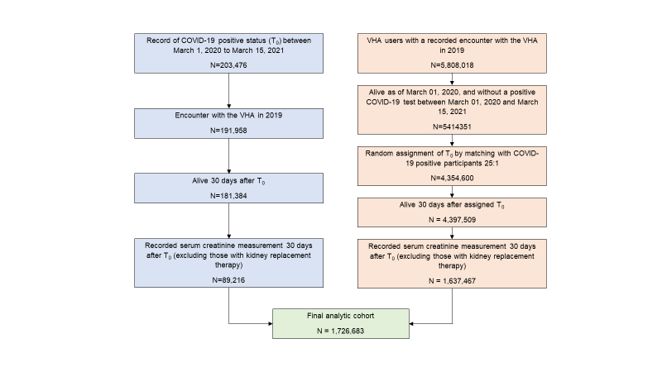

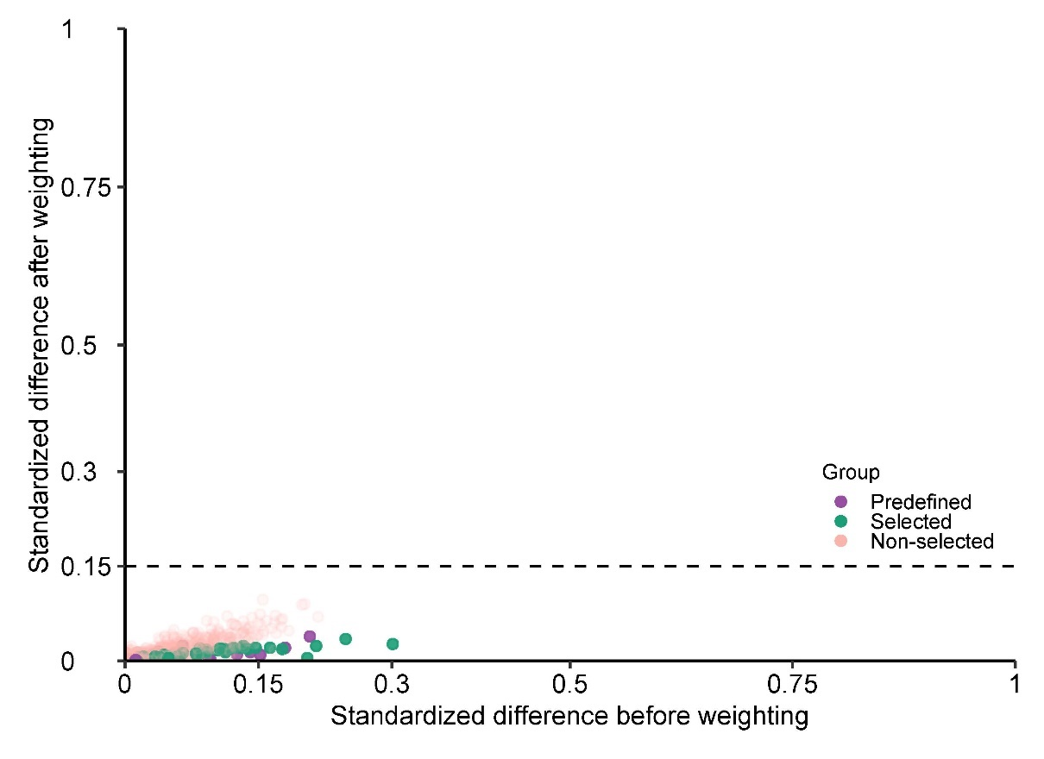

**Supplemental Figure 2: Covariate balance in the comparison of COVID-19 positive Veterans with VHA users.** Standardized differences before and after inverse probability of treatment weighting are plotted, where a standardized difference less than 0.15 (reference line) was taken as evidence of covariate balance. Standardized differences are colored to denote if covariates examined were: 1) 30 predefined; 2) 100 selected by the high dimensional variable section (HDVS) algorithm; or 3) 734 tested as potential covariates, but were not selected by the HDVS algorithm.

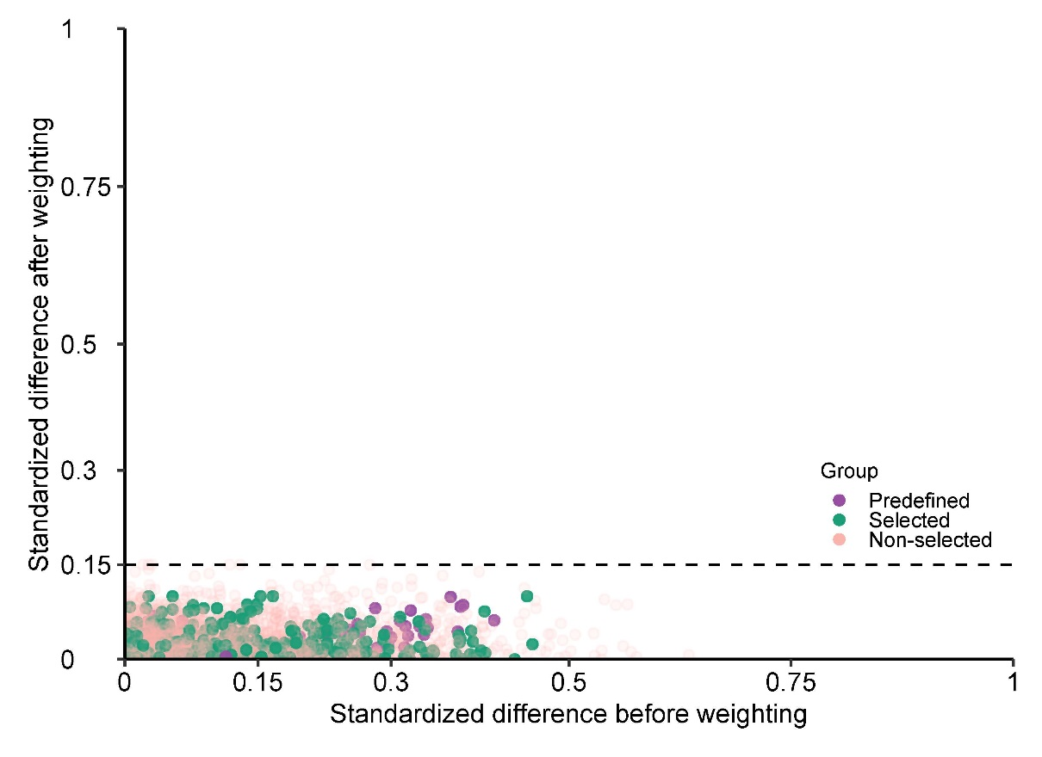

**Supplemental Figure 3: Covariate balance in the comparison of COVID-19 positive Veterans by severity of the acute infection with VHA users.** Standardized differences before and after inverse probability of treatment weighting are plotted, where a standardized difference less than 0.15 (reference line) was taken as evidence of covariate balance. Standardized differences are colored to denote if covariates examined were: 1) 30 predefined; 2) 100 selected by the high dimensional variable section (HDVS) algorithm; or 3) 734 tested as potential covariates, but were not selected by the HDVS algorithm.

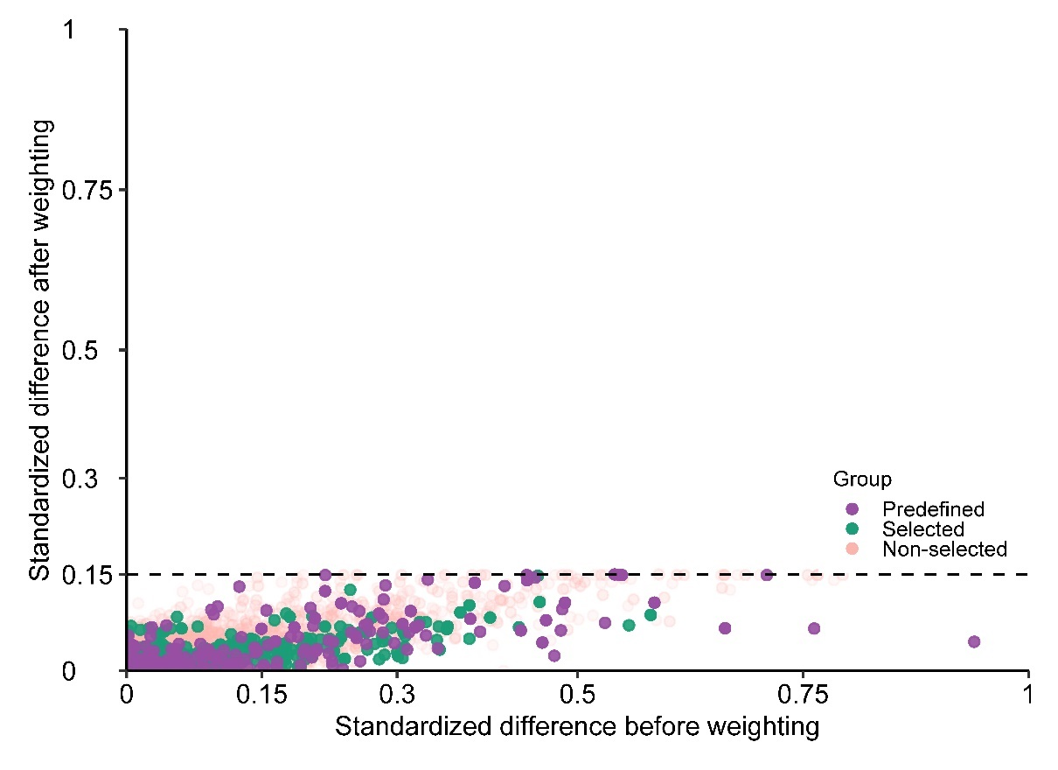

**Supplemental Figure 3: Covariate balance in the comparisons of COVID-19 positive Veterans by AKI status during the acute phase of care with VHA users.** Standardized differences before and after inverse probability of treatment weighting are plotted, where a standardized difference less than 0.15 (reference line) was taken as evidence of covariate balance. Standardized differences are colored to denote if covariates examined were: 1) 30 predefined; 2) 100 selected by the high dimensional variable section (HDVS) algorithm; or 3) 734 tested as potential covariates, but were not selected by the HDVS algorithm.

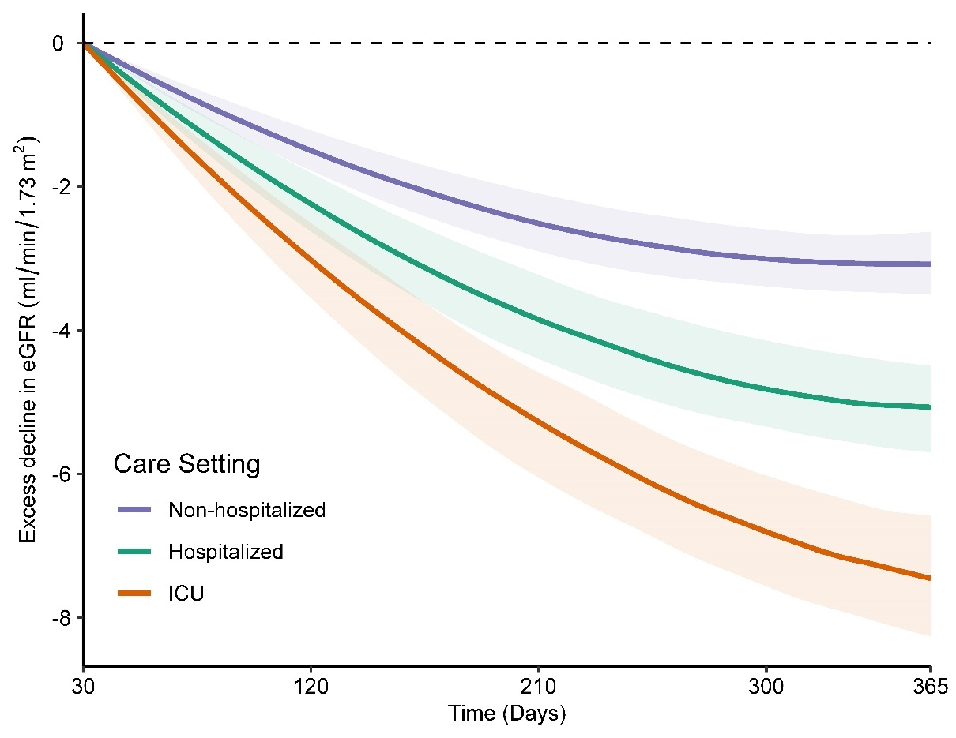

**Supplemental Figure 5:** Excess decline in eGFR in post-acute COVID-19 adjusting for predefined covariates. Differences in the trajectory of eGFR by day of follow-up compared to users of the Veteran Health Administration healthcare system with no record of a positive COVID-19 test (control group), estimated after adjustment for baseline characteristics. Changes are estimated starting from 30 days after a COVID-19 positive test. Bands represent the 95% CI.

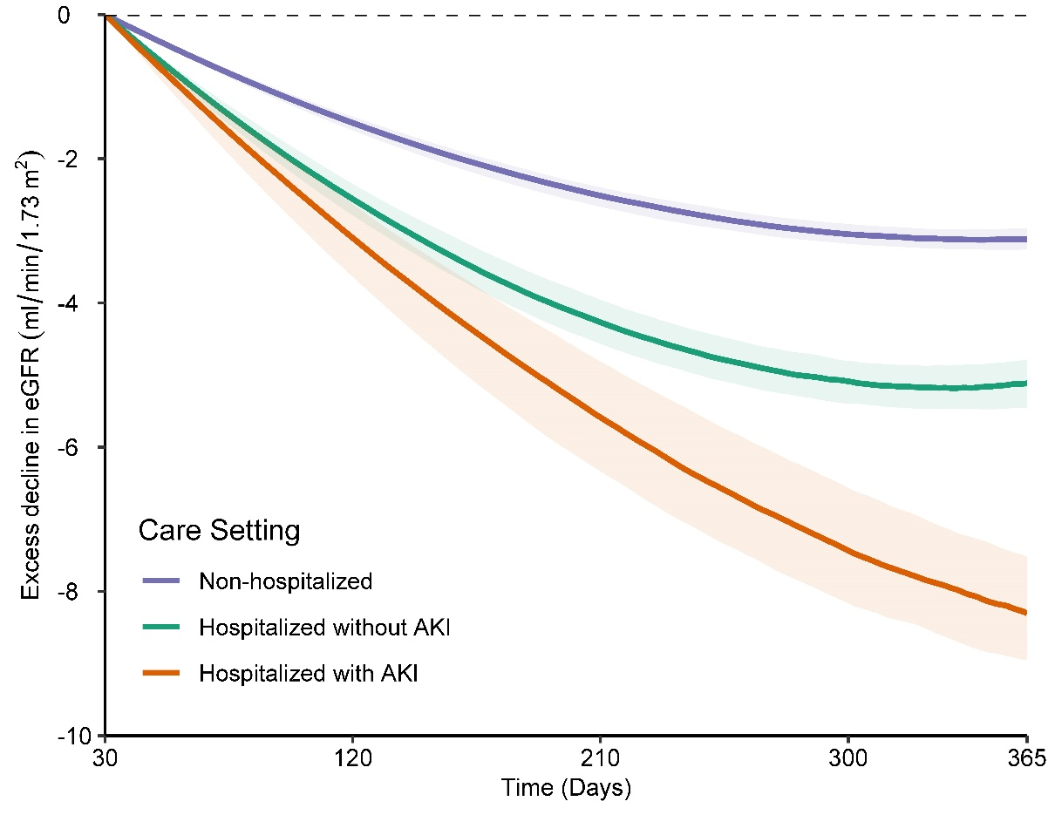

**Supplemental Figure 6:** Excess decline in eGFR in post-acute COVID-19 by AKI status during the acute phase of the illness adjusting for only predefined covariates. Differences in the trajectory of eGFR by day of follow-up compared to users of the Veteran Health Administration healthcare system with no record of a positive COVID-19 test (control group), estimated after adjustment for baseline characteristics. Changes are estimated starting from 30 days after a COVID-19 positive test. Bands represent the 95% CI.