Supplementary Information

Spatially resolved transcriptomic analysis of acute kidney injury in a female murine model

Eryn E. Dixon, Haojia Wu, Yoshiharu Muto, Parker C. Wilson, Benjamin D. Humphreys

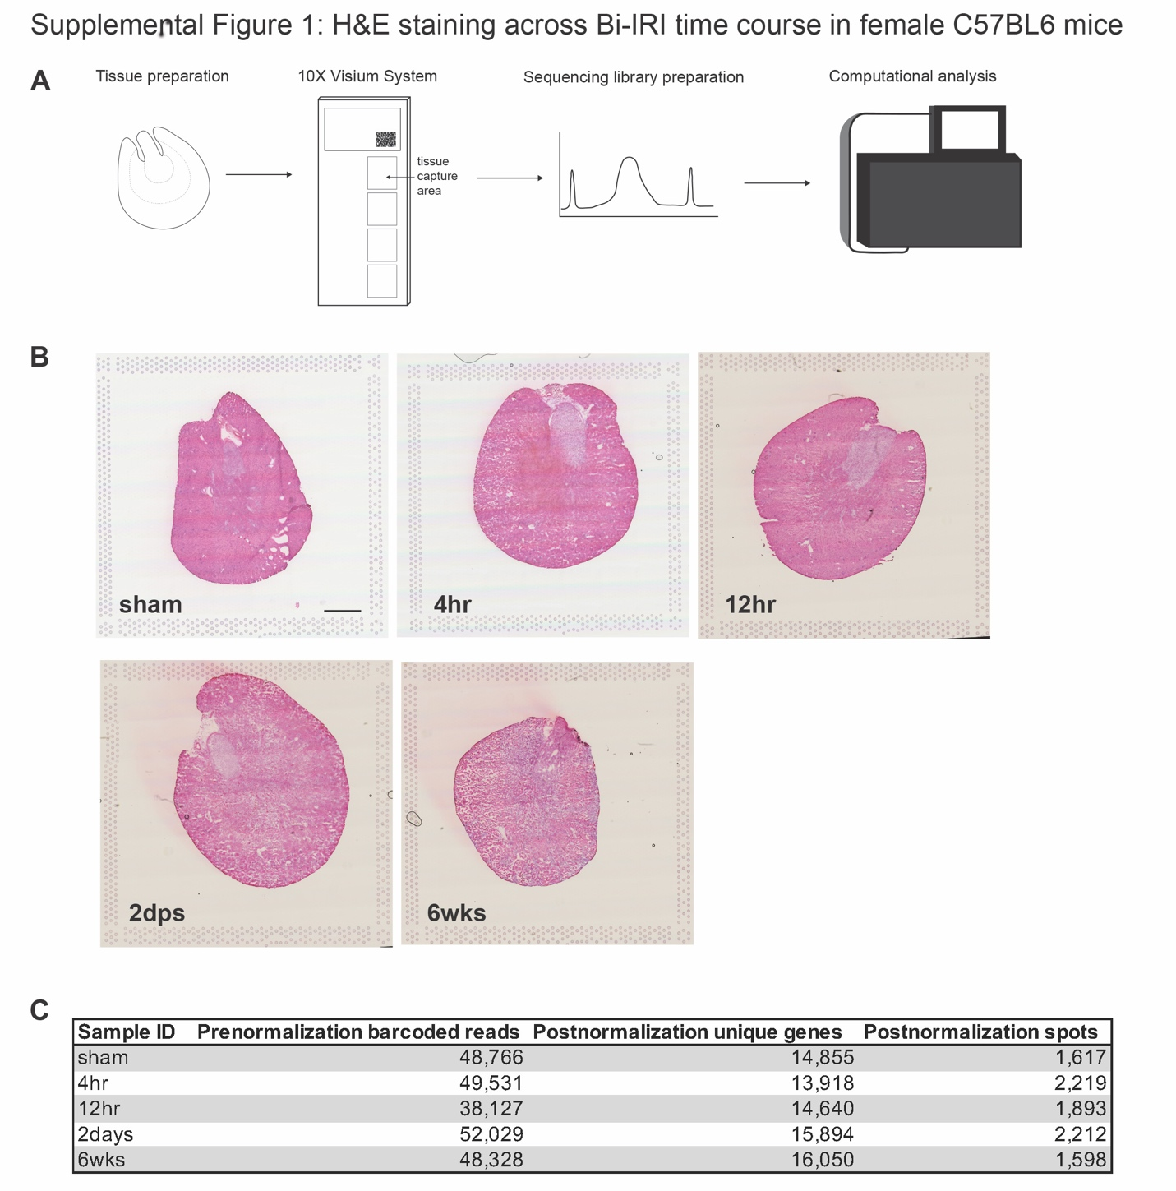
Supplementary Figure 1 – Hematoxylin and eosin images and library quality for Visium: (A) Schematic workflow of spatial sequencing library preparation from tissue to computational analysis. (B) Brightfield images of H&E staining on coronal kidney sections from each time point sample for spatial library preparation. Objective 10X, Scale bar 1000 μm. (C) Quality metrics for each of the sequencing libraries generated from the IRI time course, including prenormalization barcoded reads, postnormalization unique genes, and spots following SCTransform.

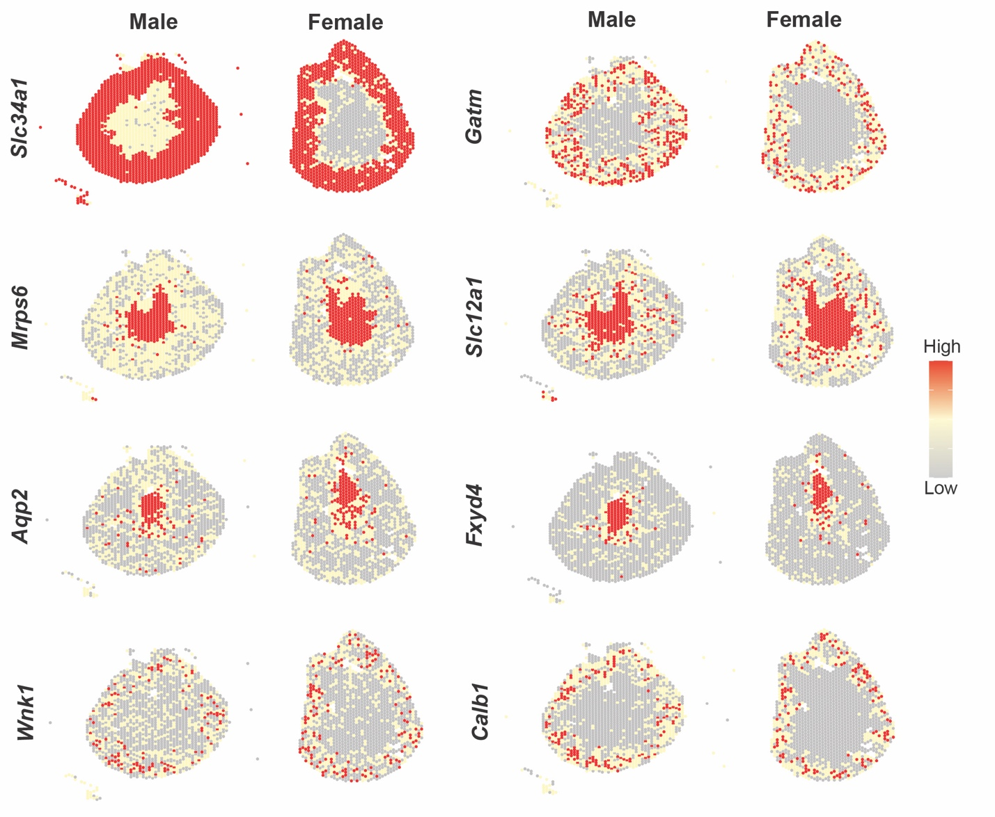
Supplementary Figure 2 – PAGE enrichment of cell type specific DEGs in female and male shams: Representative genes from cell type classification used for PAGE enrichment in Giotto. DEGs were derived from male snRNAseq (Kirita et al, 2020) and demonstrated to be similarly expressed between male sham (Melo Ferreira et al, 2021) and female sham kidneys. Gene classifications are as follows: proximal tubule (Slc34a1, Gatm), thick ascending limb (Mrps6, Slc12a1), collecting duct principal cells (Aqp2, Fxyd4), and connecting tubule (Wnk1, Calb1).

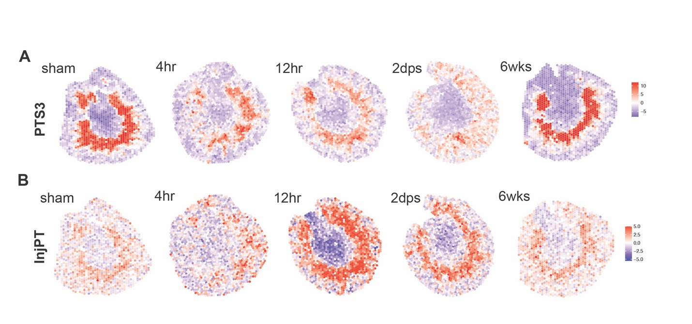
Supplementary Figure 3 – Visualizing injured cell types in Giotto: Changes across injury time course in spatial expression patterns of proximal tubule segment 3 (PTS3) (A) and injured proximal tubule (InjPT) (B) defined by PAGE enrichment.

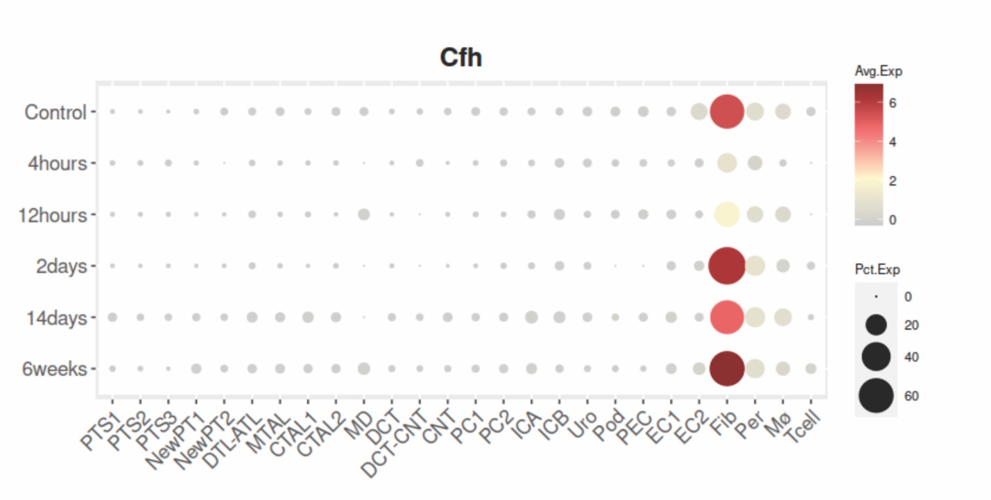Supplementary Figure 4 – Factor H expression in injury: Factor H (Cfh) expression increases in fibroblasts (Fib) following Bi-IRI; expression plot generated from http://humphreyslab.com/SingleCell/.

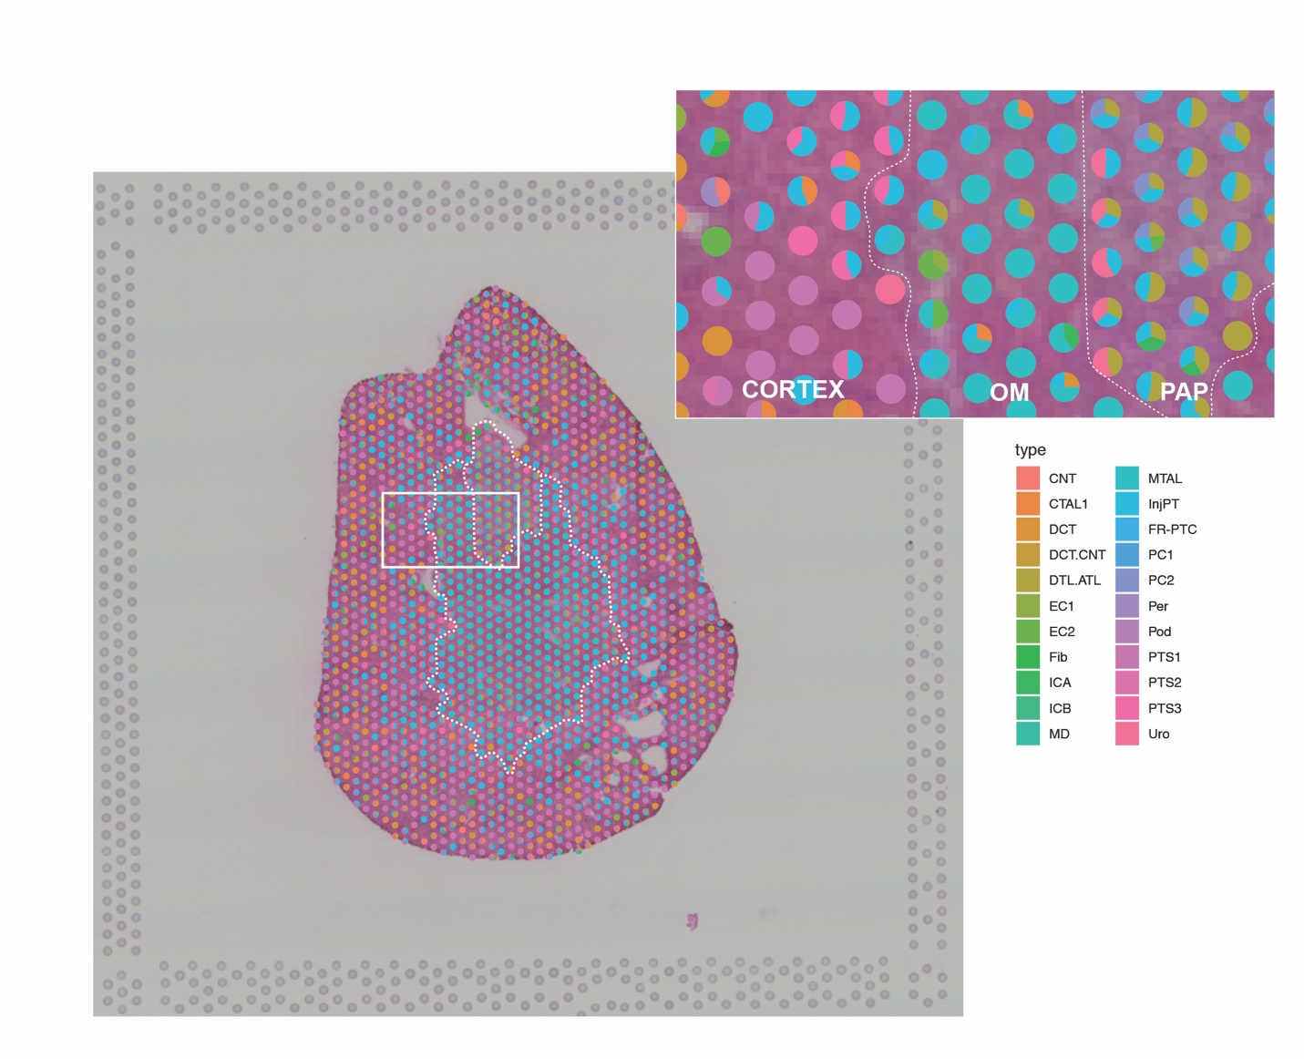
Supplementary Figure 5 – SPOTlight deconvolution of total female sham kidney: White dotted lines demarcate three regions, including cortex, outer medulla (OM), and papilla (Pap) in total female sham. White box shows magnified region for visualization of region specific scatterpies. Cell types: connecting tubule (CNT), thick ascending limb of loop of Henle in cortex (CTAL1), distal convoluted tubule (DCT), descending and ascending thin limp of loop of Henle (DTL.ATL), endothelial cells (EC1-2), fibroblasts (Fib), intercalated cells (ICA-B), macula densa (MD), thick ascending limb of loop of Henle in medulla (MTAL), injured proximal tubule cells (InjPT), failed repair proximal tubule cells (FR-PTC), principal cells (PC1-2), pericytes (Per), podocytes (Pod), proximal tubule segments 1-3 (PTS1-3), urothelium (Uro).

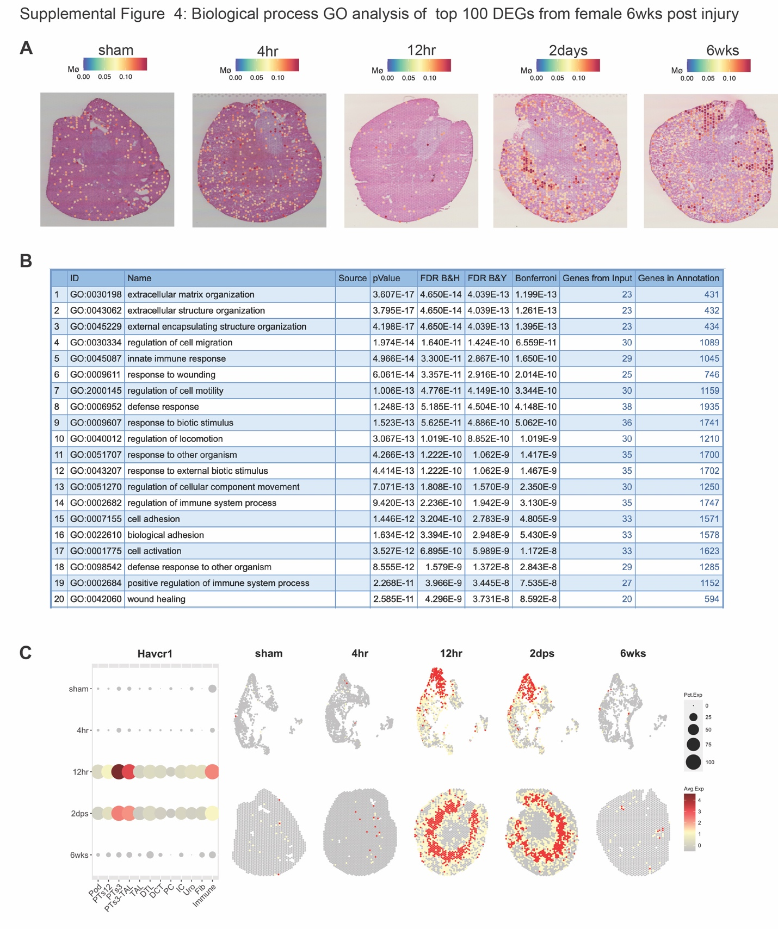
Supplementary Figure 6 – Macrophage marker expression, gene ontology of DEGs, and visualization on KIT: (A) Time course of macrophage (Mø) marker expression. (B) Gene ontology (GO) term analysis of biological processes from the top 100 differentially expressed genes (DEGs), ranked by largest fold change, from six weeks post injury. (C) Representative output from KIT website for gene, Havcr1, where genes of interest are visualized with both expression (dot plot), UMAP (top panel), and spatial plots (bottom panel).

