Online supplementary content

This appendix has been provided by the authors to give readers additional information about their work.
Supplementary content to: Maturation of glomerular filtration rate in term-born neonates: an individual participant data meta-analysis.

Table of contents

Online-Only Figures 2
Supplemental Figure 1: Spline basis functions for cubic splines with five knots as used in our model, and model results. 2
Supplemental Figure 2: Cross validation of mean GFR reference values. 3
Supplemental Figure 3: Predicted mGFR values by original model versus predicted values by cross-validation. 4
Supplemental Figure 4: Sensitivity analysis without mannitol values. 5
Supplemental Figure 5: Sensitivity analysis without CrCL values from neonates younger than three days of age. 6
Supplemental Figure 6: Sensitivity analysis without mGFR values for which height was imputed. 7
Supplemental Figure 7: Sensitivity analysis without potential duplicates. 8
Supplemental Figure 8: The development of mGFR in the first month of life in term-born neonates as measured by exogenous markers versus creatinine clearance 9
Supplemental Figure 9: The development of mGFR in the first month of life in term-born neonates by health status 10
Supplemental Figure 10: The development of mGFR in the first month of life in term-born neonates by sex. 11
Supplemental Figure 11: The development of mGFR in the first month of life in term-born neonates by year of publication. 12
Supplemental Figure 12: Additional evaluation of GFR maturational pattern by using aggregated data 13
Online-Only Tables 14
Supplemental Table 1: Systematic assessment of Risk of Bias according to ROBINS-E tool in which exposure was defined as postnatal age. 14
Supplemental Table 2: Reference values for mGFR in the first month of life 17

Online-Only Figures

Supplemental Figure 1: Spline basis functions for cubic splines with five knots as used in our model, and model results.
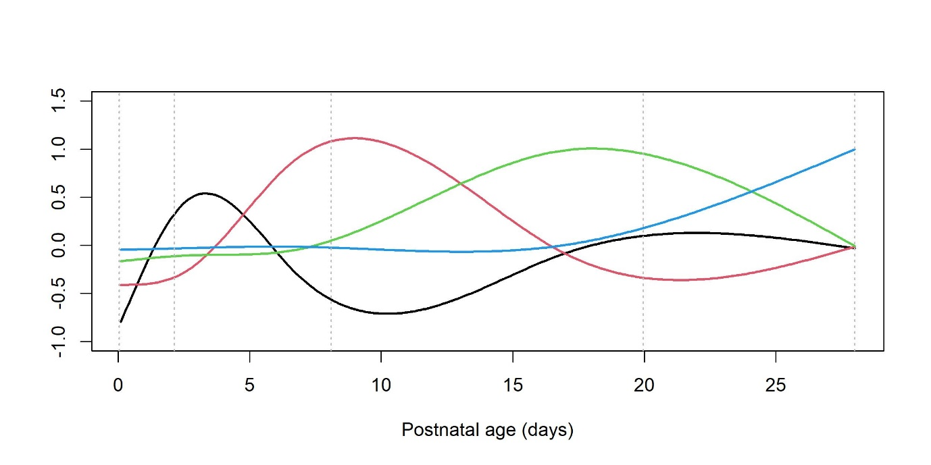
Supplemental Figure 1. Spline basis functions for cubic splines with five knots placed at 0, 25%, 50%, 75% and 100% of the postnatal age data points. Black: first trajectory of postnatal age; Red: second trajectory; Green: third trajectory; Blue: fourth trajectory.
Corresponding model: The smooth term for postnatal age was statistically significant (p-value
1.3 x 10⁻⁶). The following coefficients were estimated for the intercept, linear slope, and the four smooth terms, respectively: Intercept: 27.79 (SE 2.58); Age 1.14 (SE 0.30); s(Age).1: 7.39 (SE 1.72); s(Age).2: 9.99 (SE 2.22); s(Age).3: 3.02 (SE 4.93); s(Age).4: 0.00 (SE 0.00).

Supplemental Figure 2: Cross validation of mean GFR reference values.
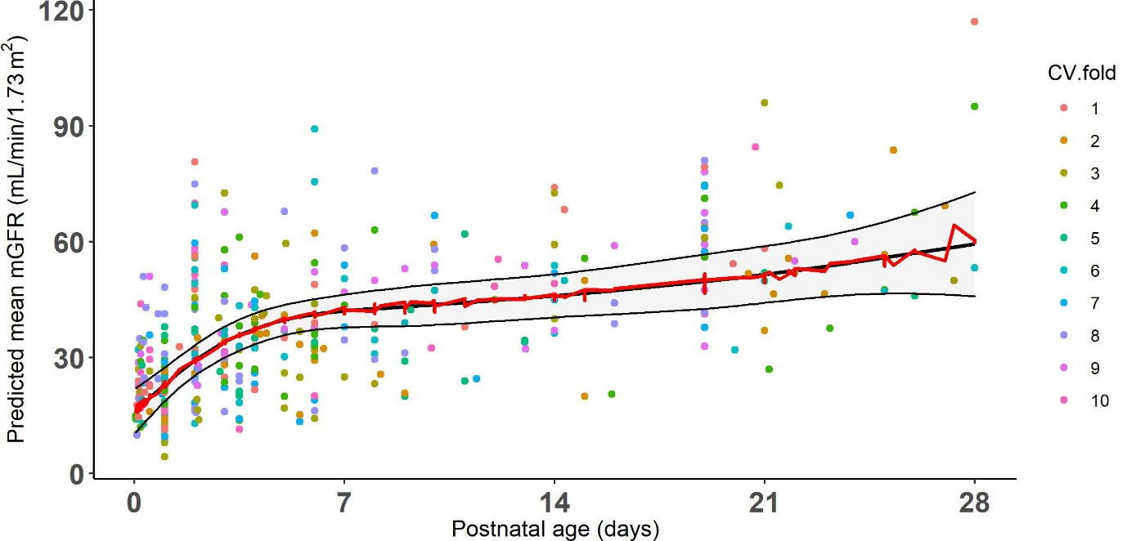

Supplemental Figure 2: Cross validation of GFR reference values. The development of glomerular filtration rate in the first month of life in term-born neonates (mean ±95% confidence interval). Predicted mean mGFR by original model including 95% CI (black curve) and by 10-fold cross validation (red curve). Using different partitions yielded similar results.

Supplemental Figure 3: Predicted mGFR values by original model versus predicted values by cross-validation.

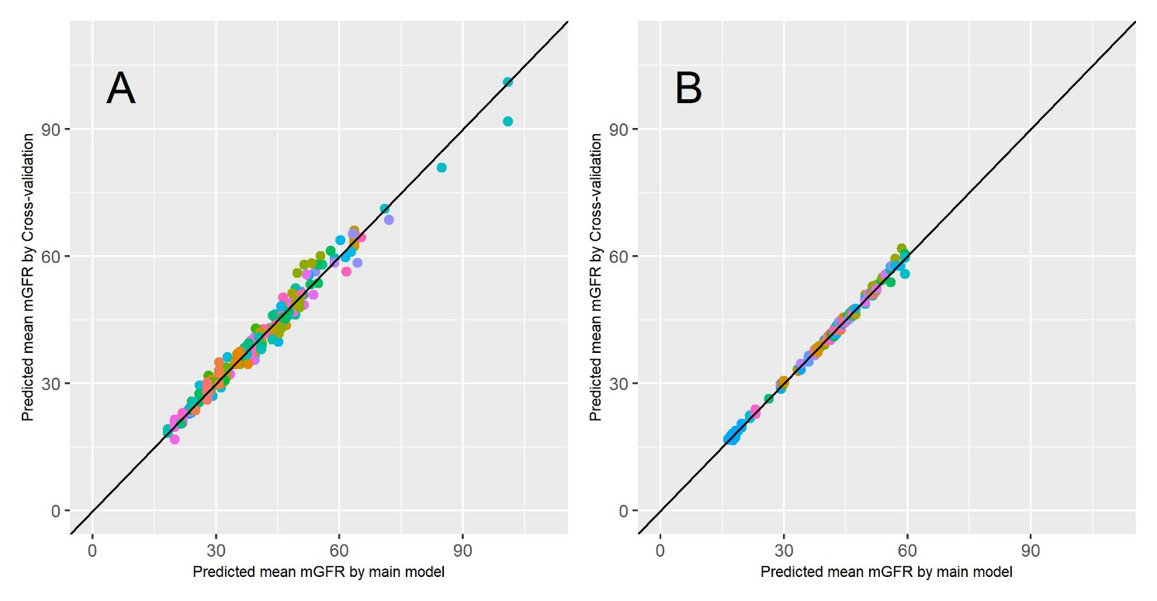
Supplemental Figure 3: Predicted mGFR values by main model versus predicted values by 10-fold cross-validation. A. Including study effects in the prediction; B. Excluding study effects in the prediction.

Supplemental Figure 4: Sensitivity analysis without mannitol values.

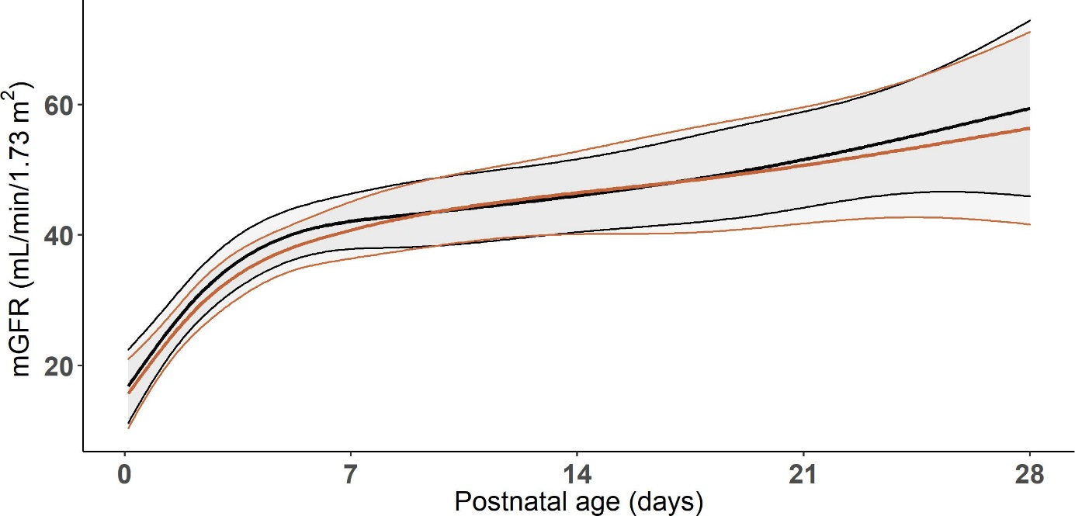

Supplemental Figure 4: Sensitivity analysis without all mannitol values. Black lines represent mean and 95% confidence intervals of the original model, orange lines represent same model but without mannitol values (n=59).

Supplemental Figure 5: Sensitivity analysis without CrCL values from neonates younger than three days of age.

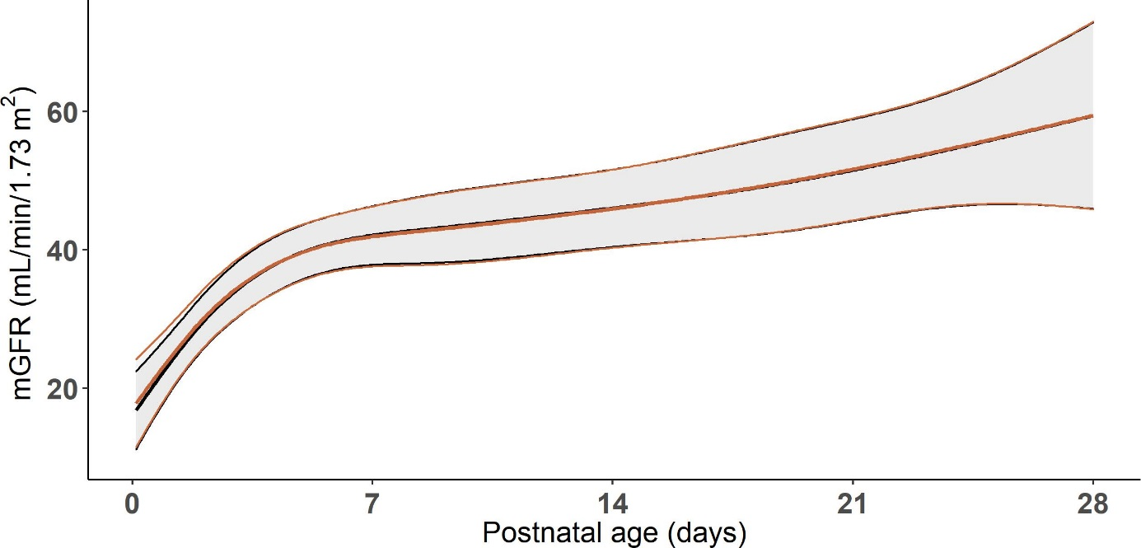
Supplemental Figure 5: Sensitivity analysis without CrCL values from neonates younger than three days of age. Black lines represent mean and confidence intervals of the original model, orange lines represent same model but without CrCL values from neonates younger than three days of age (n=33).

Supplemental Figure 6: Sensitivity analysis without mGFR values for which height was imputed.

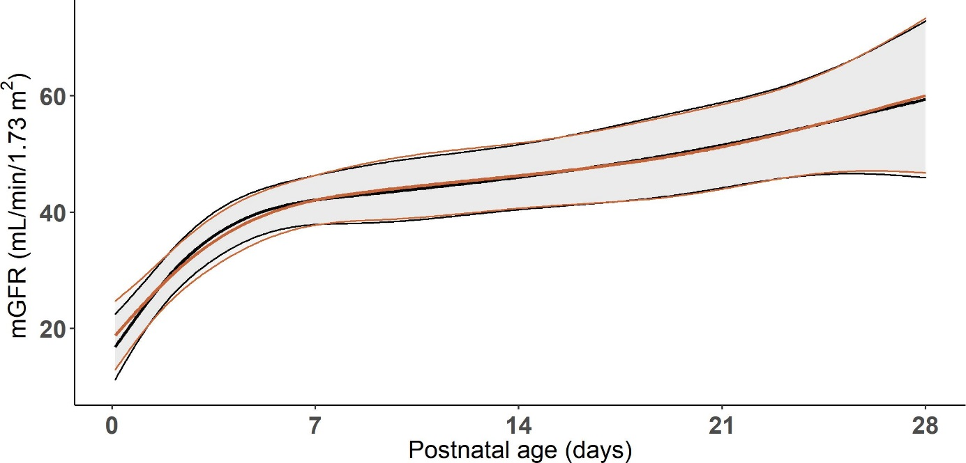
Supplemental Figure 6: Sensitivity analysis without mGFR values for which height was imputed . Black lines represent mean and confidence intervals of the original model, orange lines represent same model but with GFR values for which height was imputed excluded (n=28).

Supplemental Figure 7: Sensitivity analysis without potential duplicates.

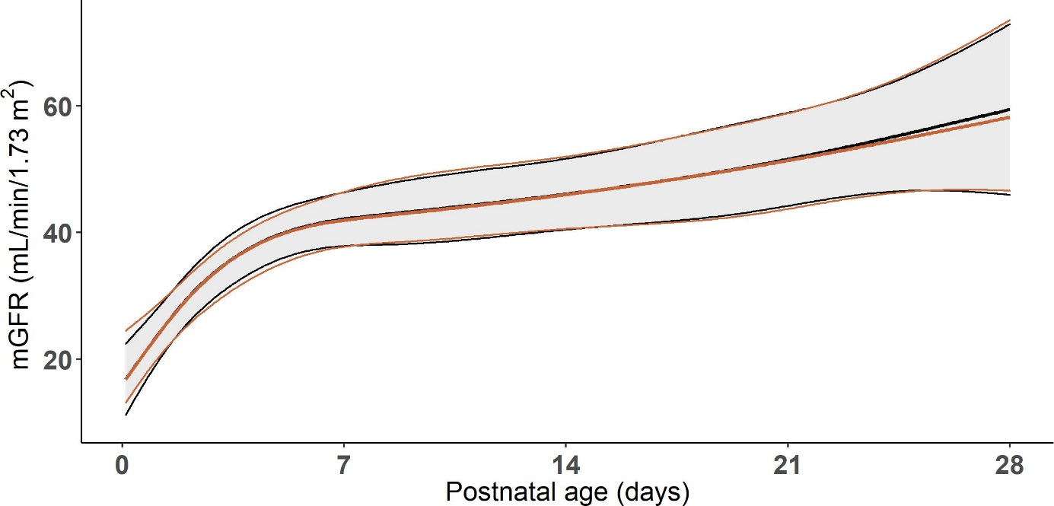

Supplemental Figure 7: Sensitivity analysis without potential duplicates. Black lines represent mean and confidence intervals of the original model, orange lines represent same model but with potential duplicates (n=8).

Supplemental Figure 8: The development of mGFR in the first month of life in term-born neonates as measured by exogenous markers versus creatinine clearance

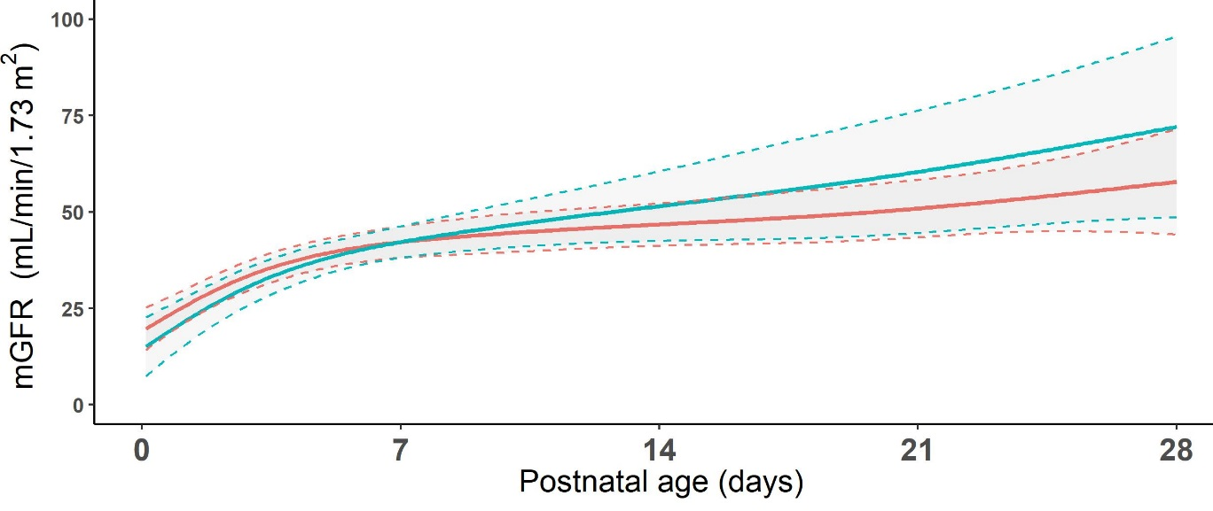
Supplemental Figure 8: The development of mGFR in the first month of life in term-born neonates as measured by exogenous markers (red line) and creatinine clearance (CrCL) (blue line) with means (straight line) and 95% confidence intervals (dashed lines).No significant differences between the models exist (p=0.277).

Supplemental Figure 9: The development of mGFR in the first month of life in term-born neonates by health status

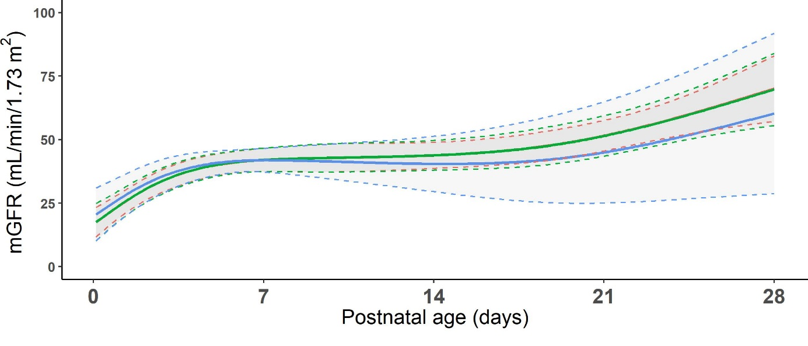
Supplemental Figure 9: The development of mGFR in the first month of life in term-born neonates by health status. Distinction was made between healthy neonates (red line), neonates with a disease without effect on GFR (green line) and neonates with a disease with a potential effect on GFR (blue line). Trajectory of green line is exactly similar to red line. No significant differences between the models exist (p=0.737)

Supplemental Figure 10: The development of mGFR in the first month of life in term-born neonates by sex.

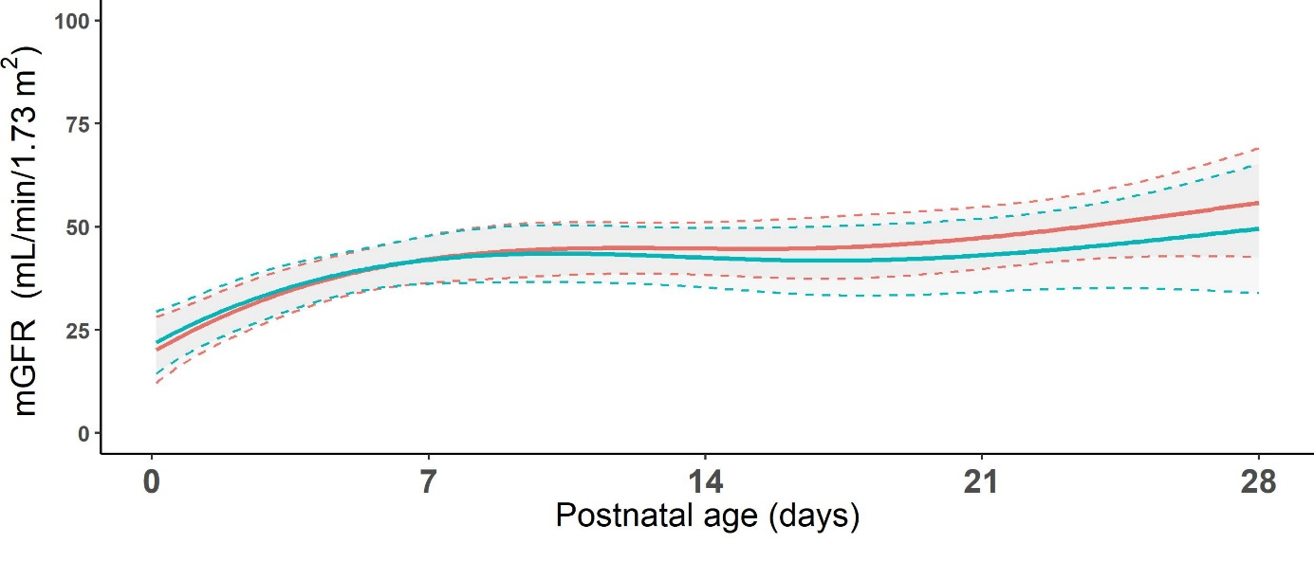
Supplemental Figure 10: The development of mGFR in the first month of life in term-born neonates for boys (red line) and girls (green line). No significant differences between the models exist (p=0.289)

Supplemental Figure 11: The development of mGFR in the first month of life in term-born neonates by year of publication.

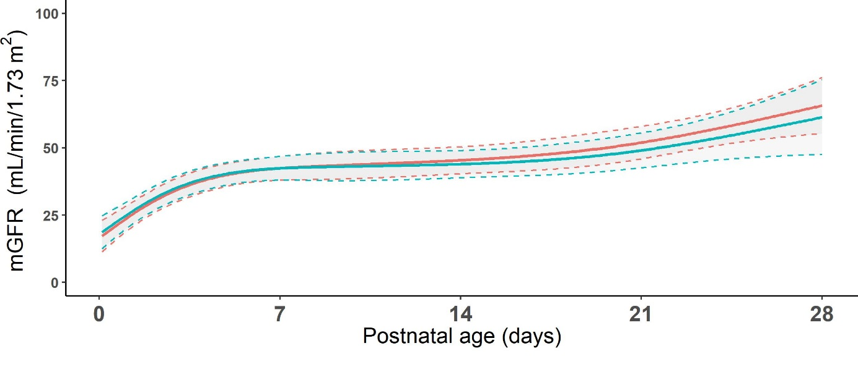
Supplemental Figure 11: The development of mGFR in the first month of life in term-born neonates by year of publication. Before 1980 (red line) and from 1980 onwards (green line). No significant differences between the models exist (p=0.373)

Supplemental Figure 12: Verification of GFR maturational pattern by using aggregated data

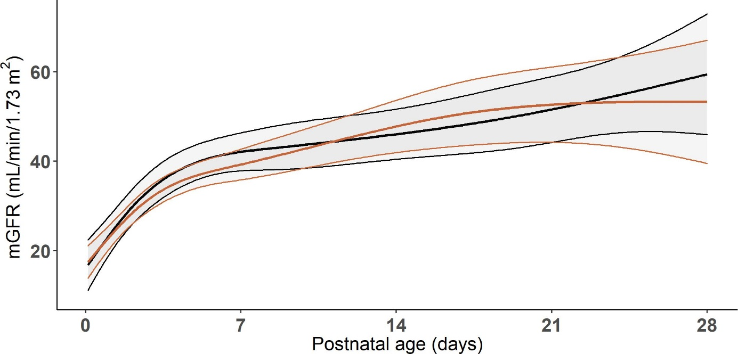
Supplemental Figure 12: Verification of GFR maturational pattern by using aggregated data. Original model with IPD data only (black lines) and model in which IPD and aggregated data were combined (orange lines).

Online-Only Tables

Supplemental Table 1: Systematic assessment of Risk of Bias according to ROBINS-E tool in which exposure was defined as postnatal age.

Bias items | Risk of bias | Direction of bias | Rationale
Bias due to confounding | Low | Unknown | Specific details with regards to covariates (weight, height, BSA) were not always reported by authors. However, critical possible confounders (used GFR marker, used creatinine assay, health status and year of publication) were, if reported by authors, accounted for in our analysis.  Of course, there is a possibility of residual unmeasured (e.g., treatment effect, undiagnosed kidney disease) confounding we did not account for in our analysis. Yet, as only healthy neonates were included, we consider the risk of bias low.
Bias in selection of participants into the study | Low | Underestimation of GFR | Only healthy term born neonates were included in our analysis. When the health status was questionable or not reported by authors, we did not include these neonates in our analysis. Some articles mentioned to have only included healthy neonates but included them from neonatal intensive care units. In such cases, we assigned these records to ‘health status with possible influence on GFR’. Although health status did not influence the relationship between postnatal age and mGFR, still, non-healthy neonates could theoretically be included which might have led to an underestimation of GFR, assuming disease has a negative effect on GFR.
Bias in classification of exposures | Absent | N/A | Postnatal age was always reported by authors, otherwise we were not able to include results in our analysis
Bias due to deviations from intended exposures | Absent | N/A | There is no concern that changes in postnatal age occurred among participants, also due to the cross-sectional nature of the studies.
Bias due to missing data | Low | No systematic direction | There is no missing data on exposure (postnatal age) level. Critical confounders (as defined under item 1) did not have missing data. Only for studies reporting mGFR as measured by CrCL, the exact analytical assay used to measure serum creatinine levels were not always reported. In 5 out of 24 studies, this was unknown. All other 19 studies reported to have used the Jaffe of compensated Jaffe to measure serum creatinine levels. Four studies in which the exact analytical method was unclear were published in 1974, 1976, 1982 and 1987. It is highly unlikely that these studies measured serum creatinine levels using the enzymatic method. One study published in 2014 did also no report the exact method and could have used enzymatic creatinine values to calculate creatinine clearance. Results from this study might deviate from other studies using CrCL, if indeed another method is used. But, as mGFR measured by CrCL did not significantly differ from mGFR measured by exogenous methods, we consider the risk of bias due to missing data with regards to the exact analytical method low.  Other covariates also had missing data. For instance, weight and height were not always reported. For studies reporting GFR in ml/min without reporting height or BSA, height was derived from the growth charts for growth and BSA was calculated accordingly. This may have resulted in less accurate determination of GFR. Nevertheless, the influence of over- or underestimation of height has little influence on the determination of BSA and GFR as extensively discussed in our manuscript.
Bias in measurement of the outcome | Low | No systematic direction | It is unlikely that the outcome could be affected by knowledge of postnatal age. However, as GFR was measured using several methods, imprecision with regards to reporting mGFR might have occurred. However, systematic error due to measurements errors towards under or overestimation of GFR is highly unlikely.
Bias in selection of the reported result | Low | No systematic direction. | Selective reporting based on outcome is unlikely as mGFR was often presented as a by-product in included articles. It is, however, imaginable that mGFR was only reported in case there were concerns about GFR in the studied population. But, this would then only apply to ill neonates that were also included in these studies and not to healthy neonates that were included as a control group.
Overall bias | Low | No systematic direction | Overall bias was judged as low and deemed unlikely to significantly alter our results.

Supplemental Table 1: Systematic assessment of Risk of Bias according to ROBINS-E tool in which exposure was defined as postnatal age. Abbreviations: BSA: body surface area; CrCL: creatinine clearance; GFR: Glomerular Filtration Rate; mGFR: measured Glomerular Filtration Rate; p75: 75th percentile; p90: 90th percentile.

Postnatal age (days) | mGFR (ml/min/1.73m²)
 | Mean | CI (lower; upper) | p10 | p25 | p75 | p90
0 | 19.6 | 14.7; 24.6 | 4.7 | 11.8 | 27.5 | 34.6
1 | 26.3 | 22.3; 30.3 | 11.4 | 18.5 | 34.1 | 41.2
2 | 31.9 | 27.9; 35.8 | 17.0 | 24.0 | 39.7 | 46.7
3 | 35.4 | 31.9; 40.0 | 21.1 | 28.1 | 43.8 | 50.8
4 | 38.8 | 34.8; 42.7 | 23.9 | 30.9 | 46.6 | 53.6
5 | 40.6 | 36.7; 44.5 | 25.7 | 32.8 | 48.4 | 55.5
6 | 41.7 | 37.7; 45.8 | 26.9 | 33.9 | 49.6 | 56.6
7 | 42.4 | 38.0; 46.9 | 27.5 | 34.6 | 50.3 | 57.3
10 | 44.0 | 38.7; 49.4 | 29.0 | 36.1 | 51.9 | 59.1
14 | 46.4 | 40.7; 52.1 | 31.3 | 38.4 | 54.3 | 61.5
21 | 52.1 | 44.6; 59.5 | 36.6 | 43.9 | 60.2 | 67.5
28 | 59.4 | 45.9; 72.9 | 42.3 | 50.4 | 68.4 | 76.5

Supplemental Table 2: Reference values for mGFR in the first month of life

Supplemental Table 2: Reference values for mGFR in the first month of life. Abbreviations: GFR: Glomerular Filtration Rate; CI: 95% Confidence Interval; p10: tenth percentile; p25: 25th percentile, p75: 75th percentile; p90: 90th percentile.

