Supplemental Material for “Acute kidney injury associates with long-term increases in plasma TNFR1, TNFR2, and KIM-1: Findings from the CRIC study.”

Supplemental Table of Contents:
Appendix 1. CCS categories used to classify hospitalizations.
Table S1. Sensitivity Analyses.
Figures S1-S3. Box and whisker plots of biomarker concentrations.

Appendix 1. CCS categories used to classify hospitalizations.

The following CCS categories will be classified as hospitalizations with cardiovascular disease:
7 Diseases of the circulatory system
7.1 Hypertension
7.1.1 Essential hypertension [98]
7.1.2 Hypertension with complications and secondary hypertension [99]
7.1.2.1 Hypertensive heart and/or renal disease
7.1.2.2 Other hypertensive complications
7.2 Diseases of the heart
7.2.1 Heart valve disorders [96]
7.2.1.1 Chronic rheumatic disease of the heart valves
7.2.1.2 Nonrheumatic mitral valve disorders
7.2.1.3 Nonrheumatic aortic valve disorders
7.2.1.4 Other heart valve disorders
7.2.2 Peri-; endo-; and myocarditis; cardiomyopathy (except that caused by TB or STD) [97]
7.2.2.1 Cardiomyopathy
7.2.2.2 Other peri-; endo-; and myocarditis
7.2.3 Acute myocardial infarction [100]
7.2.4 Coronary atherosclerosis and other heart disease [101]
7.2.4.1 Angina pectoris
7.2.4.2 Unstable angina (intermediate coronary syndrome)
7.2.4.3 Other acute and subacute forms of ischemic heart disease
7.2.4.4 Coronary atherosclerosis
7.2.4.5 Other forms of chronic heart disease
7.2.5 Nonspecific chest pain [102]
7.2.6 Pulmonary heart disease [103]
7.2.7 Other and ill-defined heart disease [104]
7.2.8 Conduction disorders [105]
7.2.8.1 Atrioventricular block
7.2.8.2 Bundle branch block
7.2.8.3 Anomalous atrioventricular excitation
7.2.8.4 Other conduction disorders
7.2.9 Cardiac dysrhythmias [106]
7.2.9.1 Paroxysmal supraventricular tachycardia
7.2.9.2 Paroxysmal ventricular tachycardia
7.2.9.3 Atrial fibrillation
7.2.9.4 Atrial flutter
7.2.9.5 Premature beats
7.2.9.6 Sinoatrial node dysfunction
7.2.9.7 Other cardiac dysrhythmias
7.2.10 Cardiac arrest and ventricular fibrillation [107]
7.2.11 Congestive heart failure; nonhypertensive [108]
7.2.11.1 Congestive heart failure
7.2.11.2 Heart failure
7.3 Cerebrovascular disease
7.3.1 Acute cerebrovascular disease [109]
7.3.1.1 Intracranial hemorrhage
7.3.1.2 Occlusion of cerebral arteries
7.3.1.3 Acute but ill-defined cerebrovascular accident
7.3.2 Occlusion or stenosis of precerebral arteries [110]
7.3.3 Other and ill-defined cerebrovascular disease [111]
7.3.4 Transient cerebral ischemia [112]
7.3.5 Late effects of cerebrovascular disease [113]
7.4 Diseases of arteries; arterioles; and capillaries
7.4.1 Peripheral and visceral atherosclerosis [114]
7.4.1.1 Atherosclerosis of arteries of extremities
7.4.1.2 Peripheral vascular disease unspecified
7.4.1.3 Other peripheral and visceral atherosclerosis
7.4.2 Aortic; peripheral; and visceral artery aneurysms [115]
7.4.2.1 Abdominal aortic aneurysm; without rupture
7.4.2.2 Other aneurysm
7.4.3 Aortic and peripheral arterial embolism or thrombosis [116]
7.4.3.1 Arterial embolism and thrombosis of lower extremity artery
7.4.3.2 Other arterial embolism and thrombosis
7.4.4 Other circulatory disease [117]
7.4.4.1 Hypotension
7.4.4.2 Other and unspecified circulatory disease
7.5 Diseases of veins and lymphatics
7.5.1 Phlebitis; thrombophlebitis and thromboembolism [118]
7.5.1.1 Phlebitis and thrombophlebitis
7.5.1.2 Other venous embolism and thrombosis
7.5.2 Varicose veins of lower extremity [119]
7.5.3 Hemorrhoids [120]
7.5.4 Other diseases of veins and lymphatics [121]

The following CCS categories will be classified as hospitalizations with infection:
1 Infectious and parasitic diseases
1.1 Bacterial infection
1.1.1 Tuberculosis [1]
1.1.2 Septicemia (except in labor) [2]
1.1.2.1 Streptococcal septicemia
1.1.2.2 Staphylococcal septicemia
1.1.2.3 E Coli septicemia
1.1.2.4 Other gram negative septicemia
1.1.2.5 Other specified septicemia
1.1.2.6 Unspecified septicemia
1.1.3 Sexually transmitted infections (not HIV or hepatitis) [9]
1.1.4 Other bacterial infections [3]
1.2 Mycoses [4]
1.2.1 Candidiasis of the mouth (thrush)
1.2.2 Other mycoses
1.3 Viral infection
1.3.1 HIV infection [5]
1.3.2 Hepatitis [6]
1.3.3 Other viral infections [7]
1.3.3.1 Herpes zoster infection
1.3.3.2 Herpes simplex infection
1.3.3.3 Other and unspecified viral infection
1.4 Other infections; including parasitic [8]
1.5 Immunizations and screening for infectious disease [10]
6.1 Central nervous system infection
6.1.1 Meningitis (except that caused by TB or STD) [76]
6.1.2 Encephalitis (except that caused by TB or STD) [77]
6.1.3 Other CNS infection and poliomyelitis [78]
8.1 Respiratory infections
8.1.1 Pneumonia (except that caused by TB or STD) [122]
8.1.1.1 Pneumococcal pneumonia
8.1.1.2 Other bacterial pneumonia
8.1.1.3 Pneumonia; organism unspecified
8.1.1.4 Other pneumonia
8.1.2 Influenza [123]
8.1.3 Acute and chronic tonsillitis [124]
8.1.4 Acute bronchitis [125]
8.1.5 Other upper respiratory infections [126]
8.1.5.1 Acute upper respiratory infections of multiple or unspecified sites
8.1.5.2 Chronic sinusitis
8.1.5.3 Croup
8.1.5.4 Other and unspecified upper respiratory infections
9.1 Intestinal infection [135]
10.1.4 Urinary tract infections [159]
10.1.4.1 Infections of kidney
10.1.4.2 Cystitis and urethritis
10.1.4.3 Urinary tract infection; site not specified
12.1 Skin and subcutaneous tissue infections [197]
12.1.1 Cellulitis and abscess
12.1.1.1 Cellulitis and abscess of fingers and toes
12.1.1.2 Cellulitis and abscess of face
12.1.1.3 Cellulitis and abscess of arm
12.1.1.4 Cellulitis and abscess of hand
12.1.1.5 Cellulitis and abscess of leg
12.1.1.6 Cellulitis and abscess of foot
12.1.1.7 Other cellulitis and abscess
12.1.2 Other skin and subcutaneous infections

Table S1. Sensitivity Analyses.
Biomarker/Analysis | Coefficient for AKI-change interaction (95% CI) in the mixed effects model* | P value
TNFR1
Primary analysis | 0.10 (0.02-0.19) | 0.013
Sensitivity Analysis #1 (limit to 147 perfect matches) | 0.09 (-0.001-0.18) | 0.054
Sensitivity Analysis #2 (use all 198 matches but adjust for matching variables) | 0.09 (0.01-0.17) | 0.028
TNFR2
Primary analysis | 3498 (1166-5831) | 0.003
Sensitivity Analysis #1 (limit to 147 perfect matches) | 3724 (1017-6432) | 0.007
Sensitivity Analysis #2 (use all 198 matches but adjust for matching variables) | 3295 (939-5650) | 0.006
KIM-1
Primary analysis | 0.17 (0.06-0.27) | 0.002
Sensitivity Analysis #1 (limit to 147 perfect matches) | 0.20 (0.08-0.32) | 0.001
Sensitivity Analysis #2 (use all 198 matches but adjust for matching variables) | 0.16 (0.06-0.27) | 0.002
*Note that this is the coefficient for log transformed biomarker levels for TNFR1 and KIM-1. Raising e to the power of this coefficient yields the ratio of percent change in biomarker level in the AKI group compared to the non-AKI group. TNFR2 was modeled without log transformation and the coefficient represents the absolute difference in differences between change in TNFR2 level in the AKI group compared to in the non-AKI group.

Figure S1. Box and whisker plot of plasma TNFR1 concentrations.

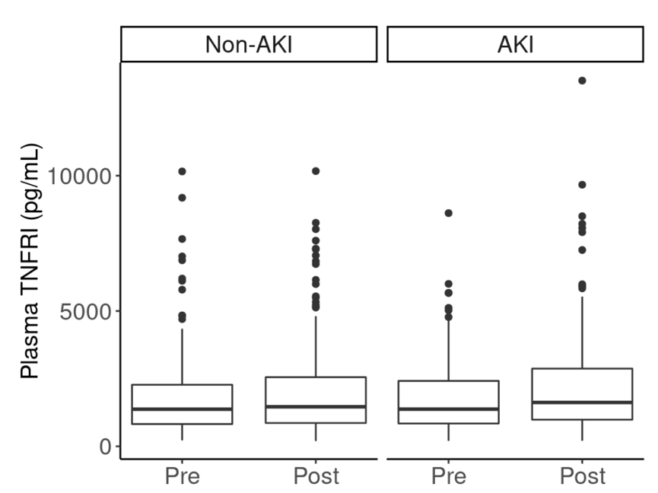

Figure S2. Box and whisker plot of plasma TNFR2 concentrations.
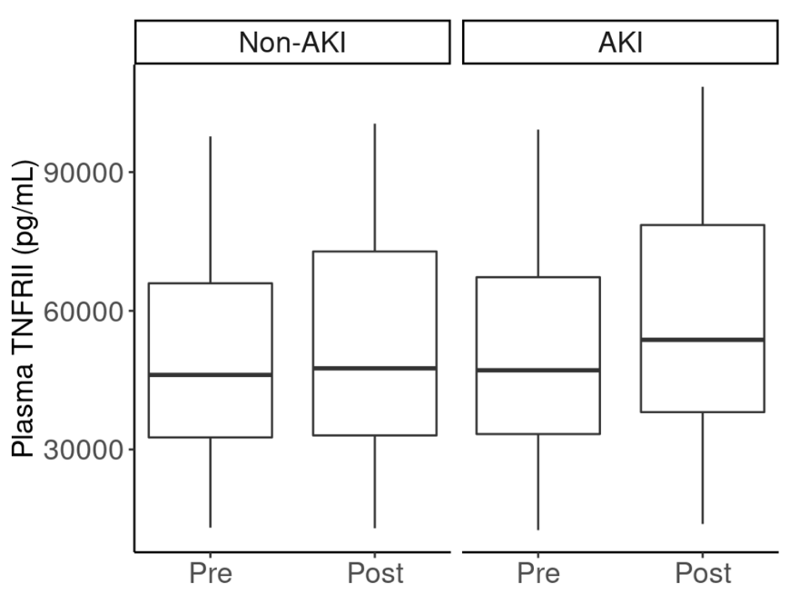

Figure S3. Box and whisker plot of plasma KIM-1 concentrations.
