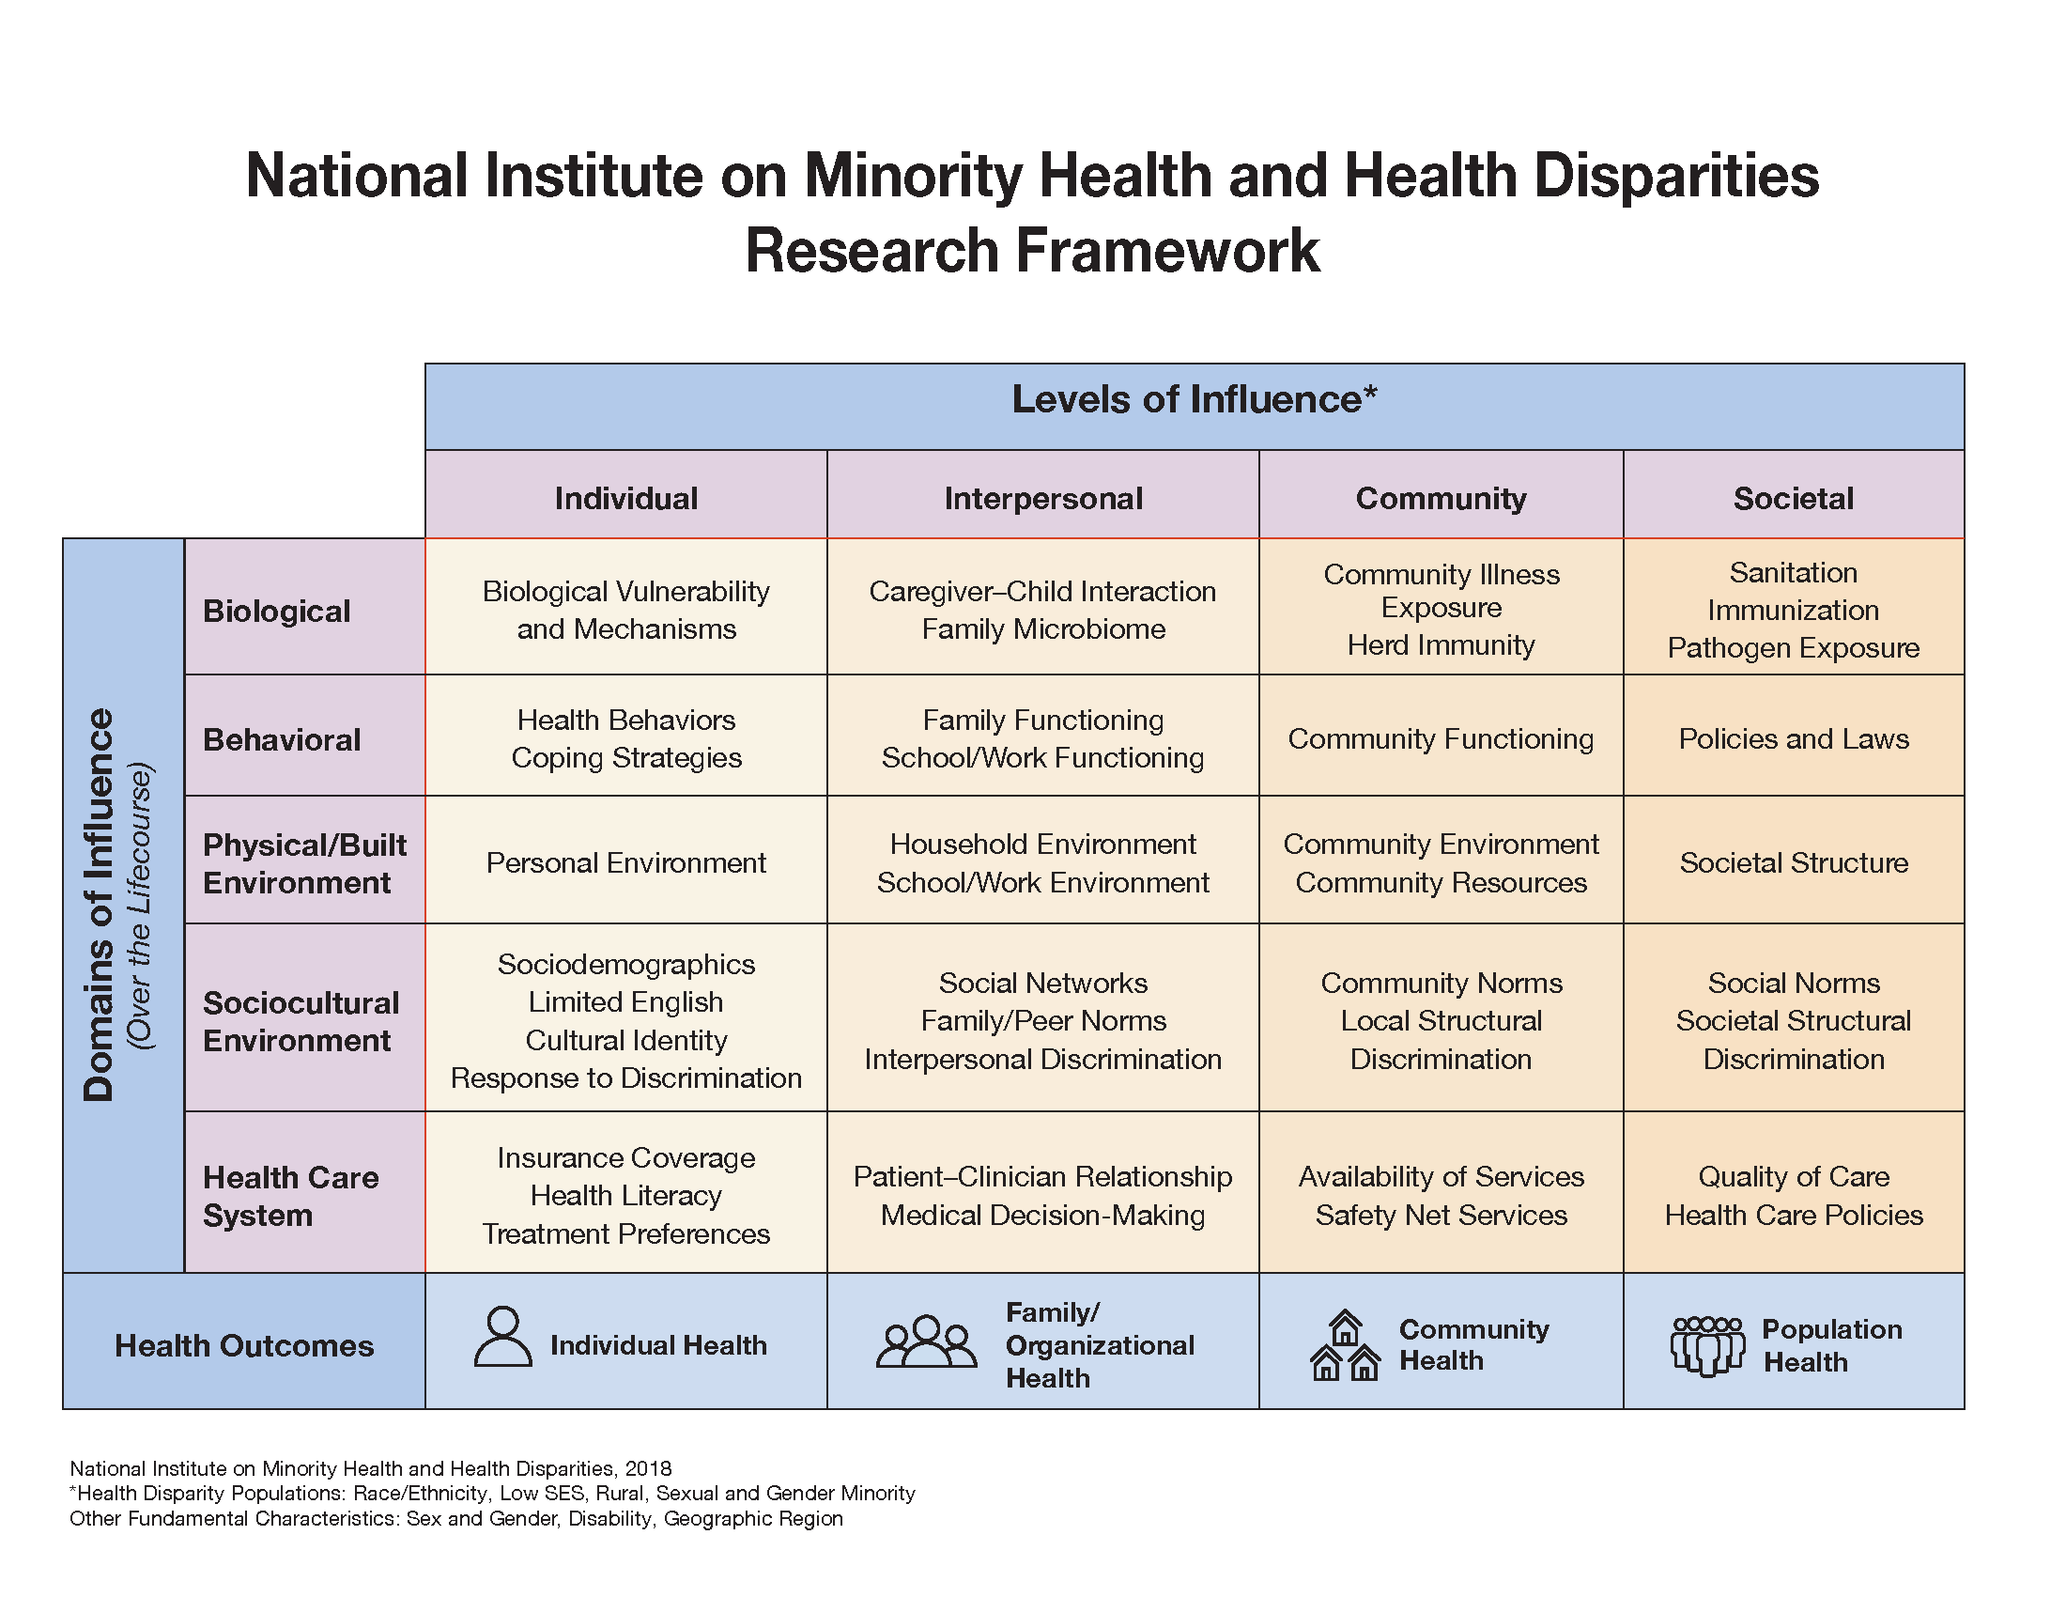
Supplemental Figure 1. National Institute on Minority Health and Health Disparities Research Framework

The research framework developed by the National Institute on Minority Health and Health Disparities (NIMHD) describes the multiple socioecological domains (e.g., biological, behavioral, socio-cultural, environmental, physical environment, health system) and levels of influence (e.g., individual, interpersonal, community, societal) that can help guide the development of interventions to mitigate structural racism and the social and health inequities it perpetuates.

