Table of content of Supplementary Data

Fig-S1. PAS positivity and amylase sensitivity reveal glycogen deposition in kidney from TM-G6PT^{-/-} mice 2
Fig-S2. Hexokinase I expression in TKPTS cells cultured at different glucose and insulin concentration 3

Fig-S1. PAS positivity and amylase sensitivity reveal glycogen deposition in kidney from TM-G6PT^{-/-} mice

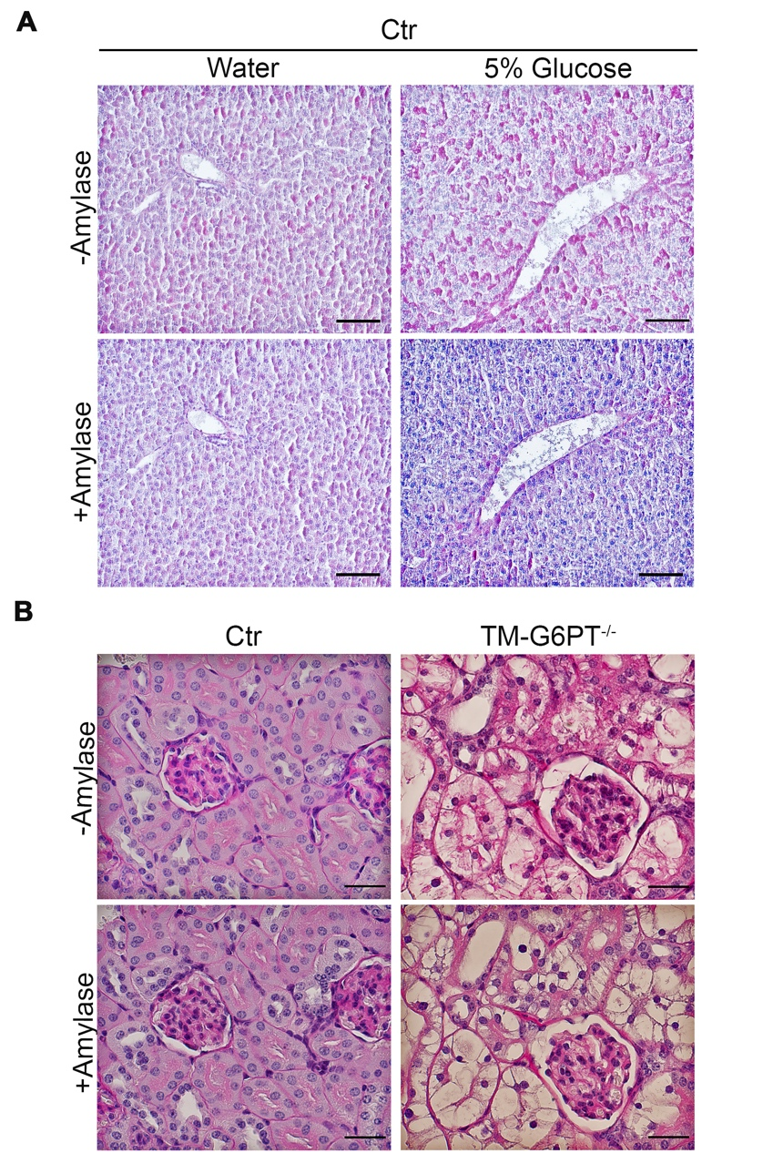

Representative serial sections from liver (A) and renal cortex (B) of control and TM-G6PT^{-/-} mice treated with and without the glycogenolytic enzyme, amylase (scale bar: liver 50µm; kidney 20µm).

Fig-S2. Hexokinase I expression in TKPTS cells cultured at different glucose and insulin concentration

TKPTS cells were cultured with low glucose (5.5 mM, LG) or high glucose (24.9 mM, HG) medium plus or minus insulin (3,4 mg/mL). Baseline hexokinase I (HK1) expression was evaluated by immunoblotting. An increase in HK1 abundance was detected only in high glucose (HG) + insulin treated cells.

