Supplemental Material

SARS-CoV-2 infection during the Omicron surge among patients receiving dialysis: the role of circulating receptor-binding domain antibodies and vaccine doses

Maria E. Montez-Rath, Pablo Garcia, Jialin Han, LinaCel Cadden, Patti Hunsader, Curt Morgan, Russell Kerschmann, Paul Beyer, Mary Dittrich, Geoffrey A Block, Julie Parsonnet, Glenn M Chertow, Shuchi Anand

Table of Contents

STable 1. Observed vaccine type combinations among patients in the main analytic cohort p3
STable 2. Characteristics of patients with a RBD antibody test performed between December 1 through December 24, 2021, alive and on dialysis p4
STable 3. Sensitivity analyses for relative risk of SARS CoV-2 during the Omicron period at varying RBD thresholds and by vaccine type p5
STable 4. Proportions of patients with documented SARS CoV-2 infection by RBD index value categories p6
STable 5. Number of patients included in each 30-day period in Figures 2 A and B. p7
SFigure 1. Boxplots of antibody index values between February 1 through December 24 2021 plotted from days since first dose, measured in 30-day periods. A. mRNA1273 B. BNT162b2 p8
SFigure 2. Boxplots of antibody index values prior to December 24, 2021, plotted by documented SARS-CoV-2 infection and number of vaccine doses p9

STable 1. Observed vaccine type combinations among patients in the main analytic cohort (sorted in decreasing order of observed percent)
Vaccine type combination | Count | Percent
U | 852 | 23.83
BB | 728 | 20.36
MM | 657 | 18.37
MMM | 449 | 12.56
BBB | 344 | 9.62
B | 245 | 6.85
M | 169 | 4.73
MMB | 59 | 1.65
MB | 20 | 0.56
BBM | 20 | 0.56
MBB | 7 | 0.20
MMMM | 6 | 0.17
MBM | 5 | 0.14
BBBB | 5 | 0.14
BM | 4 | 0.11
MBBB | 1 | 0.03
BMM | 1 | 0.03
BMMB | 1 | 0.03
BMB | 1 | 0.03
BBMB | 1 | 0.03
BBBM | 1 | 0.03
U: Unvaccinated; M: mRNA1273; B: BNT162b2.

STable 2. Characteristics of patients with a RBD antibody test performed between December 1 through December 24, 2021, alive and on dialysis
 | IgG index  <23 | IgG index  ≥ 23 | Overall
 | N=1773* (50.6) | N=1731 (49.4) | N=3504 (100)
Age (years), mean (SD) | 61.6 (14.1) | 64.0 (13.9) | 62.8 (14.0)
18 to 44 | 214 (12.1) | 169 (9.8) | 383 (10.9)
45 to 64 | 783 (44.2) | 654 (37.8) | 1437 (41.0)
65 to 79 | 598 (33.7) | 681 (39.3) | 1279 (36.5)
≥ 80 | 178 (10.0) | 227 (13.1) | 405 (11.6)
Women | 758 (42.8) | 722 (41.7) | 1480 (42.2)
Race and Ethnicity
Hispanic | 206 (11.6) | 290 (16.8) | 496 (14.2)
Non-Hispanic Black | 461 (26.0) | 441 (25.5) | 852 (24.3)
Non-Hispanic Other$ | 240 (13.5) | 391 (22.6) | 534 (15.2)
Non-Hispanic White | 533 (30.1) | 294 (17.0) | 974 (27.8)
Missing | 333 (18.8) | 315 (18.2) | 648 (18.5)
Region
Northeast | 177 (10.0) | 142 (8.2) | 319 (9.1)
South | 949 (53.5) | 784 (45.3) | 1733 (49.5)
Midwest | 189 (10.7) | 121 (7.0) | 310 (8.9)
West | 458 (25.8) | 684 (39.5) | 1142 (32.6)
Diabetes | 961 (54.2) | 1073 (62.0) | 2034 (58.0)
Vaccine doses
0 | 604 (34.1) | 228 (13.2) | 832 (23.7)
1 | 210 (11.8) | 194 (11.2) | 404 (11.5)
2 | 753 (42.5) | 620 (35.8) | 1373 (39.2)
3 or more | 206 (11.6) | 689 (39.8) | 895 (25.5)

Data are shown as percentages unless otherwise specified. RBD = receptor-binding domain; SD, standard deviation.
$Persons self-reporting Asian, American Indian, Alaskan, and Pacific Islander heritages are captured as ‘other.’
*IgG index < 10, N=1561; IgG 10-23, N=212

STable 3. Sensitivity analyses for relative risk of SARS CoV-2 during the Omicron period at varying RBD thresholds and by vaccine type
 | Relative risk adjusted for Age, sex, region and prior SARS-CoV-2 infection*
RBD IgG index value
< 1 vs ≥ 1 | 2.3 (1.7, 3.1)
10 vs ≥ 10 | 2.1 (1.7, 2.6)
23 vs ≥ 23 | 2.3 (1.9, 2.9)
30 vs ≥ 30 | 2.3 (1.8, 2.9)
40 vs ≥ 40 | 2.4 (1.9, 3.0)
Vaccine type^
Unvaccinated | Ref
BNT162b2 1-2 doses | 0.69 (0.54, 0.89)
BNT162b2 3+ doses | 0.60 (0.41, 0.87)
mRNA1273 1-2 doses | 0.56 (0.42, 0.75)
mRNA1273 3+ doses | 0.40 (0.24, 0.57)
^ N=3385 for persons with homologous (all doses from the same manufacturer) vaccination
*as documented in the electronic health record

STable 4. Proportions of patients with documented SARS CoV-2 infection by RBD index value categories

RBD IgG Index value | N | N with SARS CoV-2 infection*^
<1 | 189 | 41 (22%)
1 to < 10 | 1372 | 174 (13%)
10 to <23 | 212 | 25 (12%)
23 to < 50 | 195 | 19 (10%)
50 to <100 | 160 | 15 (9%)
≥100 | 1311 | 65 (5%)
^()=% of total in the RBD index value category with COVID-19
*as documented in the electronic health record

STable 5. Number of patients included in each 30-day period in Figures 2A and B.
Days since  first dose |  | mRNA1273 |  |  | BNT162b2
 |  | 1-2 doses | 3+ doses |  | 1-2 doses | 3+ doses
0-30 |  | 149 | 1,105 |  | 669 | 568
31-60 |  | 152 | 1,086 |  | 675 | 560
61-90 |  | 142 | 1,128 |  | 682 | 573
91-120 |  | 134 | 1,113 |  | 681 | 558
121-150 |  | 137 | 1,121 |  | 663 | 549
151-180 |  | 134 | 1,121 |  | 662 | 555
181-210 |  | 129 | 1,106 |  | 669 | 541
211-240 |  | 125 | 1,103 |  | 639 | 525
241-270 |  | 107 | 1,041 |  | 372 | 311
271-300 |  | 56 | 694 |  | 234 | 178
301-330 |  | 27 | 336 |  | 117 | 99

SFigure 1. Boxplots of antibody index values between February 1 through December 24 2021 plotted by days since first dose, measured in 30-day periods. A. mRNA1273 B. BNT162b2
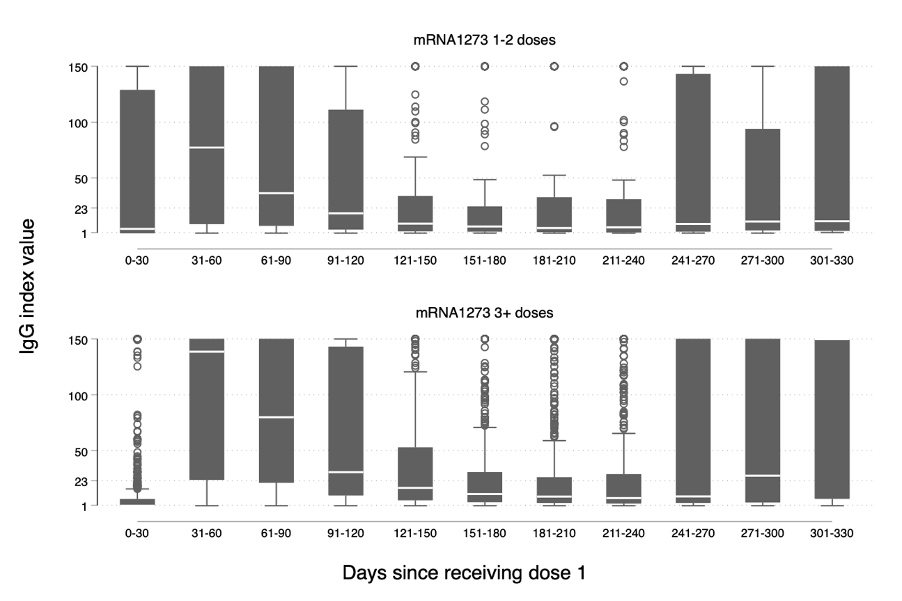
A

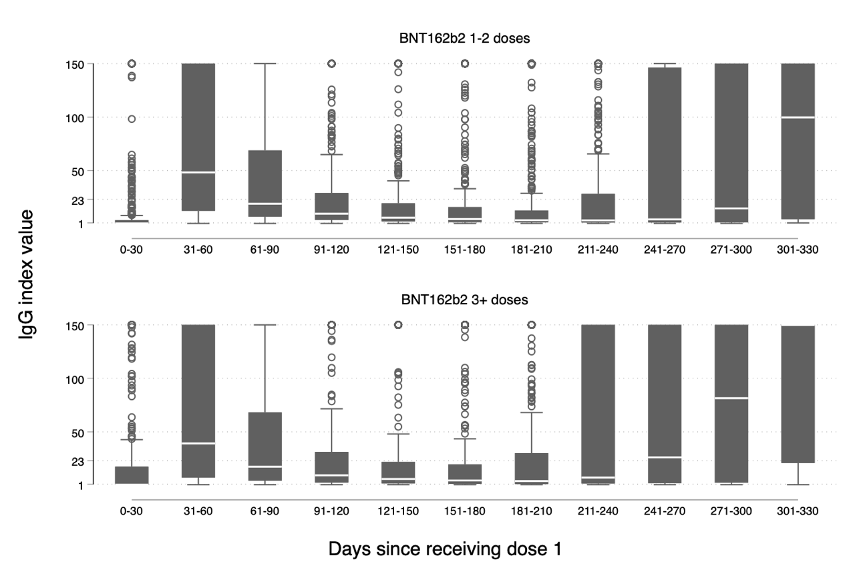
B

SFigure 2. Boxplots of antibody index values plotted by documented SARS-CoV-2 infection and number of vaccine doses
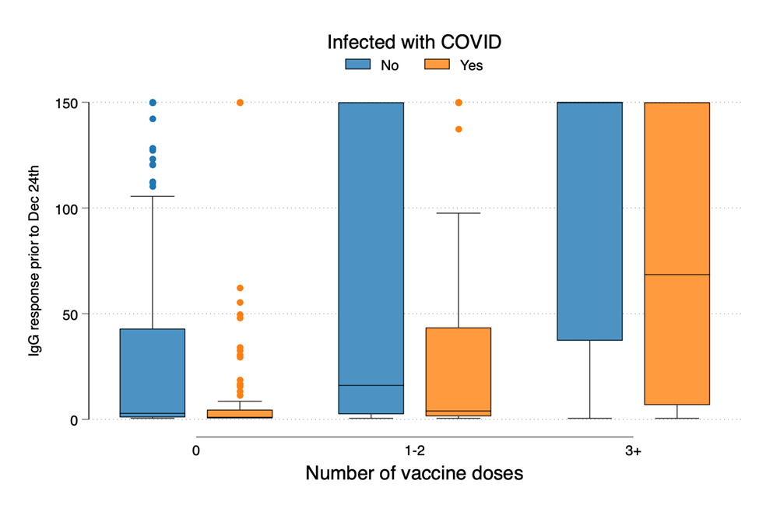

Note that, median values for those patients with 3+ doses who did not contract a documented infection is ≥150.

