Supplemental Material

Supplemental Table of Contents:

Supplementary Table 1. List of candidate predictors

Supplementary Table 2. Risk adjusted models using the current SRTR 1-year graft failure endpoint and the proposed composite endpoint of either 1-year graft failure and/or eGFR <30 ml/min.

Supplementary Table 3. Risk prediction model with linear spline in graft failure event

Supplementary table 4. Risk Prediction model with linear spline in Composite metric

Supplementary Figure 1. Relationship between the log-odds and each continuous predictor in the risk prediction models.

Supplementary Figure 2. Calibration plot comparing observed probabilities vs. predicted probabilities estimated from the model using: a). the traditional endpoint on training data and b). the traditional endpoint on testing data; c). composite endpoint on training data and d). composite endpoint on testing data.

Supplementary Table 1. List of candidate predictors

Category | Description | % Missing
Recipient Demographics | Recipient Age (yrs) | 0%
 | Recipient Gender | 0%
 | Recipient Ethnicity Category | 0%
 | Body Mass Index (kg/m²) | 0.1%
 | Recipient Highest Educational Level at Registration | 4.9%
 | Recipient Functional Status at Transplant | 2.7%
 | Recipient Primary Payment Source at Transplant | 0.1%
 | Recipient Work for Income at Transplant? | 0.3%
Recipient Medical | Total Days on Kidney Waiting List | 0%
 | Total Days on Dialysis | 10.7%
 | Recipient CMV Status at Transplant | 1.4%
 | Recipient Epstein Barr Virus Status at Transplant | 0%
 | Recipient Hepatitis B-Core Antibody | 0%
 | Recipient Hep B Surface Antigen | 0%
 | Recipient HBV Surface Antibody Total at Transplant | 62.0%
 | Recipient Hep C Status | 0%
 | Recipient HIV Serostatus at Transplant | 0%
 | Any Previous Malignancy? | 0%
 | Recipient Peripheral Vascular Disease at Registration | 0.3%
 | Recipient Diabetes at Registration | 0%
 | Recipient Total Serum Albumin at Registration (g/dL) | 7.5%
 | Number Previous Kidney Transplants | 0%
 | Kidney Recipient Primary Diagnosis at Transplant | 0%
 | Candidate Most Recent Calculated PRA | 0%
 | Recipient Serum Creatinine at Time of Transplant (mg/dL) | 0.8%
 | Recipient Pretransplant Dialysis at Transplant | <0.1%
Donor | Donor Gender | 0%
 | Deceased Donor-History of Cigarettes in Past (>20 pack Yrs) | 0%
 | Deceased Donor-History of Cocaine Use in Past | <0.1%
 | Deceased Donor-History of Other Drug Use in Past | <0.1%
 | Deceased Donor-History of Diabetes | 0%
 | Deceased Donor-History of Cancer | 0%
 | Deceased Donor-History of Hypertension | 0%
 | Deceased Donor-Antihypertensives within 24 Hrs Pre-Cross Clamp | <0.1%
 | Deceased Donor-Was Donor Given Insulin within 24 Hrs Pre Cross Clamp | <0.1%
 | Deceased Donor-Terminal Blood Urea Nitrogen (mg/dL) | 0%
 | Deceased Donor-Synthetic Anti Diuretic Hormone (DDAVP) | <0.1%
 | Deceased Donor Inotropic Medication at Procurement | <0.1%
 | Deceased Donor Protein in Urine | 0%
 | Deceased Donor-Diuretics B/N Brain Death W/In 24 Hrs of Procurement | <0.1%
 | Deceased Donor-Steroids B/N Brain Death W/In 24 Hrs of Procurement | <0.1%
 | Deceased Donor-Vasodilators within 24hrs Pre-Cross Clamp | <0.1%
 | Deceased Donor-Was Donor Given Arginine Vasopressin within 24 Hrs Pre Cross Clamp? | <0.1%
 | Donor Serology Anti CMV | 0%
 | Deceased Donor Epstein Barr Virus by IgM Test Result | 0%
 | Deceased Donor Epstein Barr Virus by IgG Test Result | 0%
 | Deceased Donor HBsAb Test Result | <0.1%
 | Donor HBV Core Antibody | 0%
 | Donor Hep B Surface Antigen | 0%
 | Deceased Donor-Triiodothyronine-T3 B/N Brain Death W/In 24 Hrs of Procurement (Y/N) | <0.1%
 | Deceased Donor-Thyroxine-T4 B/N Brain Death W/In 24 Hrs of Procurement (Y/N) | <0.1%
 | Deceased Donor-RPR-VDRL Result | 0%
 | Expanded Criteria Donor | 0%
 | Deceased Donor-Terminal SGOT/AST (IU/L) | 0%
 | Deceased Donor-Terminal SGPT/ALT (IU/L) | 0%
 | AST/ALT Ratio | 0%
 | Deceased Donor-Terminal Total Bilirubin (mg/dL) | 0%
Transplant | HLA Mismatch Level | 0%
 | KDRI | 0.3%
 | Candidate Tested for Anti HLA Antibodies | 53.2%
 | Cold Ischemic Time (Hours) | 0%
 | Deceased Donor-Left/Right Kidney %Glomerulosclerosis at Recovery | 0.9%
 | Distance From Donor Hosp to Transplant Center (Nautical Miles) | 0%
 | Allocation Type-Local/Regional/National | 0%
 | Kidney Received on Ice Or Pump | 0%
 | Kidney Transplant Procedure Type | 0%

Supplementary Table 2. Risk adjusted models using the current SRTR 1-year graft failure endpoint and the proposed composite endpoint of either 1-year graft failure and/or eGFR <30 ml/min.

Variable | Current SRTR 1-year graft failure model |  |  | Proposed composite metric of 1-year graft failure and eGFR <30 ml/min
 | Coefficient | OR (95% CI) | P |  | Coefficient | OR (95% CI) | P
Age (years) | 0.0111 | 1.01 (1.01, 1.01) | <.0001 |  | 0.00884 | 1.01 (1.01, 1.01) | <.0001
Race/Ethnicity
NHW vs. Hispanics | 0.2236 | 1.25 (1.15, 1.37) | <.0001 |  | 0.3116 | 1.37 (1.27, 1.47) | <.0001
Black vs. Hispanics | 0.2344 | 1.26 (1.16, 1.38) | <.0001 |  | 0.2909 | 1.34 (1.25, 1.44) | <.0001
Other vs.Hispanics | 0.0524 | 1.05 (0.93, 1.19) | 0.41 |  | 0.0476 | 1.05 (0.95, 1.16) | 0.36
BMI | 0.0153 | 1.02 (1.01, 1.02) | <.0001 |  | 0.0302 | 1.03 (1.03, 1.03) | <.0001
Function Status
Effort vs. Normal | 0.0275 | 1.03 (0.96, 1.10) | 0.42 |  | 0.0442 | 1.05 (0.99, 1.10) | 0.10
Dependent vs. Normal | 0.2445 | 1.28 (1.16, 1.40) | <.0001 |  | 0.1893 | 1.21 (1.12, 1.30) | <.0001
Disabled vs. Normal | 0.4921 | 1.64 (1.39, 1.93) | <.0001 |  | 0.3745 | 1.45 (1.26, 1.67) | <.0001
Insurance
Public vs. Private/Self | 0.2204 | 1.25 (1.15, 1.35) | <.0001 |  | 0.187 | 1.21 (1.13, 1.28) | <.0001
Work for Income
No vs. Yes | 0.1960 | 1.22 (1.13, 1.31) | <.0001 |  | 0.0996 | 1.10 (1.04, 1.17) | 0.001
Unknown vs. Yes | 0.1854 | 1.20 (1.05, 1.38) | 0.008 |  | 0.0256 | 1.03 (0.92, 1.15) | 0.65
Recipient HBsAb
Negative vs. Positive | 0.0800 | 1.08 (0.98, 1.20) | 0.12 |  | 0.0828 | 1.09 (1.01, 1.17) | 0.037
Unknown vs. Positive | 0.3650 | 1.44 (1.34, 1.55) | <.0001 |  | 0.2681 | 1.31 (1.24, 1.38) | <.0001
Recipient History of PVD
Yes vs. No | 0.2684 | 1.31 (1.20, 1.43) | <.0001 |  | 0.1334 | 1.14 (1.06, 1.23) | 0.0003
Recipient History of Diabetes
Yes vs. No | 0.1619 | 1.18 (1.11, 1.25) | <.0001
Unknown vs. No | 0.18 | 1.20 (0.98, 1.46) | 0.07
Serum Album (g/dL) | -0.1201 | 0.89 (0.84, 0.93) | <.0001 |  | -0.1076 | 0.90 (0.86, 0.93) | <.0001
Previous Kidney Transplant
Yes vs. No | 0.3289 | 1.39 (1.28, 1.51) | <.0001
Pre-Transplant Dialysis
Yes vs. No | 0.3998 | 1.49 (1.33, 1.67) | <.0001 |  | 0.2198 | 1.25 (1.14, 1.36) | <.0001
Donor Smoking Status
Yes vs. No |  |  |  |  | 0.0875 | 1.09 (1.04, 1.15) | 0.001
Donor History of Drug Use
No vs. Yes |  |  |  |  | 0.169 | 1.18 (1.13, 1.24) | <.0001
Donor History of Diabetes
Yes vs. No | 0.121 | 1.13 (1.03, 1.24) | 0.01 |  | 0.0463 | 1.05 (0.97, 1.13) | 0.22
Donor History of HTN
Yes vs. No |  |  |  |  | 0.0633 | 1.07 (1.01, 1.13) | 0.02
Donor BUN (mg/dL) |  |  |  |  | 0.00591 | 1.01 (1.00, 1.01) | <.0001
Donor Arginine
No vs. Yes | 0.1096 | 1.12 (1.06, 1.18) | 0.0001 |  | 0.1693 | 1.18 (1.13, 1.24) | <.0001
Donor ALT (log10) |  |  |  |  | -0.1913 | 0.83 (0.78, 0.87) | <.0001
KDRI | 0.9191 | 2.51 (2.29, 2.74) | <.0001 |  | 1.2818 | 3.60 (3.29, 3.95) | <.0001
Cold Ischemic Hours | 0.0135 | 1.01 (1.01, 1.02) | <.0001 |  | 0.0142 | 1.01 (1.01, 1.02) | <.0001
Glomerulosclerosis%
<10 vs. Indeterminate |  |  |  |  | 0.1061 | 1.11 (1.05, 1.18) | 0.0003
≥10 vs. Indeterminate |  |  |  |  | 0.4241 | 1.53 (1.40, 1.67) | <.0001
Procedure Type
Unilateral vs. Sequential |  |  |  |  | 0.7276 | 2.07 (1.68, 2.55) | <.0001
EN-BLOC vs. Sequential |  |  |  |  | 0.4756 | 1.61 (1.23, 2.11) | 0.0006

Supplementary Table 3. Risk prediction model with linear spline in graft failure event
Variable | Graft failure model |  | Graft failure model with linear spline
 | Coefficient | P | Coefficient | P
Age, linear | 0.0111 | <.0001 | -0.0257 | <.0001
Apply to > 40 |  |  | 0.0793 | 0.0002
Apply to > 45 |  |  | -0.059 | 0.008
Apply to > 55 |  |  | 0.0383 | 0.03
Apply to > 60 |  |  | -0.009 | 0.51
Race/Ethnicity
NHW vs. Hispanics | 0.2236 | <.0001 | 0.2053 | <.0001
Black vs. Hispanics | 0.2344 | <.0001 | 0.2423 | <.0001
Other vs. Hispanics | 0.0524 | 0.41 | 0.0429 | 0.5
BMI, linear | 0.0153 | <.0001 | -0.0087 | 0.23
Apply to > 28 |  |  | 0.075 | 0.01
Apply to > 30 |  |  | -0.0413 | 0.15
Function Status
Effort vs. Normal | 0.0275 | 0.42 | 0.0306 | 0.37
Dependent vs. Normal | 0.2445 | <.0001 | 0.2463 | <.0001
Disabled vs. Normal | 0.4921 | <.0001 | 0.5074 | <.0001
Insurance
Public vs. Private/Self | 0.2204 | <.0001 | 0.2041 | <.0001
Work for Income
No vs. Yes | 0.196 | <.0001 | 0.168 | <.0001
Unknown vs. Yes | 0.1854 | 0.008 | 0.1666 | <.0001
Recipient HBsAb
Negative vs. Positive | 0.08 | 0.12 | 0.0818 | 0.02
Unknown vs. Positive | 0.365 | <.0001 | 0.3734 | <.0001
Recipient History of PVD
Yes vs. No | 0.2684 | <.0001 | 0.2722 | <.0001
Recipient History of Diabetes
Yes vs. No | 0.1619 | <.0001 | 0.1765 | <.0001
Unknown vs. No | 0.18 | 0.07 | 0.2062 | 0.04
Serum Album, linear | -0.1201 | <.0001 | -0.3948 | 0.0009
Apply to > 3 |  |  | 0.7287 | 0.11
Apply to > 3.2 |  |  | -0.4693 | 0.24
Apply to > 4.6 |  |  | 0.5213 | 0.2
Apply to > 4.8 |  |  | -0.4361 | 0.34
Previous Kidney Transplant
Yes vs. No | 0.3289 | <.0001 | 0.3316 | <.0001
Pre-Transplant Dialysis
Yes vs. No | 0.3998 | <.0001 | 0.4089 | <.0001
Donor History of Diabetes
Yes vs. No | 0.121 | 0.01 | 0.1308 | 0.006
Donor Arginine
No vs. Yes | 0.1096 | 0.0001 | 0.1016 | 0.0004
KDRI, linear | 0.9191 | <.0001 | 1.0527 | 0.014
Apply to > 0.8 |  |  | 0.9711 | 0.31
Apply to > 0.9 |  |  | -1.0855 | 0.14
Apply to > 1.3 |  |  | 0.2864 | 0.77
Apply to > 1.4 |  |  | -0.457 | 0.81
Apply to > 1.5 |  |  | -0.5011 | 0.83
Apply to > 1.6 |  |  | -0.1348 | 0.96
Apply to > 1.7 |  |  | 0.7013 | 0.7
Apply to > 2 |  |  | -1.422 | 0.14
Cold Ischemic Hours, linear | 0.0135 | <.0001 | 0.0654 | 0.12
Apply to > 6 |  |  | -0.0397 | 0.4
Apply to > 14 |  |  | -0.0506 | 0.24
Apply to > 16 |  |  | 0.0371 | 0.58
Apply to > 18 |  |  | 0.0015 | 0.97

Supplementary table 4. Risk Prediction model with linear spline in Composite metric
Variable | Composite Metric |  | Composite Metric with Linear Spline
 | Coefficient | P | Coefficient | P
Age, linear | 0.00884 | <.0001 | -0.0132 | <.0001
Apply to > 40 |  |  | 0.0493 | 0.004
Apply to > 45 |  |  | -0.0408 | 0.02
Apply to > 55 |  |  | 0.0287 | 0.04
Apply to > 60 |  |  | -0.0067 | 0.55
Race/Ethnicity
NHW vs. Hispanics | 0.3116 | <.0001 | 0.3004 | <.0001
Black vs. Hispanics | 0.2909 | <.0001 | 0.2939 | <.0001
Other vs. Hispanics | 0.0476 | 0.36 | 0.0338 | 0.52
BMI, linear | 0.0302 | <.0001 | 0.0127 | 0.03
Apply to > 28 |  |  | 0.0427 | 0.0687
Apply to > 30 |  |  | -0.0154 | 0.49
Function Status
Effort vs. Normal | 0.0442 | 0.1 | 0.0468 | 0.08
Dependent vs. Normal | 0.1893 | <.0001 | 0.192 | <.0001
Disabled vs. Normal | 0.3745 | <.0001 | 0.3854 | <.0001
Insurance
Public vs. Private/Self | 0.187 | <.0001 | 0.1755 | <.0001
Work for Income
No vs. Yes | 0.0996 | 0.001 | 0.0845 | 0.005
Unknown vs. Yes | 0.0256 | 0.65 | 0.0181 | 0.75
Recipient HBsAb
Negative vs. Positive | 0.0828 | 0.037 | 0.0831 | 0.04
Unknown vs. Positive | 0.2681 | <.0001 | 0.2776 | <.0001
Recipient History of PVD
Yes vs. No | 0.1334 | 0.0003 | 0.1381 | 0.0002
Serum Album, linear | -0.1076 | <.0001 | -0.304 | 0.003
Apply to > 3 |  |  | 0.317 | 0.41
Apply to > 3.2 |  |  | -0.0969 | 0.77
Apply to > 4.6 |  |  | 0.1002 | 0.76
Apply to > 4.8 |  |  | -0.1771 | 0.63
Pre-Transplant Dialysis
Yes vs. No | 0.2198 | <.0001 | 0.2271 | <.0001
Donor Smoking Status
Yes vs. No | 0.0875 | 0.02 | 0.0537 | 0.046
Donor History of Drug Use
No vs. Yes | 0.169 | <.0001 | 0.1477 | <.0001
Donor History of Diabetes
Yes vs. No | 0.0463 | 0.22 | 0.0656 | 0.078
Donor History of HTN
Yes vs. No | 0.0633 | 0.02 | 0.0233 | 0.41
Donor BUN, linear | 0.00591 | <.0001 | 0.0095 | <.0001
Apply to > 30 |  |  | -0.0097 | 0.005
Donor Arginine
No vs. Yes | 0.1693 | <.0001 | 0.1604 | <.0001
Donor ALT (log10), linear | -0.1913 | <.0001 | -0.2082 | 0.0023
Apply to > 1.59 |  |  | 0.0253 | 0.7933
KDRI, linear | 1.2818 | <.0001 | 1.741 | <.0001
Apply to > 0.8 |  |  | 0.5773 | 0.48
Apply to > 0.9 |  |  | -0.6322 | 0.3
Apply to > 1.3 |  |  | -0.7559 | 0.3
Apply to > 1.4 |  |  | -0.3095 | 0.83
Apply to > 1.5 |  |  | 1.0813 | 0.55
Apply to > 1.6 |  |  | -1.8874 | 0.34
Apply to > 1.7 |  |  | 0.9685 | 0.49
Apply to > 2 |  |  | -0.7255 | 0.32
Cold Ischemic Hours, linear | 0.0142 | <.0001 | 0.0197 | 0.53
Apply to > 6 |  |  | -0.0042 | 0.91
Apply to > 14 |  |  | 0.0032 | 0.93
Apply to > 16 |  |  | -0.0339 | 0.52
Apply to > 18 |  |  | 0.033 | 0.23
Glomerulosclerosis%
<10 vs. Indeterminate | 0.1061 | 0.0003 | 0.0473 | 0.11
≥10 vs. Indeterminate | 0.4241 | <.0001 | 0.3539 | <.0001
Procedure Type
Unilateral vs. Sequential | 0.7276 | <.0001 | 0.608 | <.0001
EN-BLOC vs. Sequential | 0.4756 | 0.0006 | 0.2637 | 0.057

Supplementary Figure 1. Relationship between the log-odds and each continuous predictor in the risk prediction models.

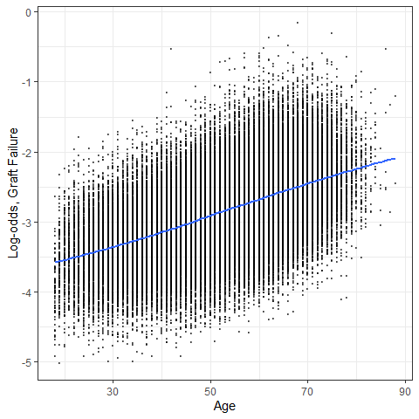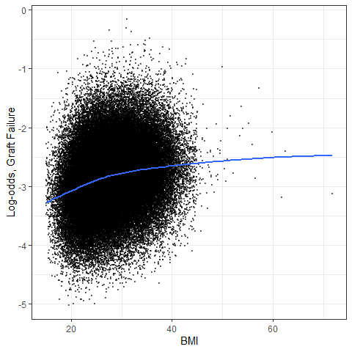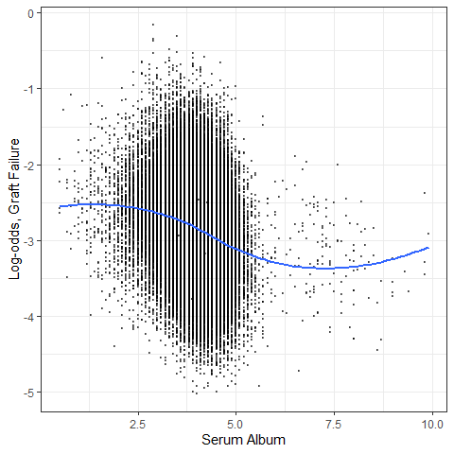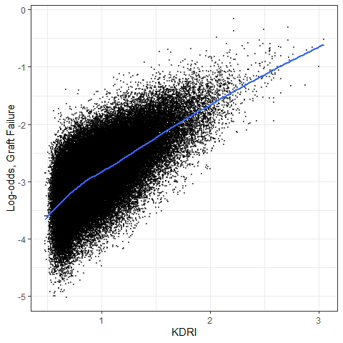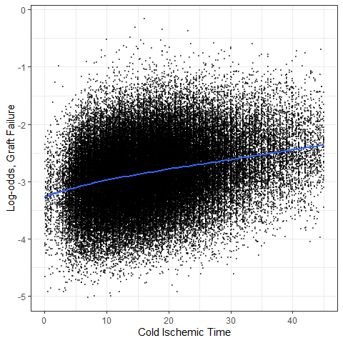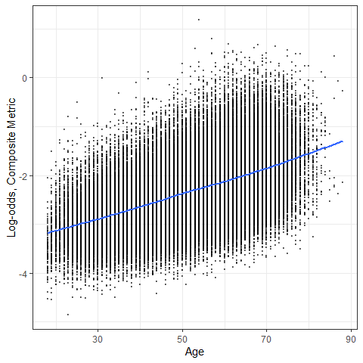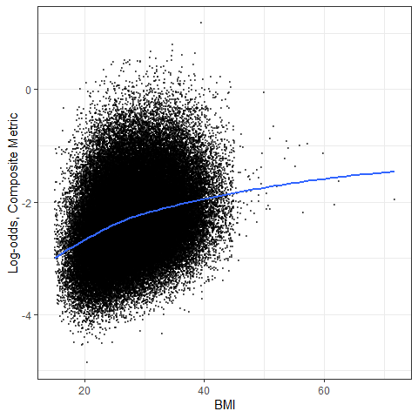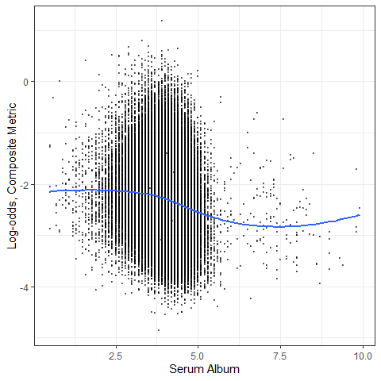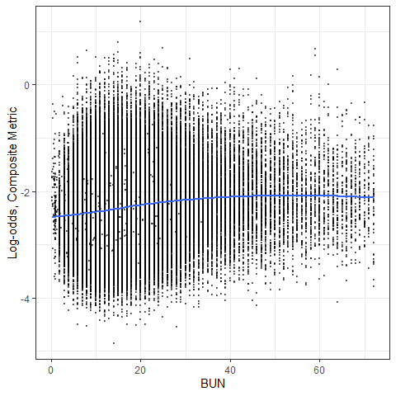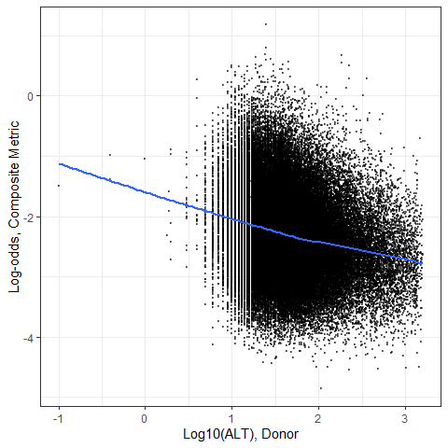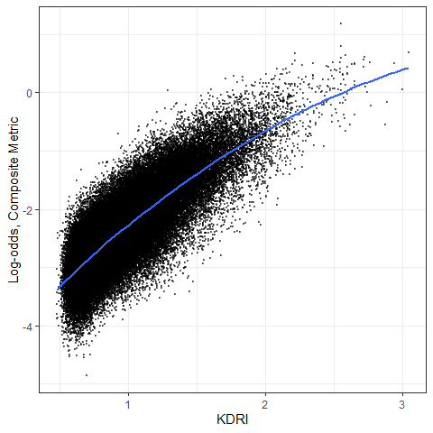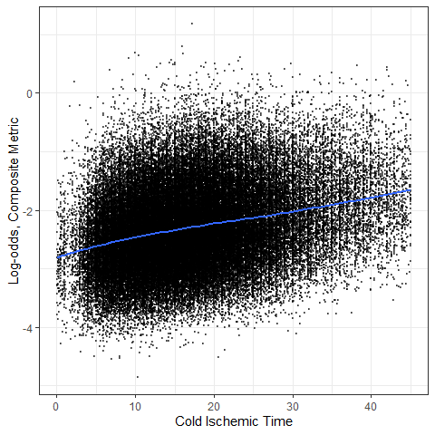

Supplementary Figure 2. Calibration plot comparing observed probabilities vs. predicted probabilities estimated from the model using: a). the traditional endpoint on training data and b). the traditional endpoint on testing data; c). composite endpoint on training data and d). composite endpoint on testing data.
.

