Supplementary Appendix

Albuminuria lowering effect of eplerenone, dapagliflozin and their combination in patients with chronic kidney disease

Content:
Supplement 1: Full list of ROTATE-3 Investigators
Table 1: Percent change from baseline in 24-hour urinary albumin excretion at week 4
Table 2: UACR change after adjustment for concomitant blood pressure and body weight changes

Figure 1: Trial profile
Figure 2: Changes in systolic blood pressure in patient subgroups during treatment with dapagliflozin, eplerenone and dapagliflozin-eplerenone
Figure 3: Changes in eGFR in patient subgroups during treatment with dapagliflozin, eplerenone and dapagliflozin-eplerenone

Appendix 1: ROTATE-3 Investigators
Italy - University of Campania, Naples, Italy
- Luigi Pennino
- Ilaria De Gregorio
- Lucio Polese
- Alfredo Caturano
- Roberto Minutolo
- Ferdinando Sasso

Italy – University of Catanzaro, Catanzaro, Italy
- Ida Gagliardi,
- Mariateresa Zicarelli
- Giuseppina Crugliano

Spain – Clinic University hospital, INCLIVA Health Research Institute Valencia Spain
- Elena Gimenez Civera
- Nayara Panizo

Netherlands – University of Groningen, Groningen, Netherlands
- Taha Sen
- Di Xie

Supplement table 1: Percent change from baseline in 24-hour urinary albumin excretion at week 4 (95% confidence interval)
 | Dapagliflozin | Eplerenone | Dapagliflozin-eplerenone
Change from baseline | -19.2% (-34.2, -0.9) | -34.2 (-46.7, -18.9) | -52.9 (-61.7, -42.1)
Difference vs dapagliflozin |  | -22.8 (-60.4, 5.9)  P=0.1290 | -41.7 (-55.1, -24.3)  P=<0.0001
Difference vs eplerenone |  |  | -28.4 (-45.2, -6.5)  P=0.0149

Supplement table 2: UACR change after adjustment for concomitant blood pressure and body weight changes

 | Dapagliflozin-eplerenone vs dapagliflozin | Dapagliflozin-eplerenone vs eplerenone
No adjustment | -41.6 (-55.2, -23.9) | -29.1 (-45.8, -7.3)
Adjustment for systolic blood pressure | -39.6 (-53.7, -21.1) | -26.8 (-44.1, -4.2)
Adjustment for body weight | -41.7 (-24.3, -55.1) | -28.4 (-45.2, -6.5)
Adjustment systolic blood pressure and body weight | -39.6 (-53.6, -21.5) | -25.9 (-43.2, -3.1)

Figure 1: Trial profile
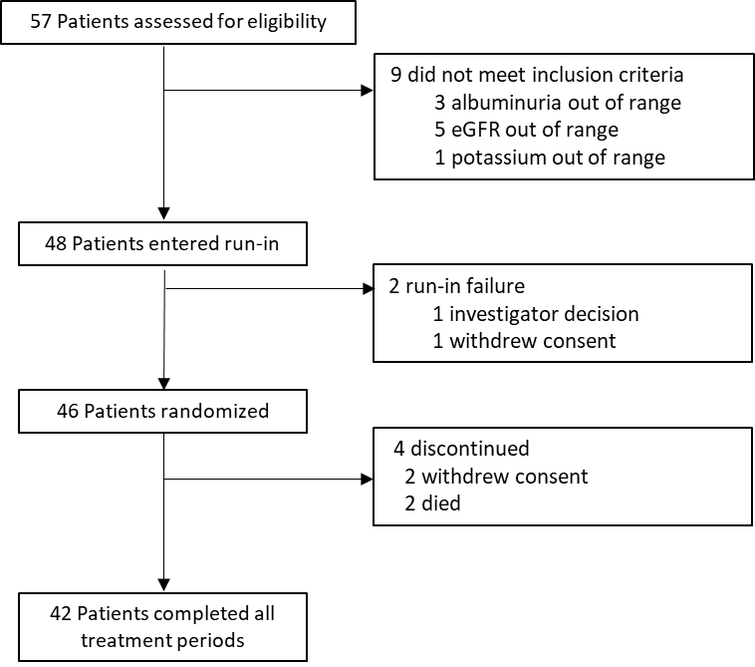

One patient withdrew consent after completing 2 treatment periods; one patient withdrew consent during the first treatment period.

Figure 2: Changes in systolic blood pressure in patient subgroups during treatment with dapagliflozin, eplerenone and dapagliflozin-eplerenone
Figure 3: Changes in eGFR in patient subgroups during treatment with dapagliflozin, eplerenone and dapagliflozin-eplerenone

