**Supplementary Materials:**

**Blood transcriptomes of SARS-CoV-2 infected kidney transplant recipients associate with immune insufficiency proportionate to severity**

**Supplementary Figures**

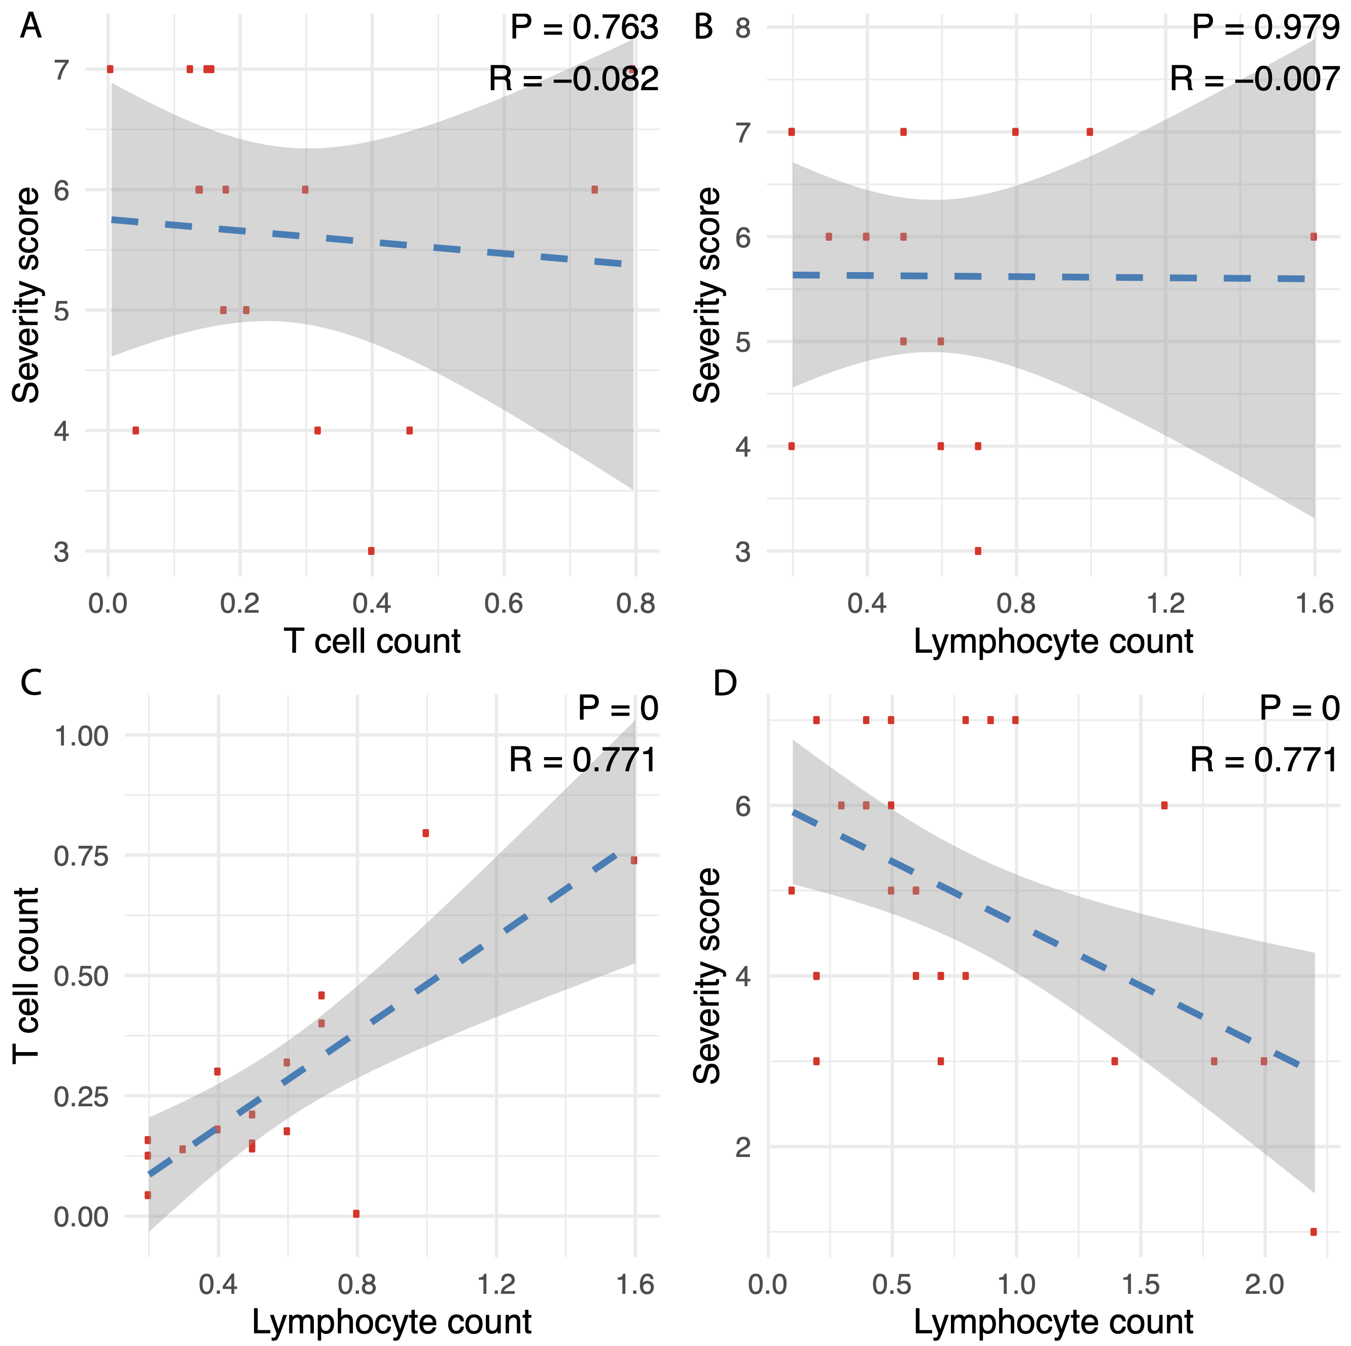

**Figure S1. Correlation of Lymphocyte count, T cell count, and severity score.** Correlation analyses were performed in the 16 acute KTRs with T cell count information for (**A**) T cell count vs. severity score, (**B**) lymphocyte count vs. severity score, and (**C**) lympocypte count vs. T cell count. Pearson correlation coefficient and accompanied p-value are shown. (**D**) correlation between lymphocyte count and severity score was calculated in all 31 acute KTRs.

**Figure S2. Functional enrichment of COVID-19 severity associated genes in the 16 acute KTRs with T cell count information.** Differentially expressed genes (DEGs) in KTRs with high severity score (6-7) versus moderate severity score (3-5) were derived at nominal p-value ≤ 0.05, adjusted by age, gender and T cell count.



**Figure S3. Anti-SARS-CoV-2 evaluation in COVID-19 KTRs.** Contemporaneous serum samples collected in acute (n = 24/31) and post-acute KTRs (n = 28/33) were evaluated using the One-Lambda Luminex platform (see methods). (**A**) Linear regression lines (with ± SD bands) show relationships of COVID-19 severity score in acute KTRs against MFI of anti-Spike , anti-RBD, and anti-Nucleocapsid IgG. Red lines in each plot show MFI cut-offs (by manufacturer) for positive vs. negative IgG responses. (**B**) Stacked bar graphs show percentage of anti-SARS-CoV-2 IgG seropositives among acute KTRs stratified by cumulative IS score, while (**C**) bar graphs compare IgG seropositivity rates in acute vs post-acute KTRs. SD: standard deviation; IS: immunosuppression; MFI: mean fluorescence intensity; IgG: Immunoglobulin G; P-value was derived from Fisher’s exact test.

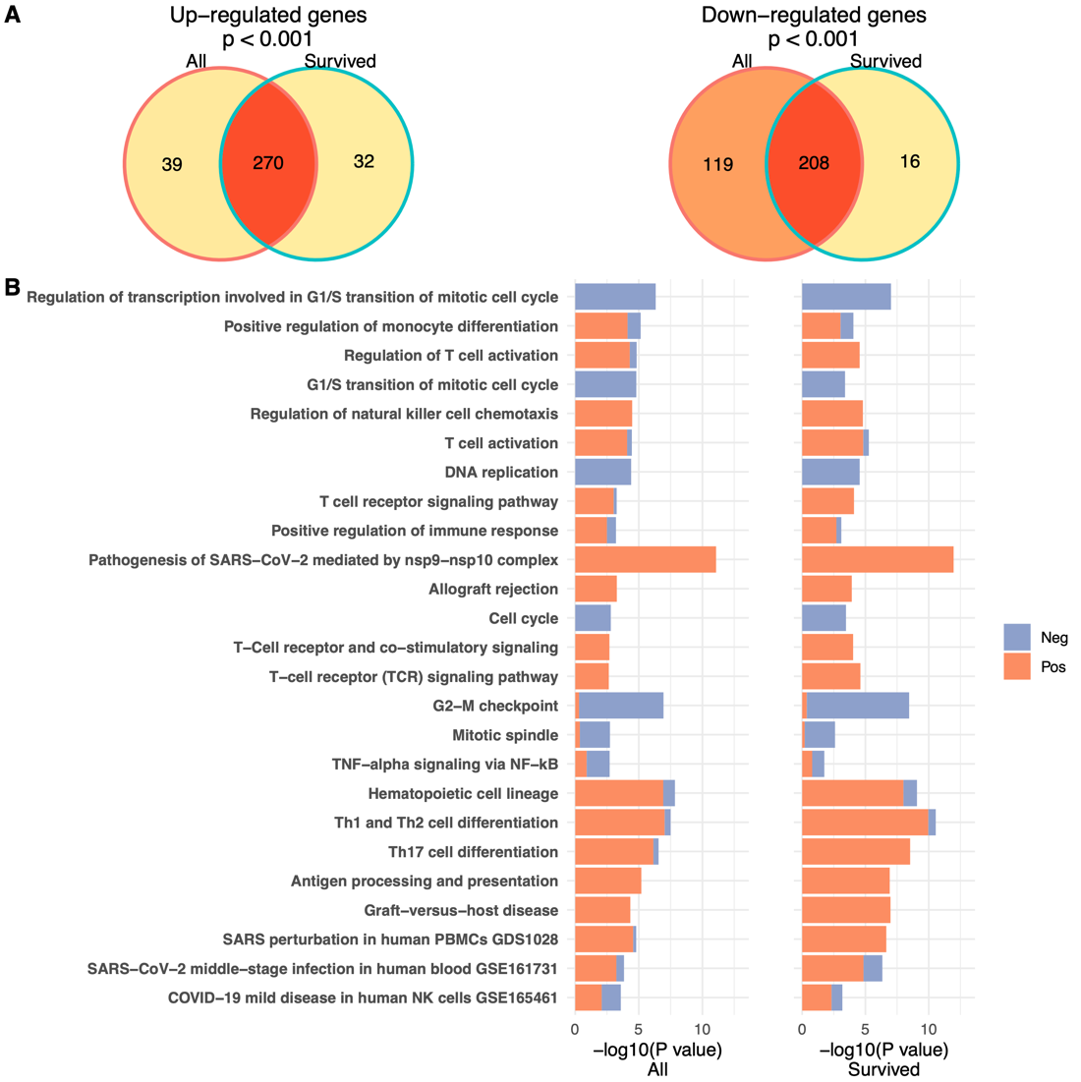

**Figure S4. Sensitivity analysis in comparison of transcriptomes in post-acute versus survived acute KTRs.** The results from the original analysis (post-acute [n = 33] vs. whole group of acute KTRs [n = 31]) and the sensitivity analysis (post-acute [n = 33] vs. the subset of survived acute KTRs [n = 23]) are compared side by side. (**A**) Venn diagrams of overlapped differentially expressed genes (DEGs) from the original analysis and the sensitivity analysis are shown for up-regulated and down-regulated genes respectively (hypergeometric test p-value < 0.001). DEGs were identified with nominal p ≤ 0.01. (**B**) Pathways enriched in DEGs with the proportion of up- and down-regulated genes colored in red and blue correspondingly. The original analysis is on the left panel while the sensitivity analysis is on the right panel.

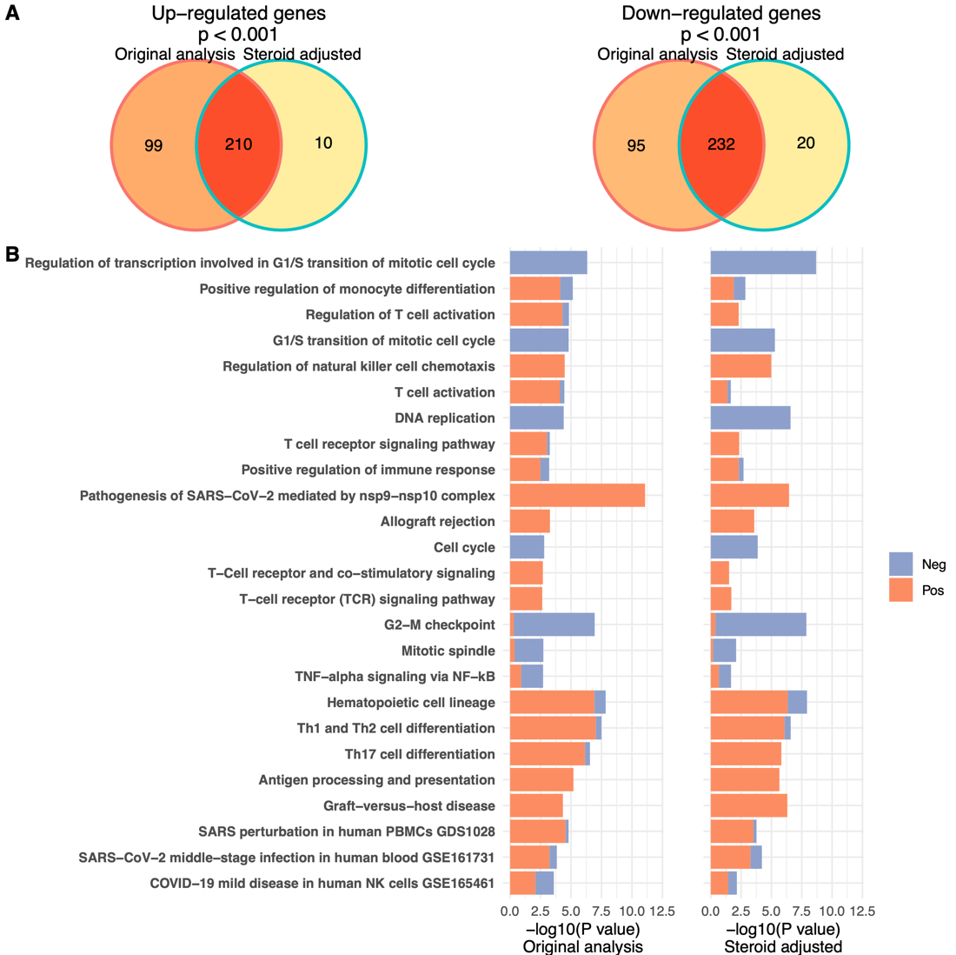

**Figure S5. Sensitivity analysis accounting for steroids dosage in comparison of transcriptomes in post-acute versus acute KTRs.** The results from the original analysis and the sensitivity analysis, in which dosage of steroids was included into adjusted covariates, are compared side by side. (**A**) Venn diagrams of overlapped differentially expressed genes (DEGs) from the original analysis and the sensitivity analysis are shown for up-regulated and down-regulated genes respectively (hypergeometric test p-value < 0.001). DEGs were identified with nominal p ≤ 0.01. (**B**) Pathways enriched in DEGs with the proportion of up- and down-regulated genes colored in red and blue correspondingly. The original analysis is on the left panel while the sensitivity analysis is on the right panel.

**Figure S6. Sensitivity analysis accounting for cumulative immunosuppression in comparison of transcriptomes in post-acute versus acute KTRs.** The results from the original analysis and the sensitivity analysis, which included cumulative IS (CNI + MMF + Steroids) to adjusted covariates, are compared side by side. (**A**) Venn diagrams of overlapped differentially expressed genes (DEGs) from the original analysis and the sensitivity analysis are shown for up-regulated and down-regulated genes respectively (hypergeometric test p-value < 0.001). DEGs were identified with nominal p ≤ 0.01. (**B**) Pathways enriched in DEGs with the proportion of up- and down-regulated genes colored in red and blue correspondingly. The original analysis is on the left panel while the sensitivity analysis is on the right panel.

**Figure S7. Pathways enriched in DEGs associated with COVID-19 severity in acute and post-acute KTRs.** DEGs associated with the severity score were determined at nominal p-value ≤ 0.01 in acute and post-acute KTRs respectively. In acute KTRs, differential expression analysis was adjusted by age, gender, and lymphocyte count, while in post-acute KTRs, adjusted by age, gender, and days after initial COVID-19 diagnosis.

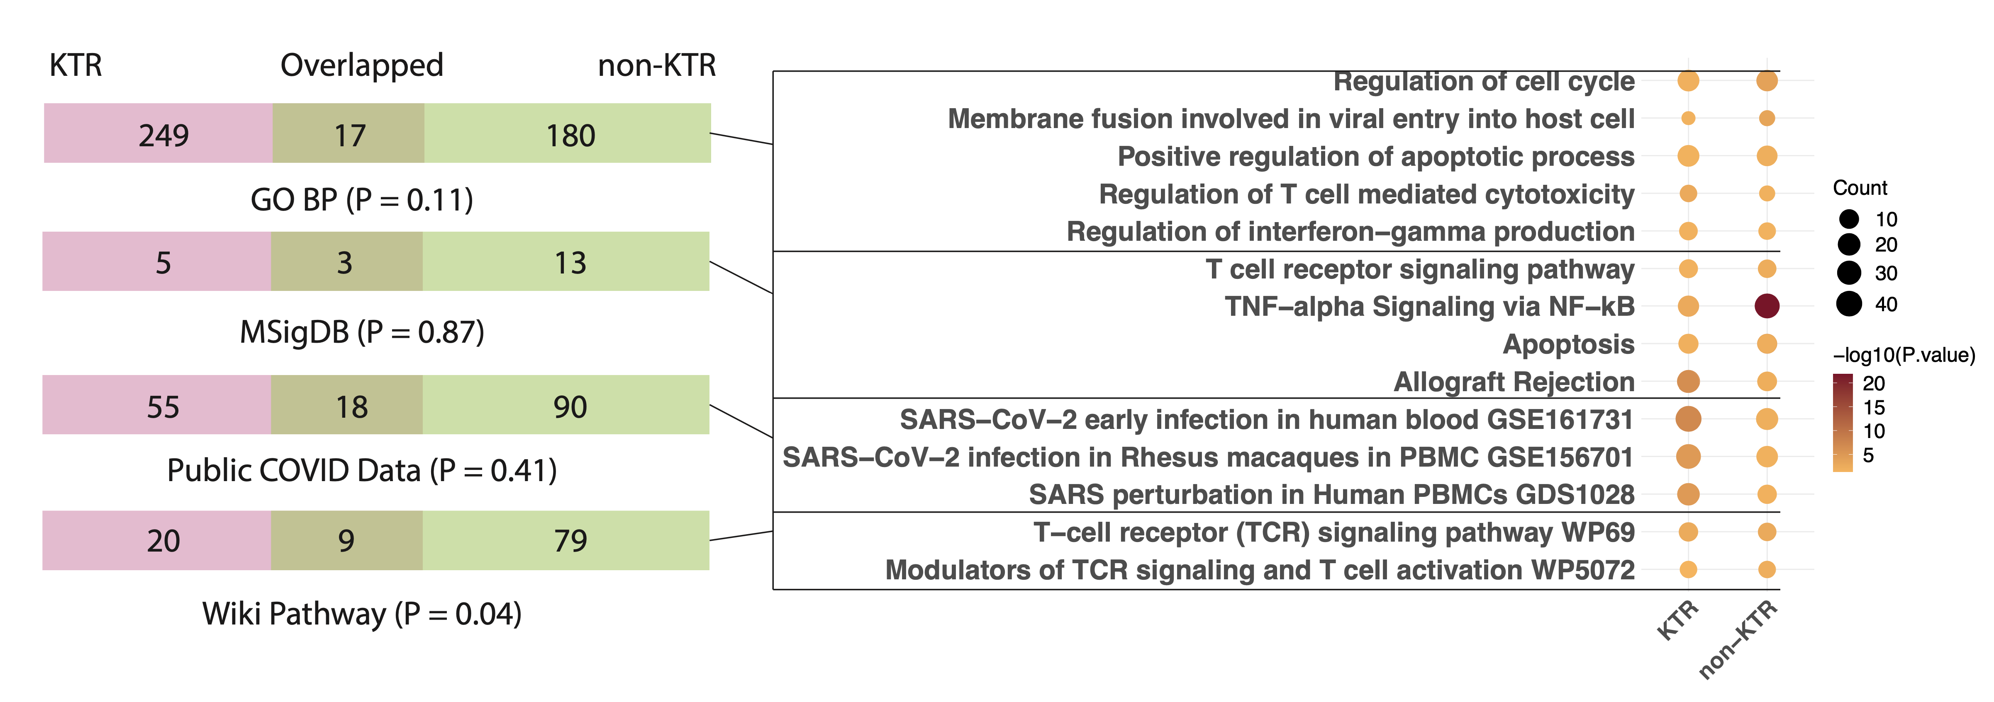

**Figure S8. Overlapped immune-related pathways in blood transcriptome of COVID-19 infected KTRs and non-KTRs.** Pathways are enriched in differentially expressed genes (DEGs) identified in post-acute patients as compared to acute patients. On the left panel, each Venn diagram (displayed in the form of bars) shows the overlap of enriched pathways between KTRs and non-KTRs (GEO accession: GSE157859).(*1*) The overlap significance was evaluated with a hypergeometric test. On the right panel, the representative overlapped pathways were listed in the dot plot with the size of the dot indicating the number of DEGs in each pathway and the color indicating the enrichment significance.

**Supplementary Tables**

**Table S1. Flow cytometry analysis on total blood or Ficoll-isolated PBMCs in a subset of acute KTRs.**

|  |  |  |
| --- | --- | --- |
| **Subset** | **Markers** | **Parent population** |
| Total lymphocytes | - | Acquired cells |
| Total T cells | CD3+ | Acquired cells |
| CD4+ T cells | CD3+CD8-CD4+ | CD3+ cells |
| CD8+ T cells | CD3+CD4-CD8+ | CD3+ cells |

**Table S2. Demographic and clinicopathologic characteristics of all enrollees and patients selected for transcriptome study.**

|  |  |  |  |
| --- | --- | --- | --- |
| **Variable**a | **All recruited** (n = 89) | **Study cohort**  (n = 64) | **P-value**b |
| **Demographics** |  |  |  |
| Age (years) | 54.8 ± 13.2 | 55.7 ± 13.4 | 0.68 |
| Gender, male | 51 (57.3) | 36 (56.2) | 1 |
| Race, African American | 23 (25.8) | 13 (20.3) | 0.45 |
| Time from COVID-19 diagnosis (days) | 58.2 ± 87.1 | 66.8 ± 95.4 | 0.57 |
| **Transplant information** |  |  |  |
| Transplant vintage (years) | 4.42 ± 5.1 | 5.49 ± 5.7 | 0.24 |
| Donor status, living donor | 31 (34.8) | 26 (40.6) | 0.5 |
| T-cell depletion induction | 59 (67.8) | 46 (73) | 0.59 |
| **Comorbidity** |  |  |  |
| Smoking | 20 (22.5) | 11 (17.2) | 0.54 |
| Diabetes | 51 (57.3) | 38 (59.4) | 0.87 |
| Hypertension | 84 (94.4) | 61 (95.3) | 1 |
| **COVID-19 severity score** |  |  | 0.98 |
| 1 | 18 (20.2) | 10 (15.6) |  |
| 2 | 6 (6.7) | 5 (7.8) |  |
| 3 | 18 (20.2) | 14 (21.9) |  |
| 4 | 13 (14.6) | 11 (17.2) |  |
| 5 | 13 (14.6) | 7 (10.9) |  |
| 6 | 11 (12.4) | 9 (14.1) |  |
| 7 | 10 (11.2) | 8 (12.5) |  |
| **Transplant outcome** |  |  |  |
| Graft loss within one year | 6 (6.7) | 3 (4.7) | 0.74 |
| Death | 11 (12.4) | 8 (12.5) | 1 |

a: Unless otherwise specified, numeric variables are summarized as mean ± SD, and categorical variables as counts (percentage).

b: In comparing between different severity strata, p-values were calculated by t-test for numeric variables and Fisher’s Exact test or Chi-square test for categorical variables. Bold p-value < 0.05.

**Table S3. Demographic and clinicopathologic characteristics of the acute KTRs stratified by the COVID-19 severity.**

|  |  |  |  |  |
| --- | --- | --- | --- | --- |
| **Variable**a | **Low**b (n =8) | **Median**b (n = 10) | **High**b (n = 13) | **P-value**c |
| **Demographics** |  |  |  |  |
| Age (years) | 54 ± 13.44 | 46 ± 16.21 | 62.62 ± 10.09 | **0.02** |
| Gender, male | 5 (62.5) | 6 (60) | 5 (38.5) | 0.48 |
| Race, African American | 2 (25) | 4 (40) | 4 (30.8) | 0.79 |
| Body mass index (BMI) (kg/m2) | 30.55 ± 3.54 | 31.46 ± 4.8 | 29.47 ± 6.24 | 0.66 |
| Time from COVID-19 diagnosis (days) | 9.38 ± 8.62 | 7 ± 5.1 | 10.54 ± 6.98 | 0.48 |
| **Transplant information** |  |  |  |  |
| Transplant vintage (years) | 3.3 ± 3.6 | 7.6 ± 7.8 | 7.9 ± 7.4 | 0.39 |
| Donor status, living donor | 4 (50) | 4 (40) | 7 (53.8) | 0.90 |
| T-cell depletion induction | 4 (50) | 8 (80) | 6 (46.2) | 0.11 |
| Immunosuppression modification |  |  |  |  |
| Calcineurin inhibitors (CNI) |  |  |  | 0.22 |
| Not on CNI | 0 (0) | 1 (10) | 1 (7.7) |  |
| >50% reduction in CNI | 4 (50) | 3 (30) | 5 (38.5) |  |
| <50% reduction in CNI | 2 (25) | 6 (60) | 7 (53.8) |  |
| No change in CNI | 2 (25) | 0 (0) | 0 (0) |  |
| Mycophenolate Mofetil (MMF) |  |  |  | 1.00 |
| Not on MMF | 0 (0) | 0 (0) | 2 (15.4) |  |
| Held dose | 4 (50) | 6 (60) | 6 (46.2) |  |
| >50% reduction or off | 4 (50) | 4 (40) | 5 (38.5) |  |
| Similar dose | 0 (0) | 0 (0) | 0 (0) |  |
| Steroids (in Prednisone equivalents) |  |  |  | **0.02** |
| <0.5 mg | 8 (100) | 8 (80) | 5 (38.5) |  |
| 0.5 ~ 1 mg | 0 (0) | 2 (20) | 3 (23.1) |  |
| >1 mg | 0 (0) | 0 (0) | 5 (38.5) |  |
| **Comorbidity** |  |  |  |  |
| Smoking | 2 (25) | 1 (10) | 0 (0) | 0.10 |
| Diabetes | 5 (62.5) | 6 (60) | 7 (53.8) | 1.00 |
| Hypertension | 7 (87.5) | 10 (100) | 12 (92.3) | 0.72 |
| ACEI/ARBd | 1 (12.5) | 1 (10) | 4 (30.8) | 0.52 |
| **COVID-19 symptoms** |  |  |  |  |
| Respiratory symptoms | 2 (25) | 7 (70) | 9 (69.2) | 0.09 |
| **Transplant outcome** |  |  |  |  |
| Acute kidney injury | 4 (50) | 10 (100) | 13 (100) | 1.00 |
| Graft loss within one year | 0 (0) | 0 (0) | 1 (7.7) | 1.00 |
| Death | 0 (0) | 0 (0) | 8 (61.5) | **<0.01** |
| Lymphocytes (103/ml) | 1.46 ± 0.7 | 0.5 ± 0.24 | 0.62 ± 0.4 | **<0.01** |
| Baseline serum Creatinine (mg/dl) | 1.07 ± 0.23 | 2.76 ± 2.41 | 1.3 ± 0.44 | **0.03** |
| Peak serum Creatinine (mg/dl) | 2.34 ± 2.34 | 6.19 ± 6.11 | 3.1 ± 1.8 | 0.12 |

a: Unless otherwise specified, numeric variables are summarized as mean ± SD, and categorical variables as counts (percentage).

b: Low: COVID-19 severity score 1-3; Median: COVID-19 severity score 4-5; High: COVID-19 severity score 6-7.

c: In comparing between different severity strata, p-values were calculated by ANOVA for numeric variables and Fisher’s exact test or Chi-square test for categorical variables. Bold p-value < 0.05.

d: ACEI/ARB: Angiotensin-converting enzyme inhibitor/Angiotensin receptor blocker.

**Table S4. Immune suppression status stratified by COVID-19 severity score in acute and post-acute KTRs.**

**(A) Acute KTRs**

|  |  |  |  |  |  |  |  |  |  |
| --- | --- | --- | --- | --- | --- | --- | --- | --- | --- |
| **Variable** | **IS score**a | **All**  (n = 31) | **1**  (n = 1) | **3**  (n = 7) | **4**  (n = 6) | **5**  (n = 4) | **6**  (n = 5) | **7**  (n = 8) | P-valueb |
| Calcineurin inhibitors (CNI) |  |  |  |  |  |  |  |  | 0.32 |
| Not on CNI | 0 | 2 (6.5) | 0 (0) | 0 (0) | 1 (16.7) | 0 (0) | 0 (0) | 1 (12.5) |  |
| >50% reduction in CNI | 1 | 12 (38.7) | 1 (100) | 3 (42.9) | 3 (50) | 0 (0) | 3 (60) | 2 (25) |  |
| <50% reduction in CNI | 2 | 15 (48.4) | 0 (0) | 2 (28.6) | 2 (33.3) | 4 (100) | 2 (40) | 5 (62.5) |  |
| No change in CNI | 3 | 2 (6.5) | 0 (0) | 2 (28.6) | 0 (0) | 0 (0) | 0 (0) | 0 (0) |  |
|  |  |  |  |  |  |  |  |  |  |
| Mycophenolate Mofetil (MMF) |  |  |  |  |  |  |  |  | 0.87 |
| Not on MMF | 0 | 2 (6.5) | 0 (0) | 0 (0) | 0 (0) | 0 (0) | 1 (20) | 1 (12.5) |  |
| Held dose | 0 | 16 (51.6) | 1 (100) | 3 (42.9) | 3 (50) | 3 (75) | 2 (40) | 4 (50) |  |
| >50% reduction or off | 1 | 13 (41.9) | 0 (0) | 4 (57.1) | 3 (50) | 1 (25) | 2 (40) | 3 (37.5) |  |
| Similar dose | 2 | 0(0) | 0 (0) | 0 (0) | 0 (0) | 0 (0) | 1 (20) | 0(0) |  |
| Steroids (in Prednisone equivalents) | | | | | | | | | 0.03 |
| <0.5 g | 1 | 21 (67.7) | 1 (100) | 7 (100) | 6 (100) | 2 (50) | 3 (60) | 2 (25) |  |
| 0.5 ~ 1 g | 2 | 5 (16.1) | 0 (0) | 0 (0) | 0 (0) | 2 (50) | 0 (0) | 3 (37.5) |  |
| >1 g | 3 | 5 (16.1) | 0 (0) | 0 (0) | 0 (0) | 0 (0) | 2 (40) | 3 (37.5) |  |

**(B) Post-acute KTRs**

|  |  |  |  |  |  |  |  |  |  |
| --- | --- | --- | --- | --- | --- | --- | --- | --- | --- |
| **Variable** | **IS Score**a | **All**  (n = 33) | **1**  (n = 9) | **2**  (n = 5) | **3**  (n = 7) | **4**  (n = 5) | **5**  (n = 3) | **6**  (n = 4) | P-valueb |
| Calcineurin inhibitors (CNI) | |  |  |  |  |  |  |  | 0.71 |
| Not on CNI | 0 | 1 (3) | 0 (0) | 0 (0) | 0 (0) | 0 (0) | 0 (0) | 1 (25) |  |
| >50% reduction in CNI | 1 | 27 (81.8) | 7 (77.8) | 4 (80) | 6 (85.7) | 5 (100) | 3 (100) | 2 (50) |  |
| <50% reduction in CNI | 2 | 5 (15.2) | 2 (22.2) | 1 (20) | 1 (14.3) | 0 (0) | 0 (0) | 1 (25) |  |
| Mycophenolate Mofetil (MMF) | | |  |  |  |  |  |  | 0.56 |
| Not on MMF | 0 | 1 (3) | 0 (0) | 0 (0) | 0 (0) | 0 (0) | 0 (0) | 1 (25) |  |
| Held dose | 0 | 13 (39.4) | 2 (22.2) | 1 (20) | 4 (57.1) | 3 (60) | 1 (33.3) | 2 (50) |  |
| >50% reduction or off | 1 | 14 (42.4) | 4 (44.4) | 2 (40) | 3 (42.9) | 2 (40) | 2 (66.7) | 1 (25) |  |
| Similar dose | 2 | 5 (15.2) | 3 (33.3) | 2 (40) | 0 (0) | 0 (0) | 0 (0) | 0 (0) |  |
| Steroids (in Prednisone equivalents) | | |  |  |  |  |  |  | 0.21 |
| <0.5 g | 0 | 32 (97) | 9 (100) | 5 (100) | 7 (100) | 5 (100) | 3 (100) | 3 (75) |  |
| 0.5 ~ 1 g | 1 | 1 (3) | 0 (0) | 0 (0) | 0 (0) | 0 (0) | 0 (0) | 1 (25) |  |

a: Cumulative IS score was calculated by CNI + MMF + Steroids.

b: Fisher’s exact test

**Table S5. Pathways enriched in DEGs associated with COVID-19 severity in acute KTRs.**

(Supplementary_Tables_S5_to_S10.xlsx)

**Table S6. Overlapped pathways enriched in DEGs associated with COVID-19 severity in acute KTRs and non-KTRs.**

(Supplementary_Tables_S5_to_S10.xlsx)

**Table S7. Pathways enriched in DEGs between post-acute and acute KTRs.**

(Supplementary_Tables_S5_to_S10.xlsx)

**Table S8. Overlap of pathways enriched in DEGs associated with COVID-19 severity in acute KTRs and in DEGs between post-acute and acute KTRs.**

(Supplementary_Tables_S5_to_S10.xlsx)

**Table S9. Neutrophil related functions are not enriched in DEGs between post-acute and acute KTRs.**

(Supplementary_Tables_S5_to_S10.xlsx)

**Table S10. Overlapped pathways enriched in DEGs between post-acute and acute in KTRs and non-KTRs.**

(Supplementary_Tables_S5_to_S10.xlsx)

**Supplementary References**

1. H. Y. Zheng *et al.*, Longitudinal transcriptome analyses show robust T cell immunity during recovery from COVID-19. *Signal Transduct Target Ther* **5**, 294 (2020).