Supplemental Digital Content. Measurement of Inter-recti Distance
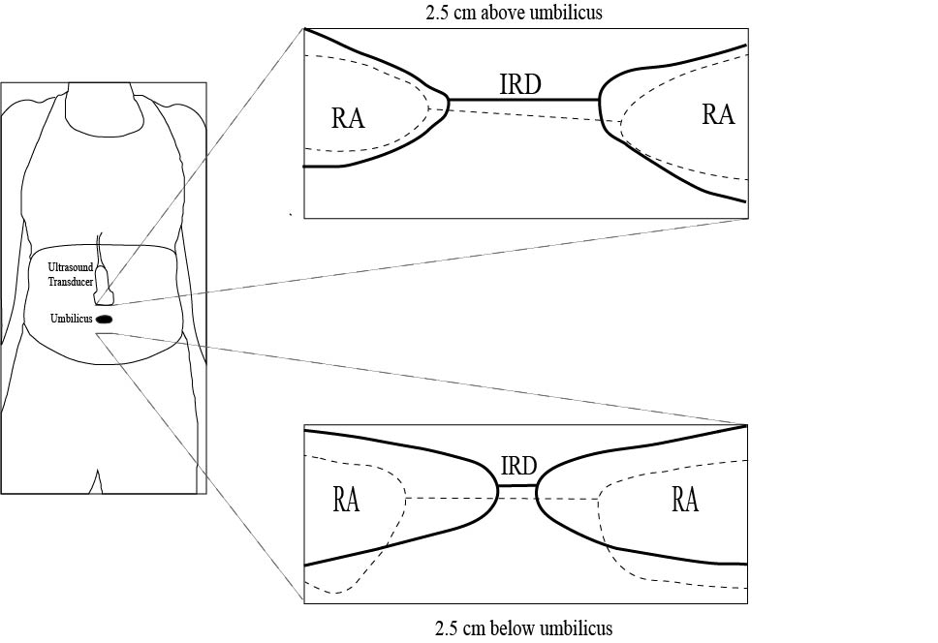
SDC Figure 2. This schematic demonstrates the location of ultrasound measurement for inter-recti distance (IRD). Representative data from one subject (2 years postpartum at study enrollment). The fascial borders of the rectus abdominis (RA) muscles on the ultrasound image were outlined, as well as the line measuring IRD. Dotted lines represent the ultrasound image obtained at baseline, while the solid dark lines represent the ultrasound image obtained at the end of intervention.

