Supplemental Material

Methods: Guinea Pig Pharmacokinetic Studies
Care and Use of Laboratory Animals
All animal studies were conducted under an approved institutional protocol according to the National Institutes of Health (NIH) Guidelines.

FX-322 Pharmacokinetic Studies in Guinea Pigs and Modeling
Pharmacokinetic studies were performed as non-recovery procedures in pigmented, NIH-strain guinea pigs weighing 400-600 g. Experiments were performed under protocol 20180054, approved by the Institutional Animal Care and Use Committee of Washington University. Animal use followed policies in accordance with the U.S. Department of Agriculture and NIH guidelines for the handling and use of laboratory animals. Animals were anesthetized with 100 mg/kg sodium thiobutabarbital (Inactin, Sigma, St Louis, MO) after which a polyethylene tracheal cannula was placed. The animal was then maintained on 0.8% to 1.2% isofluorane in oxygen using a mechanical ventilator. End-tidal CO₂ level was held close to 5% by adjustment of the ventilator tidal volume. Heart rate and O₂ saturation were monitored, and core body temperature was maintained at 38°C with a thermistor-controlled heating blanket.

Drug Application to the Round Window Niche
The auditory bulla was exposed by a ventral approach. After the cochlear apex or LSCC had been prepared for fluid sampling a 20 µL bolus of poloxamer containing 3.14 µg/mL CHIR99021 and 88.6 mg/mL VPA was applied to the round window (RW) niche using a positive displacement hand pipettor (Eppendorf Biomaster 4830). The applied volume was sufficient to fill the RW niche with excess flowing over the stapes footplate towards the apical bulla.

Sequential Sampling from the Cochlear Apex
The cochlear apex was prepared for sampling by removing the mucosa with a cotton swab and allowing the bone to dry. A thin layer of cyanoacrylate glue (Permabond 101; Permabond, Pottstown, PA) was applied to the dry bone, followed by layers of two-part silicone adhesive (Kwik-Cast, World Precision Instruments, Sarasota, FL), built up at the edges to form a hydrophobic cup. At the time of sampling a 30-40 μm fenestration was made at the apex through the adhesives using a 30⁰ House stapes pick (N1705 80, Bausch and Lomb Inc.). Clear fluid flowed from the fenestration, accumulating on the hydrophobic surface. Fluid was collected into hand-held, blunt tipped capillary tubes (VWR 53432-706; VWR Radnor, PA), each marked for a nominal volume of 1 μL and taking 1-2 min to collect. The length of each sample in its capillary tube was immediately measured with a calibrated dissecting microscope, to establish the exact sample volume. Ten individual samples were collected in this manner and each expelled into 25 μL of 1:1 acetonitrile:water diluent. Samples were stored frozen at -80⁰C until analysis.

Quantitative Simulation of Sequential Sample Data
Our established finite-element inner ear fluids simulation program (FluidSim v3.24) has been used to interpret the distribution of more than 13 molecules in perilymph, resulting in 37 publications on the topic. The program was configured to replicate all aspects of the experiments performed in this study. For intratympanic applications, calculations included entry from the middle ear at the round window and the stapes. Drug distribution through the fluid and tissue spaces of the entire inner ear were calculated based on defined diffusion coefficients and elimination rates. Simulation of the sequential sampling procedure accounted for the associated volume flows, replicating the flow rates necessary to account for the specific volumes, and collection times for each of the samples.

Human Perilymph Collection
After exact supine positioning of the head of the patient, FX-322 was applied intratympanically so that a coverage of the round and oval window niche was achieved and allowed to contact for approximately 60 minutes. Within this time, a standard mastoidectomy and posterior tympanotomy were performed as follows: The postauricular region was infiltrated with xylocain and 1:100000 epinephrine for local pain control and hemostasis. Needle electrodes were placed in the main muscles innervated by the facial nerve, i.e. orbicularis oculi et oris, and were hooked to a monitor. Impedances were checked and the function of the monitor was confirmed by tapping the facial muscles.

Next, the patient was prepped and draped. A postauricular incision was made using a 12 blade. The plane of the temporalis muscle and fascia was identified and prepared towards the external auditory canal. A periosteal incision was made in the periosteum and fascia was elevated. The spine of Henle and the mastoid tip were identified. Under constant suction and irrigation, a cortical mastoidectomy was carried out. The tegmen, the sigmoid sinus, and the digastric ridge were identified. Next, the air cells along the bony external canal were removed and the horizontal semicircular canal was identified. Using a small diamond burr, the aditus ad antrum was carefully exposed until the incus was visible. The posterior tympanotomy was carefully opened after delineating the facial nerve and the chorda tympani. With this procedure, the round window as well as the stapes with its muscle and tendon were exposed. All remnants of FX-322 that was applied previously via an intratympanic approach were collected for analysis, and then removed by irrigation and suctioning. After carefully checking on the presence of a false membrane over the round window, this was carefully removed without opening or damaging the round window. Thereafter, the bony overhang was removed. Human perilymph was collected with a modified micro glass capillary prior to cochlear implantation as previously described (Schmitt et al., 2017).

Analysis of Perilymph Samples
Samples were analyzed using high-pressure liquid chromatography with mass spectrometry detection (HPLC-MS) methods that were validated under matrix matched conditions, e.g., perilymph and plasma matrices. Analysts were blinded to the dose levels used in the animal experiments.

Phase 1b Clinical Safety Study
Study Oversight
The study was conducted according to International Conference on Harmonisation guidelines, Good Clinical Practices, and the Declaration of Helsinki. The protocol and amendments were approved by the Institutional Review Boards for participating investigators. Each patient provided written informed consent. Frequency Therapeutics designed the in vivo and clinical studies and prepared the statistical analysis plan. Analyses were performed and data interpreted by Frequency and the authors. All the authors vouch for the integrity, completeness, and accuracy of the data and analyses and assume responsibility for the fidelity of the trial protocol. All the authors reviewed the manuscript and made the decision to submit the manuscript for publication.

Study Design and Patient Population
This was a Phase 1b, randomized, double-blind, placebo-controlled safety study conducted at three study sites in the United States. Adults aged 18-65 years were eligible if they had an established diagnosis of stable (no documented changes of >10 dB at any standard frequency for >6 months) noise-induced or idiopathic sudden SNHL. Patients were excluded for 1) current use of VPA in any form; 2) tympanic membrane perforation or other disorders of the tympanic membrane; 3) conductive hearing loss of >10 dB in either ear at two or more frequencies; 4) pure tone average of >70 dB at 500, 1000, 2000, and 4000 Hz in the ear to be injected; 5) active chronic middle ear disease; 6) history of major middle ear surgery as an adult; 7) receipt of an intratympanic injection within 6 months; 8) history of clinically significant vestibular symptoms; 9) clinically significant systemic autoimmune disease; or 10) history of head or neck radiation treatment.

Trial Population
Twenty-three patients were randomized to four treatment groups: low volume placebo (0.05 mL), high volume placebo (0.2 mL), low volume FX-322 (0.05 mL), and high volume FX-322 (0.2 mL).. Demographic variables were consistent across treatment groups (Table 1). While etiology was considered accurately defined by the investigators due to their familiarity with the subjects, the duration of hearing loss was difficult to characterize accurately. This was especially the case for noise-induced hearing loss (NIHL) patients since their hearing loss typically accumulates over time and is not often associated with any singular noise trauma event.

Study Endpoints
The primary study endpoint was safety. Plasma samples were obtained pre-dose and up to 24 hours post injection to assess the systemic exposure to the active pharmaceutical ingredients of FX-322, CHIR99021 and VPA. Patients underwent routine physical examination, vital signs, electrocardiogram, drug screen, clinical laboratory testing (hematology, serum chemistry, urinalysis), and hepatitis B and C antibody tests.

Additional analyses included measures of audibility and speech intelligibility. Audiologic assessment including otoscopy, tympanometry, air and bone conduction audiometry, word recognition (WR) in quiet using the Maryland CNC test (31), and speech-in-noise using the Words-in-Noise (WIN) (32) test were performed at screening and follow-up days 15, 30, 60, and 90 (Figure S1).

Statistical Analysis
Clinical trial: For this safety study, a sample size of approximately 24 patients was considered adequate for an initial assessment of safety and tolerability and was not based on formal statistical considerations. Pre-specified statistical analyses were exclusively descriptive and included 95% confidence intervals (CIs) as appropriate.

Audiometric analyses were considered exploratory and conducted without multiplicity adjustments. A mixed model for repeated measures (MMRM) with an unstructured covariance matrix was used for exploratory analyses of the relative dB change from baseline for audiometry at 8 kHz and the percent change from baseline for WR and WIN. Fixed effects were baseline values, treatment group (FX-322 vs. placebo), study day (categorical), and treatment by study day interaction. Patients were included in the model as a random effect. One patient missing Day 30 and Day 60 values was included in the analysis under the assumption that their data were missing at random.

Prospective group-level analyses of speech perception changes from baseline were conducted using the Thornton and Raffin method (33). Specifically, the 95% CI bounds were calculated in radians using the arcsine transformation for proportions of words recognized as detailed by Studebaker (34). Radian CIs were then converted back to word recognition proportions per the iterative procedure detailed by Thornton and Raffin (33). For individual patients, changes from baseline falling outside the 95% CIs were determined to be significant.

Baseline and Day 90 results of the WIN test were used to fit linear mixed model cubic polynomials across the tested signal-to-noise ratios (SNR) (35). Estimates of SNR values that correspond to the 50% correct word threshold were calculated for each patient using the Spearman-Karber formula (32). These values were then analyzed via a MMRM for the group differences in mean change from baseline to Day 90. There were 4 subjects who had a 35-word WIN test administered at baseline rather than the specified 70-word test. Two of these subjects also had a 35-word test administered at Day 15. This was considered to be a random error on the part of the Investigator. A post hoc bivariate regression of the second 35-word set score versus the first 35-word set score for subjects administered the complete 70-word test was conducted using the baseline values for the treated ear. The results yielded a constant = 0.58; slope = 0.98, mean square error = 2.41, and a Pearson correlation = 0.94. Given these results, where relevant, the number of correct words resulting from the 35-word test was doubled and used as the imputed 70-word score for these 4 subjects.

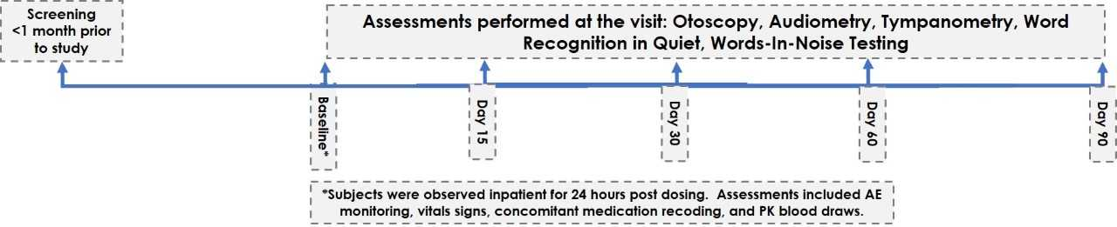
Supplemental Figure S1: Study timeline

AE = adverse events; PK = pharmacokinetic

Supplemental Figure S2: Guinea pig pharmacokinetic studies of FX-322. Decline of middle ear concentration of CHIR99021 (A) and VPA (B) following applications to the round window (RW) niche demonstrated in samples taken from the niche after perilymph sampling. Red curves are exponentials fitted to the data. Perilymph concentrations of CHIR99021 (C) and VPA (D) determined by sequential sampling from the cochlear apex 60 min after FX-322 was applied to the RW niche.

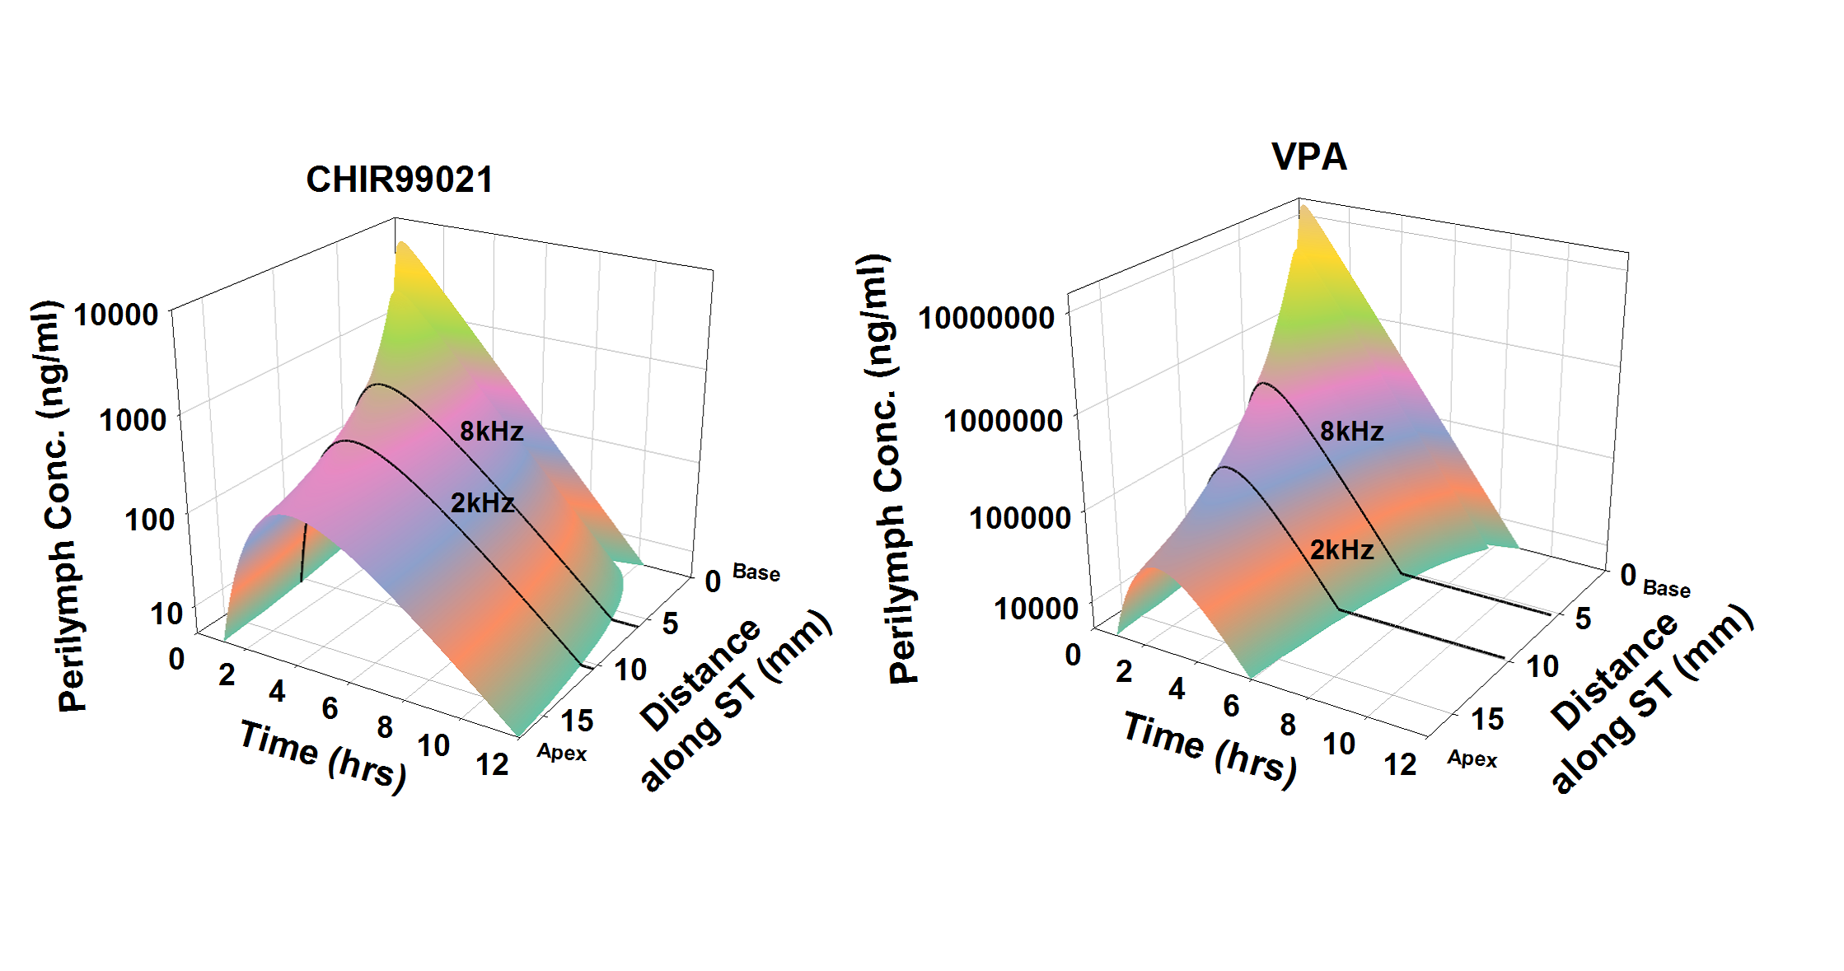
Supplemental Figure 3: Guinea pig PK modeling. Calculated distributions of CHIR99021 and VPA as a function of distance and time based on the measured distribution of drug 1 hour and 3 hours after round window (RW) niche applications. Calculations include kinetic processes of the middle ear, entry into perilymph and elimination from perilymph, as summarized in Table S2.

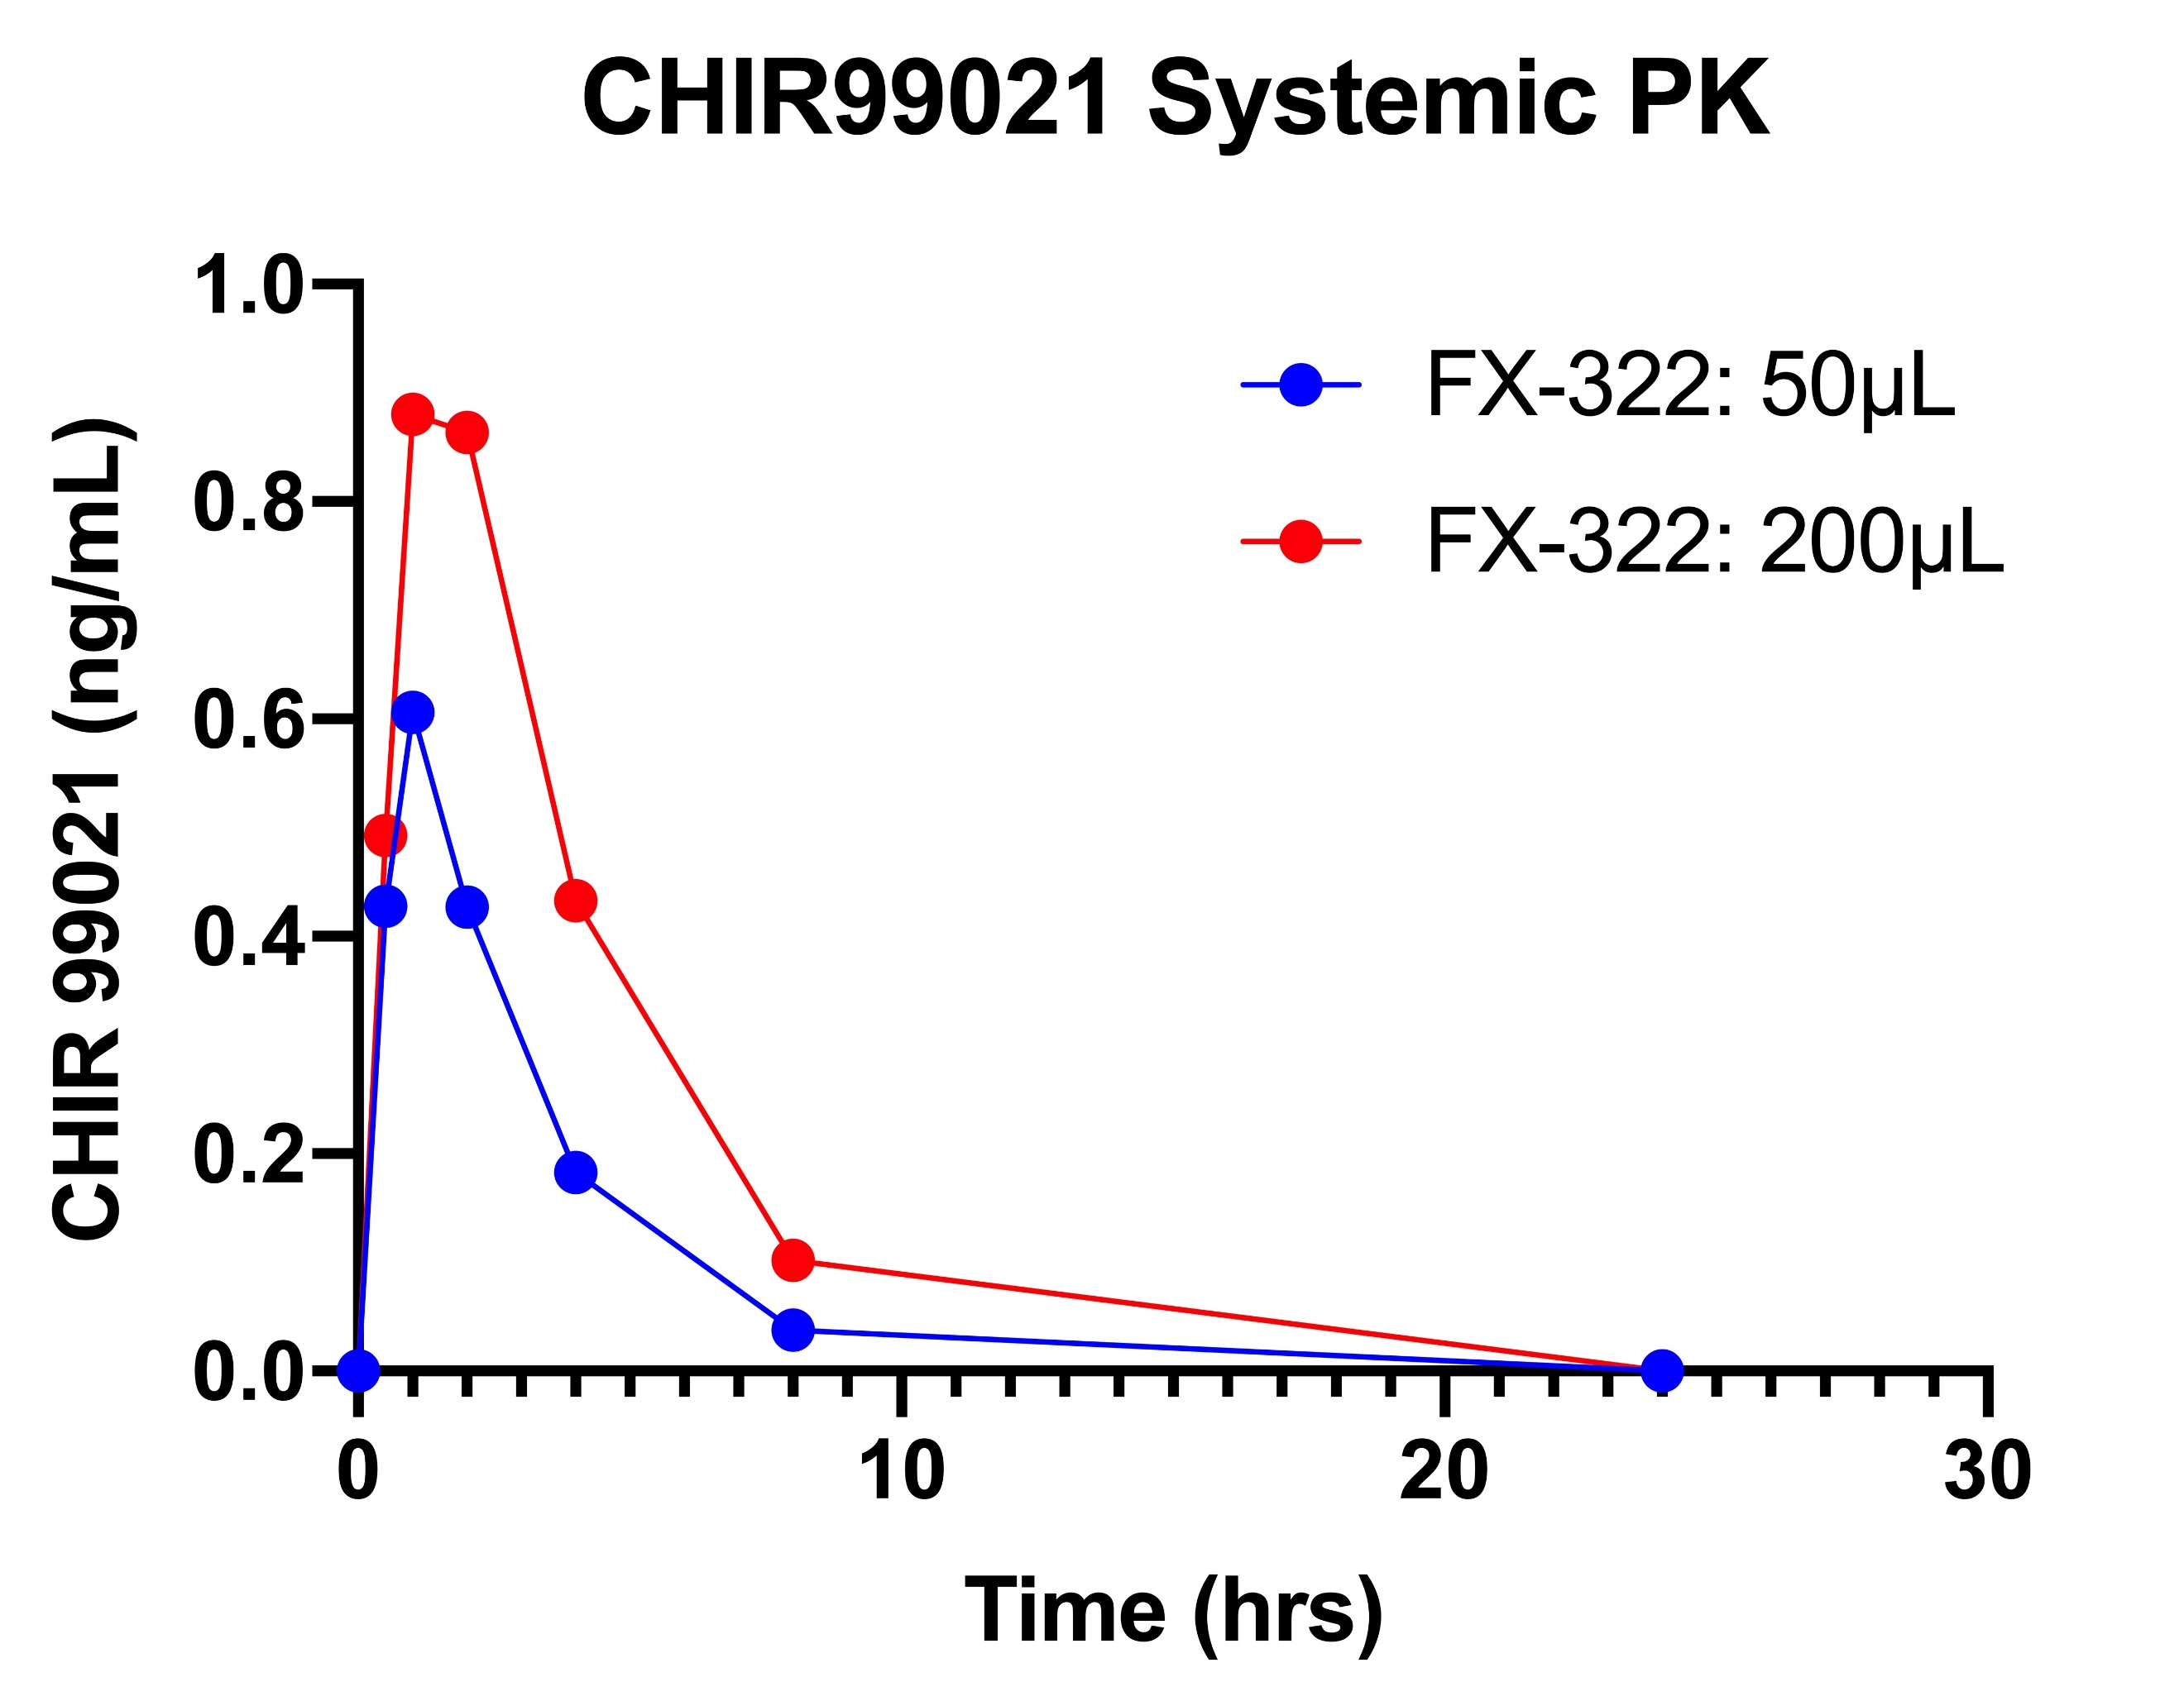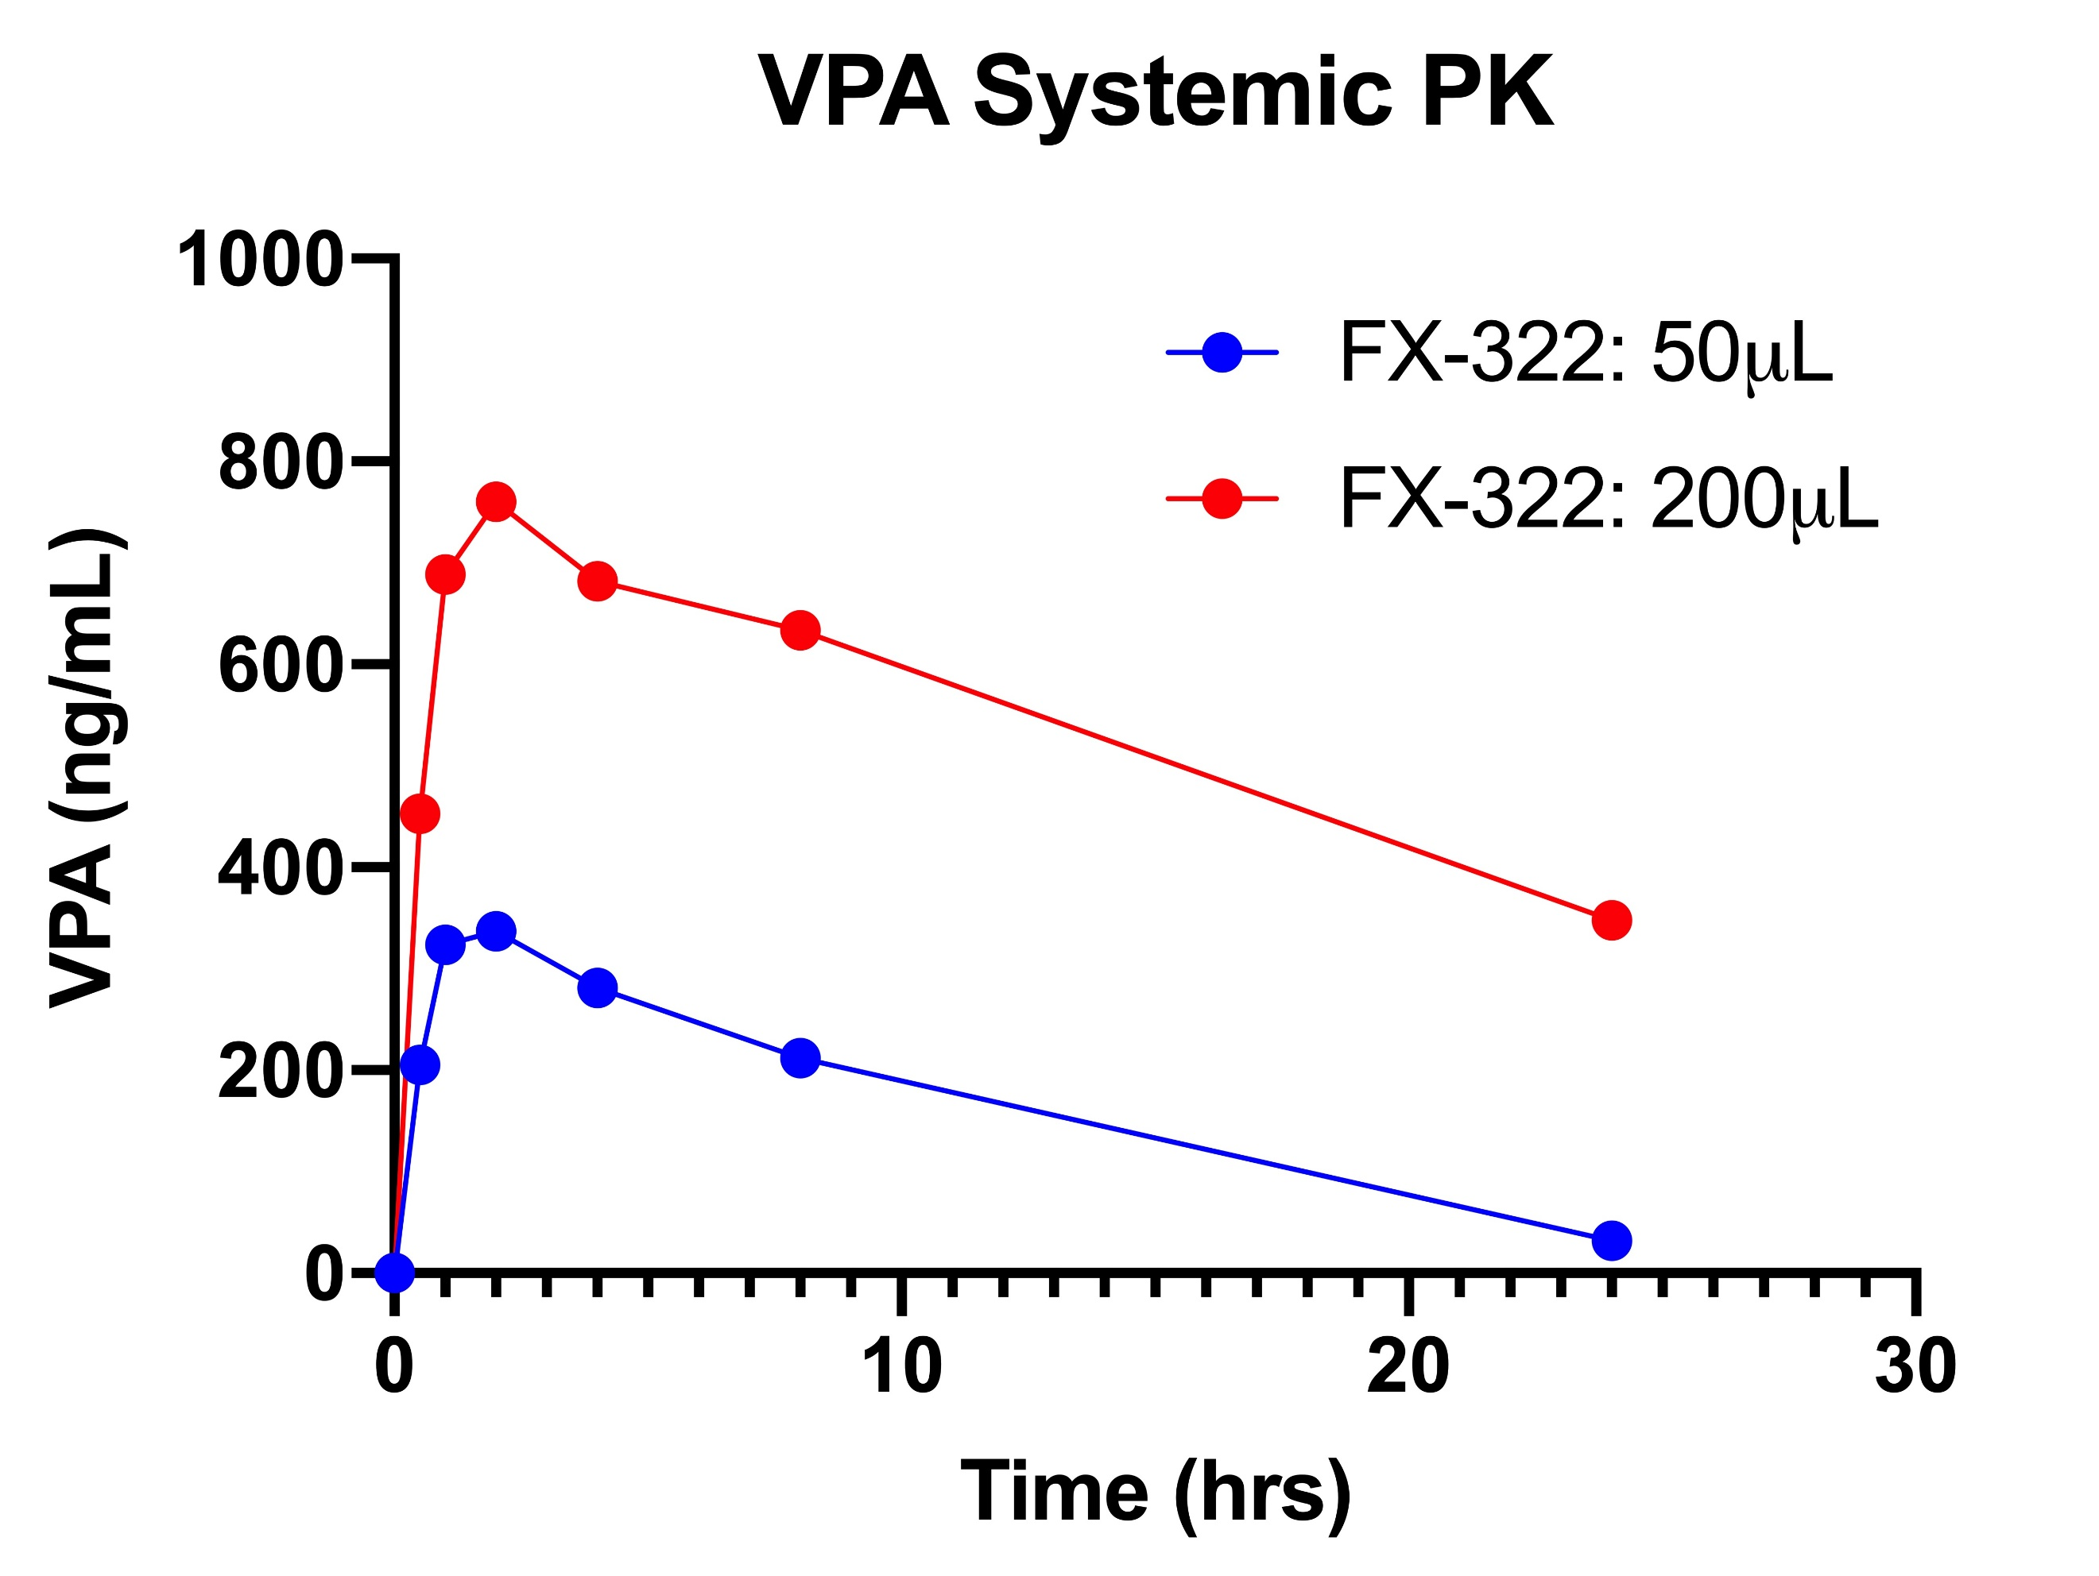
Supplemental Figure S4: Measured plasma levels of FX-322 components CHIR99021 and VPA in Humans

PK = pharmacokinetics

Supplemental Table S1: Kinetic parameters of the guinea pig model derived by fitting sample measurements.
 | CHIR99021 | VPA
SV Elimination half-time (min) | 28 | 45
ST Elimination half-time (min) | 90 | 19
Middle Ear Elimination half-time (min) | 56.4 | 48.6
RW Permeability | 2 | 260
Stapes Permeability | 57 | 5100

RW = round window; ST = scala tympani; SV = scala vestibuli; VPA = valproic acid

Patient # | Time (in minutes) from injection to gel sampling | Time (in minutes) from injection to sample collection | RW niche status (bony overhang, false membrane, thick RWM, other) | Volume of gel sample | Volume or perilymph collected | Time of FX-322 injection | Time of middle ear gel sampling | Time of perilymph sample collection
1 | 68 | 82 | mucosal folds present, oval window normal | 0.1 g | 2.0 µL | 9:38 | 11:06 | 11:20
2 | 79 | 89 | mucosal folds present, oval window normal | 0.1 g | 1.5 µL | 13:38 | 14:57 | 15:07
3 | 67 | 83 | very thick RWM, mucosal folds present, oval window normal | 0.1 g | 1.5 µL | 8:57 | 10:04 | 10:20
4 | 60 | 64 | strong osseous overhang, very thick RWM, mucosal folds absent, oval window normal | 0.5 g | 2.0 µL | 8:46 | 9:46 | 9:50
5 | 64 | 66 | strong osseous overhang, mucosal folds present, oval window abnormal with overhanging facial nerve present | 0.2 g | 1.0 µL | 8:32 | 9:36 | 9:38
6 | 64 | 72 | strong osseous overhang, mucosal folds absent, oval window normal | 0.1 g | 2.0 µL | 12:38 | 13:42 | 13:50
7 | 60 | 63 | strong osseous overhang, mucosal folds present, oval window normal | 0.05 g | 2.0 µL | 8:48 | 9:48 | 9:51
Supplemental Table S2: Human PK Sample Details and Middle Ear Anatomical Observations

PK = pharmacokinetic; RW = round window; RWM = round window membrane

Supplemental Table S3: Kinetic parameters of the human model derived by fitting sample measurements.
 | CHIR99021 | VPA
SV Elimination half-time (min) | 28 (from guinea pig) | 46 (from guinea pig)
ST Elimination half-time (min) | 90 (from guinea pig) | 11 (from guinea pig)
Middle Ear Elimination half-time (min) | 10.59 | 8.91
RW Permeability | 10.0 | 136
Stapes Permeability | 1056 | 15630

RW = round window; ST = scala tympani; SV = scala vestibuli; VPA = valproic acid

