Preserved function of circulating invariant natural killer T cells in patients with chronic hepatitis B virus infection

Authors：Haoxiang Zhu, PhD, Yongmei Zhang, PhD, Hongyan Liu, PhD, Yijun Zhang, PhD, Yaoyue Kang, MD, Richeng Mao, PhD, Feifei Yang, MD, Dapeng Zhou, PhD, Jiming Zhang, PhD

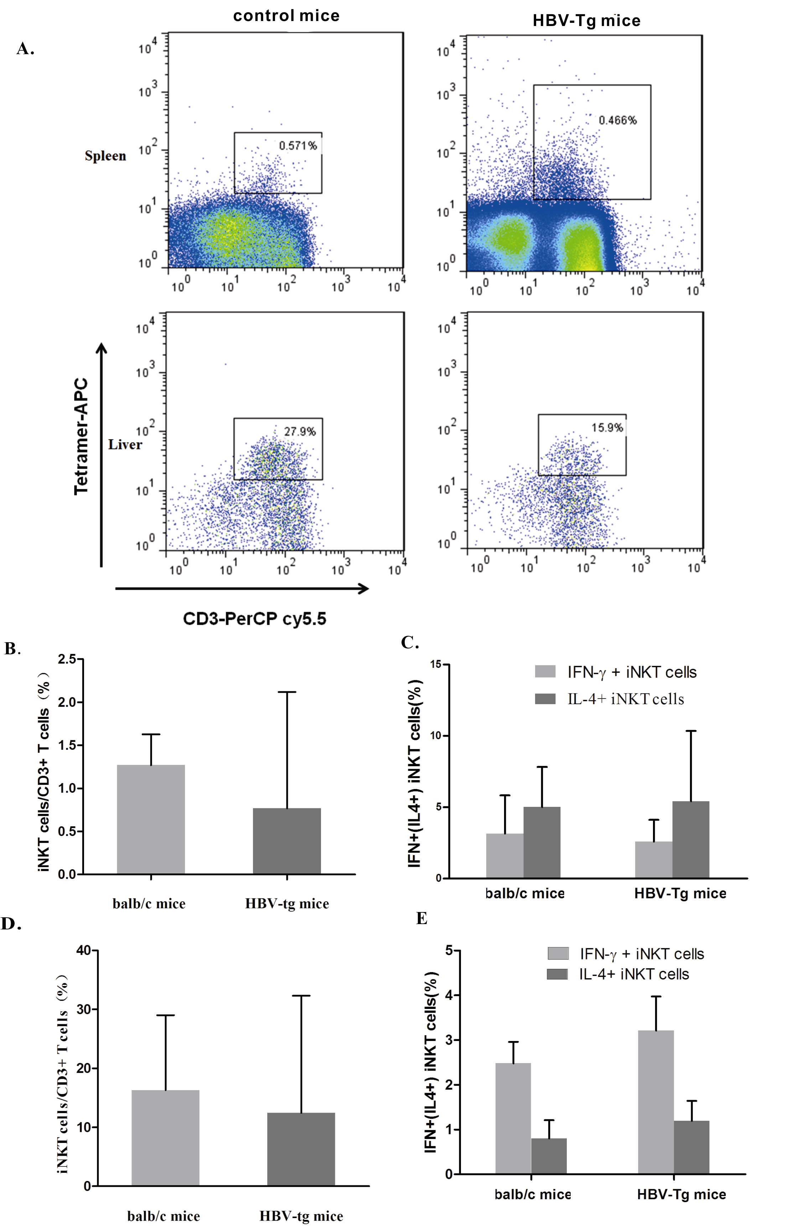

Supplemental Figure 1. The frequency and cytokine producing capacity of hepatic and splenic iNKT cells from HBV-Tg mice are comparable to those from control mice. (A) Representative analysis of splenic and hepatic iNKT cell numbers in HBV-Tg mice compared to control mice. iNKT cells were identified as CD3 and CD1d tetramer double-positive cells. (B) Pooled splenic iNKT cell frequency in HBV-Tg mice (n = 8) and control mice (n = 8). (C) Pooled percentage of IFN-γ and IL-4 producing splenic iNKT cells in HBV-Tg mice and control mice. (D) Pooled hepatic iNKT cell frequency in HBV-Tg mice and control mice. (E) Pooled percentage of IFN-γ and IL-4 producing hepatic iNKT cells in HBV-Tg mice and control mice. Horizontal bars represent the median and max values. Comparisons between these two subgroups were performed using Mann-Whitney test.

Supplementary Table 1. Patient characterization and iNKT profiles during Tenofovir therapy.
Patient NO. | Visit time | ALT  (U/L) | Liver  pathology | HBsAg  (IU/ml) | HBV-DNA  (log₁₀copies/ml ) | HBeAg | iNKT cell (%) | IFN-γ⁺ iNKT cell (%) |  | IL-4⁺ iNKT cell (%)
1 | 0w | 74 | G2S3 | 3199.93 | 8.1 | + | 0.069 |  | 83.40 | 5.68
 | 48w | 18 | G1S1 | 4939.8 | <2.06 | + | 0.014 |  | 58.80 | 39.30
 | 72w | 20 |  | 3379.2 | <2.06 | + | 0.037 |  | 55.60 | 6.67
2 | 0w | 45 | G2S2 | 1944.05 | 6.4 | - | 0.030 |  | 76.70 | 8.59
 | 48w | 34 | G1S2 | 2408.58 | <2.06 | - | 0.041 |  | 60.00 | 8.33
 | 72w | 29 |  | 2546.12 | <2.06 | - | 0.053 |  | 47.10 | 19.30
3 | 0w | 174 | G2S2 | 379.83 | 6.06 | - | 0.031 |  | 85.20 | 17.09
 | 48w | 18 | G1S2 | 267.75 | <2.06 | - | 0.037 |  | 55.00 | 7.14
 | 72w | 16 |  | 200.42 | <2.06 | - | 0.034 |  | 73.90 | 14.30
4 | 0w | 150 | G2S1 | 4802.34 | 8.18 | + | 0.310 |  | 50.20 | 12.10
 | 48w | 19 | G1S1 | 243.09 | <2.06 | + | 0.368 |  | 25.20 | 12.20
 | 72w | 17 |  | 179.09 | <2.06 | + | 0.376 |  | 61.70 | 19.30
5 | 0w | 272 | G2S2 | 3838.79 | 6.17 | - | 0.009 |  | 48.10 | ND
 | 48w | 17 | G1S2 | 3242.23 | <2.06 | - | 0.007 |  | 66.70 | ND
 | 72w | 17 |  | 4648.09 | <2.06 | - | 0.004 |  | 50.00 | ND
6 | 0w | 62 | G1S2 | 3161.69 | 5.42 | - | 0.063 |  | 53.20 | 18.74
 | 48w | 19 | G0S0 | 2558.16 | <2.06 | - | 0.054 |  | 62.13 | 9.78
 | 72w | 14 |  | 1956.19 | <2.06 | - | 0.064 |  | 64.32 | 12.56
7 | 0w | 96 | G3S3 | 3168.46 | 8.72 | - | 0.027 |  | 35.00 | 9.09
 | 48w | 25 | G2S3 | 3007.9 | 5.28 | - | 0.022 |  | 27.84 | 17.33
 | 72w | 25 |  | 3033.44 | <2.06 | - | 0.031 |  | 46.28 | 10.10
8 | 0w | 288 | G2S2 | 74398.7 | 9.58 | + | 0.189 |  | 71.20 | 32.40
 | 48w | 19 | G1S0 | 1429.72 | 2.61 | + | 0.173 |  | 56.22 | 18.70
 | 72w | 20 |  | 1630.22 | 2.36 | + | 0.163 |  | 63.40 | 19.83
9 | 0w | 292 | G2S2 | 188634 | 10.25 | + | 0.019 |  | 52.50 | 4.35
 | 48w | 15 | G1S0 | 1707.08 | 5.19 | + | 0.021 |  | 43.80 | 5.43
 | 72w | 21 |  | 1547.72 | 2.23 | + | 0.028 |  | 58.70 | 7.92
10 | 0w | 227 | G2S2 | 34473.6 | 8.91 | + | 0.052 |  | 61.70 | 5.63
 | 48w | 27 | G1S1 | 3828.43 | <2.06 | + | 0.045 |  | 44.90 | 10.20
 | 72w | 28 |  | 3841.29 | <2.06 | + | 0.053 |  | 53.80 | 7.84
11 | 0w | 124 | G3S3 | 19200.1 | 9.37 | + | 0.119 |  | 45.40 | 15.73
 | 48w | 40 | G3S4 | 12429.2 | 6.34 | + | 0.108 |  | 33.80 | 14.27
 | 72w | 37 |  | 9719.92 | 3.68 | + | 0.107 |  | 52.78 | 18.45
12 | 0w | 145 | G1S1 | 82618.8 | 9.1 | + | 0.034 |  | 38.50 | 8.20
 | 48w | 30 | G0S0 | 889.94 | 2.32 | + | 0.045 |  | 45.33 | 8.35
 | 72w | 18 |  | 677.8 | 2.13 | + | 0.041 |  | 40.67 | 9.56
13 | 0w | 58 | G2S2 | 1867.78 | 6.71 | - | 0.277 |  | 25.70 | 3.98
 | 48w | 16 | G1S1 | 1705.59 | 2.63 | - | 0.258 |  | 44.94 | 7.58
 | 72w | 21 |  | 1968.26 | <2.06 | - | 0.256 |  | 32.88 | 9.47
G: necroinflammation grading ; S: fibrosis staging ; ND: not determined

