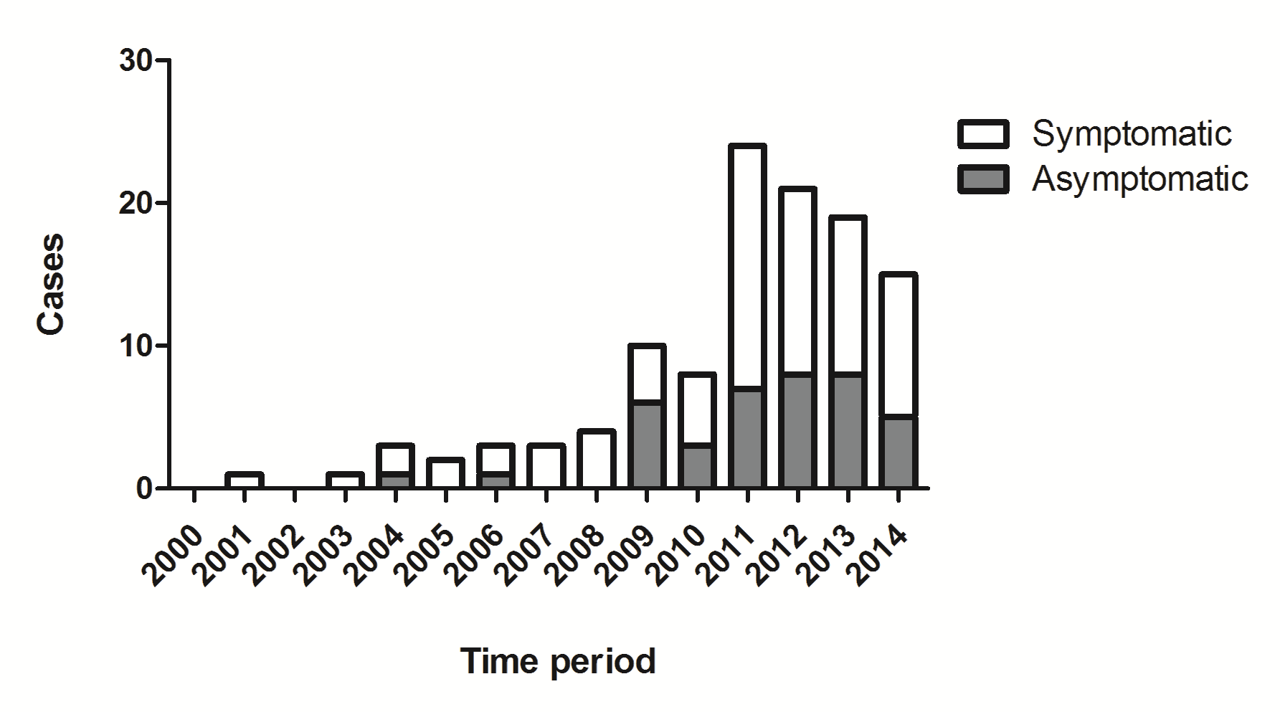
Supplemental Figure 1. Increase in number of PCN over the years. The initial presentation of patients with a PCN was classified in symptomatic or asymptomatic. Patients were considered symptomatic when initial presentation included abdominal pain, jaundice, acute pancreatitis, chronic pancreatitis, weight loss or other complaints. Asymptomatic presentation includes discovery of the lesion incidentally or due to surveillance for familial risk.

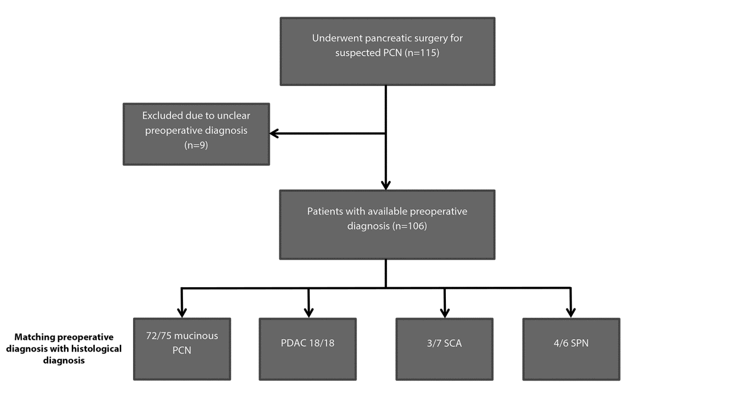
Supplemental Figure 2. Flowchart for evaluation of diagnostic performance of all PCN resections. Patients were excluded when preoperative diagnosis was not clearly stated or when multiple imaging modalities contradicted. IPMN and MCN were clustered as mucinous PCN. All preoperatively diagnosed pancreatic ductal adenocarcinoma (PDAC) were histopathologically confirmed as such. Numbers are presented as ‘correct diagnosed/total type PCN’.

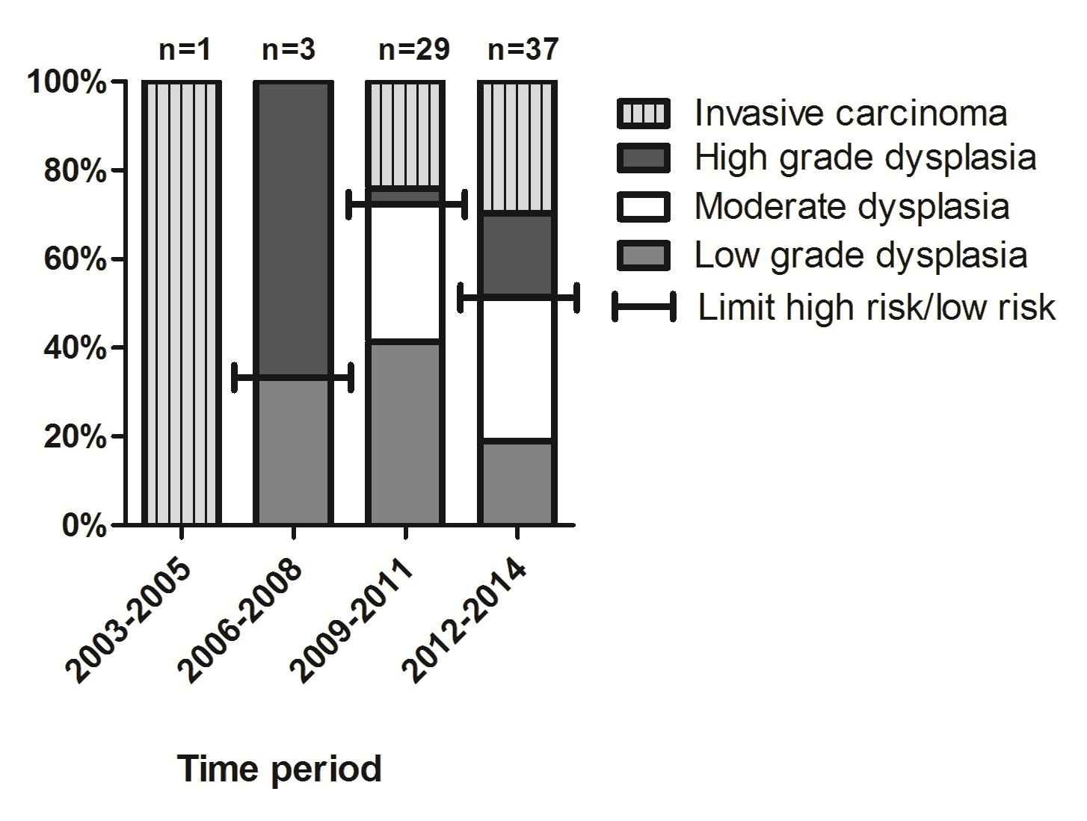
Supplemental Figure 3. Distribution of dysplasia in resected IPMN over the years. The rate of resections for low risk PCN, while declining in the last few years, remains as high as 51.4% between 2012 and 2014.

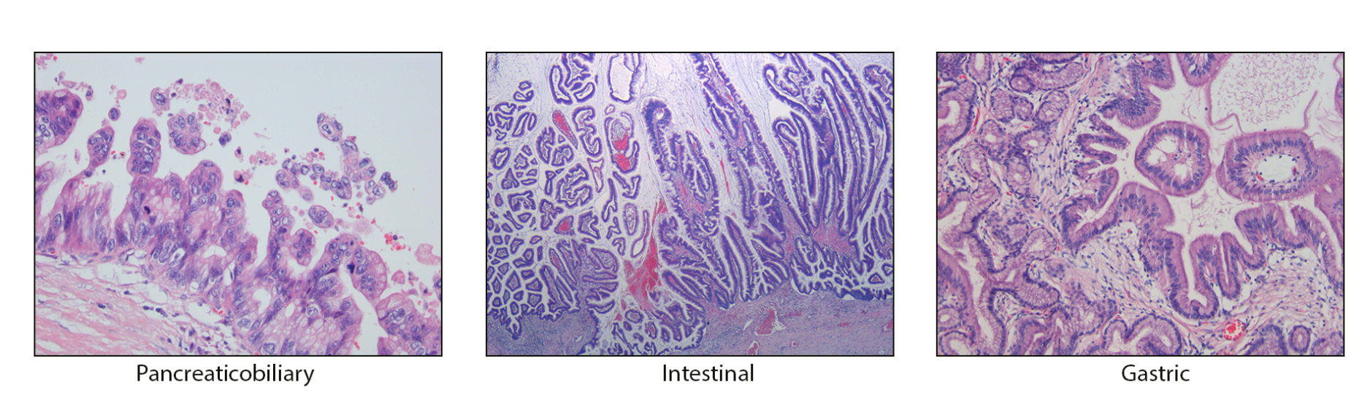
Supplemental Figure 4. Different subtypes of IPMN as can be evaluated with regular H&E staining (200x magnification).

Subtype, n |  |  | Dysplasia |  |  |  |  | High risk cyst (%)
Subtype, n | Unknown | No  dysplasia | Low grade dysplasia | Moderate  dysplasia | High grade dysplasia | Invasive carcinoma | Total | High risk cyst (%)
IPMN
Pancreatobiliary | 0 | 0 | 3 | 2 | 1 | 6 | 12 | 7/12 (58.3)
Intestinal | 0 | 0 | 6 | 11 | 3 | 3 | 23 | 6/23 (26.1)
Gastric | 1 | 0 | 10 | 4 | 0 | 4 | 19 | 4/19 (21.1)
Oncocytic | 0 | 0 | 0 | 0 | 1 | 1 | 2 | 2/2 (100)
Tubulo-papillary neoplasia | 0 | 0 | 0 | 0 | 2 | 0 | 2 | 2/2 (100)
Intestinal and Gastric | 0 | 0 | 0 | 2 | 1 | 2 | 5 | 3/5 (60)
Gastric and Pancreatobiliary | 0 | 0 | 0 | 2 | 2 | 1 | 5 | 3/5 (60)
Intestinal and Pancreatobiliary | 0 | 0 | 0 | 0 | 0 | 1 | 1 | 1/1 (100)
Intestinal and Colloid | 0 | 0 | 0 | 0 | 0 | 1 | 1 | 1/1 (100)
Unknown | 0 | 0 | 1 | 0 | 0 | 0 | 1
MCN | 1 | 2 | 20 | 2 | 0 | 2 | 27 | 2/26 (7.7%)

Supplemental Table 1. Subtypes and dysplasia of IPMN and MCN patients in retrospective cohort.

In case of adjacent PDAC, the dysplasia of the IPMN was noted
The dysplasia of 1 case and the subtype of another case could not be retrieved

Variable | Sensitivity, % | Specificity, % | Positive Predictive Value, % | Negative Predictive Value, % | Diagnostic accuracy, %
CEA≥192 ng/ml | 39.0 | 96.7 | 94.1 | 53.7 | 63.4
Mucin background | 66.6 | 81.8 | 83.3 | 64.3 | 73
CEA≥192 ng/ml + Mucin background | 75.0 | 79.1 | 82.7 | 70.4 | 76.8

Supplemental Table 2. Diagnostic performance of CEA and the presence of mucin in cytological analysis.

