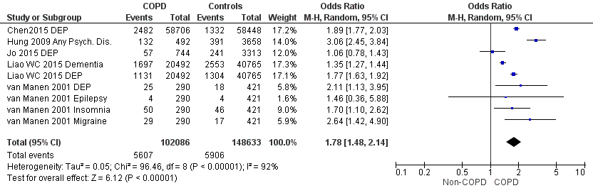
Figure SI: Forest plot showing the significantly higher prevalence of neurological and psychiatric comorbidities in COPD patients in comparison with non-COPD patients. Abbreviations in study identity: DEP, Depression; Psych. Dis., psychiatric disorder

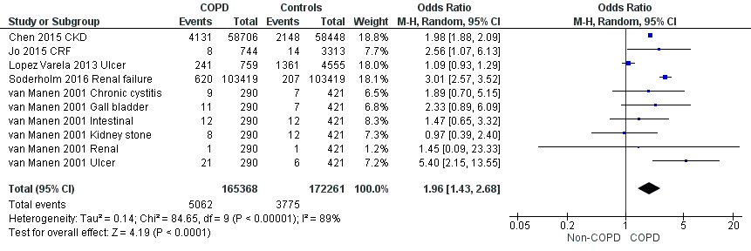
Figure S2: Forest plot showing the significantly higher prevalence of renal and gut comorbidities in COPD patients in comparison with non-COPD patients. Abbreviations in study identity: CKD, chronic kidney disease.

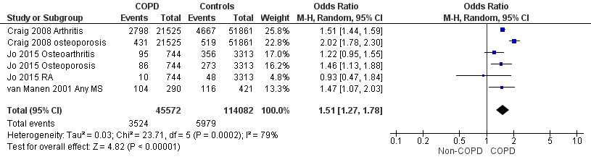
Figure S3: Forest plot showing the significantly higher prevalence of musculoskeletal comorbidities in COPD patients in comparison with non-COPD patients. Abbreviations in study identity: RA, rheumatoid arthritis.

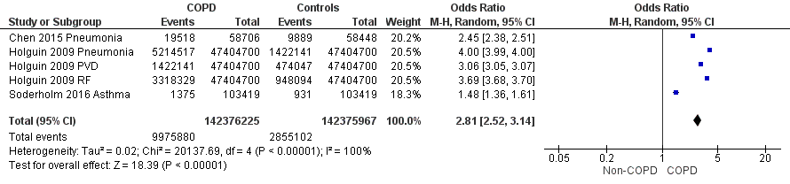
Figure S4: Forest plot showing the significantly higher prevalence of non-COPD respiratory comorbidities in COPD patients in comparison with non-COPD patients. Abbreviations in study identity: PVD, pulmonary vascular disease; RF, respiratory failure.

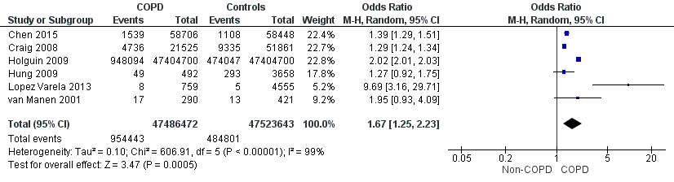
Figure S5: Forest plot showing the significantly higher prevalence of cancer in COPD patients in comparison with non-COPD patients.

