Supplemental Figure 1: Distribution of patient outcomes following index hospitalization for pneumonia for health system. The FFS cohort outcomes are presented for the entire cohort (1998-2009) and the more recent cohort (2005-2009).

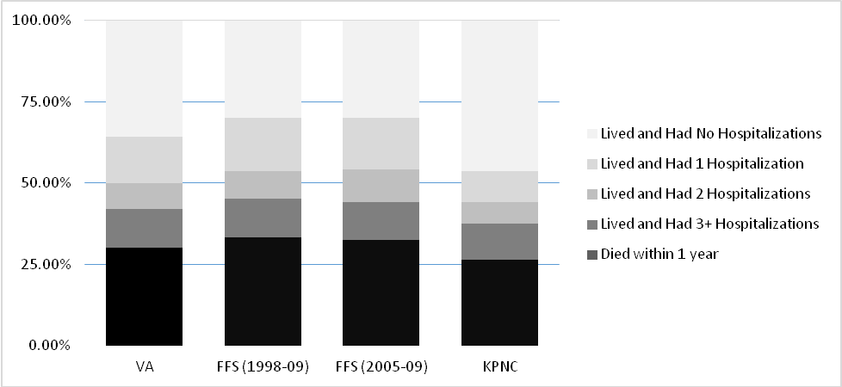

Supplemental Content

Supplemental Table 1: Demographic Information and Hospitalization characteristics with the FFS cohort from 2005-2009 specifically included.
Demographic or Hospitalization Characteristics | VA  (N = 23,536) | FFS  (all years)  (N = 2,731) | FFS  (more recent years)  (N = 935) | KPNC  (N = 39,147)
Years of data included | 2013-2014 | 1998-2009 | 2005-2009 | 2010-2014
Number of hospitals | 113 | 908 | 908 | 21
Age, mean (SD) | 70.7 (12.5) | 78.3 (10) | 78.3 (9.9) | 71.8 (16.2)
Male, n (%) | 22,773 (97) | 1,153 (47.9) | 446 (47.7%) | 19,367 (49.5)
Race/ethnicity, n (%)
White | 18,145 (77) | 1,968 (81.8) | 760 (81.3) | 28,115 (71.8)
Black/African American | 3,648 (16) | 347 (14.4) | 141 (15.1) | 3,467 (8.9)
Other/Missing | 1,743 (8) | 92 (3.8) | 34 (3.6) | 7,565 (19.3)
Charlson score, median (IQR) | 2 (1-3) | 3 (2-5) | 3 (2-5) | 2 (1-3)
Hospital length of stay (d), median (IQR) | 4 (3-8) | 5 (3-8) | 5 (3-8) | 3.7 (2.1-6.5)
Admitted to intensive care unit, n (%) | 1,034 (4.0) | 372 (15.5) | 177 (18.9) | 10,834 (27.7)

